Kanosh Town held its regular council meeting at 7:00 p.m. on Wednesday, December 10, 2025, 2025, in the Kanosh Town Hall, located at 55 North Main, Kanosh, Utah.
Members present: Council members present: Mayor Neil Shumway, Councilmembers Josh Whitaker and Dan DeGraffenried,. Kanosh Town Clerk Cindy Turner, and Kanosh Town Treasurer DeniAnn Whitaker. Councilmember David Whitaker was unable to attend tonight’s meeting.
Others in attendance: CERT Captain Geri Minton, Councilmembers-elect Brian Batt and Tim White, Mayor-elect Wenda Crabb, Jim Weaver, Star Cummings, Rod Cox, Shelly Cox, Ben Coray, Thayne Christensen, Val Nafus, Lexie Hadean, Jim Kooy, and Town Employee Lorin Shumway.
Councilmember Josh Whitaker offered the opening ceremonies through an invocation.
Councilmember Dan DeGraffenreid led everyone in attendance in the Pledge of Allegiance.
Minutes of the November 2025 meeting were read and approved by motion Councilmember Dan DeGraffenried; Councilmember Josh Whitaker provided a second to the motion, and all Council members voted in favor, as noted below:
Mayor Neil Shumway Aye
Council members
Josh Whitaker Aye
Dan DeGraffenried Aye

Warrants for November 2025 were read, discussed, and approved to be paid through a motion by Councilmember Josh Whitaker. Councilmember Dan DeGraffenried provided a second to the motion, and all Council members voted in favor as noted below:
Mayor Neil Shumway Aye
Council members
Josh Whitaker Aye
Dan DeGraffenried Aye

CERT
CERT Commander Geri Minton reported nothing new to report from CERT at this time. The December meeting was cancelled, and the cancellation was posted:
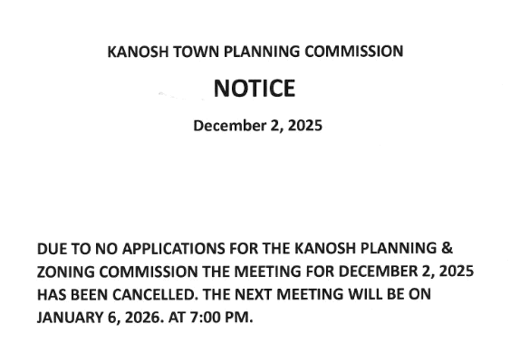
Kanosh Town Fire Chief:
Fire Chief Lorin Shumway stated the Fire Department has nothing new to report at this time.

Planning and Zoning
Planning Commission spokesperson Geri Minton presented the new building permit for Thayne Christensen. Millard County Building Inspector Adam Richins has approved the building permit. All other documents were in order and approved.
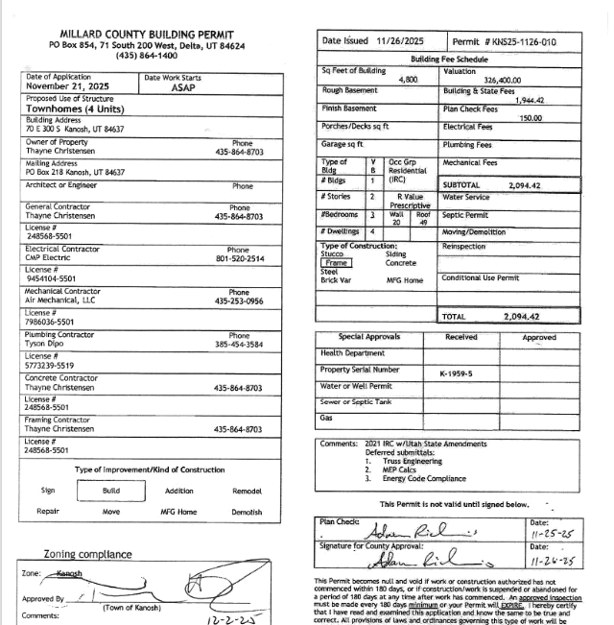

Rod Cox:
Mr. Cox stated he has met with the Millard County officials in reference to his property taxes vs property boundary. He is being assessed for property out to the middle of the road, the County indicated that this is a Town problem not a county one. It was noted that all the property lines within Kanosh Town are “off.” The Town at this time cannot financially provide a survey for the Town in its entirety; property owners can obtain an independent survey if they so desire.
Mr. Cox questioned the status of the speed limit signs on the west side of town. Town employee Lorin Shumway stated the signs have been ordered and should be here in a couple of weeks.

Mr. Cox questioned if there are plans to chipseal the west side of Town, and the width of road improvement? Councilmember Dan DeGraffenried noted the Council plans to chipseal every other year, with the high cost of materials we can on do one side of town at a time.

Dixie Power Contract:
Mayor Neil Shumway now has a purchase agreement contract, it has been submitted to our attorney for approval, upon approval the contract will be presented to Dixie Power for their approval.

Stan Koyle:
Mr. Koyle provided an update of the CCI project informing the plan for piping of the ditch from the spillway to the county road by the Karen Crooks corral. Mr. Koyle ask if there were any questions or comments, there were none.

Review electrical rates and potentially reset the surcharge based on the review
In looking at the six-month average, there is no need for a change or adjustment: we are right where we have been.

Department Report:
*Park and Cemetery: The tree lighting was a success, Councilmember Josh Whitaker thanked everyone involved with this event.
Cemetery: Nothing new to report.
Electrical: Nothing new to report.
Roads: the seed has been ordered however it has not been delivered, Councilmember Dan DeGraffenrie will follow up.
Water: Nothing new to report.

Utility Delinquency Review:
Council members reviewed the monthly delinquency list. It was determined, again, to handle those accounts in arrears according to the established Town policy. It should be noted that a very kind townsperson has now paid off all the utility delinquencies.

Public comments:
*Stan Koyle: reported the Irrigation company plans to purchase a Conex container for CCI, the location has not yet been determined. CCI questioned if the container could be located on Kanosh Town Property? This topic will serve as an agenda item for the January meeting.

*Mayor elect Wenda Crabb: Addressed the council member to thank each for their service!

Mayor elect Wenda Crabb: presented a plan for implementation of emails and a shared access of information through google drive. Mayor elect Crabb included directions for this implementation: (This will be addressed further in the January 2026 meeting)
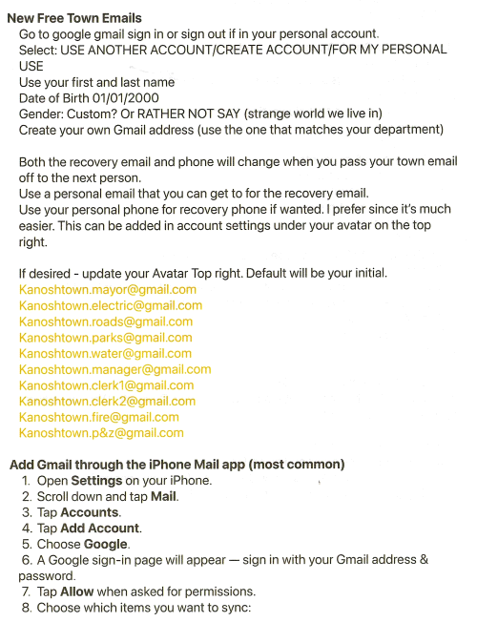
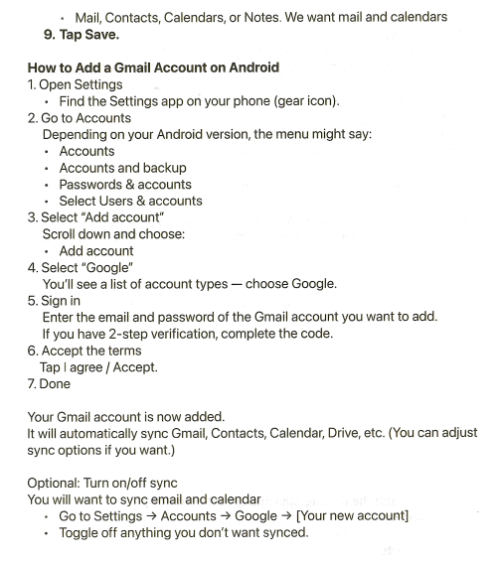
This will serve as a Project management tool the record will stay with the Town!

Mayor-Elect Crabb plans to put together a (KRA) Key Responsibility Area and therefore distributed the following: (This will be addressed further in the January 2026 meeting)
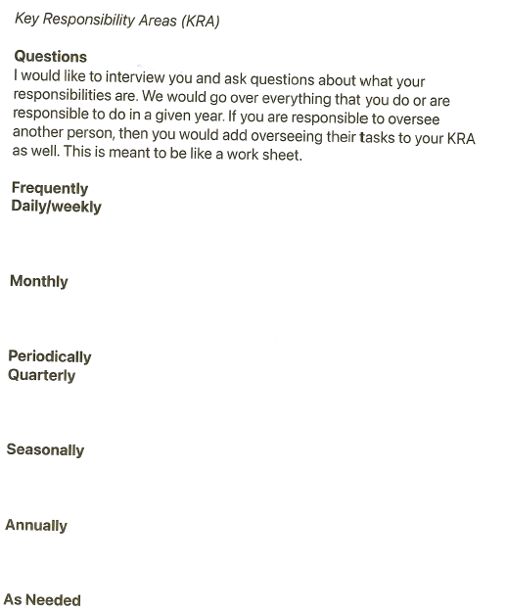

*Jim Kooy: noted how nice the Cemetery looked since Town employee Lorin Shumway cleaned it up.

Mr. Kooy offered his help when the cleanup of the old Fence at the Well house begins.

Old Business:
Corn Creek Project: and the Well Project:
*Corn Creek project: Lane Jensen plans to attend a council meeting in either January or February to provide an update of the project.

*Well Project: Mr. Ben Coray addressed the council members with updates on the well project. Tushar Construction is excited to get started. Because of the government shutdown, things are a little slower. They are now planning to start the first of the year! The project should be done before the end of April.
The town will take down the old fence and save a little money!
The 3-phase power installation, the only hang-up might be materials, but everything should be fine with our time line.
Mr. Coray requested that the Town pay the requests as submitted to Kanosh Town rather than wait for the monthly council meeting approval. The requests could be ratified. Note: With the last grant, the Kanosh Town attorney emphasized to the clerk that, prior to payments being issued, they must be presented to the council for approval to avoid any appearance of nonethical behaviors. This will serve as an agenda item for the January 2026 meeting.
Mr. Coray noted that with the grant money and the additional funding, he would ask for an amendment of the additional funding for Sunrise Engineering, stating that some of their services have been donated this far. Due to the dollar amount of $26 thousand involved, this will be an agenda item for next month.
Town Employees, Councilmembers, and their wives will meet at the fire station on Tuesday, the 16th, at 7:30 pm. for the official sacking of the Christmas Candy for the Christmas Program

There being no further business to come before the board, the meeting was adjourned.

Neil Shumway Cindy Turner,
Kanosh Town Mayor Kanosh Town Clerk

