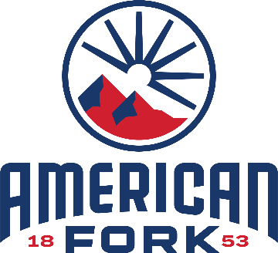

AMERICAN FORK CITY COUNCIL
JANUARY 27, 2026
PUBLIC HEARING NOTICE

PUBLIC HEARING - VACATION OF PORTION OF A PUBLIC UTILITY EASEMENT

Notice is hereby given that the American Fork City Council will hold a public hearing in conjunction with a regular session on Tuesday, January 27, 2026, at 7:00 p.m. at the American Fork City Hall, 31 N. Church Street. The City Council will receive public comments regarding the following:
- A proposed vacation of a portion of a public utility easement 452 West 1060 North. The portion of the public utility easement to be vacated is a full vacation of the existing 5’ public utility easement along the southerly boundary line and a reduction of the east side public utility easement from 10 feet to 5 feet. See map below. Action is scheduled for the regular session where the City Council will act on the proposed PUE vacation.
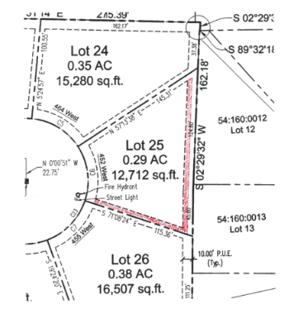
Copies of the proposed vacation are available at the City Administrative Offices, 51 E. Main Street. All interested people are invited to attend and make comments.
Posted this 15 day of January 2026.
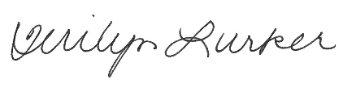
Terilyn Lurker, City Recorder

