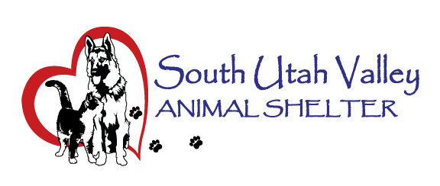
South Utah Valley Animal Special Service District
Board Meeting Minutes Tuesday November 18, 2025
South Utah Valley Animal Shelter Conference Room
582 W 3000 N Spanish Fork UT 84660
Board Member Attendance
Lt. Laursen* Chief Rod Hurst @RandiLyn Warner
Chief Lance Haight* Chief John Jackson @Dr Bott
Chief James Chief Brad Bishop @Legal-not filled
Kari Malkovich* Kevin Oyler Shawn Carter
Kierstan Munford-Ex. Director (*Absent / @ At large) Carrie Ward-Minutes
There were no Work Session items.
There were no Public Hearing Items.
The meeting was called to order at 10:33 AM by Chairman Hurst.
General Meeting Items:
- Public Comment. There were two members of the public present. Elizabeth Meltzer is a volunteer at SUVAS and said she wanted to see how a Board Meeting went. The other member of the public was Sheri Lynn Merriam. She wanted to address No-Kill at SUVAS. She has been feeding several feral cats and said that a Best Friends email had urged her to attend the meeting. She wants ear-tipped cats to go back to where they were picked up.
- Approve minutes from Board Meeting held on September 16, 2025. Motion to approve the minutes from the September 16, 2025 Board Meeting. 1st Chief Jackson, 2nd Chief Bishop. Motion passed.
- Financial Report by Kierstan Munford. She went over the handout of the financial summary July-October 2025. Chief Hurst asked why the operational costs were already at 52%. Kierstan explained that the leases and once annual costs were included in that.
- Shelter Report by Kierstan Munford. She reported daily animal numbers and there is also a monthly newsletter being done now too. During our ASPCA $30,000 grant Adoption Event there were 245 animals adopted. Shelter event dates were reported along with clinic numbers from the last few clinics. The clinic dates are being finalized for 2026. Carrie Ward reported the October statistics. Kevin Oyler wanted to know if we track kittens separately. He is interested in those intake numbers.
- Other Business. Kevin Oyler asked if SUVAS has a TNR policy? He has left a copy of a work-up he did to create discussion among the Board Members and cities. Kierstan will email this to the Board Members for input and discussion at the next Board Meeting. It was also suggested that an Open House or other networking event could be scheduled to invite city council members, county commissioners, and Board Members too as an educational event. The UACOA Conference will be held in St. George from January 21st to 23rd.
- Date and time of the next Board Meeting will be January 20, 2025 at 10:30 AM in the SUVAS meeting room.
- Motion to Adjourn. 1st Chief Bishop, 2nd Shawn Carter. Motion passed.

