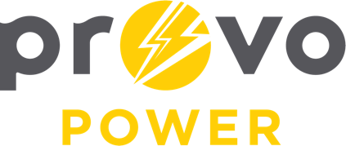
AGENDA
ENERGY BOARD MEETING
PROVO POWER
251 W 800 N
Monday, January 5, 2026
4:00 P.M.

- Welcome & Introductions – Chairman Gary Winterton
- Review & Approval of Minutes – November 4, 2025
- Introduce Fred Bandley – Scott Bunker
- 2026 Calendar Review – Jenna Li
- Financial Report – Charlie Little
- KPI Report – Charlie Little
- BYU PR Lab Project Report – Jenna Li and Carol-Lyn Jardine
- Manager Report – Scott Bunker
- Period for Public Comment
- Calendar & Scheduling
  - Next Board Meeting: March 20, 2026 in St. George
  - UMPA Conference: March 18-20, 2026

A copy of the agenda was posted in the Civic Center, and the Provo City Library, on December 30, 2025, and also delivered to the Mayor,
City Council Members, required news media, and adjacent cities in
compliance with the Utah Code 52-4-202

