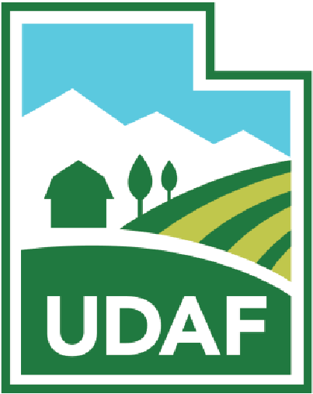
UTAH DEPARTMENT OF AGRICULTURE AND FOOD
State of Utah
Fish Health Policy Board
January 13, 2025
2:00 – 3:00 PM
UDAF offices
Taylorsville, UT
Conference Room #2508

Teleconference link: https://tel.meet/adq-ohtw-gwq?pin=5758190614028
Join by phone: (US) +1 929-251-5754‬ PIN: 682 340 058‬#‬
This meeting will be conducted in person and via electronic means. Here is the available link to the public for live broadcast and on-demand viewing: https://meet.google.com/adq-ohtw-gwq

If you do not have access to the Internet, you can join via telephone calling: (US) +1 929-251-5754 and using meeting PIN: 682 340 058‬#

AGENDA
- CALL MEETING TO ORDER – WADE CAVENDER, CHAIR.
- PUBLIC COMMENT
- APPROVAL OF THE MINUTES OF THE FHPB: [action Item]
  - Oct 1, 2025 FHPB meeting (Handout)
- UDWR RULES UPDATE [discussion item]
  - Presentation, Randy Oplinger (UDWR Aquatics)
- WHIRLING DISEASE UPDATE: [discussion item]
  - Presentation, Xavier Matheson (UDAF Aquaculture Manager)

- ANNOUNCEMENTS [discussion item]
  - UDAF “Clear the Rules” update.

- ADJOURN

