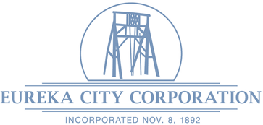
Eureka City Corporation
P. O. Box 156
15 North Church Street
Eureka, Utah 84628
U.S.A.
Phone 435-433-6915 eurekacity@eureka.utah.gov
Fax 435-433-6891 www.eureka.utah.gov

NOTICE AND AGENDA
Notice is hereby given that the Eureka City Council will hold its Work Meeting on Monday, January 12, 2026. The meeting will begin at 6:00 pm. The meeting will be held at 15 North Church Street, Eureka, Utah 84628. This meeting is open to the public, but no comments will be taken.

- ROLL CALL.
- DISCUSSION ITEMS:
- Shay Morrison, Community Advisor – OPMA and Newly Elected Official Training.
- Dan Fechner, Jones & DeMille – Road Design Standards.
- Review of Ordinance No. 2026-01-12-01 – An Ordinance Adopting Regulations for Accessory Dwelling Units and Internal Accessory Dwelling Units.
- Review of Ordinance No. 2026-01-12-02 An Ordinance Creating Short-Term Rental Code.
- Review of Consent Agenda Items:
- Minutes from December 8, 2025, Council Meeting.
- Treasurer’s Report for December 2025,
- Claims against the City from December 12, 2025 – January 15, 2026.
- Building Permit Report for December 2025.
- Work Order Report for December 2025.
3. ADJOURNMENT.

DATED THIS 9th DAY OF JANUARY 2026

Patricia Bigler
CITY RECORDER

In compliance with the Americans with Disabilities Act, individuals needing special accommodations (including auxiliary communicative aids and services) during this meeting should notify the Eureka City Office at 435-433-6915 at least three working days prior to the meeting.
The order of agenda items may be changed to accommodate the needs of the City Council, staff, and the public.

