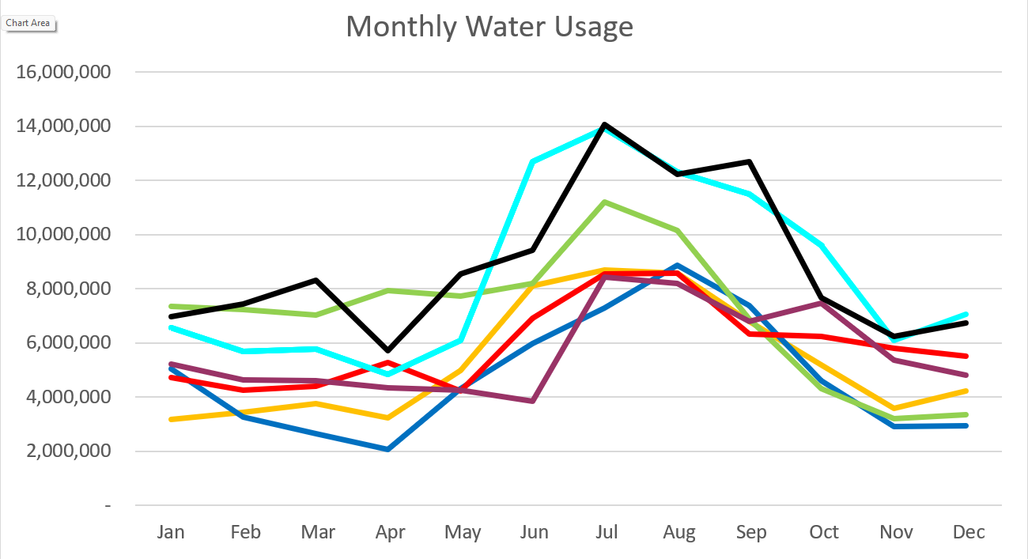2025 - Black
2024 – Light Blue 2023 – Purple
2022 – Red 2021 – Yellow
2020 – Blue 2019 – Green

December 2025

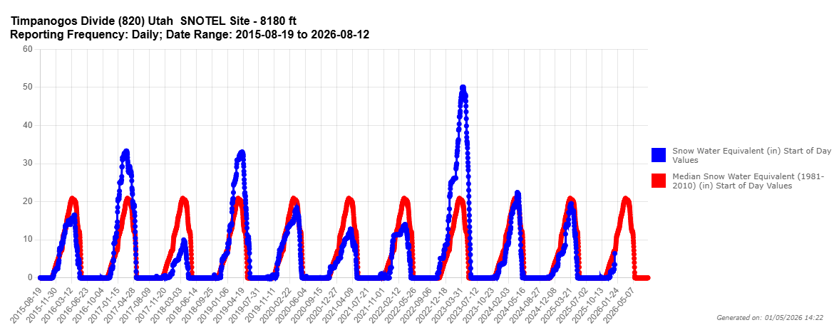
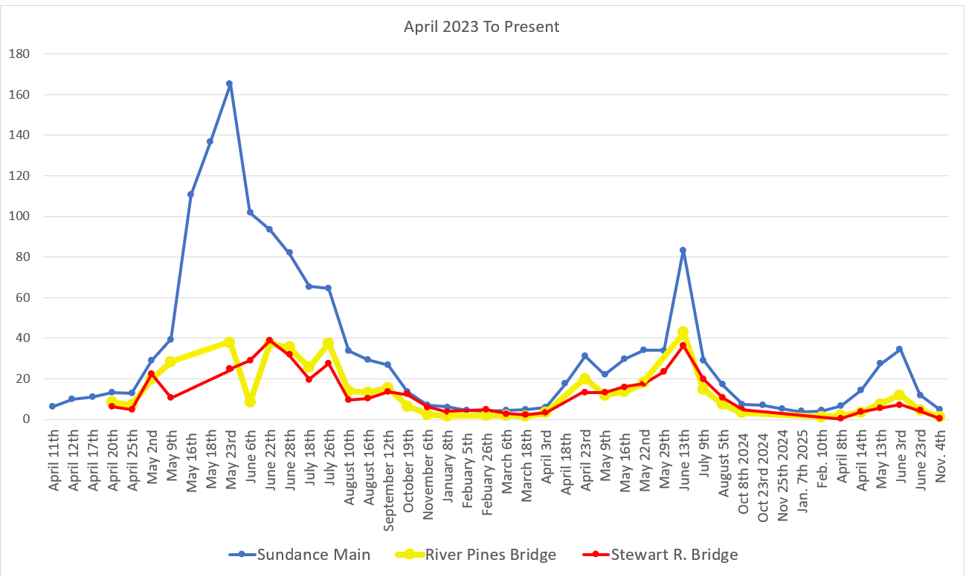
C
F
S

Water Department Information for December
- Our overall water consumption is similar to last year.
- Aspen Grove wet-well levels are averaging 5.42 feet for December 2025 which is slightly down from last month. This time last year, in December 2024, our average was 5.86 feet.
- Stewart Spring is averaging 68 gpm for December 2025, which is same as last month. This time last year it was averaging 68 gpm for December 2024.
- Stewart spring overflow is running 2.35 gpm for the month of December which is down from last month. Total, Stewart Spring produced an average of 70.35 gpm for December 2025.
- Unaccounted water
  - Upper Pressure Zone
    - Still at zero.
  - Lower Pressure Zone and Stewart Zone
- COP has finished the roof on the water treatment plant. They are also doing electrical and inside construction. The filter canisters have been placed and piping should begin soon.
- Aqua is working on master meters and updating the master plan.
- We are now doing multiple water samples every other week. We are completing the PFAS sampling as well.
- We ordered two new master mag meters for the springs. Just waiting for them to arrive. Once they arrive, we will need to measure them and order new spools and valves.
- Unaccounted water elimination processes:
  - We have replaced almost all the service meters including the 6-inch meters.
  - Corrected meters with wrong calculations.
  - We have had the spring meters heartbeat checked multiple times
  - We have had 2 leak detection company's preform leak surveys
  - We have fixed multiple leaks
  - We have replaced 2 leaking hydrants.
  - We have inspected about 50 percent of the hydrants with a camera device.
  - We have had all the PRV’s inspected and replaced one 6 inch one 4 inch and two 2 inch PRV’s
  - We eliminated a section of old pipe on coming from the old Stewart Tank
  - We isolated Stewart tank to check for tank leaks.
  - We have two new zero meters ordered to replace the spring meters.
  - We started isolating zones in the system by transferring usage from stewart to Aspen grove sides.

Wastewater Department Information for December
- We have one lab for December; BOD was out of limits.
- The plant construction is moving forward they have plumbers and electricians in working.
- The blowers have been placed waiting on stainless steel piping.
- The mixing pumps have been installed.
- We are working through the process of keeping the plant operational and bringing new equipment online by the end of the month.
- We now have both MBR’s online.
- We had multiple sewer line sections camera inspected.
- We found a bad connection from the new Sundance maintenance sprung.
- We replaced all the rakes on the fine screen.
- We got the sewer system on the GIS map with GPS accuracy.

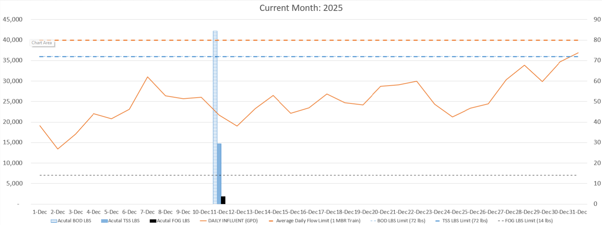

AVERAGE DAILY FLOW (GPD) | 25,275
HIGHEST DAILY FLOW (GPD) | 36,863

