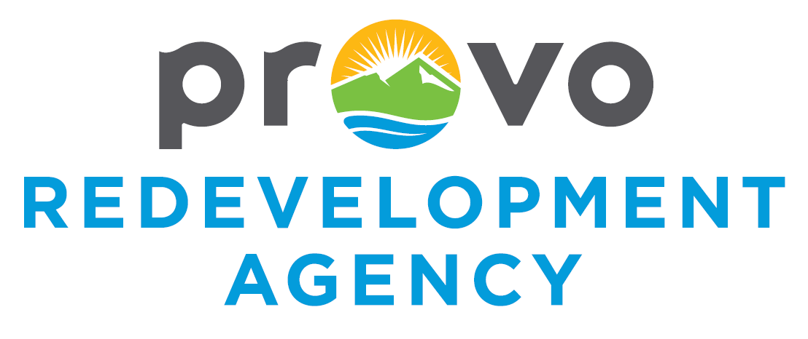

Notice of Hearing

From: The Redevelopment Agency of Provo City
Re: Public Hearing on the Lakeview Parkway CRA Project Area Plan and Budget

NOTICE IS HEREBY GIVEN, pursuant to the provisions of Utah Code Ann. § 17C-1-806, that the Board of Directors of the Redevelopment Agency of Provo City (the “Agency”) has scheduled a public hearing on the draft Project Area Plan and Budget (the “Project Budget”) for the 2025.1 Lakeview Parkway Community Reinvestment Area (the “Project Area”) to be held February 10, 2026, at 5:30 p.m. or as soon as the agenda permits, in the Council Chambers of City Hall (Rm. 100) located at 445 W. Center Street, Provo, Utah. Property owners are receiving this notice because they are the record owners of a parcel of land which is located within the proposed boundaries of the community reinvestment project area. This notice is also sent to certain taxing agencies because they levy a tax on retail point of sales located within the community reinvestment project area and is sent to others as required by Utah Code Ann. § 17C-1-806. The proposed Project Area Plan includes the geographic boundaries of the Project area and reflects the anticipated development within the area.
PURPOSES OF THE PUBLIC HEARING
The purposes of the public hearing, as required by Utah Code Ann. § 17C-4-102, will be to:
- Allow public comment on the draft Project Area Plan and Project Budget.
- Allow public comment on the Project Area Plan and Project Budget and whether they should be revised, approved or rejected: and
- Receive all written objections and hear all oral objections to the draft plan.
NOTICE IS HEREBY GIVEN of the following:
- A map of the boundaries of the proposed Project Area is attached as Exhibit A. A legal description of the proposed project Area as well as the Draft Project Area Plan And Project Budget may be found here:
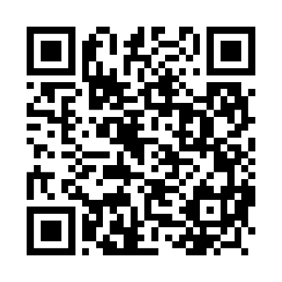 and here: https://www.provo.gov/1210/Redevelopment-Agency
Or a copy may be requested at no cost to the requestor at 801-852-6400, Provo City Redevelopment Agency 445 West Center Ste 200 Provo, UT 84601.
- A Portion of the Sales Tax Revenue resulting from Point-of-Sale revenue in the Project Area will be paid to the Agency for the Project Area Development rather than to the taxing entity to which the Sales Tax Revenue would otherwise have been paid under an interlocal agreement and the adopted Project Area Plan provides for the agency to receive tax increment.
- The recipient of this notice may submit to the Agency comments concerning the subject matter of the hearing before the date of the hearing.
- Any person objecting to the proposed Project Area Plan and Project Budget or contesting the regularity of any of the proceedings to adopt the Project Area Plan and Project Budget may appear before the board at the hearing to show cause why it should not be adopted.
- The Drafts of the Project Area Plan and Project Budget are available for inspection at the Agency offices located at 445 W. Center Street Ste. 200, Provo, Utah during regular business hours, Monday through Thursday, 7am to 6 pm.
No particular action is required of you by this notice. The adoption of the Plan and Budget will not cause property taxed within the project area to increase nor will such actions provide any eminent domain power to the Agency. The Agency is willing to meet and answer any questions you may have. All taxing entities are invited to consult with the Agency regarding the Project Area Plan and Project Budget prior to the hearing. If you have any questions, please contact Melissa McNalley at (801)852-6164.

Exhibit A
Project Area Map
