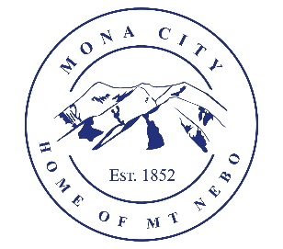
Mona City
435-623-4913
www.monacity.gov
20 West Center Street Mona, Utah

Mona City Council Closed Executive Session Agenda
Tuesday, January 13, 2026
Mona City Building – 20 West Center
5:30 pm

Notice is hereby given that the Mona City Council will hold a Closed Executive Session on Tuesday, January 13, 2026, at 5:30 p.m. in the Mona City Council Chambers located at 20 West Center Street, Mona City.

The purpose of the Closed Executive Session is in accordance with Utah Code 52-4-205, to discuss the following:

- The character, professional competence, or physical or mental health of an individual.

CERTIFICATE OF POSTING
This agenda is hereby properly advertised on this 5th day of January 2026, through posting of copies of this agenda in the following places: the Mona City Office, at the United States Post Office Mona City Branch, and on the Mona City Website at monautah.gov, and the Utah Public Notice Website at www.utah.gov/pmn/index.html.

______________________________________
Alicia Hills, Mona City Recorder

Upon Request, in compliance with the Americans with Disabilities Act, reasonable accommodations for individuals with disabilities will be provided. For assistance, please call 435-623-4913.

