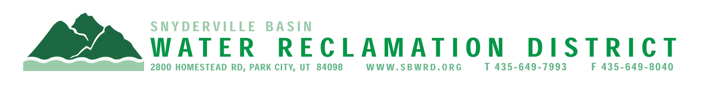

NOTICE is hereby given of the dates, time, and place for the regularly scheduled meetings of the Board of Trustees of the Snyderville Basin Water Reclamation District for the year 2026. The meetings will be public sessions to be held at the District Office located at 2800 Homestead Road, Park City, Summit County, Utah. Meetings begin at 5:00 p.m. on each of the following dates during 2026:

January 26
February 23
March 16
April 20
May 18
June 15
July 20
August 17
September 21 (Board Workshop to be held @ East Canyon Training Building @ 2:30 p.m. – regular meeting to follow @ The East Canyon Training Building @ 5:00 p.m.)
October 19
November 16
December 14 (Public Hearing – 6:00 p.m.)

If you are planning to attend any of these public meetings and, due to a disability, require reasonable accommodation in understanding, participating in or attending the meeting, please notify the District 24 or more hours in advance of the meeting, and we will try to provide whatever assistance that may be required. Board members may appear telephonically.

