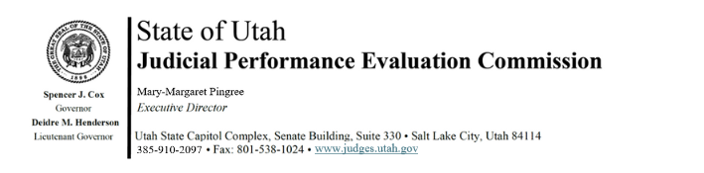
Tuesday, January 6, 2026
8:30 am-12:00
Seagull Room, Senate Building, First Floor (anchor location)
Hybrid Meeting

8:30 am Welcome Bridget Romano
Approval of Minutes – December 16, 2025

8:35 am Announcements Mary-Margaret Pingree

8:40 am Mid-level/Basic Judges Chris Russell
Closed Session

8:50 am 2028 Midterm Evaluations Chris Russell
Closed Session Mary-Margaret Pingree
Madison Klein

9:45 am Break

10:00 am Chief Justice Remarks Chief Justice Durrant
Open Session Ron Gordon

10:20 am Recognition of Courtroom Observers Julie Spilker

10:40 am 2028 Midterm Evaluations Chris Russell
Closed Session Madison Klein
Mary-Margaret Pingree

12 noon Adjourn

Next Meeting: Tuesday, January 20, 2024
8:30 a.m. – noon
CCJJ Board Room, 3rd Floor Senate Building

