ORDINANCE #25-19

AN ORDINANCE ADOPTING THE 2006 EDITION OF THE UTAH WILDLAND-URBAN INTERFACE CODE

WHEREAS, in accordance with H.B. 48, effective January 1, 2026, municipalities are encouraged to adopt the 2006 Edition of the Utah Wildland-Urban Interface Code (UWUIC) and a corresponding map depicting those areas within their boundaries that are subject to UWUIC; and

WHEREAS, the Town of Garden City is a town duly incorporated under the general law of the State of Utah; and

WHEREAS, the Garden City Town Council is the governing body for the Town of Garden City and must administer the Garden City Municipal Code; and

WHEREAS, The Garden City Town Council is authorized to govern the health, safety and wellness of the citizens and visitors of the Town of Garden City.

NOW, THEREFORE, BE IT ORDAINED BY THE GARDEN CITY PLANNING COMMISSION AND TOWN COUNCIL THAT ORDINANCE 11A-700 BE ADDED AS FOLLOWS:

11A-700 – 2006 Utah Wildland-Urban Interface Code

The 2006 Utah Wildland-Urban Interface Code along with any amendments shall apply to those areas within the City that the Council designates as wildland-urban interface areas in the City’s official Wildland-Urban Interface Map.

Wildland-Urban Interface Map – The map attached as Exhibit 1 is enacted as the official Wildland-Urban Interface Map for the Town of Garden City.

Exhibit 1: See map on Page 2

Exhibit 1:
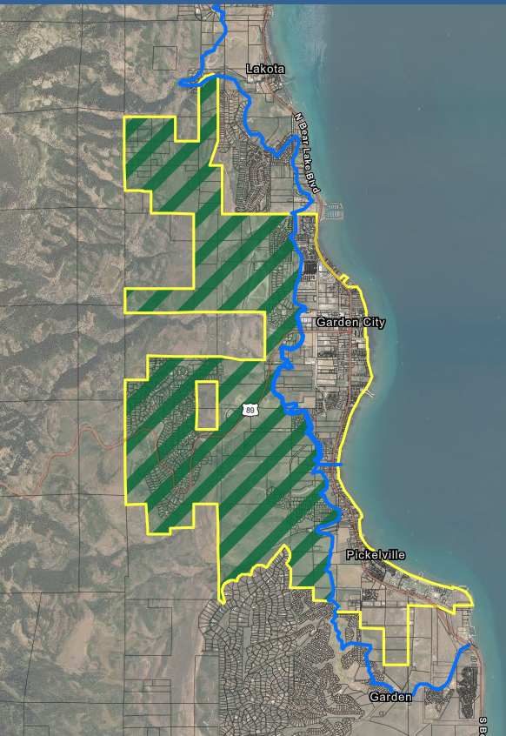

If any section, subsection, sentence, clause, phrase, or portion of this ordinance is, for any reason, held invalid or unconstitutional by any court of competent jurisdiction, such provision shall be deemed a separate, distinct, and independent provision, and such holding shall not affect the validity of the remaining portions of this ordinance.

APPROVED AND ADOPTED this 8th day of January 2026.

APPROVED: Attest:

_______________________________ ______________________________
Mike Leonhardt, Mayor Cathie Rasmussen, Town Clerk

Voting: Aye Nye
Argyle ___ ___
House ___ ___
Larsen ___ ___
Davis ___ ___

