CITY OF HYDE PARK ORDINANCE NO 2026-01RZ
AN ORDINANCE APPROVING A ZONING MAP AMENDMENT FOR PROPERTY LOCATED AT APPROXIMATELY 70 S. WOLFPACK WAY, HYDE PARK, UT 84318, Parcel 04-031-0017, AMENDING 3.47 ACRES FROM RESIDENTIAL TRANSITION AND AGRICULTURAL TO COMMERCIAL ZONE.
WHEREAS, Hyde Park City(“Owner”) is the owner of record of 3.47 acres of real property known as parcel No. 04-031-0017, more specifically described as follows:
A part of the Northwest Quarter of Section 10, Township 12 North, Range 1 East of the Salt Lake Base and Meridian. Also a part of Lot 21, Block 2, Plat “A” of the Hyde Park Farm Survey; Beginning at a point on the West right-of-way line of 200 West street located North 89°31’41” East 2591.12 feet along the South line of said section and North 00°28’19” West 3678.67 feet from the Southwest corner of said section, said point being located by record North 652.00 feet from the Southeast corner of Lot 20, Block 2, Plat “A” of the Hyde Park Farm Survey; running thence North 88°29’42” West 1320.02 feet (1320.00 feet by record) to grantor's West property line; thence North 01°38’16” East 210.53 feet (166.00 feet by record) along said West property line to the center of Spring Creek; thence along the center of Spring Creek the following six (6) courses: (1) South 58°16’57” East 93.04 feet; (2) North 85°27’42” East 83.44 feet; (3) North 64°56’10” East 98.14 feet; (4) North 71°12’55” East 141.42 feet; (5) North 77°01’03” East 325.30 feet; (6) North 65°07’42” East 85.40 feet; thence South 01°30’42” West 56.09 feet; thence South 89°43’09” East 541.54 feet to the said West right-of-way line of 200 West street; thence South 01°30’42” West 340.98 feet along said West right-of-way line to the point of beginning. EXCEPTING THEREFROM: A part of the Northwest Quarter of Section 10, Township 12 North, Range 1 East of the Salt Lake Base and Meridian. Also a part of Lot 21, Block 2, Plat “A’ of the Hyde Park Farm Survey; Beginning at a point on the West right-of-way line of 200 West street located North 89°31'41" East 2591.12 feet along the South line of said section and North 00°28'19" West 3678.67 feet from the Southwest corner of said section, said point being located by record North 652.00 feet from the Southeast corner of Lot 20, Block 2, Plat “A” of the Hyde Park Farm Survey; running thence North 1°30'42" East 340.98 feet to the true point of beginning and running thence South 1°30'42" West 340.98 feet; thence North 88°29'42" West 600 feet; thence North 340 feet, more or less to the South line of Spring Creek; thence Easterly along Spring Creek to a point that is South 89°43'09" West 541.54 feet from the true point of beginning; thence South 89°43'09" East 541.54 feet to the said West right-of-way line of 200 West street; to the true point of beginning. ALSO EXCEPTING THEREFROM: A parcel of land in fee incident to the construction of 200 East Street, being part of an entire tract of property situate in the Southeast Quarter of the Northwest Quarter of Section 10, Township 12 North, Range 1 East of the Salt Lake Base and Meridian, also situate in Lot 20, Block 2, Plat "A", Hyde Park Farm Survey, Cache County, Utah. The boundaries of said parcel of land are described as follows: Beginning at a point on the Southerly boundary line of said entire tract which point is 658.41 feet North 01°28'57" East and 1221.31 feet North 88°29'15" West from the said Southeast corner of Lot 20, and running thence North 88°29'15" West 99.00 feet to the Southwestern corner of said entire tract; thence North 01°38'43" East 210.58 feet to the Northwestern corner of said entire tract; thence South 58°16'30" East 93.06 feet; thence North 85°28'09" East 17.97 feet; thence South 0°59'01" West 52.44 feet; thence South 01°38'41" West 113.20 feet to the point of beginning. ALSO EXCEPTING THEREFROM: A parcel of land in fee incident to the construction of 200 East Street, being part of an entire tract of property situate in the Southeast Quarter of the Northwest Quarter of Section 10, Township 12 North, Range 1 East of the Salt Lake Base and Meridian, also situate in Lot 20, Block 2, Plat "A", Hyde Park Farm Survey, Cache County, Utah. The boundaries of said parcel of land are described as follows: Beginning at a point on the Northerly boundary line of said entire tract which point is 658.41 feet North 01°28'57" East and 600.13 feet North 88°29'15" West from the said Southeast corner of Lot 20, and running thence North 88°29'15" West 621.18 feet; thence North 1°38'41" East 26.35 feet; thence South 88°29'14" East 621.13 feet; thence South 1°31'34" West 26.35 feet to the point of beginning.

WHEREAS, the applicant has submitted an application in compliance with HPC code 12-10-050, requesting to change the zoning on the subject property from Residential Transition and Agricultural zones to Commercial zone.

WHEREAS, in a public hearing on January 7, 2026, the Hyde Park Planning Commission considered all evidence and testimony presented with respect to the subject application and unanimously approved a motion to send a recommendation of ___________________________________(approval or denial) to the Hyde Park City Council.

WHEREAS, due notice was given that the Hyde Park City Council would meet to consider the Rezone application in a public meeting on January 14, 2026;
Considerations:
  - Whether the proposed amendment would be harmonious with the overall character of existing development in the vicinity of the subject property, or in cases of text amendments, in areas governed by the amended text.
  - Whether the proposed amendment would be consistent with the standards of any applicable overlay zone(s) and, in cases of text amendments, harmonious with areas governed by the amended text.
  - The extent to which the proposed amendment may adversely affect adjacent property; and
  - The adequacy of facilities and services intended to serve the subject property, including but not limited to roadways, parks and recreation facilities, police and fire protection, schools, storm water drainage systems, water supplies, waste water and refuse collection.
  - The application conforms to the provisions of the Hyde Park General Plan including the future land use map.

WHEREAS, the City Council has heard and considered all evidence and testimony presented with respect to the application subject and has determined that the adoption of this ordinance is in accordance with city code and the General Plan.

NOW, THEREFORE, BE IT ORDAINED by the Hyde Park City Council that it does hereby rezone real property located at __________________________Hyde Park, Utah, known as Cache County Parcel No. _______________________________, from __________________________________ to,___________________________________.

PASSED, ADOPTED, AND APPROVED by the Hyde Park City Council in open session this_____ day of __________________, 2026 by the following vote:
Those voting aye:
Those voting nay:
Those absent:
ATTEST:

Bryan Cox, Mayor:
Donja Wright, Recorder:
Map of Parcel
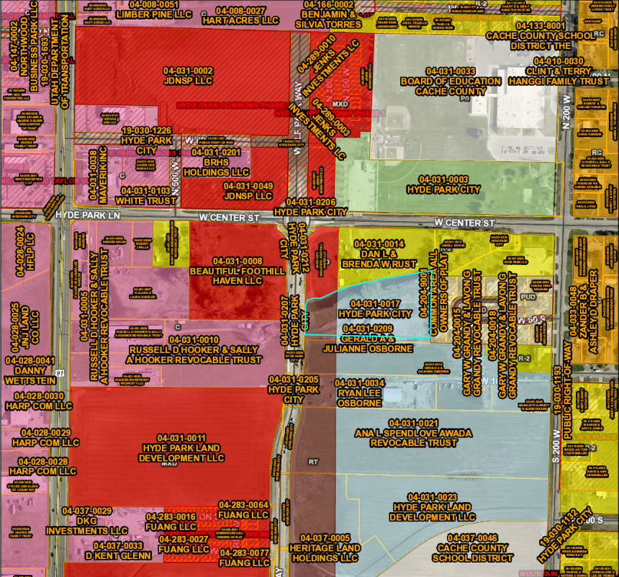

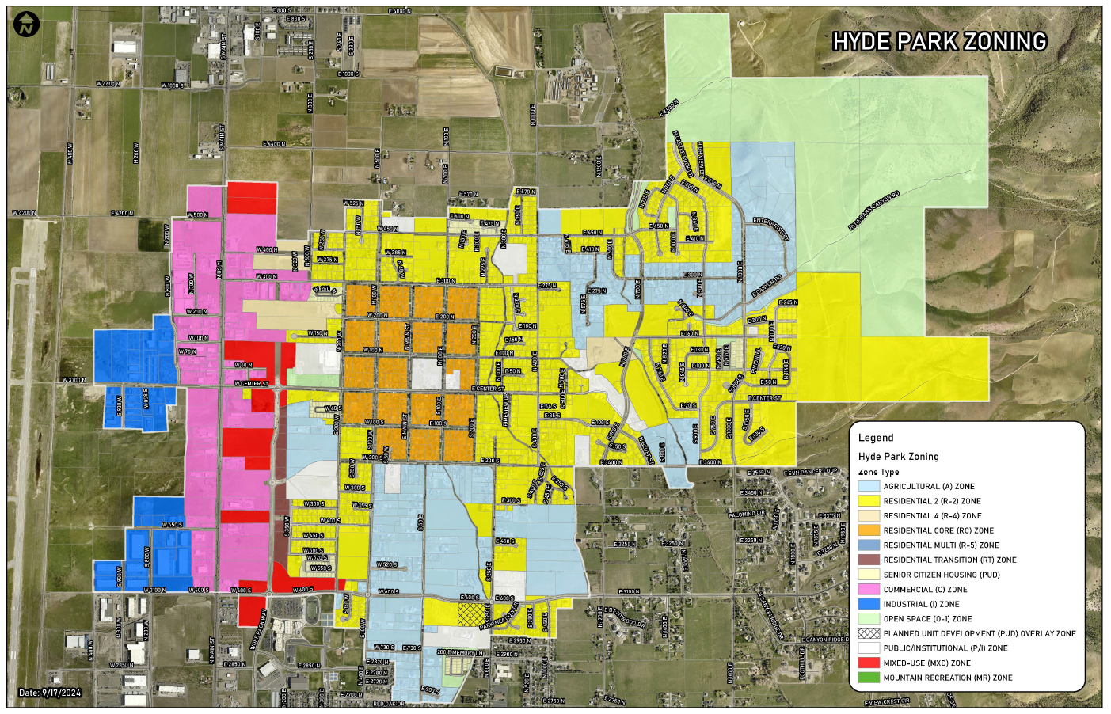
Hyde Park Zoning Map

Future Land Use Map
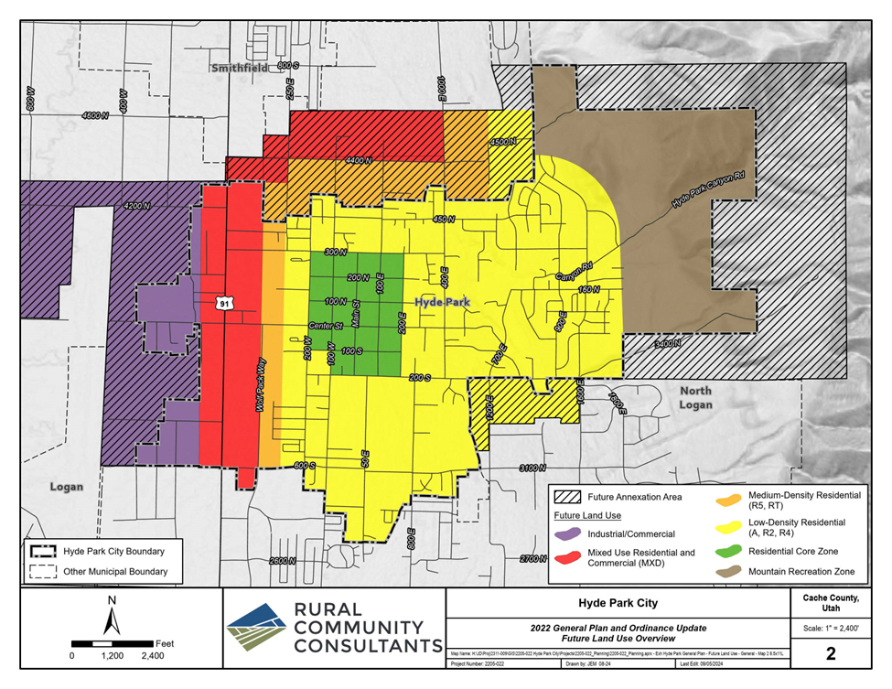
General Plan

