Ephraim City Corporation
CHRIS LARSEN, Mayor

5 South Main, Ephraim, Utah 84627
Council Members
Jack Dalene
Loren Steck
Troy Birch
Dennis Nordfelt
Anthony Beal

Manager
Katie Witt

Community Development Director/Engineer
Bryan Kimball

Recorder
Candice Maudsley

ege

City planner
Megan Spurling

Treasurer
Aubrey Adams

Finance Director
Jon Knudsen

Public Safety Director
Colby Zeeman

Power Director
Cory Daniels

Public Works Director
Jeff Jensen

ieghileigh

NOTICE OF PUBLIC HEARING

CODE AMENDMENT TO ADD CLARITY TO R4 REQUIREMENTS TO RESIDENTIAL DEVELOPMENTS IN THE C2 ZONE ON THE CURRENT SETBACK TABLE

Public notice is hereby given that the Ephraim City Planning and Zoning Commission, in accordance with Sections 10.04.060 and 10.20.060 of the Ephraim City Municipal Code, will conduct a public hearing to discuss and possibly make recommendation to the Ephraim City Council regarding a proposed amendment to the Ephraim City code which would add clarity to regulations for residential developments in the C2 zone, specifically as found on the setback table.

The public hearing will be held:
Wednesday, January 14, 2026
beginning at 6:00 p.m.
Ephraim City Hall
5 South Main Street, Ephraim, Utah 84627

Should the Planning Commission recommend approval, the City Council is expected to review and possibly give final approval for the Amendment to the setbacks table on Wednesday, January 21, 2026, at 6:00 PM at Ephraim City Hall.

Interested parties may attend in person or electronically via zoom. Those wishing to attend electronically should notify Ephraim City Staff prior to 3:00 p.m. of the day of the meeting. For further information, or to request a meeting link, please contact Megan Spurling, City Planner, 5 South Main Street, Ephraim, Utah 84624; call at (435) 283-4631; or email mspurling@ephraim.gov

Pursuant to the Americans with Disabilities Act, individuals needing special accommodations during this meeting should notify Ephraim City at (435) 283-4631 at least 24 hours prior to the meeting.

Posted: December 29, 2025
Published: December 29, 2025 – ephraim.gov and Utah Public Notice Website

The current setback table for Ephraim City:

https://ephraim.municipalcodeonline.com/book?type=ordinances#name=10.20.020_Table_A:_Setbacks

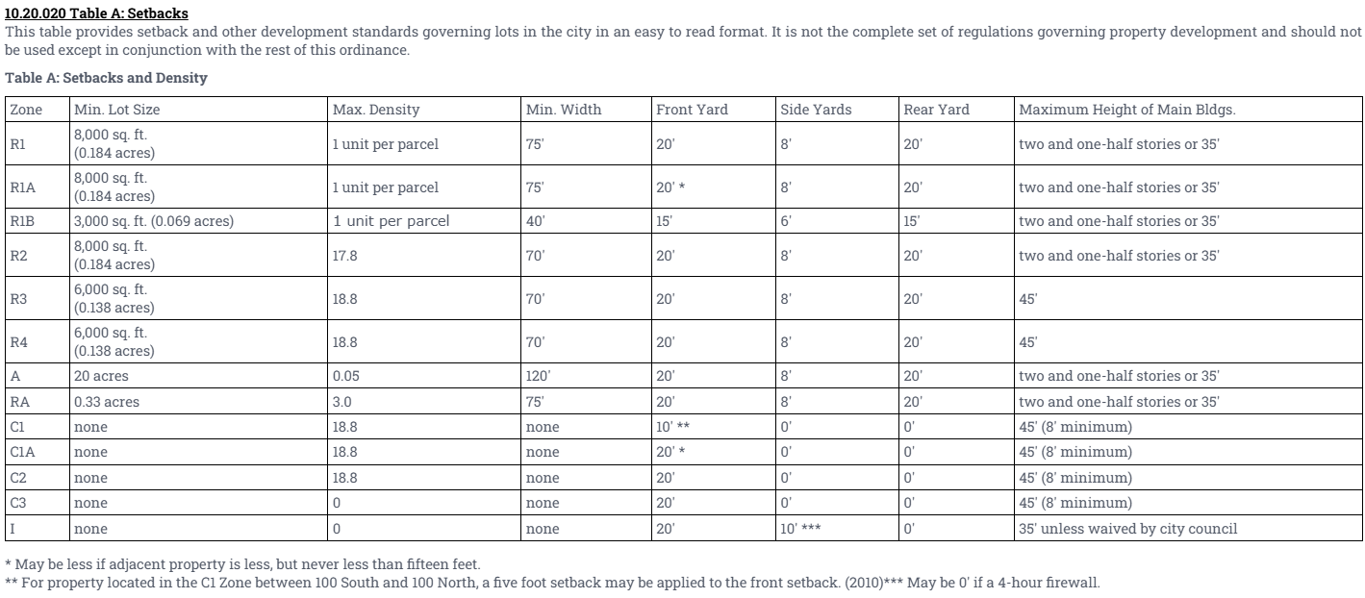

The update will reflect the language as stated in ECC 10.16.060 Commercial Zones section C, item 8
*CHANGES ARE REFLECTED IN GREEN BELOW*

“Residences in the C2 zone shall conform to all requirements under the R-4 designation including rules for the keeping of animals.
https://ephraim.municipalcodeonline.com/book?type=ordinances#name=10.16.060_Commercial_Zones

