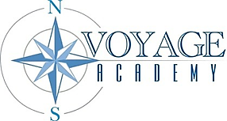

Voyage Academy Board of Directors Meeting Agenda
Date: December 30, 2025
Time: Public Session from 12:30pm-1:00pm
Location: 1891 N. 1500 W., Clinton, UT 84015 or virtually at Microsoft Teams Link

Mission Statement
Voyage Academy is dedicated to cultivating student growth through Expeditionary Learning. Our mission is to promote responsibility, integrity, and the development of essential life skills, guiding students toward becoming respectful, compassionate, and motivated lifelong learners.

Attendees
Courtnie Moore, Danielle Pedersen, Janae Howell, Valerie Hulsey, Dennis Henry, Blaire Barker, Kami Coleman, Nicole Jones, Roger Simpson

Agenda

OPening business
The meeting will formally commence with the call to order and roll call.

Public comment
Please limit comments to 3 minutes

Consent agenda
Approval of October 9, 2025, Board Meeting Minutes

Discussion and action Items
Approval of Kindergarten Playground Equipment, Ground Cover and Installation purchase price of up to $62,000.

Calendaring
The next Board Meeting is scheduled for January 15, 2026.

Adjournment
The meeting will adjourn upon completion of all agenda items.

