REQUEST FOR STATEMENT OF QUALIFICATIONS

Date: December 23, 2025

Reply to: Madison Reed, Planning Technician
125 S. Main Street
Vineyard, Utah 84059
madisonr@vineyardutah.gov

Pre-Proposal Meeting: Optional, (Not Required)
Available on Request by emailing madisonr@vineyardutah.gov Between
Monday, December 23, 2025 – Monday, December 31, 2025

Proposal Deadline: Thursday, January 22, 2026, 5:00 PM (MST)
Electronic PDF Submission via Email to Madison Reed (madisonr@vineyardutah.gov)

NOTICE TO DESIGN PROFESSIONALS

Vineyard City (City) is soliciting Statements of Qualifications (SOQs) from qualified and licensed design professionals, including architects, engineers, landscape architects, and related disciplines, to provide professional design services for municipal projects.

This procurement is conducted in accordance with Utah Code 63G-6a, Part 15, Design Professional Services, using a Qualifications-Based Selection (QBS) process outlined in this document. This RFSQ will be emailed out to Vineyard City’s Professional Services list and will be publicly announced on our City website, Utah Public Notice Website, and posted at the Vineyard City Hall located at 125 South Main Street, Vineyard, Utah 84059.

Pricing, cost proposals, hourly rates, or fee information shall NOT be submitted at any stage of this RFSQ. Inclusion of cost information will result in disqualification as non-responsive.

This RFSQ is not a request for proposals, bids, or pricing, and does not constitute a contract or offer to contract.

Questions and request for information regarding this RFSQ, please contact madisonr@vineyardutah.gov with a formal deadline of January 19th, 2026, at 5:00 PM (MST). All communication shall be submitted electronically and by email to the above-mentioned contact; where verbal or any other communication will not be considered as a formal request or response.

Submittals must be received by the City by the deadline stated above Proposal Deadline. Late submittals will not be accepted. The RFSQ was publicly noticed on Vineyard City’s official website.

PROCUREMENT METHOD (QBS)
The City will follow the procedures set forth in Utah Code 63G-6a-1501 through 1506, including:
- Public issuance of this RFSQ
- Evaluation of SOQs by a Selection Committee
- Identification and ranking of the most qualified firm(s)
- Negotiation of scope and fee only with the top-ranked firm
- If negotiations fail, proceeding sequentially to the next-ranked firm

PROJECT OVERVIEW
Project Title: The Bluffs at Vineyard – Open Space & Amenities
RFSQ Project Number: 2025-07-101
Location: Vineyard City, Utah (Utah Lake shoreline)

The Bluffs at Vineyard project is intended to rejuvenate existing open space and provide new recreational amenities for Vineyard residents and regional trail users. The project area consists of two parallel north–south multi-use trails located between Utah Lake to the west and the Lakefront at Town Center neighborhood to the east. The trails connect to the Lindon Heritage Trail to the north and continue to Vineyard’s southern boundary. The general project location and study area are shown in Figure 1.

City staff has completed extensive site visits, legal and financial research, and multiple public engagement efforts to establish a strong baseline understanding of opportunities and constraints within the project area. Public engagement to date has included coordination with Utah’s Division of Forestry, Fire, and State Lands (FFSL), the Utah Lake Authority (ULA), Vineyard City Council, Planning Commission, Active Transportation Commission, nearby residents and HOA members, and the general public.

This RFSQ seeks qualified design professionals to provide phased professional design services in support of this project, including concept development, public engagement, grading and drainage design, and landscape and irrigation design. Project construction is anticipated to occur following completion of design in 2026.

Task 1 – Amenities Concept Plan
Objective: Develop a comprehensive concept plan for amenities and open space improvements at The Bluffs at Vineyard that complies with Utah sovereign lands requirements.

Deliverables include:
- Forestry, Fire, and State Lands (FFSL) Coordination & Permitting Support
  - Research and summarize applicable FFSL statutes, administrative rules, policies, and guidance, including but not limited to requirements related to sovereign lands authorization, special use leases, right-of-entry permits, or easements.
  - Prepare materials sufficient to support FFSL review, which may include concept-level site plans, narratives, and impact descriptions. Final deliverable will include a design package ready for submission to FFSL meeting minimum submission requirements.
  - Coordinate with FFSL staff, during the subsequent tasks as needed to accomplish each task and as directed by the City, to confirm permitting pathways, submittal expectations, and review timelines.
  - Incorporate FFSL conditions, design constraints, and mitigation requirements into the amenity concept plan to the extent feasible at the concept level.

Note: Final permit applications, fees, and approval authority rest with FFSL. This task includes technical and coordination support but does not guarantee permit approval.

- Amenities Concept Plan
A conceptual site plan illustrating the location, quantity, and type of proposed amenities, including:
  - Seating and benches
  - Recreational entertainment areas, such as:
    - Disc golf course
    - Open field space
  - Utah Lake access points, including:
    - Path upgrades
    - Shoreline seating
  - Dog waste stations and dog water fountains
  - Bike racks and bicycle repair (fix-it) stations
  - Trash receptacles
  - Utah-native grasses or sod

A volleyball court is approved and permitted by FFSL to be placed within the project site. The Amenities Concept Plan should reflect the placement as well as coordinate locations of the above amenities. The volleyball court is not included in this scope. Please see Figure 2 for the plan approved by FFSL.

The Amenities Concept Plan shall include clear labels, a legend, and may incorporate product samples, branding concepts, and wayfinding elements. All concepts shall be developed to minimize disturbance to sovereign lands and shoreline resources.

- High-Level Landscaping Concept
  - Conceptual planting vision compatible with FFSL shoreline management expectations
  - Emphasis on native, drought-tolerant, and low-maintenance vegetation
  - No grading, irrigation, or construction-level details required under this task

- Public Engagement Support
Consultant will prepare and Public Engagement plan for possible execution. Participation in public meetings and work sessions, which may include:
  - Planning Commission work session
  - City Council work session
  - Active Transportation Commission work session
  - Public town hall meeting

- Schedule
  - Proposed timeline for completion of FFSL coordination, concept deliverables, and public engagement activities

This task is the amenities concept design only. Construction-level plans shall be provided as required by the negotiated scope.

Task 2 – Grading & Drainage Design
Objective: Prepare construction plans for site grading and drainage that complement the approved amenity concept plan.

Scope includes:
- Coordination with Amenities Concept Plan
- Coordination with FFSL during the design process, during the 10%, 30% and 60%.
- Final FFSL permitting for final design approval, permitting costs to be paid by the City.
- Incorporation with the City’s Stormwater Management Plan and MS4 permit.
  - Site grading design to prevent standing water
  - Minimum drainage slopes of 2% in non-hardscape areas (5% preferred)
  - Surface flow design and/or storm drain inlets and piping directing runoff to Utah Lake
  - Stormwater treatment or vegetated conveyance consistent with Vineyard City’s Stormwater Management Plan
- Plan Specifications document at 60% and Final Designs.
- Final construction design and document approval by the City Engineer’s office.

This task is limited to grading and drainage design only. Construction-level plans shall be provided as required by the negotiated scope.

Task 3 – Landscape & Irrigation Design
Objective: Prepare landscape and irrigation plans consistent with the approved amenity and grading concepts.
Scope includes:
- Coordination with FFL during the design process, during the 10%, 30%, and 60%.
- Coordination with the City Arborist.
- Landscape planting plans emphasizing Utah-native and low-maintenance vegetation
- Irrigation design as required to meet the proposed Landscaping Design
  - Irrigation source to incorporate non-drinking water source provided by the City.
- Coordination with Amenities Concept Plan placement and Grading & Drainage Design
- Plan Specifications document at 60% and Final Designs.
- Final construction design and document approval by the City Engineer’s office.

This task is limited to landscape & irrigation design only. Construction-level plans shall be provided as required by the negotiated scope.

Final scope, sequencing, and deliverables for each task will be negotiated with the top-ranked firm in accordance with Utah Code 63G-6a, Part 15.

CONTRACT TERMS
Responding firms may submit Statements of Qualifications for any individual task, any combination of two tasks, or all three tasks identified in this RFSQ.

Vineyard City may, at its discretion and in accordance with Utah Code 63G-6a, Part 15, select one firm to perform all tasks, select a single firm to perform multiple tasks, or select different firms for individual tasks. Firms will be evaluated and ranked using the evaluation criteria and weights set forth in this RFSQ, which will not be modified during the procurement process. Final task order scope, sequencing, and award structure will be determined through the qualifications-based selection and subsequent negotiation process. Vineyard City further reserves the right to cancel any individual task or to cancel this RFSQ in its entirety if it determines that doing so is in the City’s best interest.. Please be prepared to have materials on-hand during the negotiation process including price quote information.

Bids will be scored per task, even if the submittal addresses multiple for consistency of scoring and ranking. Task(s) award shall follow the approval authority outlined in the Vineyard City Purchasing policy. The Vineyard City Purchasing policy is available upon request.

Selection under this RFSQ does not guarantee assignment of work.

MINIMUM QUALIFICATIONS
Respondents must:
- Be properly licensed in the State of Utah for the applicable discipline(s)
- Demonstrate experience with similar municipal or public-sector projects
- Demonstrate capacity to meet City schedules and performance expectations
- Disclose any actual or potential conflicts of interest
- Have experience obtaining permits and following procedures through State Agencies.

SUBMITTAL REQUIREMENTS
SOQs shall not exceed 10 pages, excluding the cover letter, resumes, and required attachments. Please submit in PDF format.

Required Content
- Cover Letter (not scored)
  - Statement of interest
  - Authorized signatory
  - Primary contact information
- Firm Qualifications & Experience
  - Overview of firm
  - Relevant municipal or comparable projects (up to five)
- Project Understanding & Approach
  - Understanding of project goals
  - General design approach and methodology
  - Public Participation Plan
- Key Personnel & Team Structure
  - Organizational chart showing Key Personnel
  - Roles and responsibilities of Key Personnel
  - Utah professional licenses and relevant certifications
- Capacity & Availability Statement:
  - Brief statement describing the availability of the proposed team, current workload considerations, and the firm’s approach to maintaining responsiveness and meeting project schedules.
- References
  - Minimum of three recent professional references from relevant projects.

Do NOT include pricing, fees, rates, or cost information.

SUBMITTAL INSTRUCTIONS
SOQs must be submitted electronically via email to Madison Reed at madisonr@vineyardutah.gov no later than: Thursday, January 22, 2026 at 5:00 PM (MST)

Late or incomplete submittals will not be accepted.

EVALUATION CRITERIA (QUALIFICATIONS ONLY)
SOQs will be evaluated in accordance with Utah Code §63G-6a-1503 using the following criteria:
Criteria | Weight
Project Understanding & Approach | 25%
Firm Qualifications & Relevant Experience | 25%
Key Personnel & Team Strength | 25%
Capacity, Availability & Responsiveness | 25%
Project Understanding & Approach (25 Points)
Evaluates the firm’s demonstrated understanding of the project context, constraints, and objectives, and the proposed approach to performing the requested services.
Considerations may include:
- Understanding of the Utah Lake shoreline environment, trail-adjacent open space, and heavily used public recreation areas
- Awareness of sovereign lands considerations and coordination requirements with Utah Department of Natural Resources – Forestry, Fire, and State Lands (FFSL) and other applicable agencies
- Ability to integrate amenity concepts, grading and drainage, and landscaping in a coordinated and realistic manner
- Familiarity with stormwater treatment requirements, water-quality protection, and Vineyard City’s Stormwater Management Plan
- Clarity, logic, and feasibility of the proposed approach for the specific task(s) submitted

Firm Qualifications & Relevant Experience (25 Points)
Evaluates the firm’s overall qualifications and experience performing similar work for public-sector clients.
Considerations may include:
- Experience with municipal design projects of similar size, complexity, and scope
- Demonstrated work on shoreline, lakefront, trail, or open space projects
- Experience working within regulatory environments, including FFSL, Utah Lake Authority, or similar agencies
- Past performance on projects involving concept planning, grading/drainage, and/or landscape and irrigation design
- Quality and relevance of examples provided
- Demonstrate experience facilitating and designing public participation processes.

Key Personnel & Team Strength (25 Points)
Evaluates the qualifications, experience, and availability of the individuals proposed to perform the work.
Considerations may include:
- Experience and credentials of the project manager and key technical staff
- Direct experience of proposed personnel with similar task-specific work
- Team organization and clarity of roles and responsibilities
- Availability and capacity to complete the work within the anticipated schedule
- Experience coordinating with public agencies, stakeholders, and community groups

Capacity, Availability & Responsiveness (25 Points)
Evaluates the firm’s ability to perform the work in a timely and responsive manner.
Considerations may include:
- Current workload and availability of key staff
- Ability to meet anticipated schedules and milestones
- Responsiveness demonstrated through the SOQ (organization, clarity, completeness)
- Familiarity with Vineyard City or similar municipal processes (if applicable)

The City may, but is not required to, conduct interviews. Interviews may be requested for clarity of submittal and shall not rescope the tasks in this RFSQ.

RESTRICTIONS & COMPLIANCE
- No pricing information may be submitted (Utah Code 63G-6a-1502.5)
- Public agencies may not submit SOQs (Utah Code 63G-6a-1506)
- SOQs become the property of Vineyard City
- Evaluation Committee communications are restricted

RESERVATION OF RIGHTS
Vineyard City reserves the right to:
- Reject any or all SOQs
- Waive minor irregularities
- Request additional information
- Cancel or reissue this RFSQ

NON-CONTRACTUAL NOTICE
This RFSQ does not constitute a contract or an offer to contract. A contract will be executed only after successful negotiation with the top-ranked firm.

GOVERNING LAW
This procurement is governed by Utah Code 63G-6a, Part 15, and the Vineyard City Purchasing Policy. Where conflicts exist, state law controls.

Figure 1. Project Location and Study Area Boundary (The Bluffs at Vineyard)

Approximate project area shown in red. The outlined area represents the general shoreline corridor and trail-adjacent open space included in this RFSQ. Final limits of work are subject to verification, FFSL requirements, and final scope definition.

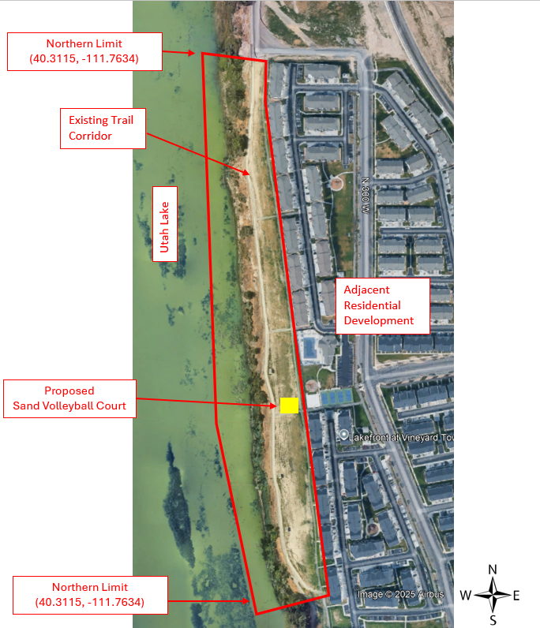

Figure 2. Location of the Sand Volleyball Court (The Bluffs at Vineyard)

Approximate location of the Sand Volleyball Court within the Bluffs at Vineyard project site. The location is outlined in a rectangular line and topographic lines as well as nearby slopes are included. The Sand Volleyball Court is not included in this request but needs to be coordinated with for the other amenity placements Final limits of work are subject to verification from City Staff.

