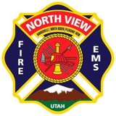
North View Fire 2026 Board Meeting Dates

January 29, 2026 July 23, 2026
February 26, 2026 August 27, 2026
March 26, 2026 September 24, 2026
April 23, 2026 October 22, 2026
May 28, 2026 November 19, 2026
June 11, 2026 December 17, 2026

Dates and times are subject to change. Please refer to the Utah Public Notice Website.
Thank you,
Nicci Roylance
North View Fire District Clerk

