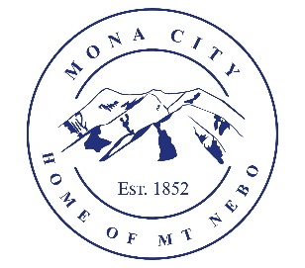
Mona City
435-623-4913
www.monacity.org
20 West Center Street Mona, Utah

Mona City Council Work Session
Tuesday, April 8, 2025
6:00 pm
Mona City Council Room – 20 West Center

Notice is hereby given that the Mona City Council will hold a work session on Tuesday, April 8, 2025, at 6:00 p.m. in the Mona City Council Chambers at 20 West Center Street, Mona City. The purpose of the work session is to discuss the following:

- Collaboration with the Irrigation Company concerning annexations and irrigation water feasibility

CERTIFICATE OF POSTING

This agenda is hereby properly advertised on the 7th day of April 2025, by posting copies of this agenda at the Mona City Office, at the United States Post Office located in Mona City, on the Mona City website at monautah.gov, and on the Utah Public Notice Website at www.utah.gov/pmn/index.html.

_______________________________________
Alicia Hills
Mona City Recorder

Upon Request, in compliance with the Americans with Disabilities Act, reasonable accommodations for individuals with disabilities will be provided. For assistance, please call 435-623-4913.

