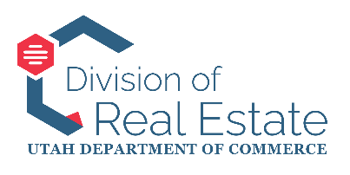
STATE OF UTAH
RESIDENTIAL MORTGAGE REGULATORY COMMISSION
MEETING AGENDA
December 23, 2025, 9:00 AM
Anchor Location:
Heber M. Wells Building – 4th Floor, Conference Room 402
160 E 300 S, Salt Lake City, Utah
This agenda is subject to be changed to 24 hours prior to the meeting. Timings and order listed are approximate and may be adjusted, accelerated, or delayed.
ELECTRONIC PARTICIPATION:
Google Meet joining info
Video call link: https://meet.google.com/bni-hhnm-ygy
Or dial: (US) +1 252-651-1302‬ PIN: 405 554 533‬#‬‬‬‬‬‬‬‬
More phone numbers: https://tel.meet/bni-hhnm-ygy?pin=6380520216756

MEETING AGENDA:
- Commencement
  - Welcome and call to order
- Stipulation & Order for the Commission’s consideration and action: In the Matter of Amy Bloxham, RE-25-5090 (Bryn Kaelin, Chief Investigator)
- Executive (Closed) Session
  - Executive session (closed to the public)
  - Results of executive session (open to the public)
- Adjournment

In compliance with the Americans with Disabilities Act, individuals needing special accommodations (including auxiliary communicative aids and services) during this meeting should notify Leigh Veillette, Division Director, Division of Real Estate, PO Box 146711, 160 E 300 S, Salt Lake City, Utah 84114-6711, Phone 801-530-6747, at least one working day prior to the meeting.

