Final
Utah National Guard Project Area Plan – Part 3
December 2025

Introduction
The Military Installation Development Authority (MIDA) was created by the state Legislature in 2007 to facilitate the development of both military and privately owned land for a military purpose in the state. MIDA assists the Utah National Guard (UTNG)—a component of the U.S. Army and Air Force that fulfills both federal and state defense missions—to enhance designated properties. These efforts aim to strengthen the Guard’s operational effectiveness and improve the overall quality and capacity of its missions across Utah.

These properties (“Project Area”)—with the exception of one federal property located on Camp Williams in Bluffdale which is owned in part by the federal government and two properties owned by Tooele City Corporation—fall under the jurisdiction of UTNG. They are military properties owned and held in trust by the Utah State Armory Board.

Pursuant to the MIDA Act, for non-military land to be included in the Project Area, both the consent of Tooele City, through the adoption of a resolution, and the consent of non-military landowners (“Landowner Consent”) is required. Utah limited liability companies; Superior Sand & Gravel, Sun Valley Development, and Over Lake Properties have parcels in Tooele City, for which they provided landowner consent. These parcels were added to the Project Area by this Part 3 Project Area Plan, pending approval of the Tooele City Council on December 17, 2025. Approximately 142.61 acres of land were added to the Project Area in the Part 3 Project Area Plan.
The Project Area was first amended in November 2024 (Part 2). Expanding the Project Area will secure strategic parcels that directly strengthen military readiness and accelerate the National Guard Armory and Readiness Center project. This amendment builds on the proven success of earlier expansions and enhances MIDA’s ability to deliver meaningful, long-term benefits to military personnel. This document is the National Guard Project Area Plan–Part 3 (“Part 3 Project Area Plan” or “Part 3 Project Area”) and is the second amendment to the Project Area. Part 2 was adopted as part of the Project Area on November 20, 2024.
As part of the MIDA Act, Utah Code Ann. 63H-1-401, a necessary step in the process of assisting the development of the Project Area, including for amendments to an existing Project Area, is the preparation of a draft Project Area Plan (“Draft Plan”). As required by law, at least 10 days’ notice was given for the public meeting of the MIDA Board to consider and discuss the Draft Plan. The plan was sent to every taxing entity located within the Project Area and every municipality that is located within one-half mile of any property within the proposed Project Area.

The public meeting was an electronic meeting and took place on December 16, 2025, at 11:30 A.M. The public had the option to attend virtually at https://us06web.zoom.us/webinar/register/WN_ia9lc0z-TFaZFYIOmr-S40. A recording of the meeting will be available on https://www.utaj.gov/pmn/.

Legal Description of Project Area
The Part 3 Project Area, shown in Exhibit A, consists of the addition of six parcels owned by three separate Limited Liability Corporations. These parcels equal approximately 142.61 acres of land in Tooele City, Utah. The additional parcels are shown in the red “hatched” area on the map. The list below reflects the properties as they are recorded at Tooele County.
This Project Area Plan takes into consideration that corrective action may need to be taken with respect to recordation details of the below listed properties. The Project Area is more fully described in Exhibit A and B attached hereto.

Map and Table with acreage
Exhibit No. | Owners | Name | Acres | Parcel ID
B-1 | Superior Sand & Gravel, LLC | Tooele South parcel (1) TEAD adjacent | 97.38 | 17-096-0-002A
B-2 | Superior Sand & Gravel, LLC | Tooele North parcel (2) Industrial | 7.06 | 02-144-0-0004
B-3 | Sun Valley Development, LLC | Tooele North parcel (3) Industrial | 2.09 | 02-144-0-0062
B-4 | Sun Valley Development, LLC | Tooele North parcel (4) Industrial | 2.97 | 02-144-0-0007
B-5 | Sun Valley Development, LLC | Tooele North parcel (5) Industrial | 6.87 | 02-144-0-0058
B-6 | Over Lake Properties, LLC | Tooele North parcel (6) Industrial | 26.24 | 02-144-0-0034
 |  | TOTAL | 142.61

Purposes and Intent
Inclusion of the Part 3 Project Area into the Project Area will not change the Purpose, Intent, Findings of Determinations sections of the Part 1 and Part 2 Project Area. Therefore, this Part 3 Project Area plan hereby incorporates by reference all those sections into this document. The inclusion of the additional parcels in the Project Area strengthens public policy objectives, supports regional growth, and enhances military readiness—all central to the mission and public benefits the Project Area was established to achieve.
The Purpose and intent of MIDA, with respect to the Project Area, is to advance its statutory mission by supporting military readiness and aligning infrastructure investment with shared strategic goals. This project area expansion will help to finance and construct a new Armory for the National Guard. Additionally, this will increase regional development, while achieving greater military readiness.
Effect on Project Area Plan
This Part 3 Project Area Plan updates and amends the Part 2 Project Area Plan. To the extent that there are inconsistencies between the Part 2 Project Area Plan and the Part 3 Project Area Plan, the Part 3 Project Area Plan shall prevail. Adding Parts to the overall Project Area does not change the base year for each of the Parts. See Utah Code Ann. §63H-1-403.5. The base year for the Part 1 and Part 2 Project Areas continues to be 2024. Part 3 Project Area plan will be effective prior to Dec. 31, 2025, therefore its base year will be 2025.

EXHIBIT A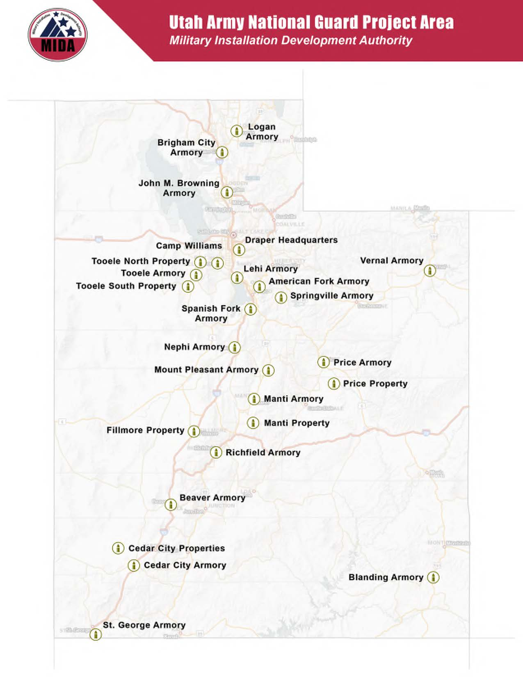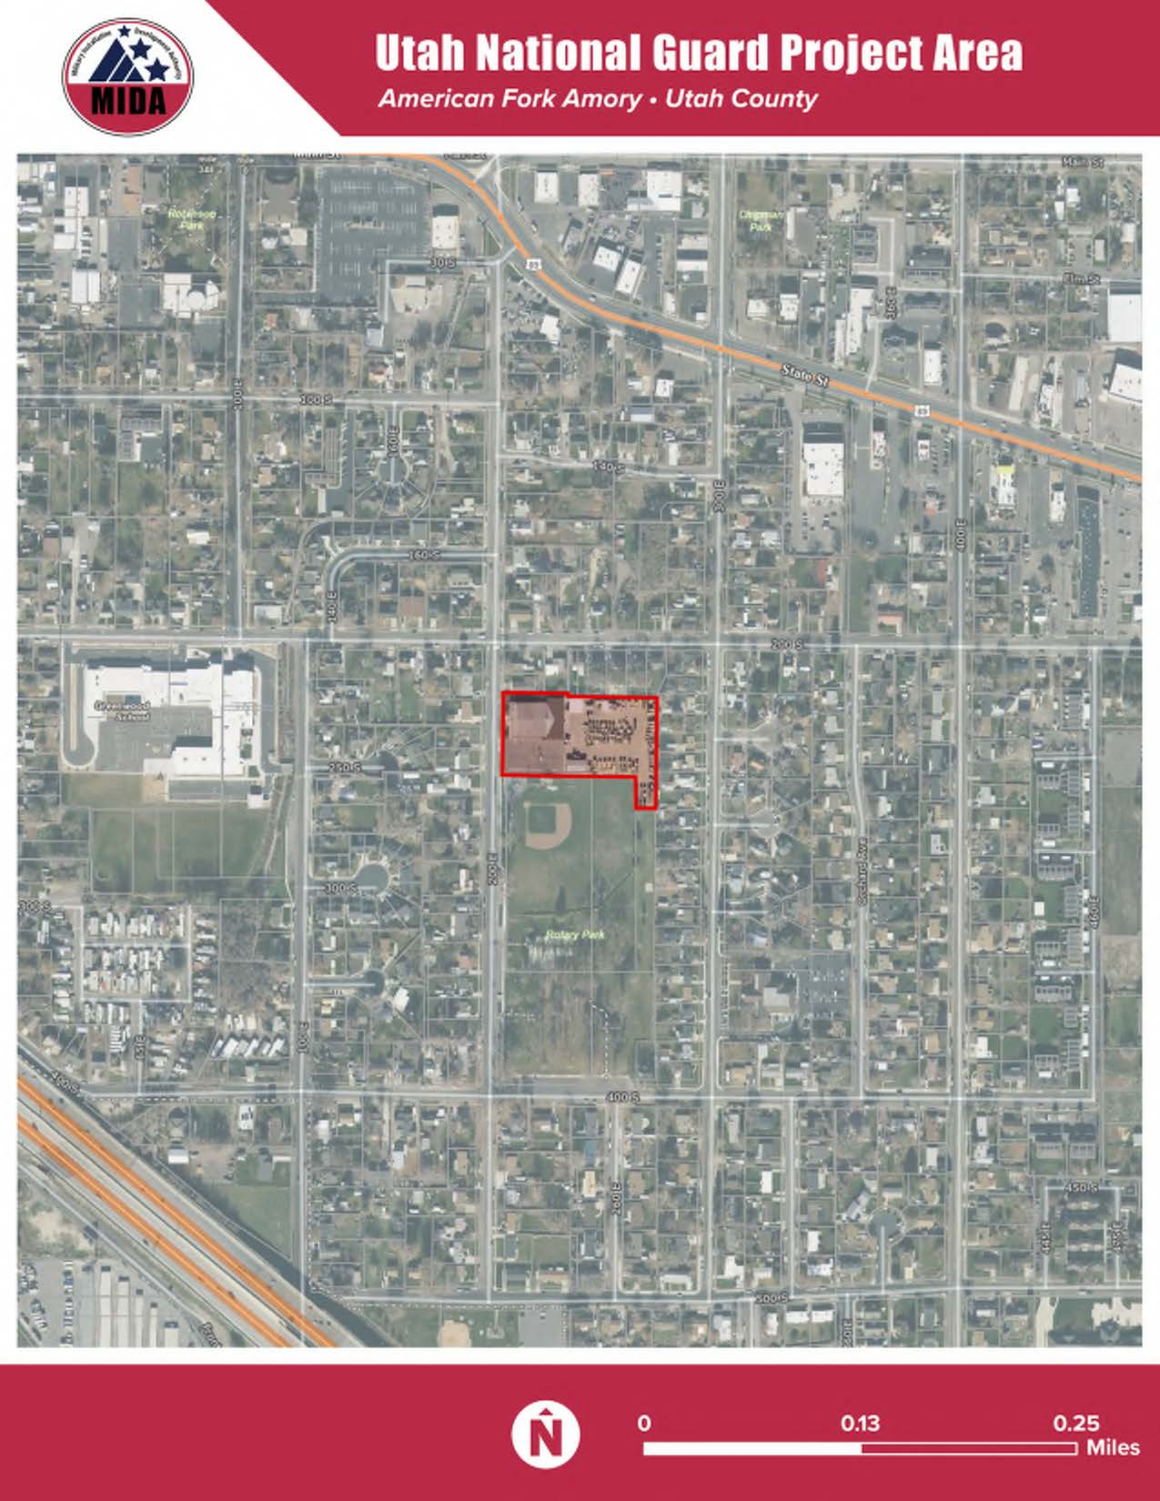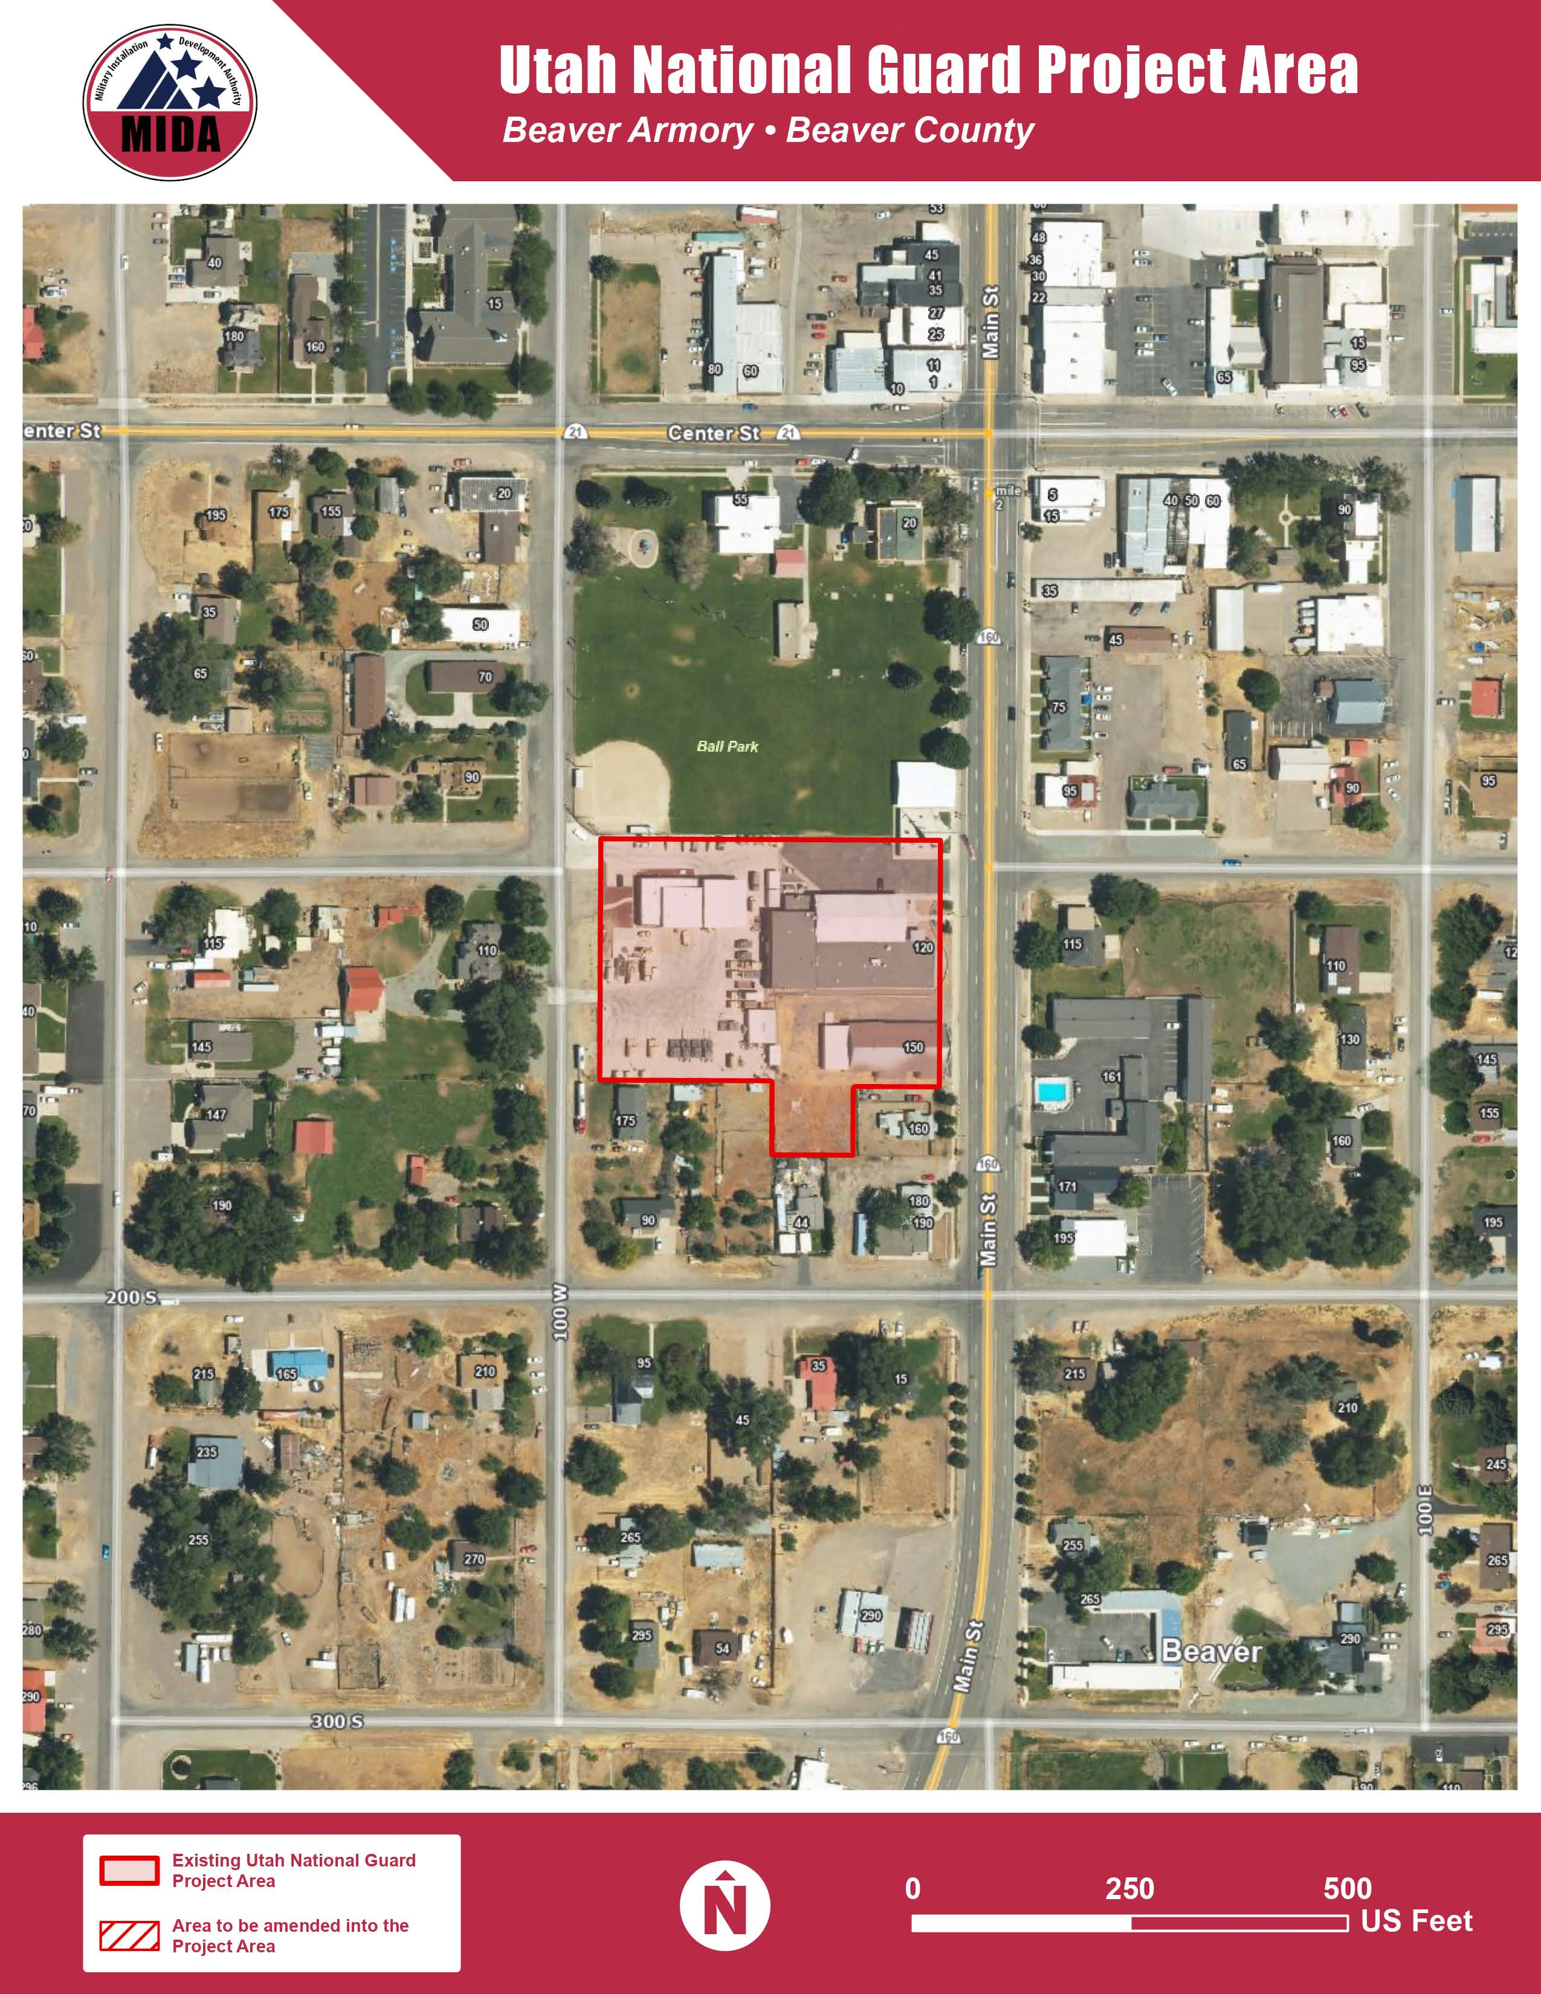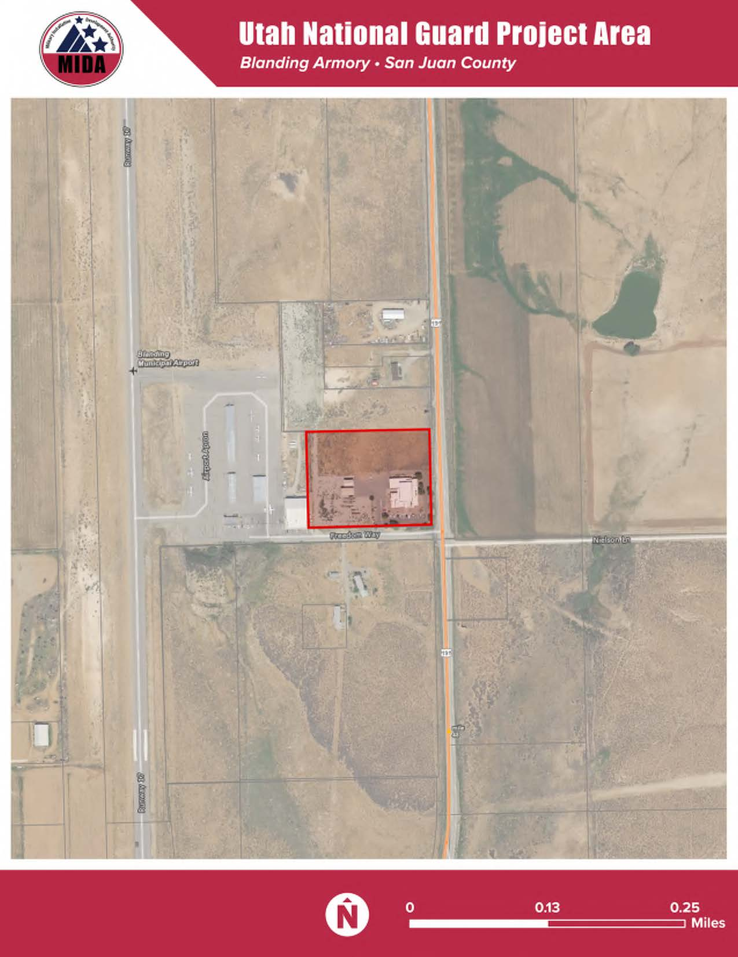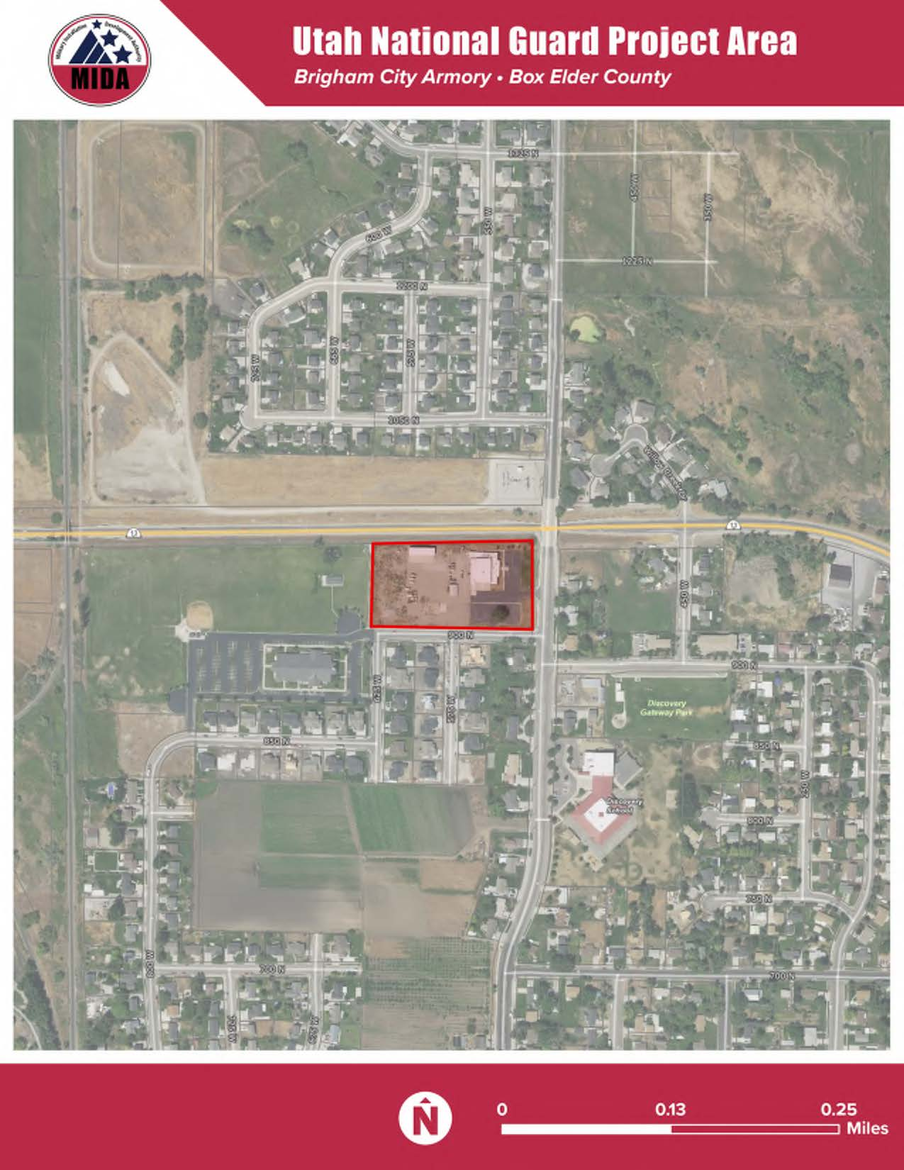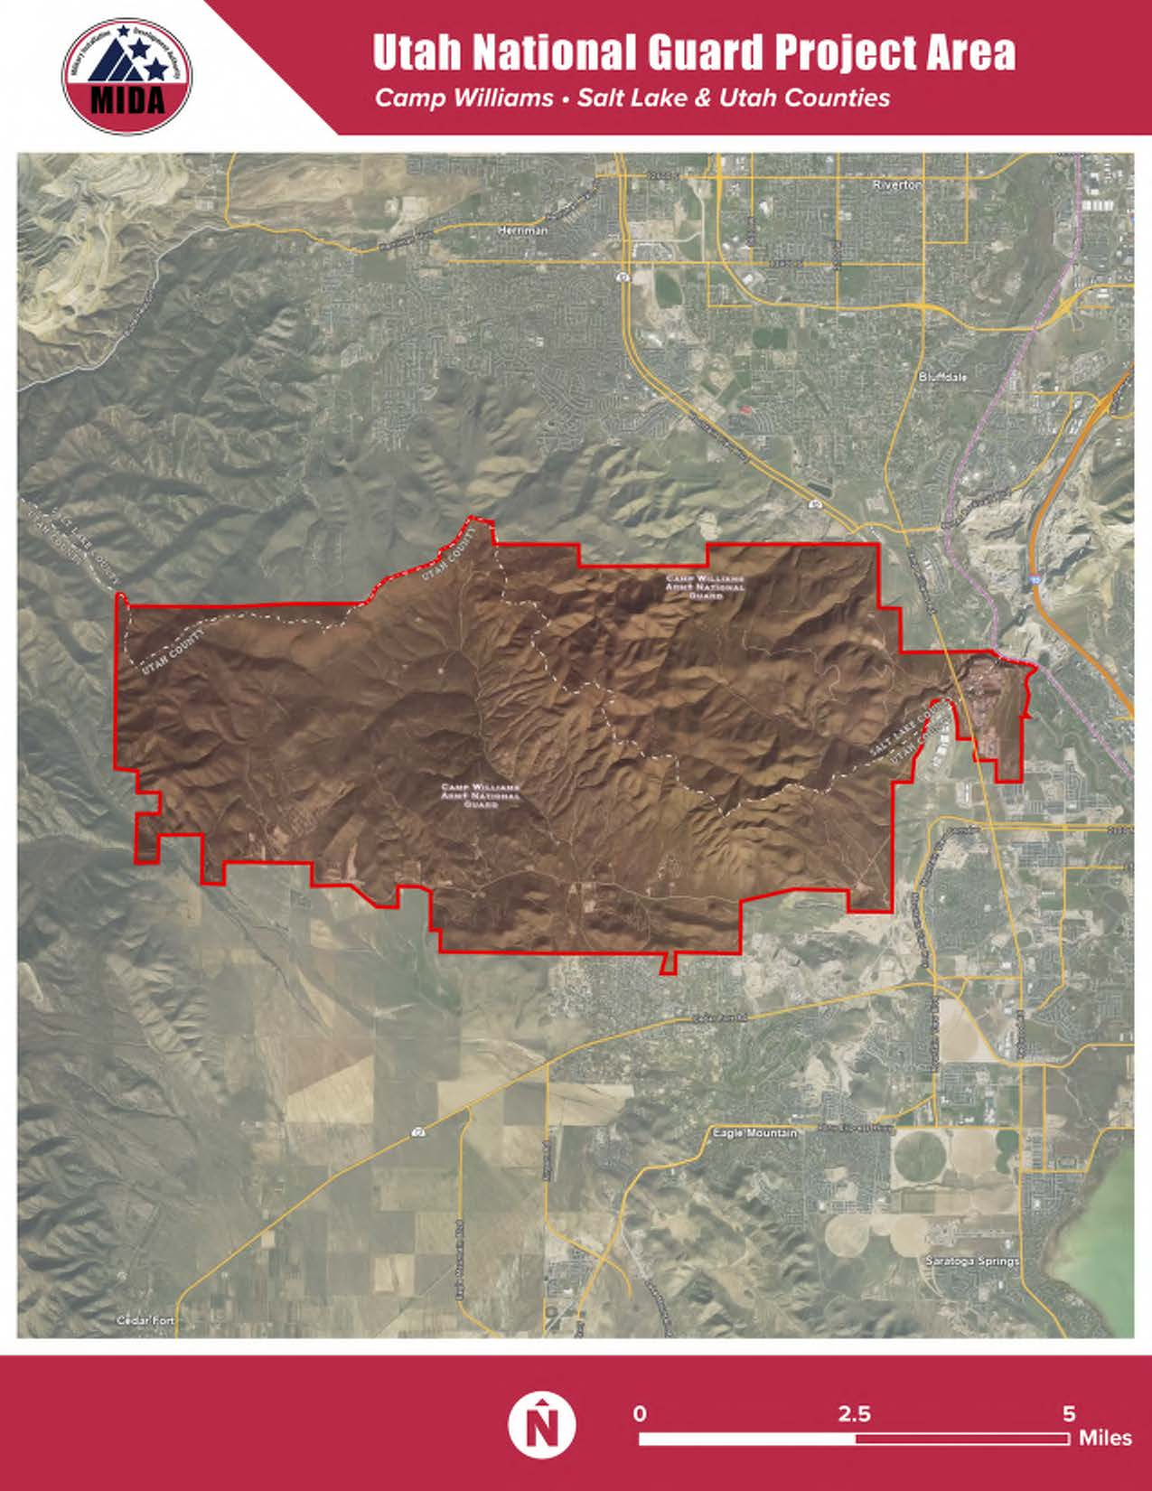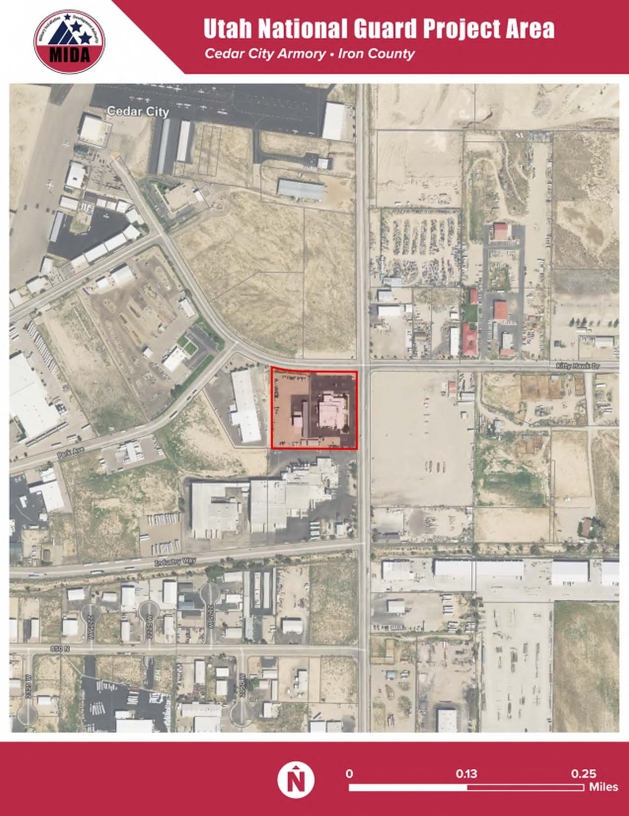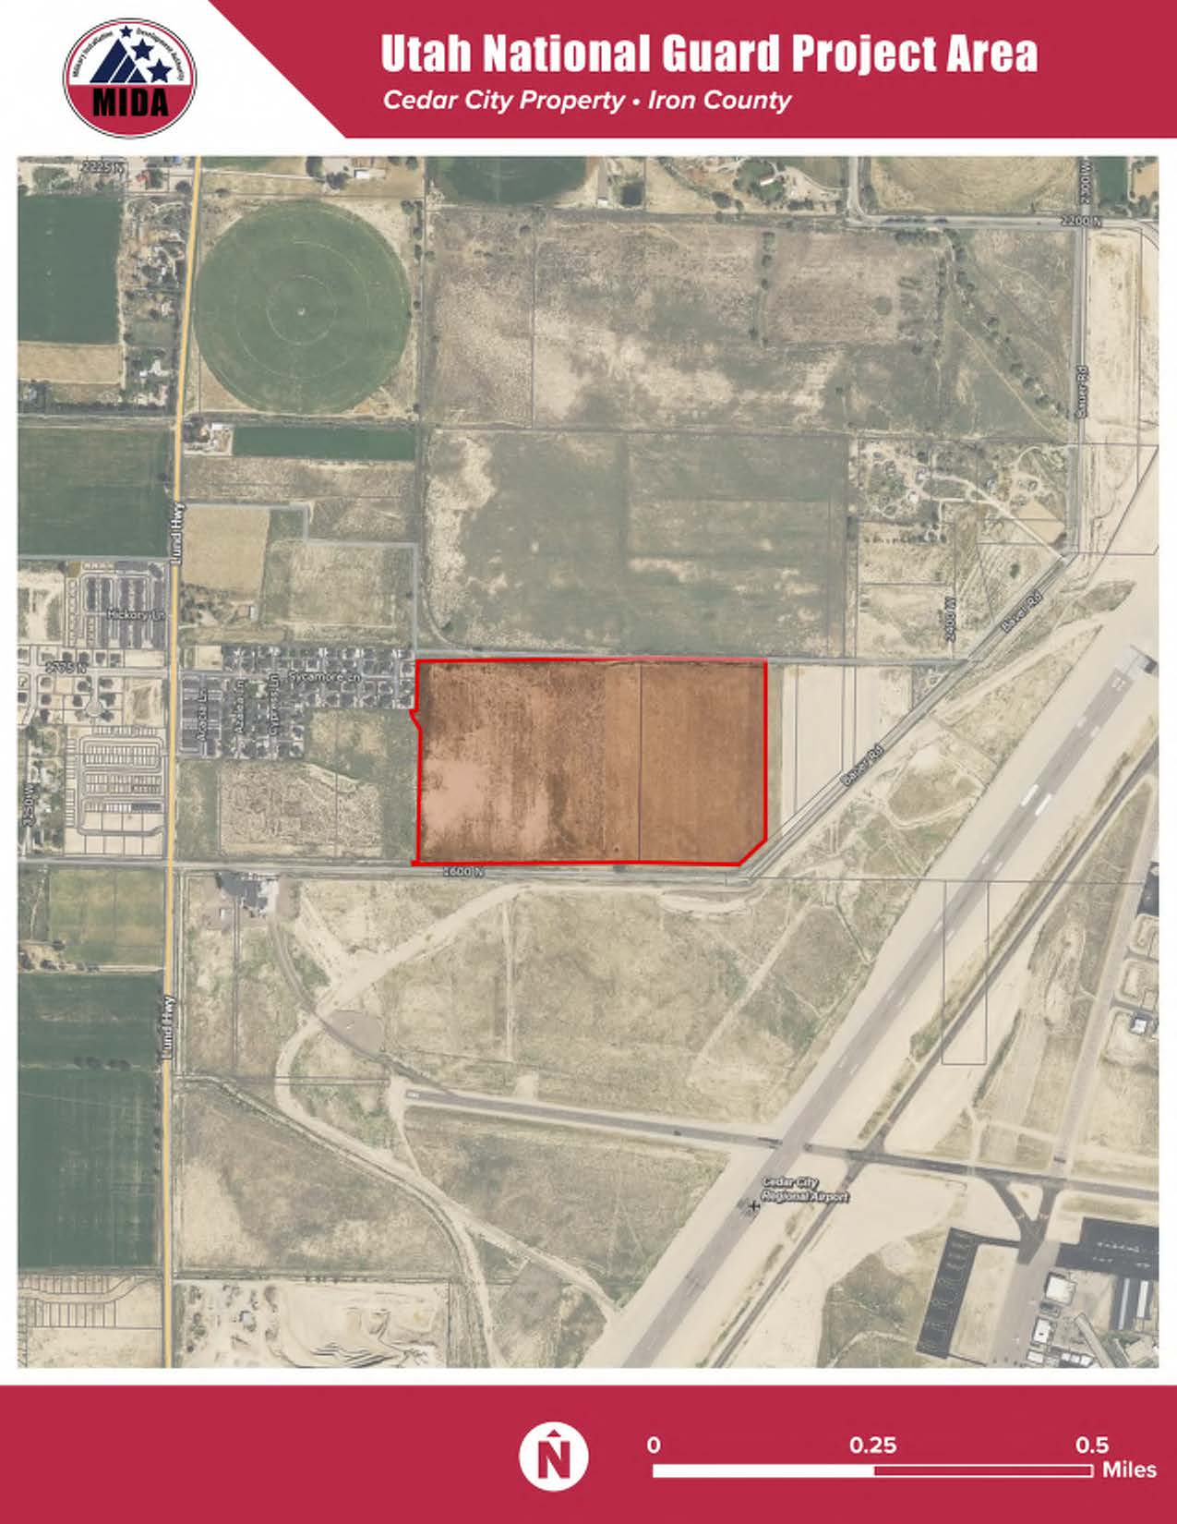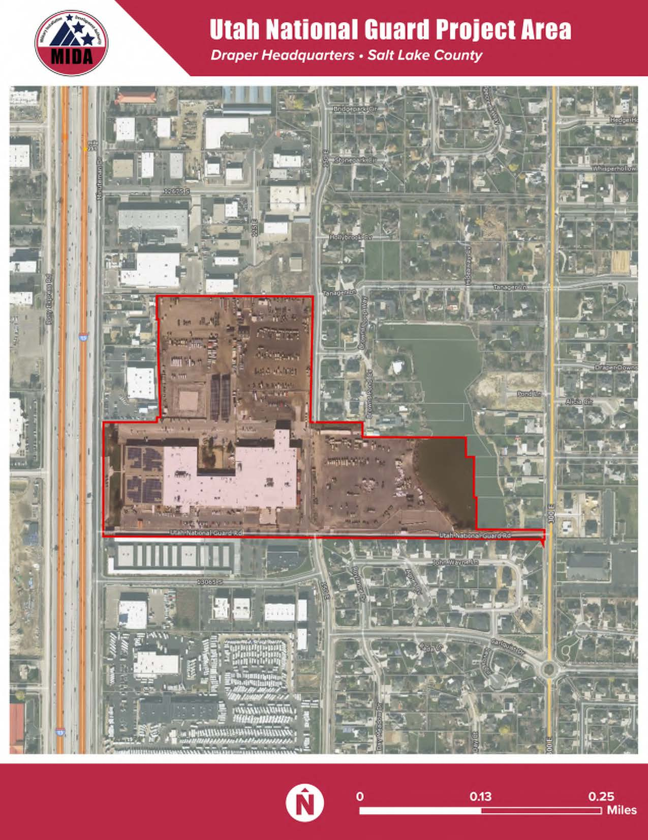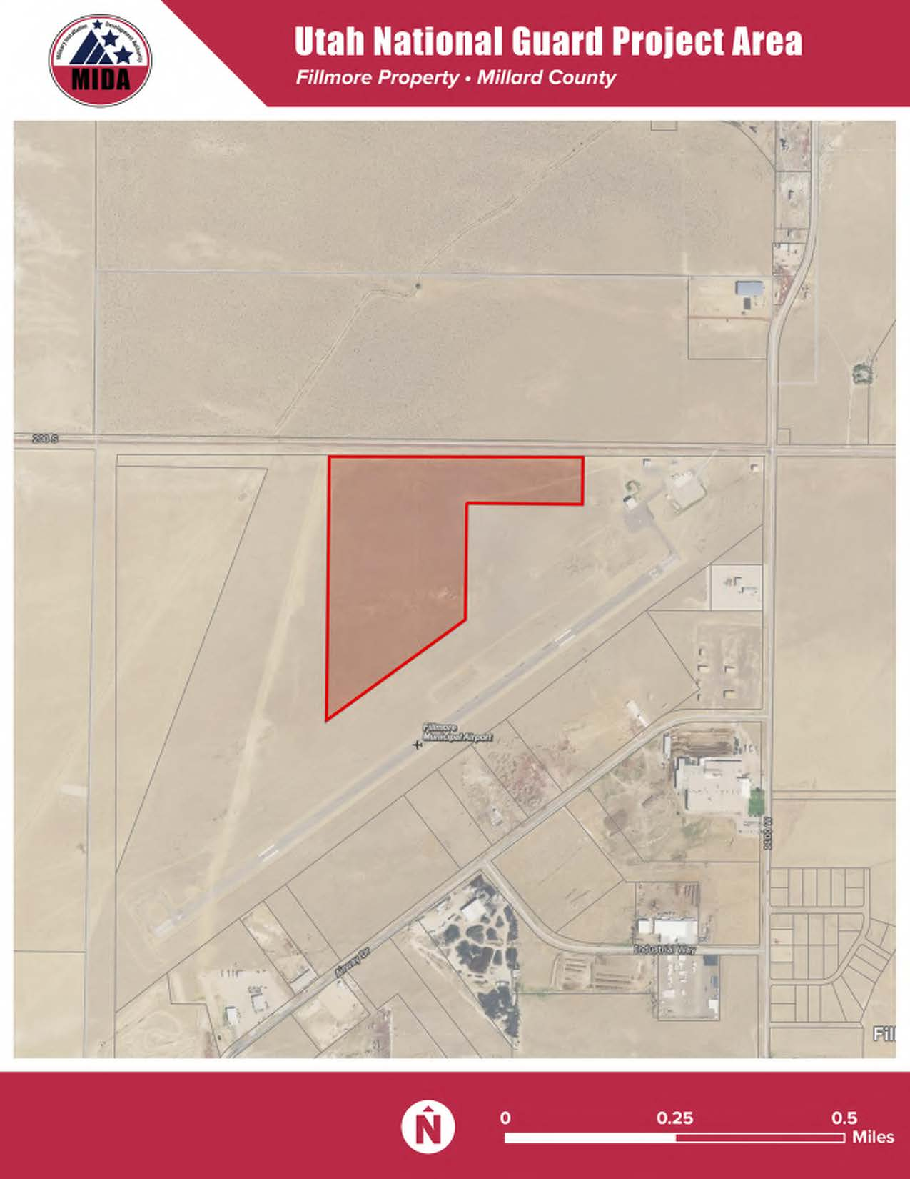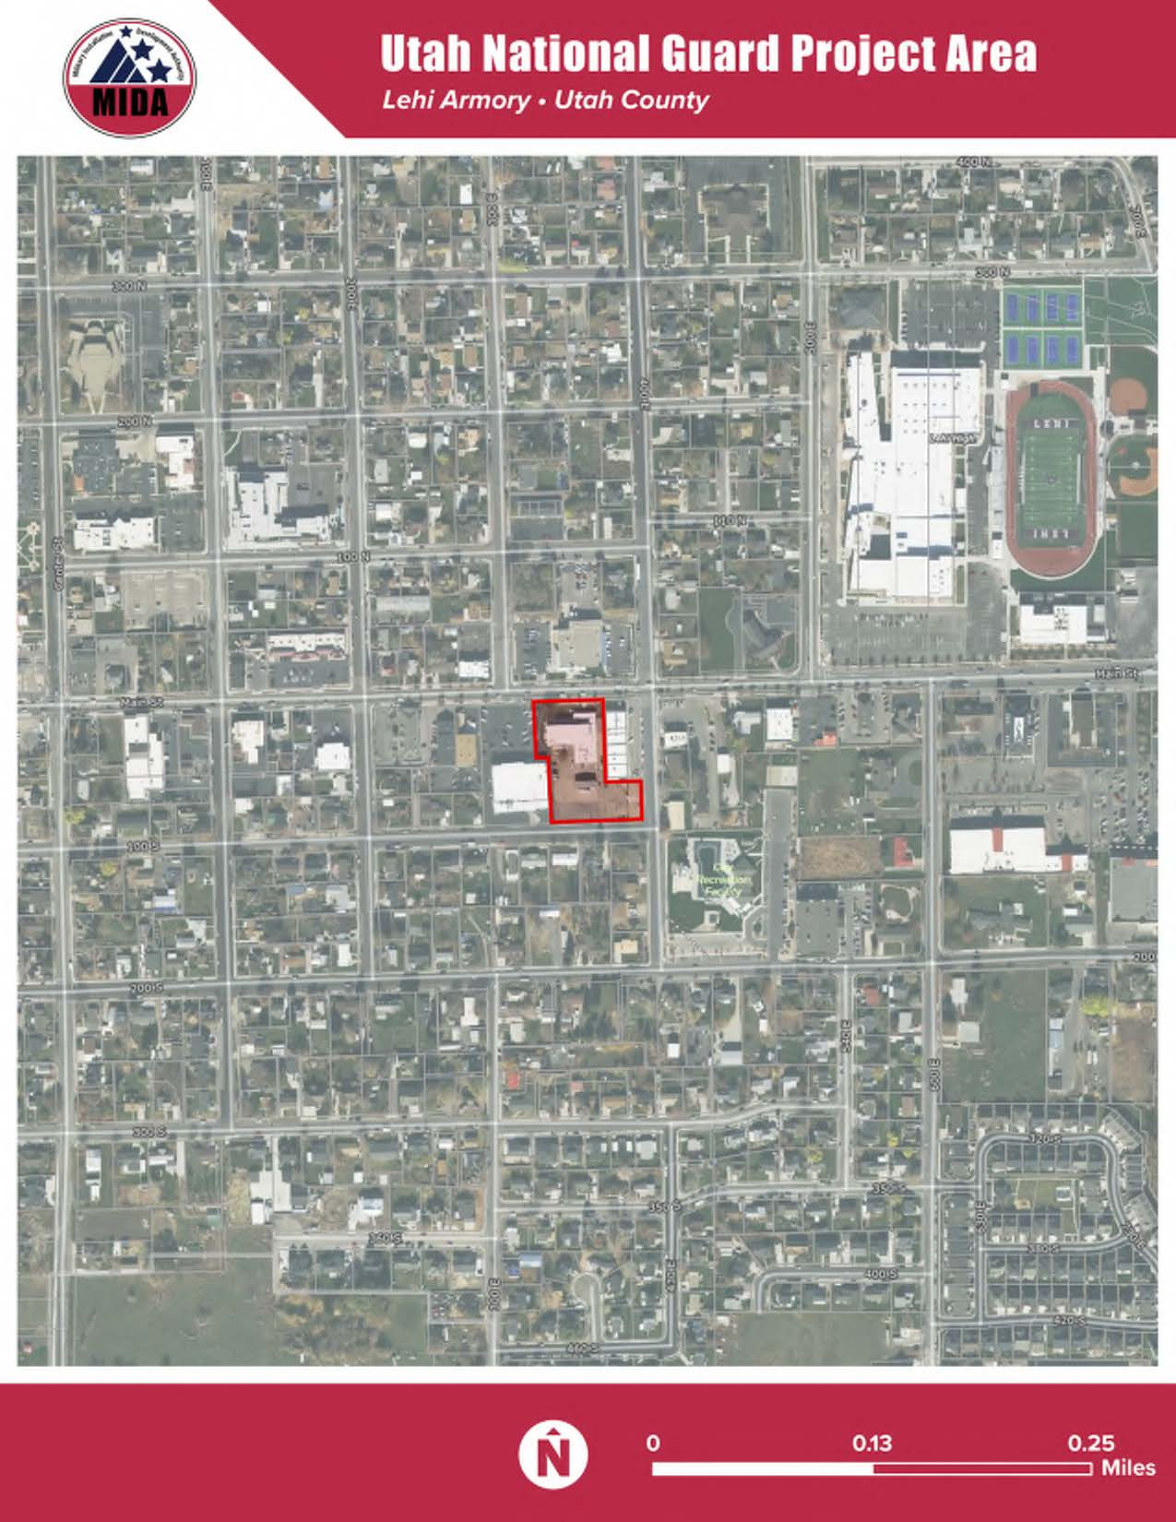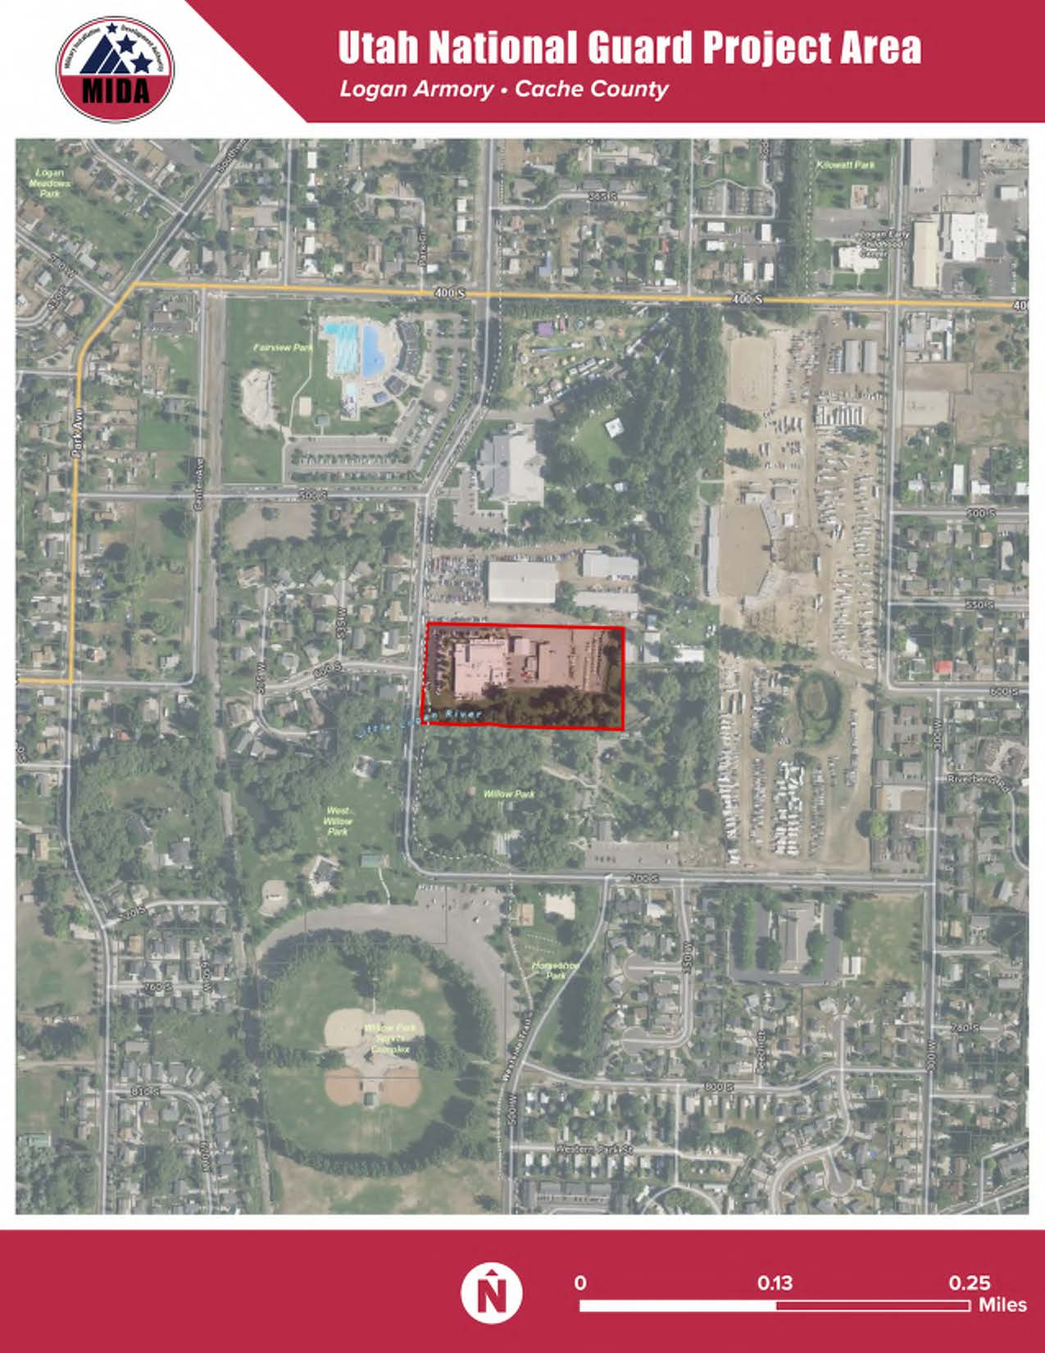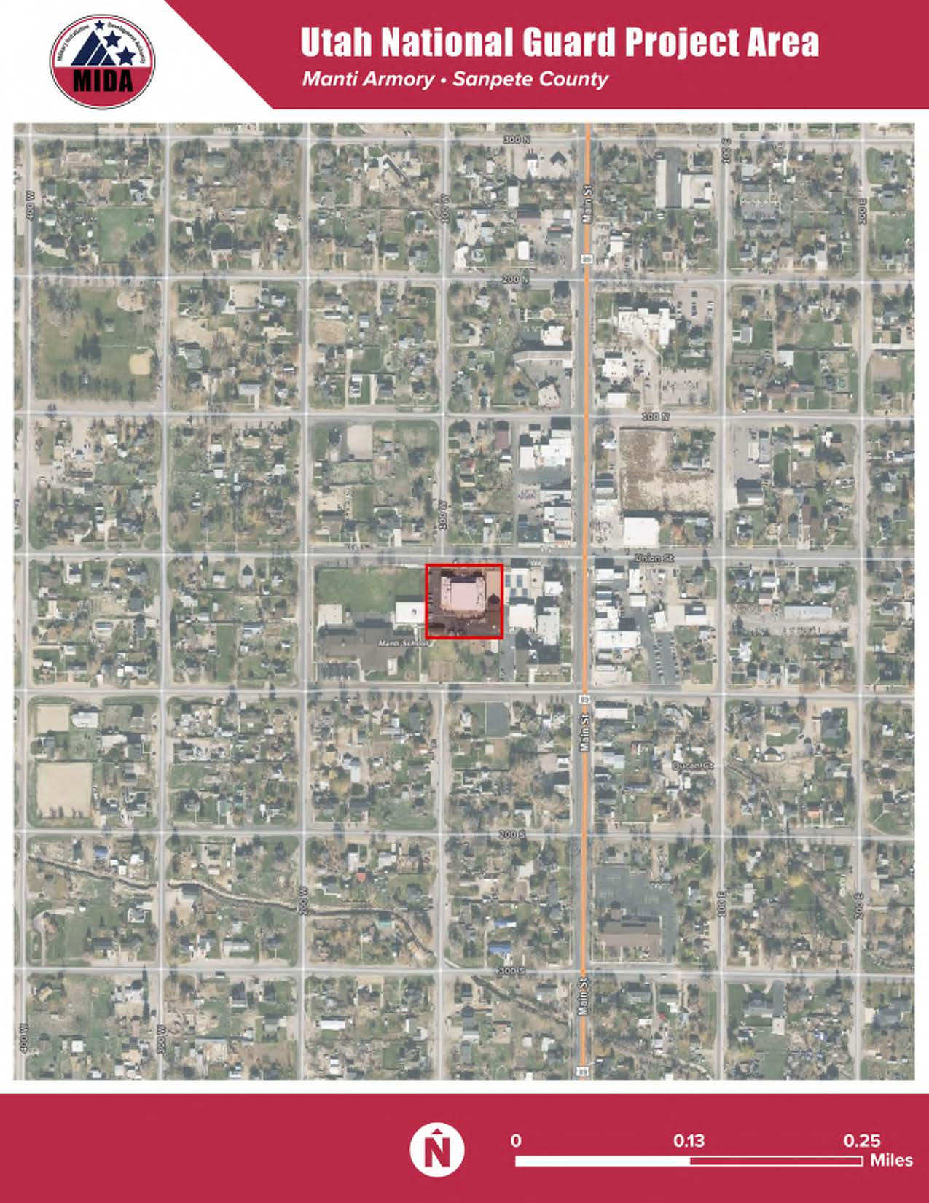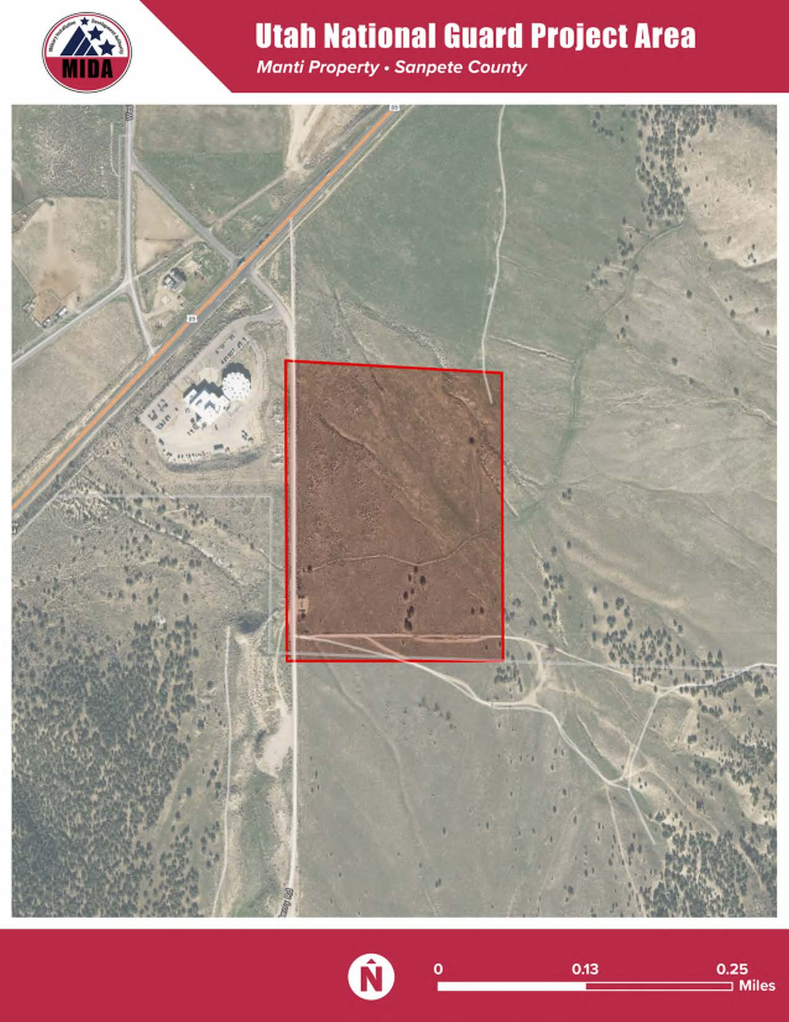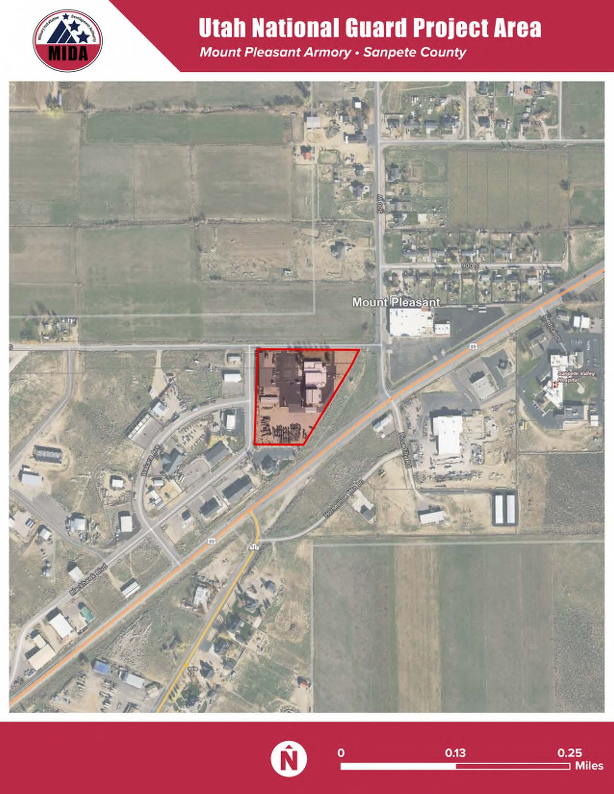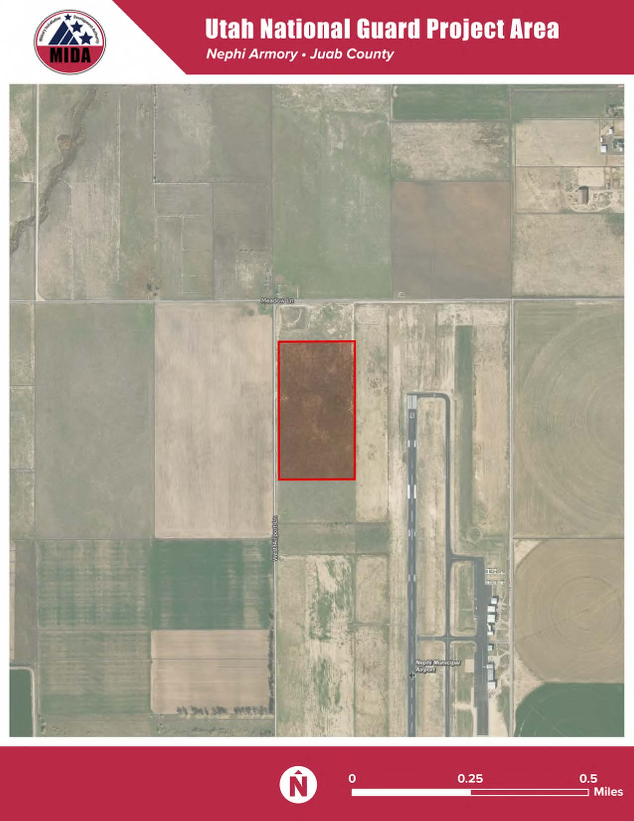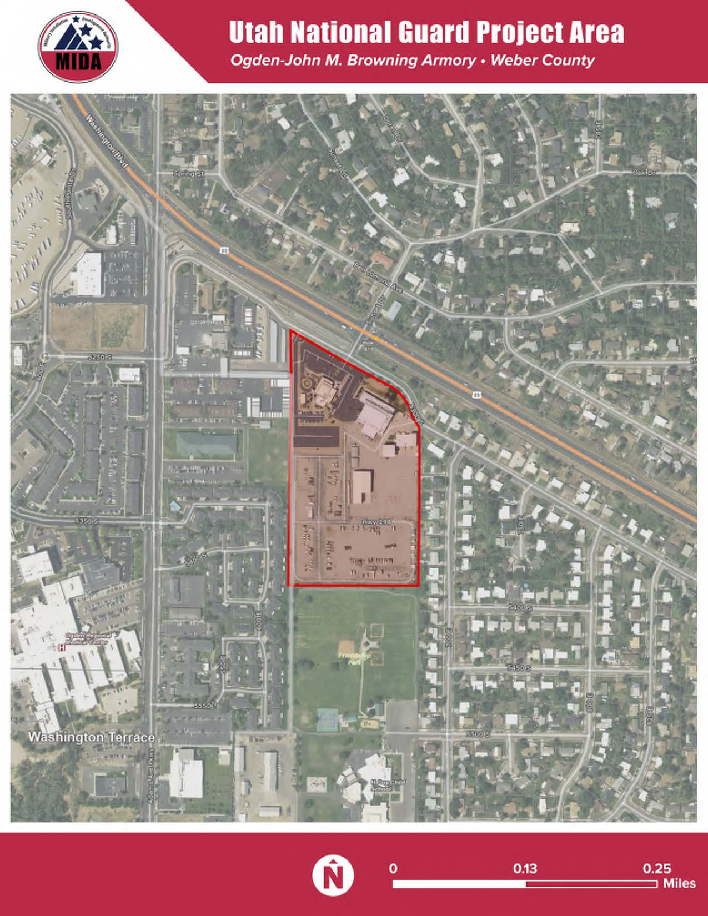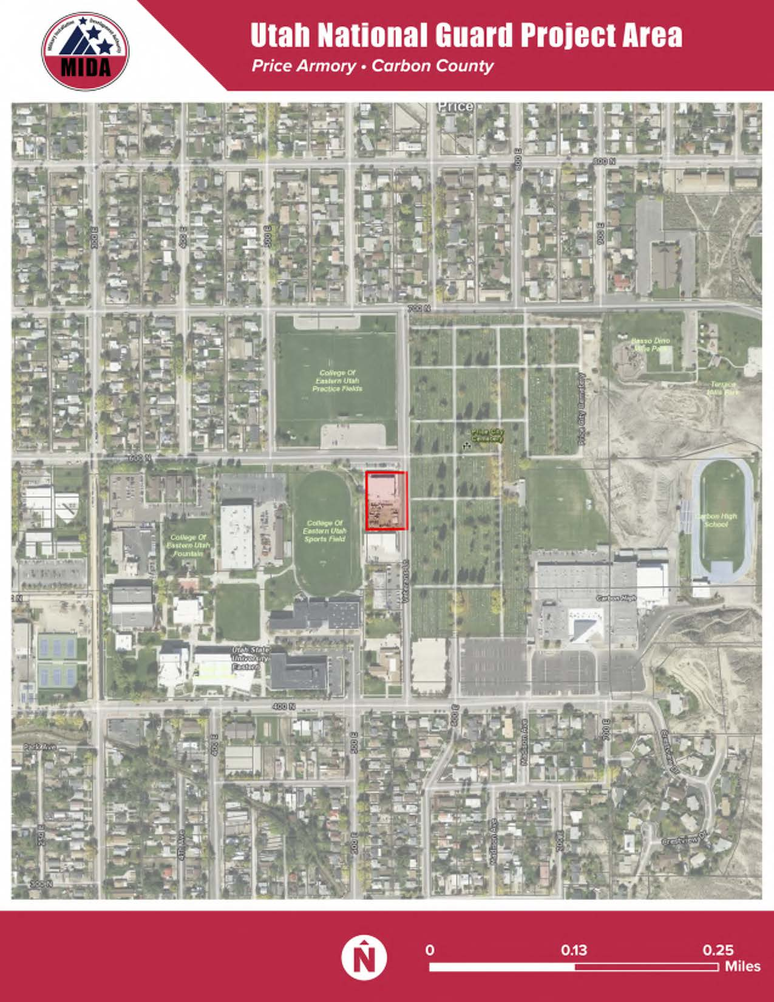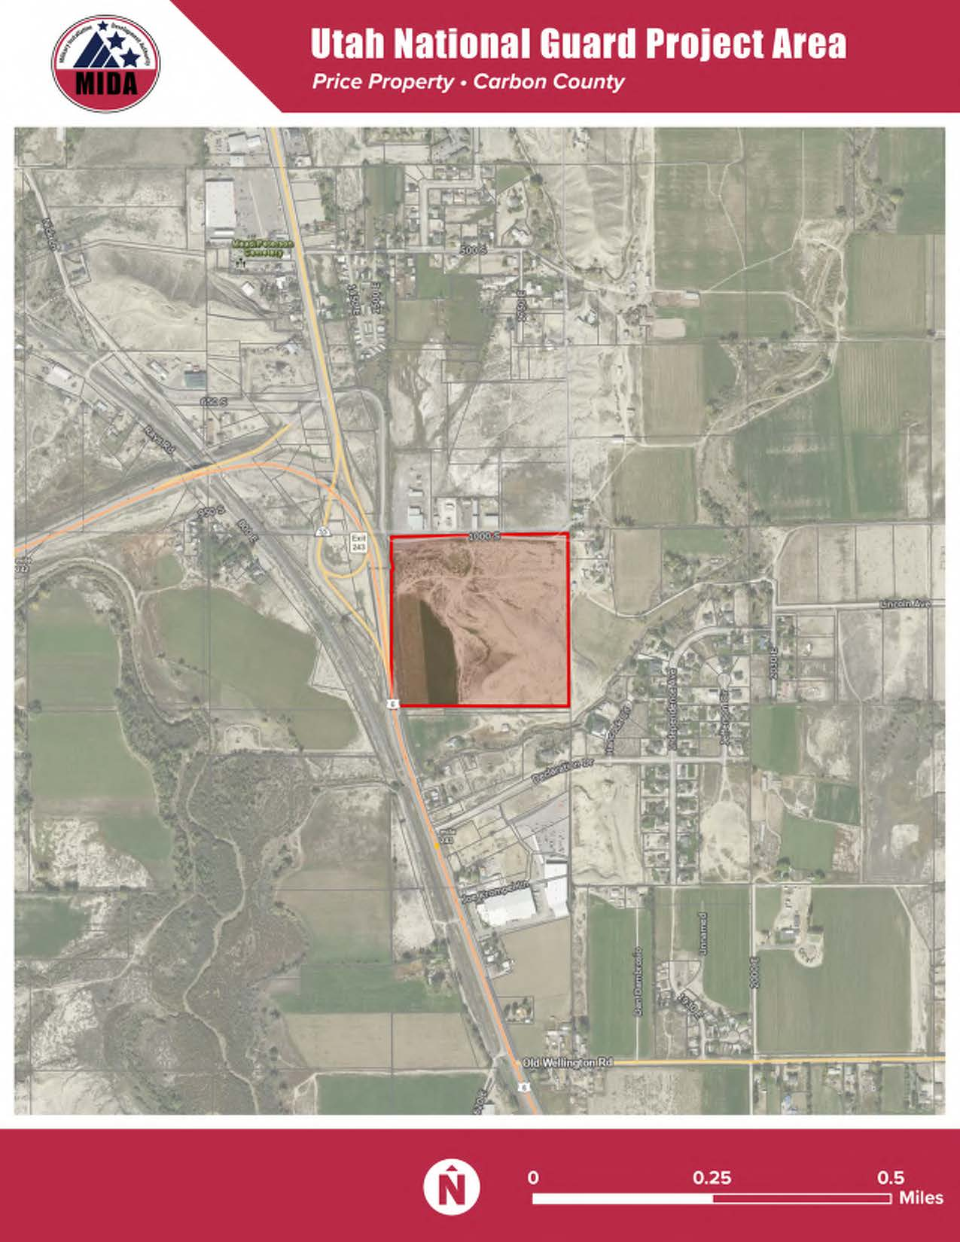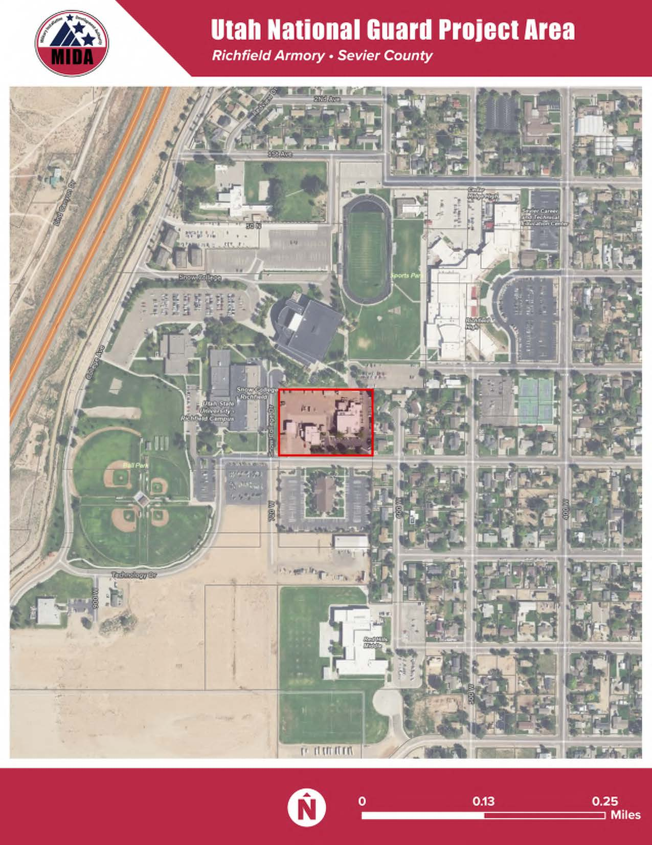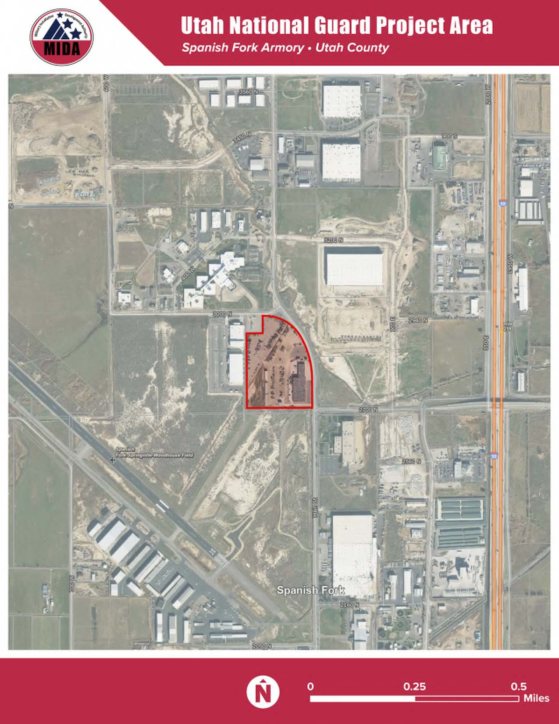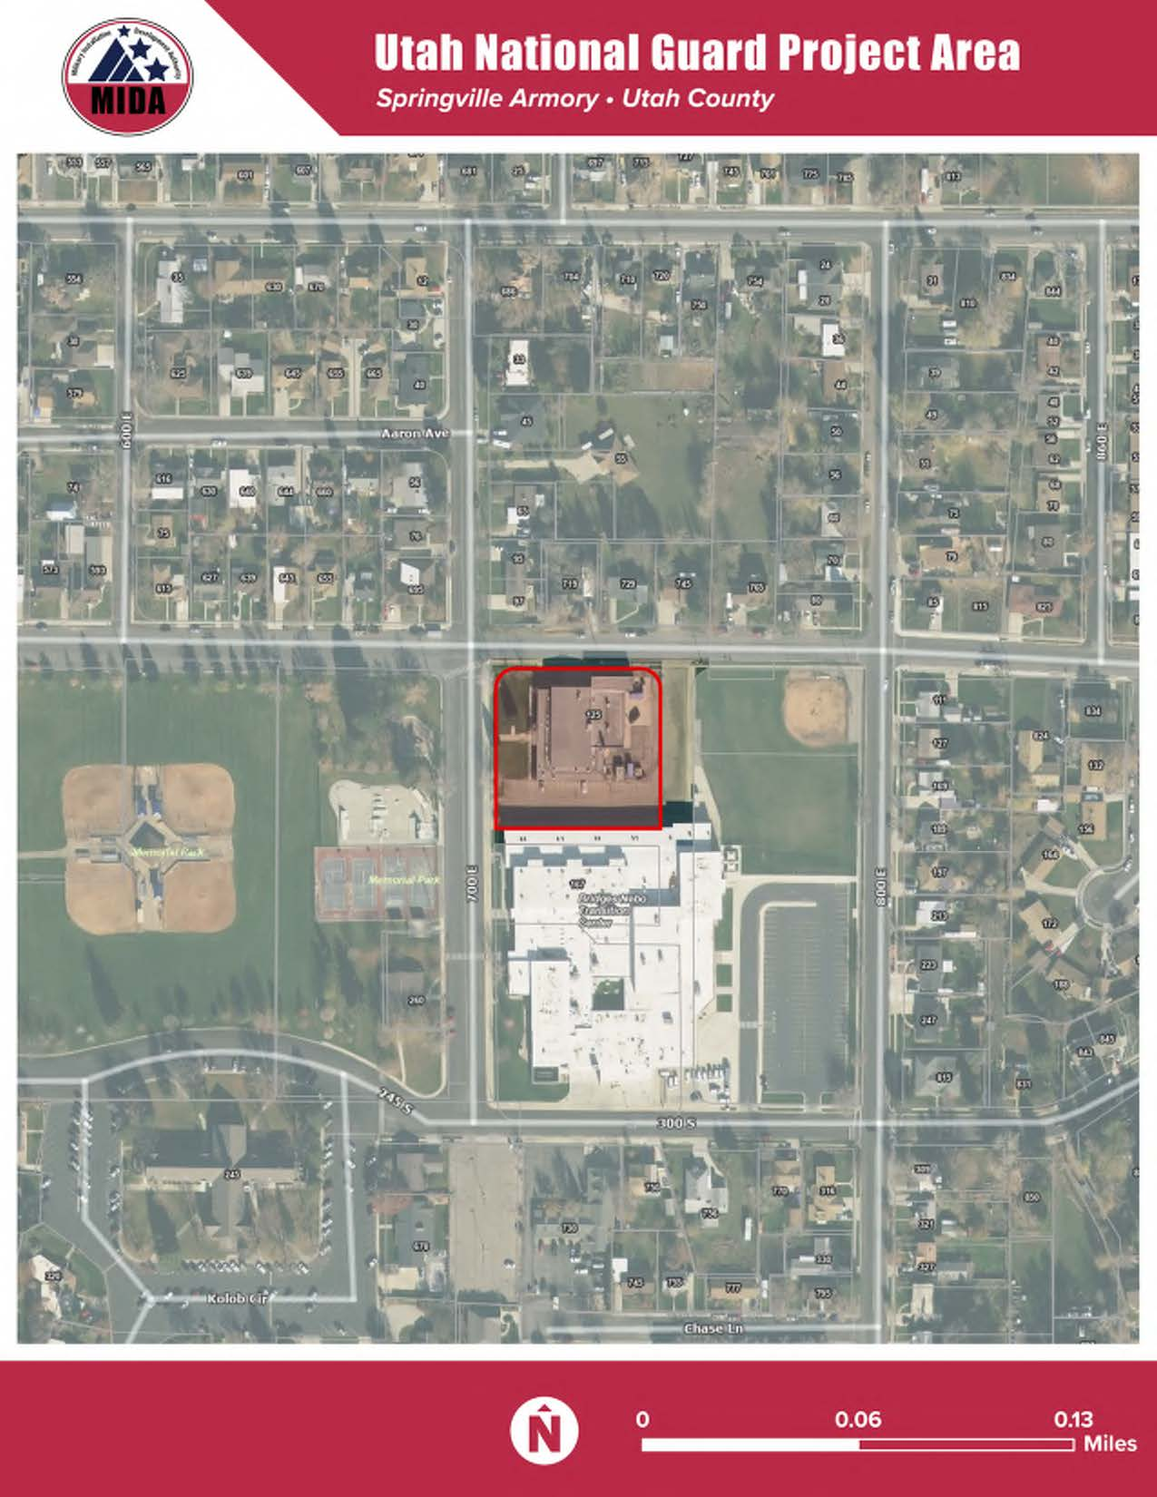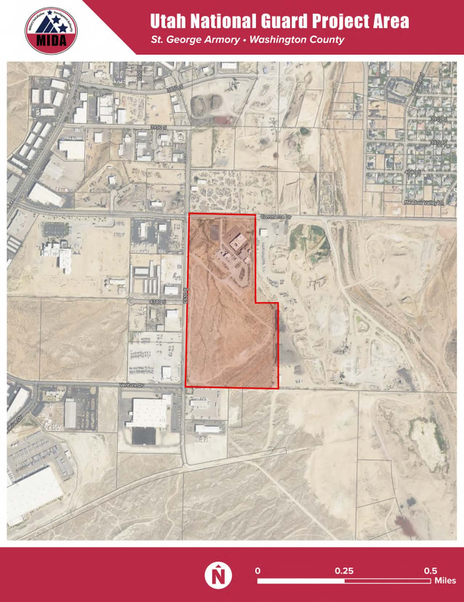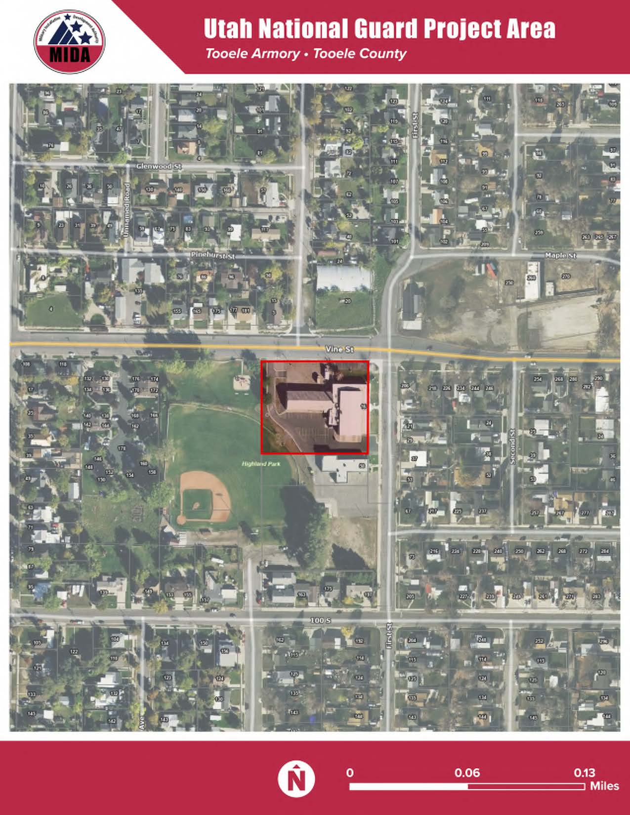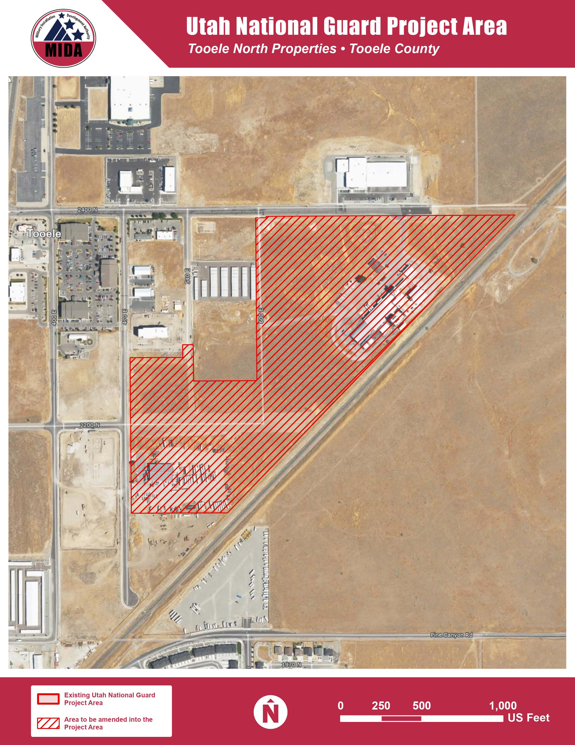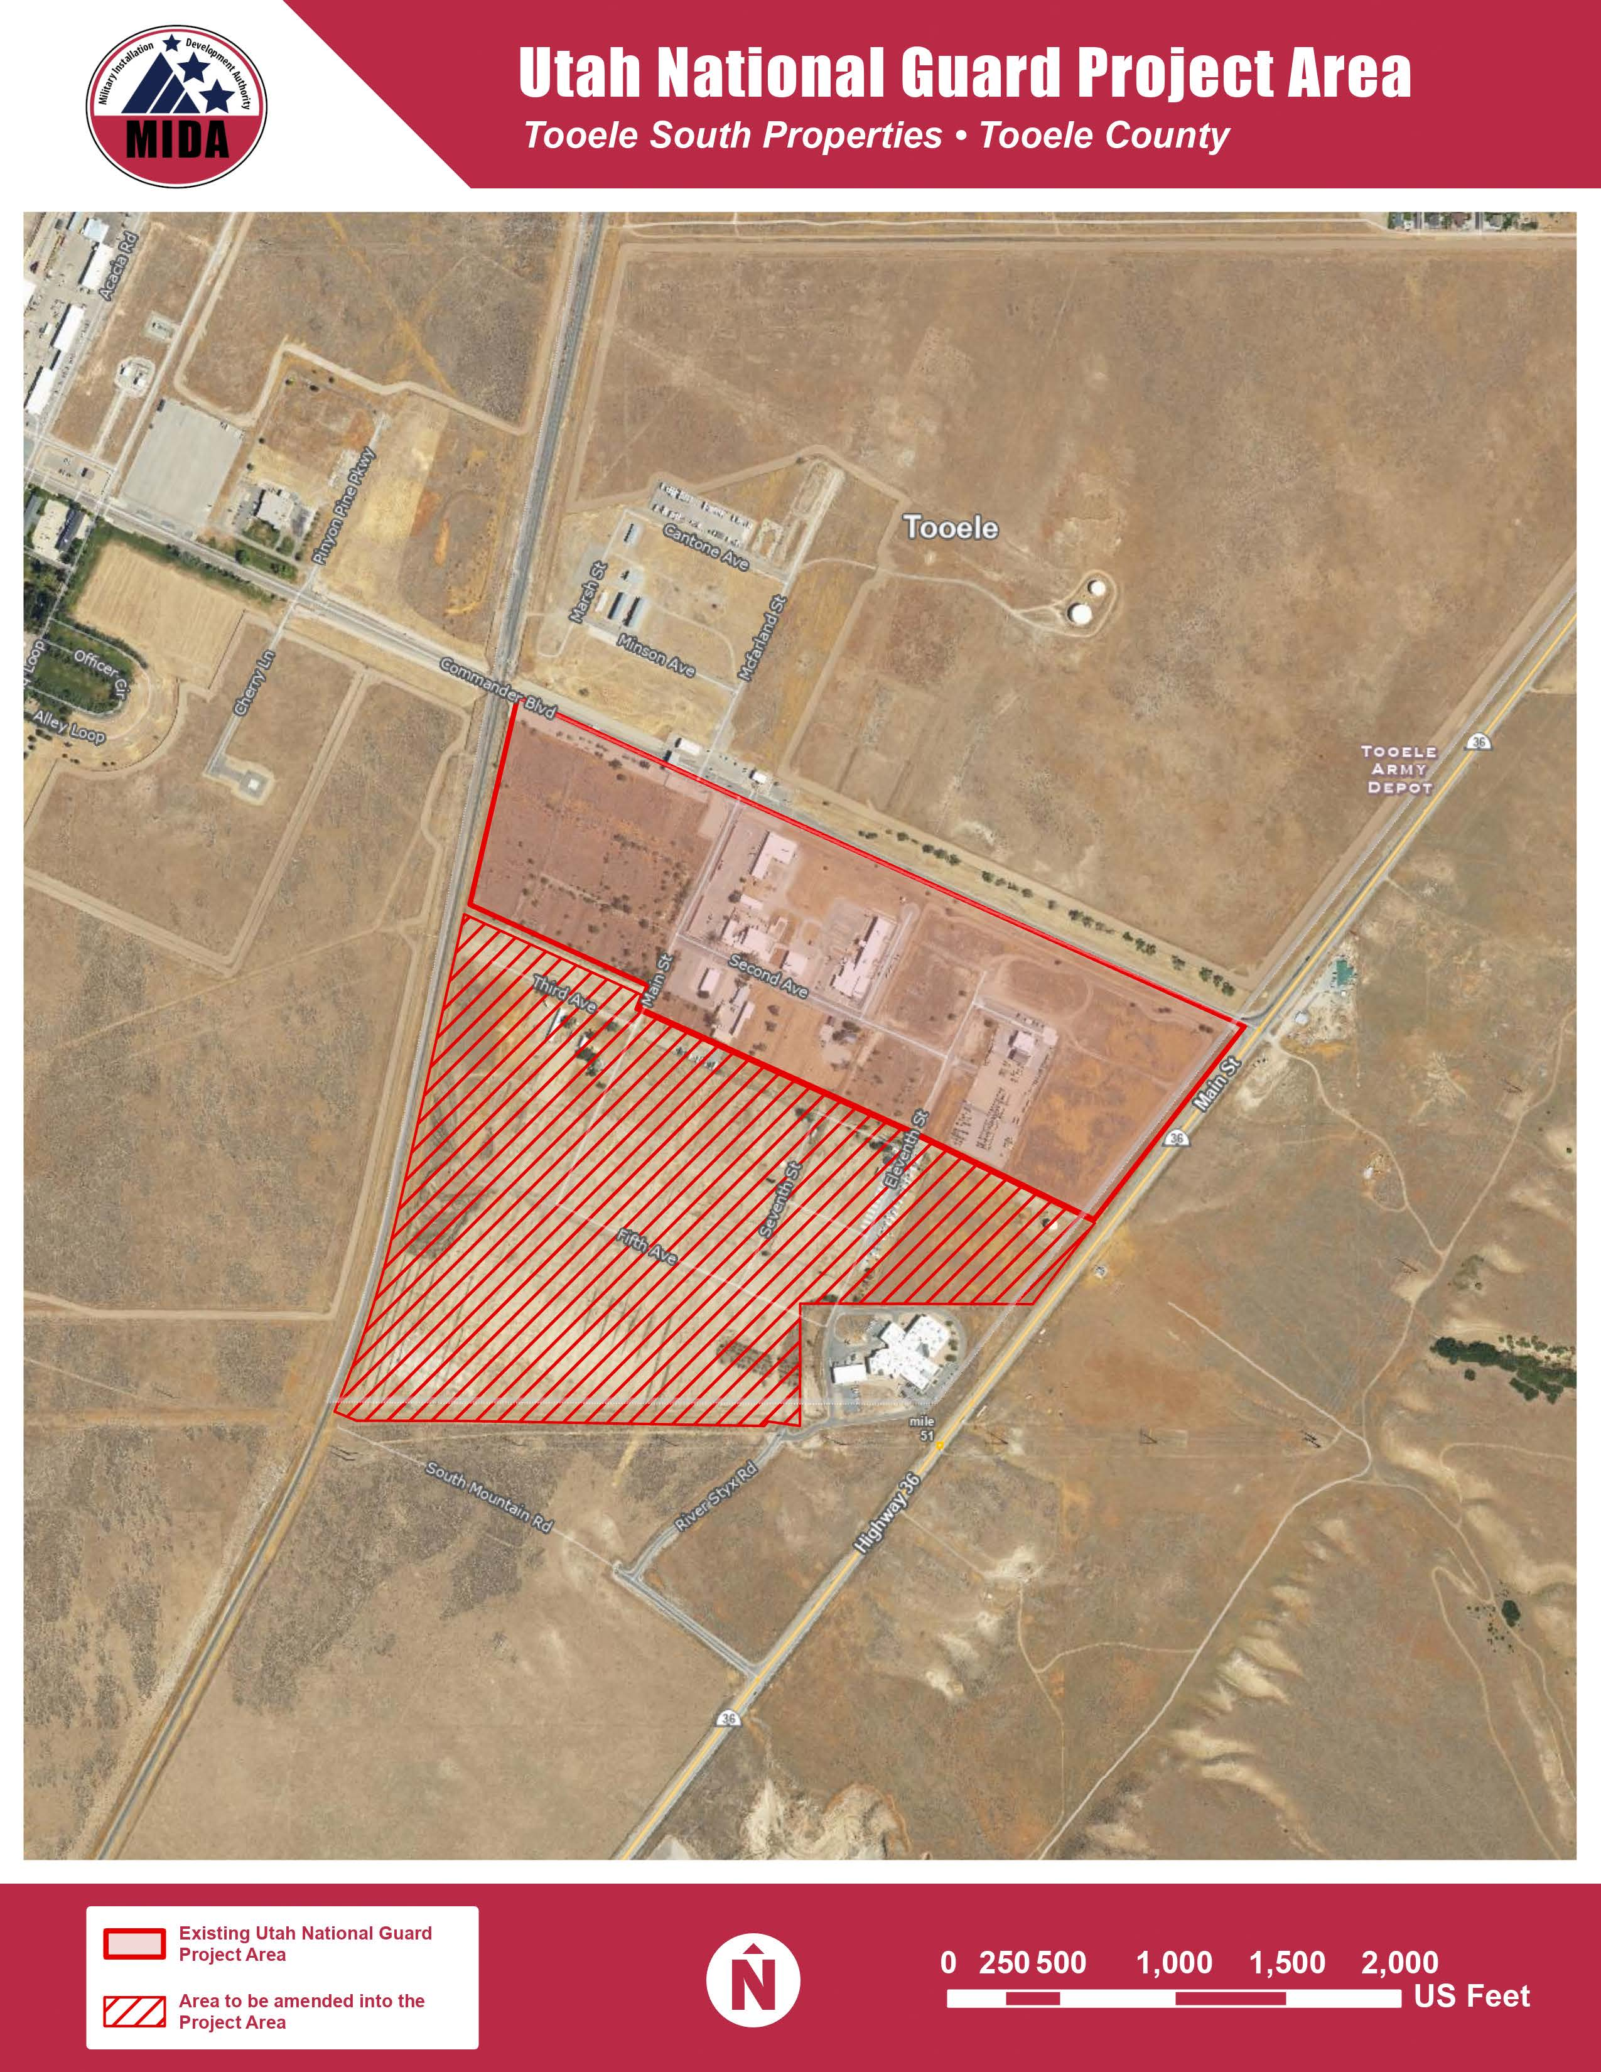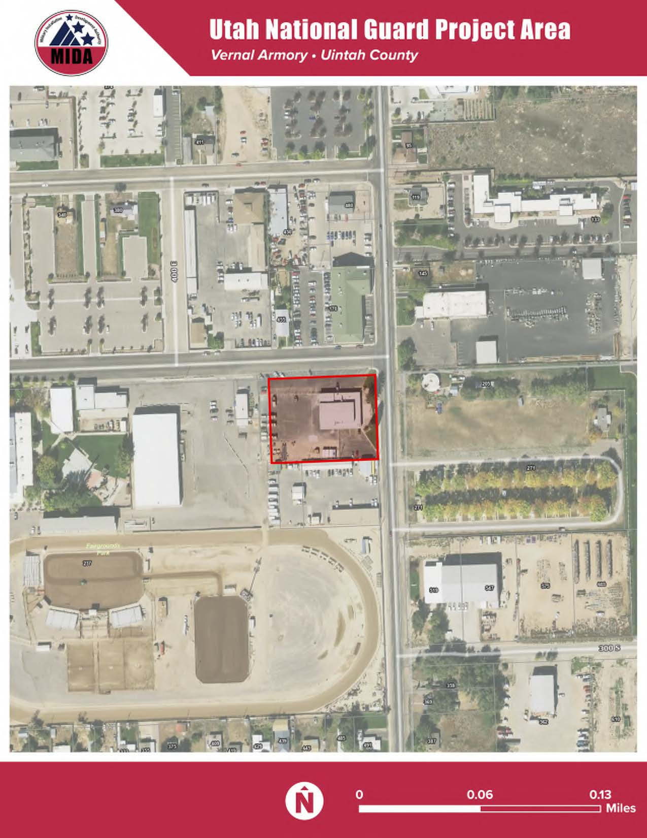

EXHIBIT B
Legal Description of Additional Land for Part 3 Project Area

B-1 Tooele South Parcel (1) TEAD adjacent
LOT 2, TOOELE COUNTY JAIL SUBDIVISION, A SUBDIVISION OF TOOELE CITY. OUT OF 15-92-1B FOR 2012 YEAR. 97.443 AC -------- LESS 0.06 AC TO SOUTH MOUNTAIN ROAD AS RECORDED ON DEDICATION PLAT ENTRY# 357038. OUT OF 17-96-2 FOR 2012 YEAR. 97.383 AC

B-2
BEG S 0°26'19" E 1347.06 FT AL THE SEC LI & N 89°33'41" E 489.53 FT FR THE W 1/4 COR OF SEC 10, T3S, R4W, SLB&M RUN TH N 89°41'08" E 584.97 FT; TH S 0°26'19" E 505.60 FT TO A PT ON THE UNION PACIFIC R/W LI; TH S 43°55'02" W 10.33 FT AL SD R/W LI; TH S 89°41'08" W 592.78 FT; TH N 0°26'19" W 497.97 FT; TH NELY 23.59 FT AL THE ARC OF 15.00 FT RADIUS CURVE TO THE RIGHT (CENTER BEARS N 89°33'41" E & LONG CHORD BEARS N 44°37'25" E 21.24 FT THROUGH A CENTRAL ANGLE OF 90°07'27") TO THE POB. OUT OF 2-144-1 FOR 99 YEAR. 7.06 AC 03/21/2000 03/21/2000

B-3
BEG S 0°26'19" E 824.26 FT ALG SEC LI AND N 89°33'41" E 864.50 FT FROM W 1/4 COR SEC 10, T3S, R4W, SLB&M AND RUN; TH N 89°41'08" E 389.89 FT; TH S 0°25'51"E 442.58 FT; TH SWLY 23.59 FT ALG THE ARC OF A 15.00 FT RADIUS CURVE TO RIGHT (CTR BEARS S 89°34'09" W AND LONG CHORD BEARS S 44°37'38" W 21.23 FT THRU A CENTRAL ANGLE OF 90°06'59"); TH S 89°41'08" W 359.83 FT; TH NWLY 23.53 FT ALG THE ARC OF A 15.00 FT RADIUS CURVE TO R (CENTER BEARS N 0°18'52" W AND LONG CHORD BEARS N 45°22'36" W 21.19 FT THRU A CENTRAL ANGLE OF 89°52'33")' TH N 0°26'19" W 442.64 TO POB. OUT OF 2-144-1 FOR 99 YEAR. 4.09 AC-----LESS 1.00 AC ( SWD 599076) BALANCE OF 2-144-6 AFTER 2-144-60 FOR 2025 YEAR. 3.09 AC ----- LESS 1.00 AC (WD 613489) BALANCE OF 2-144-60 AFTER 2-144-61 FOR 2026 YEAR. 2.09 AC

B-4
BEG S 0°26'19" E 1347.06 FT ALG THE SEC LI AND N 89°33'41" E 489.53 FT AND N 89°41'08" E 584.97 FT FROM W 1/4 COR SEC 10, T3S, R4W, SLB&M AND RUN; TH S 89°41'08" E 143.89 FT; TH SELY 13.87 FT ALG THE ARC OF A 15.00 FT RADIUS CURVE TO RIGHT (CENTER BEARS S 0°18'52" E AND LONG CHORD BEARS S 63°49'52" E 13.38 FT THRU A CENTRAL ANGLE OF 52°57'59"); TH NELY 124.49 FT ALG THE ARC OF A 50.00 FT RADIUS CURVE TO LEFT (CENTER BEARS N 52°39'07" E AND LONG CHORD BEARS N 71°19'34" E 94.74 FT THRU A CENTRAL ANGLE OF 142°39'07"); TH N 89°41'30" E 270.76 FT TO UNION PACIFIC R/W; TH S 43°55'02" W 738.91 FT ALG S R/W LI; TH N 0°26'19" W 505.60 FT TO POB. OUT OF 2-144-1 FOR 99 YEAR. 2.97 AC

B-5
BEG AT A PT ON S SEC LI OF SEC 10, T3S, R4W, SLB&M, & ON E R/W LI OF TOOELE CO RD R/W OF 400 E, SD PT BEING N 89°41'53" E ALG SD S SEC LI, 33 FT, FR SW COR OF SD SEC 10, (A FOUND TOOELE CO BRASS CAP); N 00°26'19" W, PARA & PERP 33 FT E OF W LI OF SW 1/4 OF SD SEC 10 & ALG SD E R/W LI, 2610.971 FT TO S R/W LI OF TOOELE CO RD R/W OF 2400 N; N 89°41'08" E PARA & PERP 33 FT, S OF N LI OF NW 1/4 OF SW 1/4 OF SD SEC 10, 1221.501 FT TO W R/W LI OF TOOELE CO RD R/W OF 600 E; S 00°25'51" E PARA & PERP 66 FT, W OF E LI OF NW 1/4 OF SW 1/4 OF SD SEC 10, 1289.126 FT TO S LI OF NW 1/4 OF SW 1/4 OF SD SEC 10; N 89°41'30" E, ALG S LI OF NW 1/4 OF SW 1/4 & S LI OF NE 1/4 OF SW 1/4 OF SD SEC 10, 336.753 FT TO AN EXIST FENCE, BEING ON NW'LY LI OF EXIST UPRR R/W LI; TH S 43°55'02" W ALG SD FENCE LI AND UNION PACIFIC RR R/W LI, 1844.827 FT TO S SEC LI OF SD SEC 10, S 89°41'53" W, ALG SD S SEC LI 268.334 FT TO POB. COMBINES 2-144-2 WITH 2-144-1 FOR 98 TAX YEAR. TOG/W A ROAD EASEMENT BK 468/747. LESS 7.06 AC TO 2-144-4 (AES DEV), LESS 7.06 AC TO 2-144-5 (HUNT), LESS 4.09 AC TO 2-144-6 (NELSON & SONS), LESS 2.97 AC TO 2-144-7 (NELSON & SONS) (LESS 1.07 AC TO 2-144-8 FOR 2003 YEAR/BALANCE OF 2-144-1 FOR 2003 YEAR.) (LESS 3.49 AC TO 14-56-2 AND ROADS FOR 2004 YEAR/BALANCE OF 2-144-9 FOR 2004 YEAR.) ---LESS .01 AC TO ROAD FOR 2007 YEAR. BALANCE OF 2-144-10 AFTER ROAD DEDICATION (15-85) FOR 2007 YEAR. ---LESS 6.001 AC TO 2-144-30. BALANCE OF 2-144-29 AFTER 2-144-30 FOR 2009 YEAR. 32.169 AC---LESS .17 AC TO 470 E ST. BALANCE OF 2-144-31 AFTER .17 AC TO 470 E ST FOR 2010 YEAR. 32.00 AC---LESS 0.99 AC TO 18-5(GATEWAY BUSINESS PARK PH IV). BALANCE OF 2-144-32 AFTER 18-5 (GATEWAY BUSINESS PARK PH IV) FOR 2012 YEAR. 31.01 AC-----LESS 4.12 AC (WD ENTRY# 551379) BALANCE OF 2-144-42 AFTER 2-144-43 FOR 2022 YEAR. 26.11 AC----- LESS 15.29 AC (WD #559150) BALANCE OF 2-144-44 AFTER 2-144-45 & 2-144-46 FOR 2022 YEAR. 10.82 AC---LESS 1.17 AC (WD ENTRY # 565998) BALANCE OF 2-144-47 AFTER 2-144-48 FOR 2023 YEAR. 9.65 AC ----LESS 2.67 AC ENTRY# 584539 BALANCE OF 2-144-49 AFTER 400 E COMMERCIAL SUB BK 23 PG 4 FOR 2024 YEAR. 6.98 AC ---- LESS 2.04 AC (WD ENTRY# 591762). BALANCE OF 2-144-55 AFTER 2-144-57 FOR 2024 YEAR. 6.87 AC.

B-6
BEG AT A PT S 0° 25'59" E 33.00 FT ALG 1/16TH LI FR NW COR OF NE 1/4 OF SW 1/4 OF SEC 10, T3S, R4W, SLB&M, SD 1/16 COR BEING N 89°40'55"E 1320 FT FR W 1/4 COR OF SEC 10 & RUN TH N 89°40'55" E 1538.20 FT ALG 1/4 SEC LI TO AN EXISTING FENCE LI, BEING ON W'LY LI OF AN EXISTING RR R/W LI, TH S 43°54'50" W 1799.26 FT ALG SD FENCE LI & RR R/W LI TO S LI OF THE NE1/4 OF SW 1/4 OF SEC 10, TH S 89°41'43" W 270.51 FT ALG THE SD S LI BEING THE 1/16TH LI, TO W LI OF NE 1/4 OF SW 1/4 OF SD SEC 10, TH N 0°25'59" W 1289.19 FT ALG SD W LI, BEING THE 1/16TH LI TO THE POB OUT OF 3-14-18 TOG/W R/W DESC AS: A PARCEL 66 FT WIDE WITH S'LY BNDY COM AT NE COR OF TOTAL NELSON PARCEL, EXT W'LY ALG FULL LENGTH OF N BNDY OF PARCEL & CONTUING WLY TO E BNDRY OF R/W FOR STATE H/WY 36 SUB/TO R/W DESC AS: A PARCEL 66 FT WIDE WITH E BNDY COM AT SW COR OF NELSON PARCEL, EXTENDING N ALG FULL LENGTH OF S BNDRY OF NELSON PARCEL & CONTINUING N TO S BNDRY OF N ROAD (DESC AS TOG/W R/W) 26.62 AC OUT OF 3-14-19 FOR 1994 YEAR.---LESS .38 AC TO 2400 NORTH STREET. BALANCE OF 2-144-3 AFTER 2-144-33 FOR 2010 YEAR. 26.24 AC

