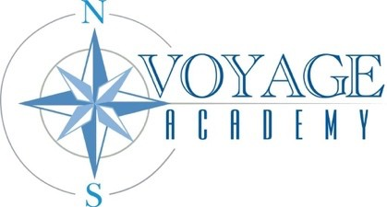
Voyage Academy
Board of Directors Meeting
Date: November 20, 2025
Location: 1891 North 1500 West Clinton, UT 84015
In Attendance: Courtnie Moore, Janae Howell, Valerie Hulsey, Dennis Henry, Blaire Barker
Others in Attendance: Kami Coleman, Anna Stanton, Heidi Bauerle
Excused: Danielle Pedersen
“The mission of Voyage Academy is that through Expeditionary Learning, children will explore Life Skills and gain personal responsibility. As they strive for excellence in the molding of their future, they will become honest, compassionate, and respectful seekers of learning.”

MINUTES
CALL TO ORDER Courtnie Moore called the meeting to order at 3:48 PM.

VOTING ITEMS AND DISCUSSION ITEMS
- Award Request for Proposals for E-Rate

Anna Stanton explained the bid process for the IT Services RFP. The bids were needed to secure services for the new building after expansion. Board members discussed the Evaluation Committee Statement. There were no questions or concerns from the board.

Janae Howell made a motion to award the RFP for E-Rate to ETS. Valerie Hulsey seconded. The motion passed unanimously. The votes were as follows: Courtnie Moore, Aye; Janae Howell, Aye; Dennis Henry, Aye; Blaire Barker, Aye; Valerie Hulsey, Aye.

CALENDARING

The next board meeting will take place January 15th, 2026.

ADJOURN

At 3:53 PM Janae Howell made a motion to adjourn the meeting. Dennis Henry seconded. The motion passed unanimously. The votes were as follows: Courtnie Moore, Aye; Janae Howell, Aye; Dennis Henry, Aye; Blaire Barker, Aye; Valerie Hulsey, Aye.

In compliance with the Americans with Disabilities Act, persons needing accommodations for this meeting should call 801-444-9378 to make appropriate arrangements. One or more board members may participate electronically or telephonically pursuant to UCA 52-4-207.
Page 1 of 1
Voyage Academy Board Meeting: 11.20.2025
Board Approved: 12.15.2025

