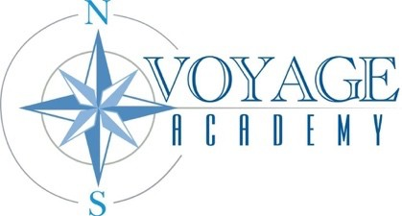
Voyage Academy
Board of Directors Meeting

Date: December 15, 2025
Location: Electronic Teams Meeting
Time: 5:00PM
Attendees: Courtnie Moore, Danielle Pedersen, Janae Howell, Valerie Hulsey, Dennis Henry, Blaire Barker, Kami Coleman, Nicole Jones
“The mission of Voyage Academy is that through Expeditionary Learning, children will explore Life Skills and gain personal responsibility. As they strive for excellence in the molding of their future, they will become honest, compassionate, and respectful seekers of learning.”

AGENDA

CALL TO ORDER
CLOSED SESSION- to discuss the character, professional competence, or physical or mental health of an individual pursuant to Utah Code 52-4-205(I)(a).

VOTING ITEMS AND DISCUSSION ITEMS

- Award Request for Proposals for Business Management Services and approval of contracted price up to 130,000.00
- Award Request for Proposals for Playground Equipment and Site Preparation Services and approval of contracted price up to 215,000.00
- Approve the purchase of ERATE Eligible Network & Infrastructure items up to $92,000.00

CONSENT ITEMS
- November 20, 2025, Board Meeting Minutes

CALENDARING
- Next Board Meeting January 15, 2026

ADJOURN

In compliance with the Americans with Disabilities Act, persons needing accommodations for this meeting should call 801-678-1761 to make appropriate arrangements. One or more board members may participate electronically or telephonically pursuant to UCA 52-4-207.
Page 1 of 1
Voyage Academy Board Meeting: 12.15.2025

