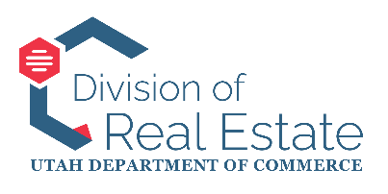
STATE OF UTAH
REAL ESTATE APPRAISER LICENSING AND CERTIFICATION BOARD
MEETING AGENDA
December 16, 2025 9:00 AM
Anchor Location:
Heber M. Wells Building – Second Floor, Herbert Conference Room
160 E 300 S, Salt Lake City, Utah
This agenda is subject to be changed up to 24 hours prior to the meeting. Timings and order listed are approximate and may be adjusted, accelerated, or delayed.

ELECTRONIC PARTICIPATION:
Google Meet joining info
Video call link: https://meet.google.com/rnq-bzio-zjg
Or dial: (US) +1 409-207-0104‬ PIN: 896 658 123‬#‬‬‬‬‬‬‬‬
More phone numbers: https://tel.meet/rnq-bzio-zjg?pin=6771374132484

MEETING AGENDA:
I. Commencement
A. Welcome and call to order
B. Consideration and approval of the meeting minutes from the November 18, 2025, meeting
C. Public comment
II. Division Section Reports
A. Director’s Report – Leigh Veillette, Division Director
B. Licensing and Education – Laurel North, Licensing and Education Manager
C. Board and Industry Issues – Justin Barney, Hearing Officer and Records Manager
D. Enforcement – Bryn Kaelin, Chief Investigator
a. Stipulations and Orders for the Board’s Consideration and Action:
1. In the Matter of John Michael Watts (Docket No. RE-2025-146)
III. Executive (Closed) Session
A. Executive (Closed) Session
B. Results of Executive (Closed) Session
IV. Informal Enforcement Hearing (Day 2) (In the Matter of David B. Richey, Docket No. RE-24-098)
V. (Optional) Executive Closed Session – Deliberations
A. Executive (Closed) Session
B. Results of Executive (Closed) Session
VIII. Adjournment

In compliance with the Americans with Disabilities Act, individuals needing special accommodations (including auxiliary communicative aids and services) during this meeting should notify Leigh Veillette, Division Director, Division of Real Estate, PO Box 146711, 160 E 300 S, Salt Lake City, Utah 84114-6711, Phone 801-530-6747, at least one working day prior to the meeting.

