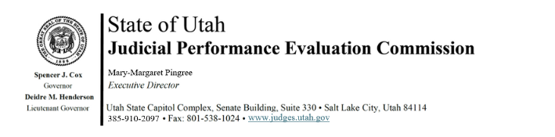
Tuesday, December 16, 2025
9:00 am-12:00
Hybrid Meeting *

Members: Lisa Watts Baskin, Mallory Bateman, Christine Durham, Christian Hansen, Blair Hodson, Curtis M. Jensen, Gil A. Miller, Mary Noonan, Bridget Romano, Tom Ross, Mike Smith, Becky Edwards, Terry Buckner

Staff: Madison Klein, Julie Spilker, Chris Russell, Mary-Margaret Pingree

9:00 a.m. Welcome Bridget Romano
Approval of Minutes – November 13

9:05 a.m. Announcements Mary-Margaret Pingree

9:15 a.m. NCSC Survey Mary-Margaret Pingree

9:25 a.m. Survey Analysis Mary-Margaret Pingree

9:35 a.m. Courtroom Observation Julie Spilker
Mary-Margaret Pingree

9:50 a.m. Performance Standards: Basic/Midlevel Judges Mary-Margaret Pingree
Madison Klein

10:05 a.m. Commissioner Community Access Madison Klein
Questions

10:15 a.m. Break

*****************************CLOSED SESSION**************************************

10:30 a.m. Final Disclosures, Recusals, Disqualifications Bridget Romano Closed Session

10:35 a.m. Part-time (Midlevel) Justice Court Evaluations Chris Russell
Closed Session

11:00 a.m. Basic Justice Court Evaluations Chris Russell
Closed Session

11:30 a.m. Adjourn

Next Meeting: Tuesday, January 6. 2026
8:30 am* – noon
CCJJ Conference Room, Suite 330
*Note earlier start time

Attachments:
Link to Salesforce community
Survey Analysis report
Commission instructions document

