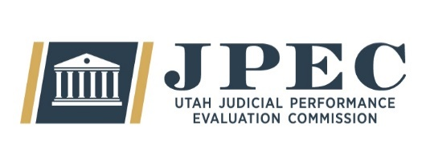
MEETING MINUTES

Committee | Judicial Performance Evaluation Commission (JPEC)
Date  Time  Location | Thursday, November 13th 2025  9:00 a.m. – 12:00 p.m.  Senate Building Suite #300
Members Present | Lisa Watts Baskin, Mallory Bateman, Christine Durham, Christian Hansen, Blair Hodson, Curtis M. Jensen, Gil A. Miller, Bridget Romano, Tom Ross, Becky Edwards, Terry Buckner, Mike Smith, Mary Noonan
Members Excused
Guests
Staff | Mary-Margaret Pingree, Chris Russell, Julie Spilker
Agenda Item: | Announcements / Approval of September 8th, 2025 Minutes Bridget Romana  Mary-Margaret Pingree
Notes: | Motion – Approval of minutes. Gil makes a motion to approve. Lisa seconds. The motion passes unanimously.  Announcements  Mary-Margaret welcomes JPEC’s new courtroom observer, Julie Spilker.  JPEC also welcomes two new commissioners, Becky Edwards, and Terry Buckner. With the changes to the JPEC rooster, Mary-Margaret requests updated contact information from all commissioners. Maddie also requests commissioners to send any updated pictures for the website “about Us” page.  The next commission meeting time has also been updated to December 16th, at 9am.
Agenda Item: | Survey Updates Mary-Margaret Pingree  Open Session
Notes: | - Court Staff Survey complete, with a 57% response rate  - The new Judge Survey is also complete, 90% of survey invitations have been opened.  - The Attorney Survey is live until Thanksgiving weekend.  - The Pilot SRL Survey is complete, We are waiting for bandwidth to process results  Some challenges have come with having a new survey provider. The first request had a significant number of emails sent to spam. JPEC staff have reached out individually to about 30 law firms, counties, and the AG offices to raise awareness about the survey. JPEC has also coordinated with the Bar for additional outreach efforts.
Agenda Item: | Deliberation Policies and Procedures Madison Klein  Open Session Bridget Romano  Paul Tonks
Notes: | Madison, Bridget and Paul review policies and training for the upcoming deliberation. They covered confidentiality, voting practices, countervailing evidence, performance metrics, and how to use the commissioner portal.

Agenda Item: | Disclosures & Recusals Paul Tonks  Open Session

Notes: | The commission discussed disclosures and recusals in preparation for deliberation. Terry will do his disclosures next meeting.
Agenda Item: | Statute Changes Mary-Margaret Pingree  Open Session
Notes: | Mary-Margaret presents the second draft of statutory changes.
Next Meeting | December 16th, 2025  9:00 a.m. – noon  CCJJ Conference Room  East Senate Building

