Present: Zachary Posner (Information Technology), Chris Harding (Auditor), Lannie Chapman-online (Clerk), Lisa Ashman-online (District Attorney), Hoa Nguyen-online (Council), Megan Hillyard (Administrative Services), Jami Johanson-online (Public Works), Will Kocher-online (Recorder), Sheila Srivastava-online (Treasurer), Heather Montgomery-online (Mayor Administration), Brad Park (Surveyor), Chris Stavros (Assessor), Robert Sampson-online (Community Services), Beth Graham-online (Human Services), Rosa Rivera-online (Sheriff)
Representation Absent: none
Staff Present: Tony Jolley-online, Corey Hess-online, Mark Miller, Mike Bailey-online, Kira Moody, Cherie Root, Valina Eckley-online, Wendy Ormsby
TOPIC | POINTS OF INTEREST
Welcome & Remote Meeting Instructions | Brad Park opened the meeting.  Cherie Root noted attendance online.  Tony Jolley shared the following slide:  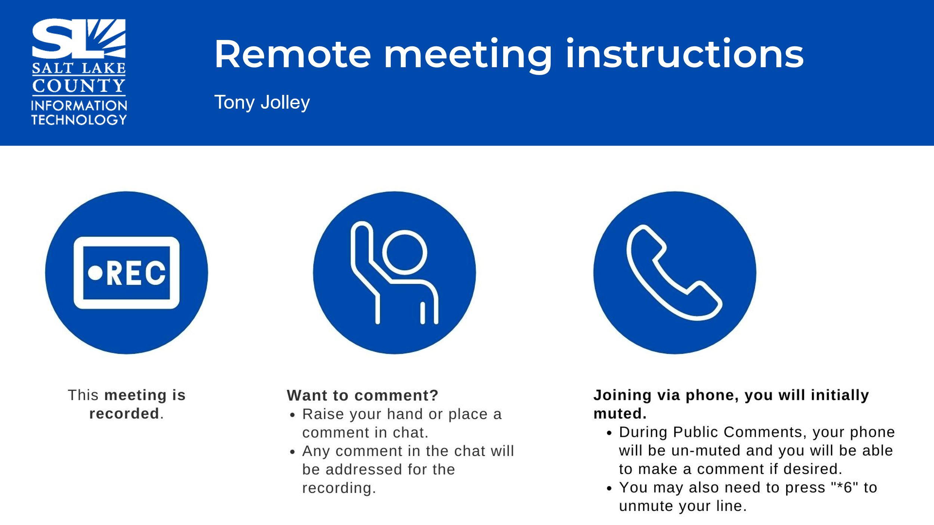
Public Comments  (Brad Park) | No comments.
Approval of minutes from August 14, 2025, meeting | Motion to approve the minutes by Chris Stavros. Lannie Chapman seconds the motion. No discussion.  Motion passed unanimously.
Follow-up Items  (Cherie Root)  Both the data privacy policy & AI presentation to council took place within the last month. We also want to give a heads up-we have found Adobe alternatives. Not necessarily recommended, but there may be some pockets where this makes sense. BRM’s will be talking with you. | 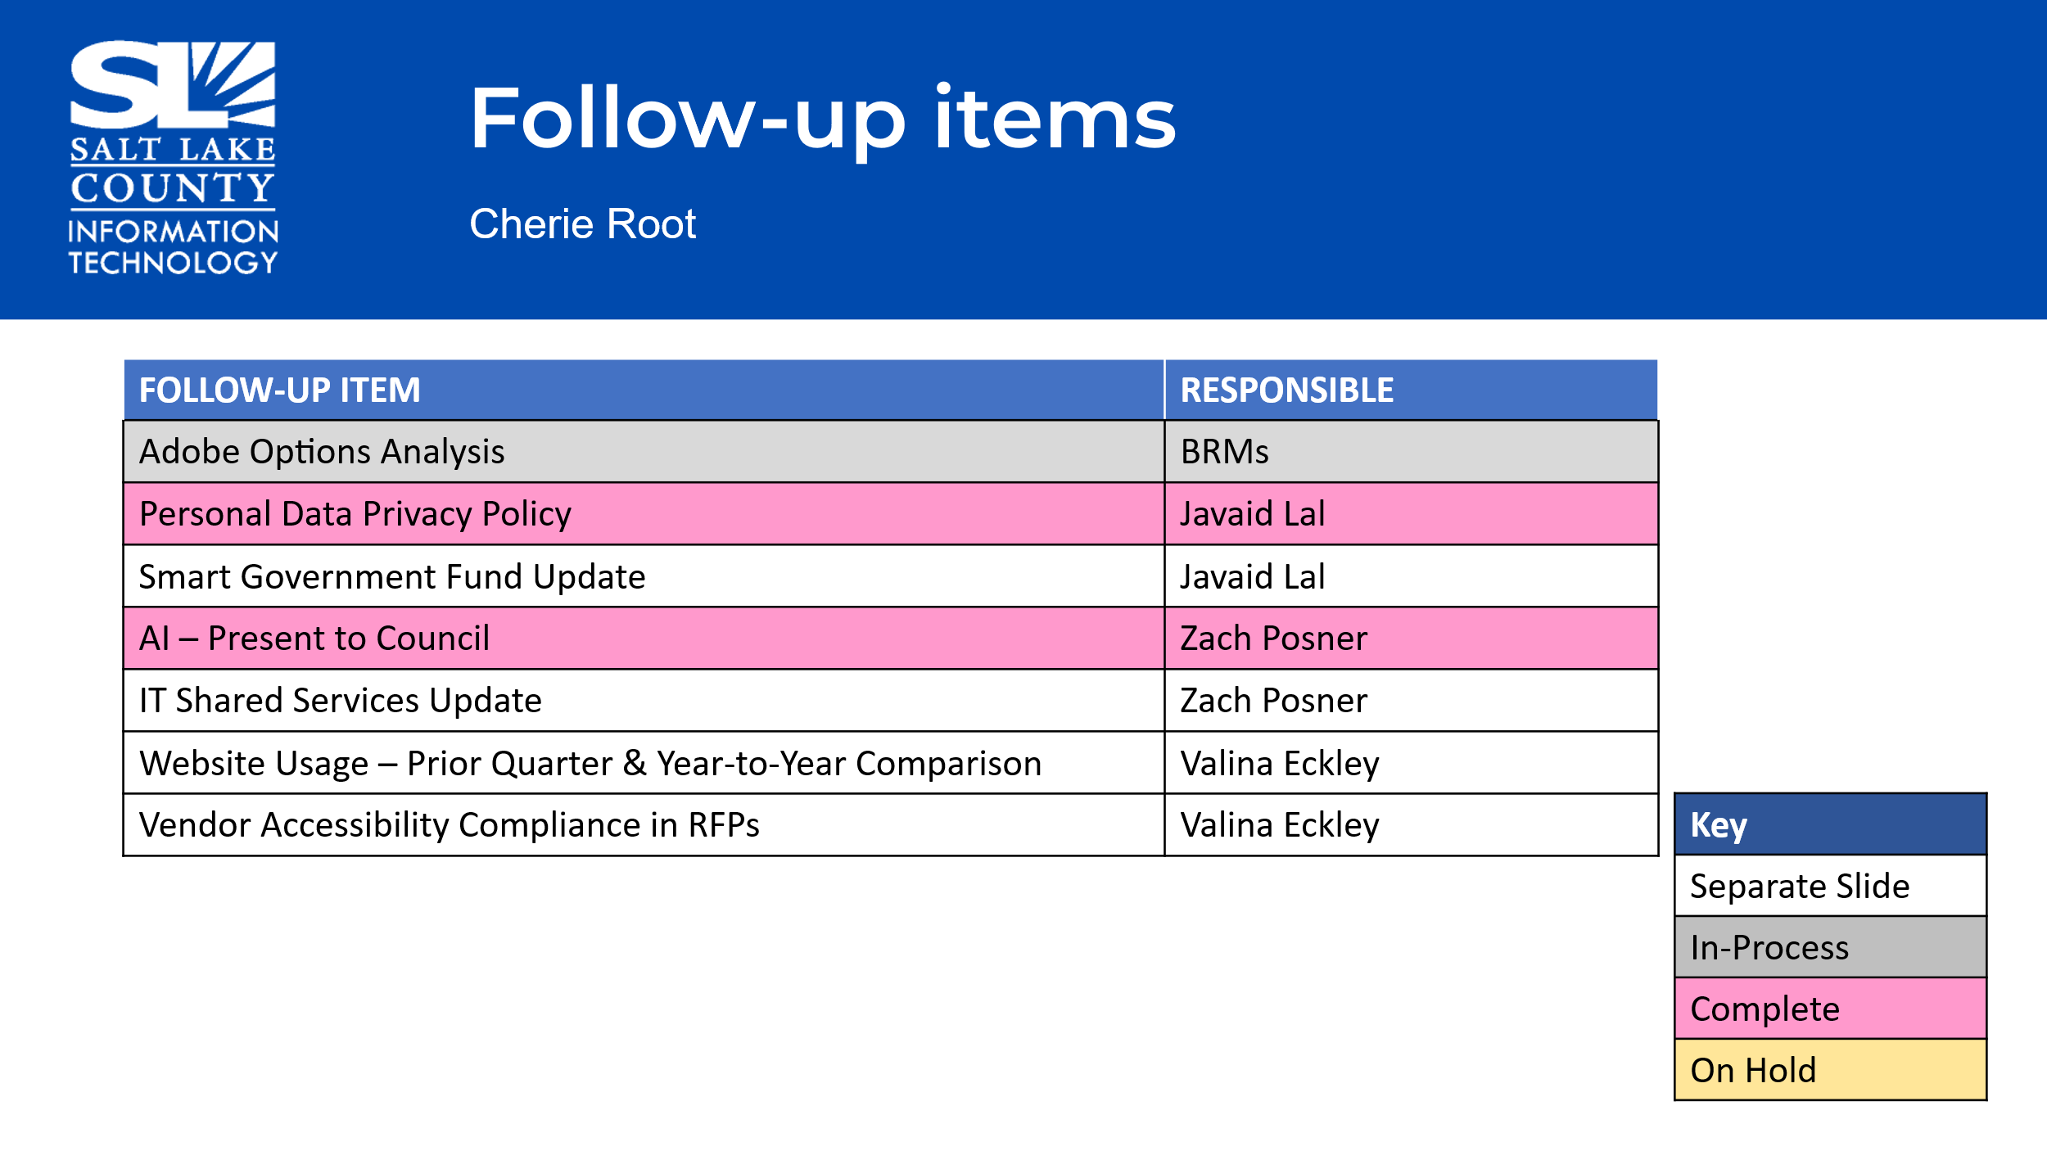
Shared Services  (Zach Posner & Kira Moody)  -Overall, well received framework  -Strong desire to collaborate  -Purposeful org charts and budgeting  -Critical solutions align with SLCO IT obj.  -Inconsistent implementation of cyber-security best practices. | 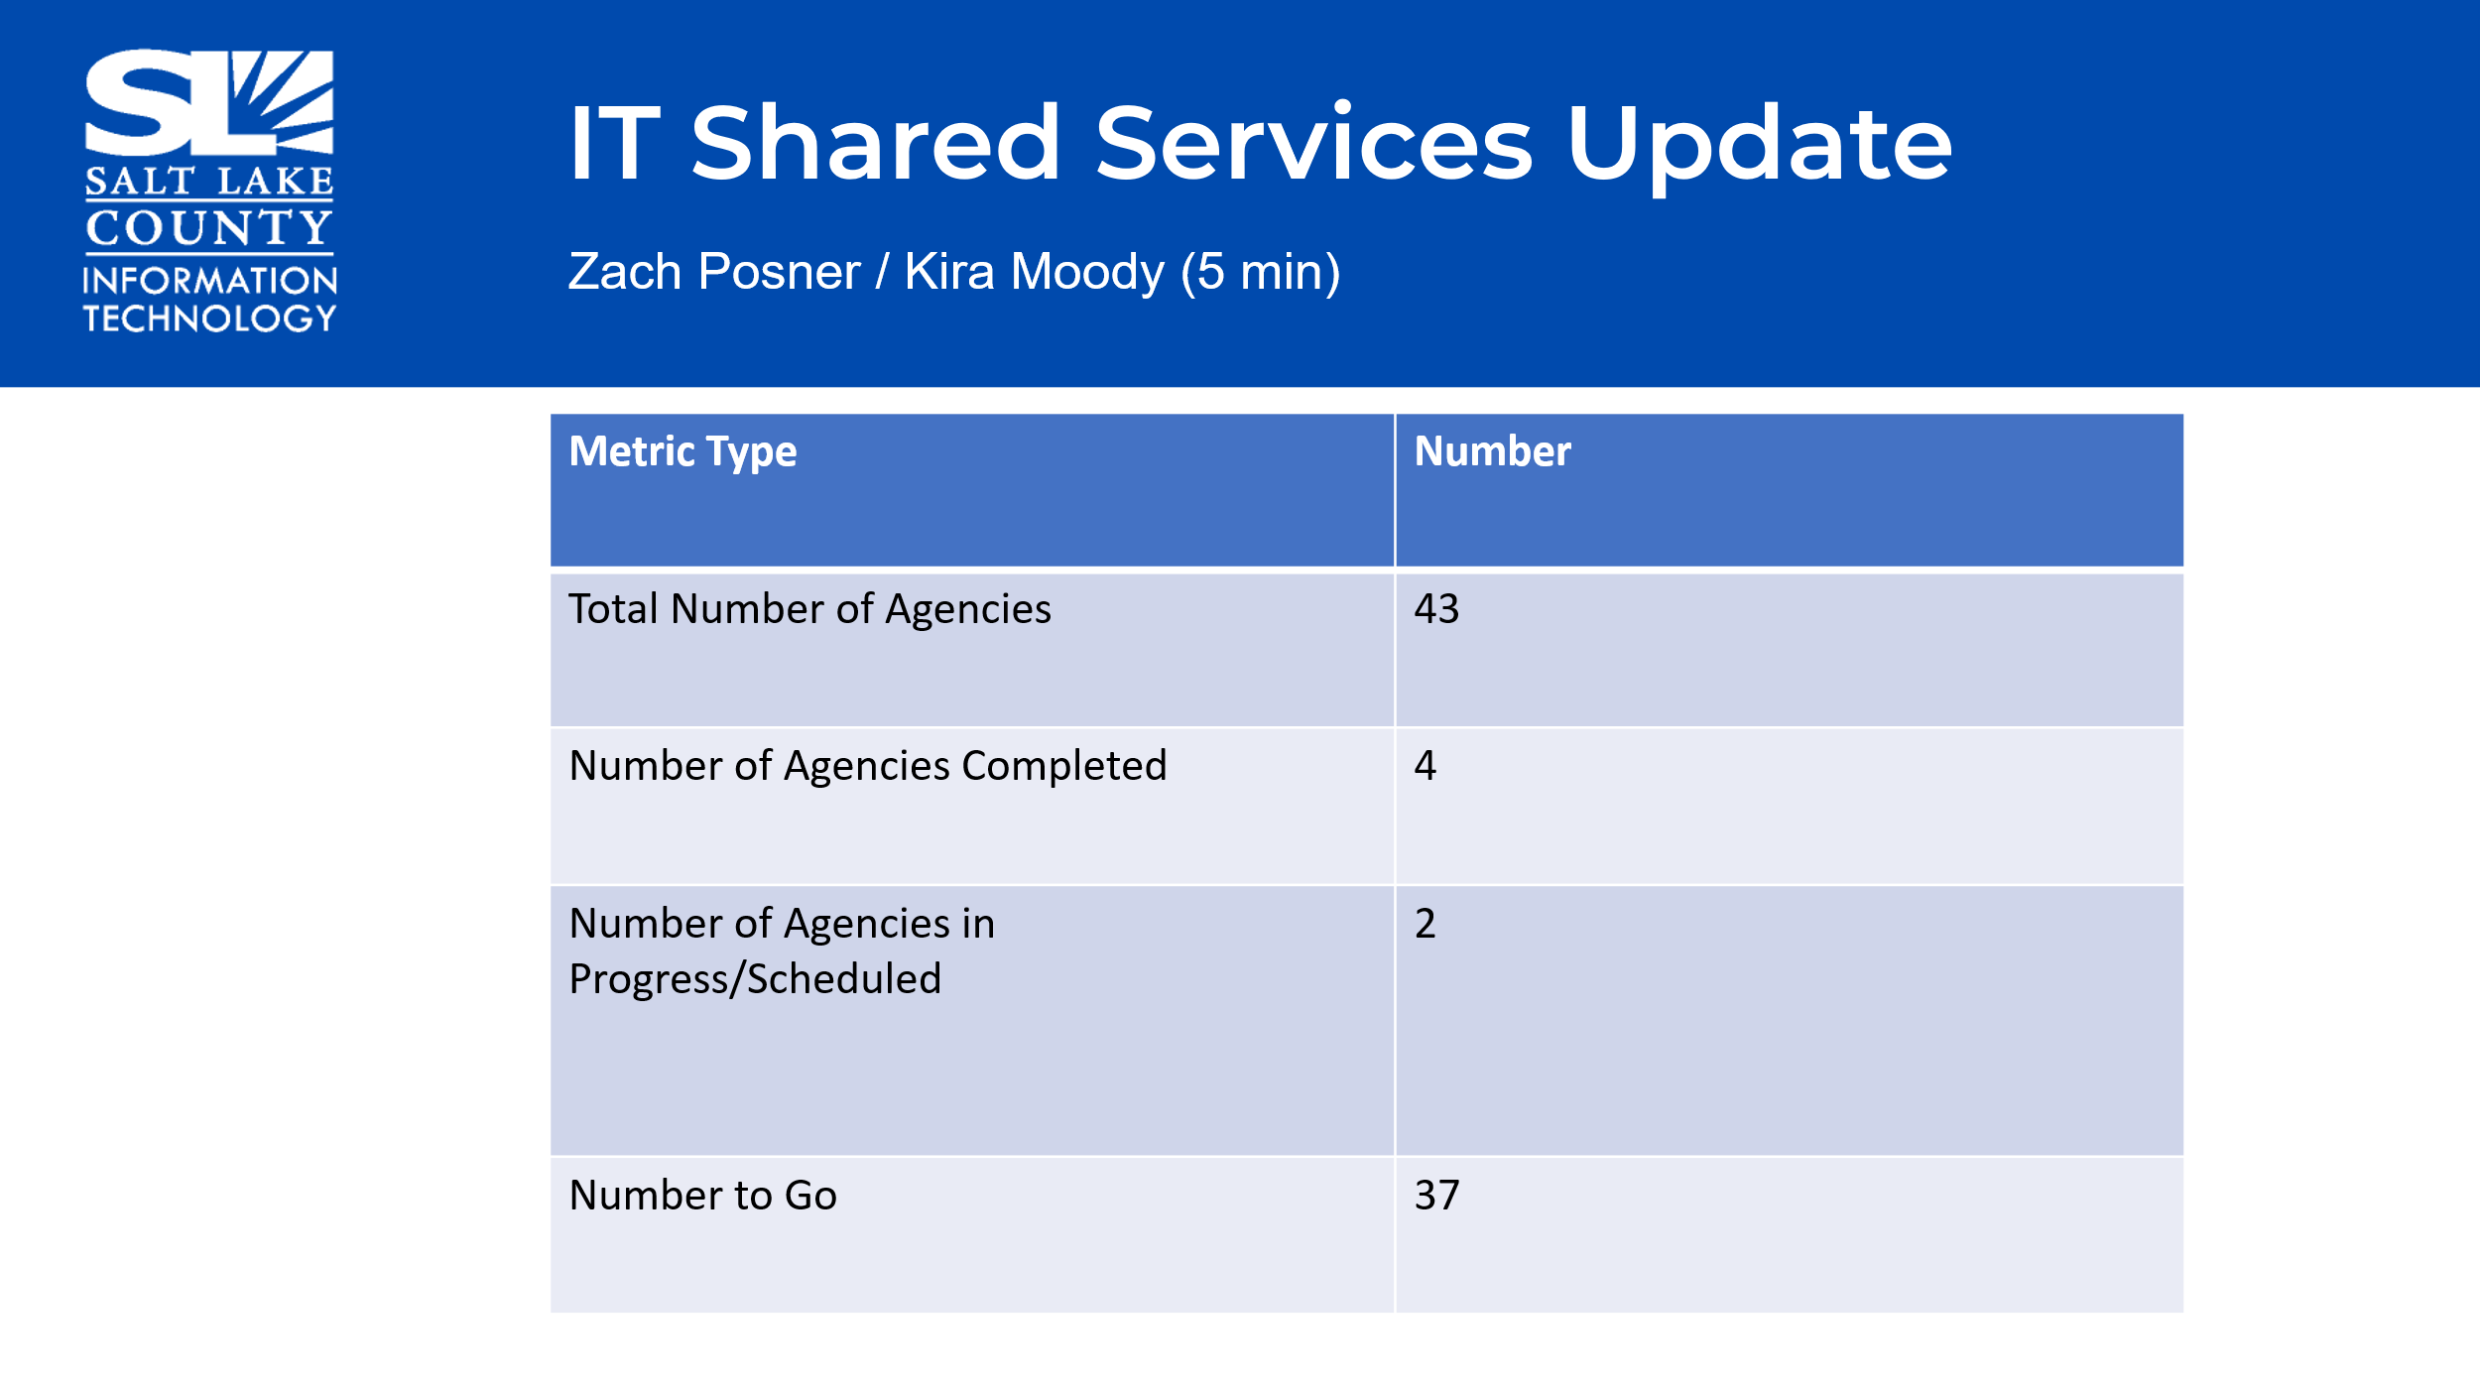
Technology Positions Update  (Nick Loomans) | 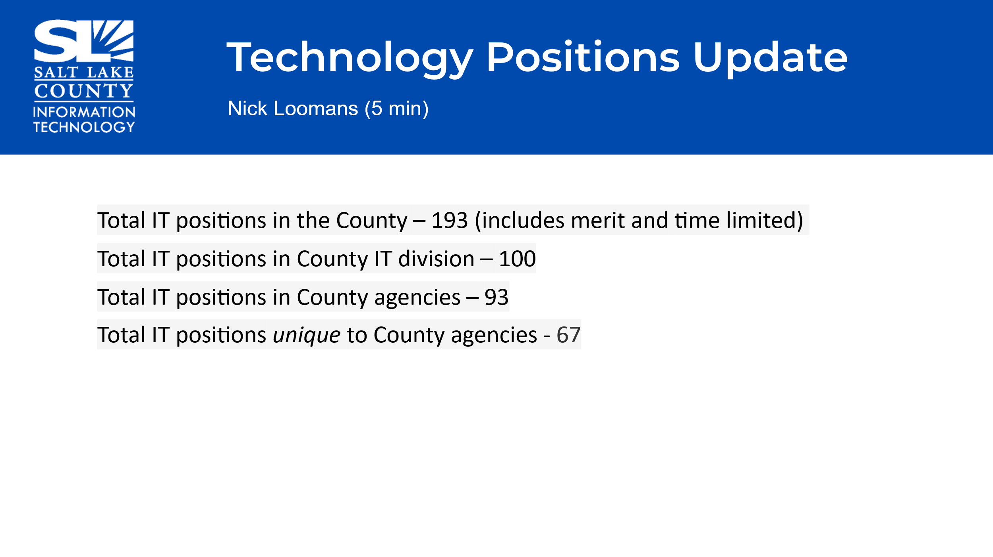
New Campus/Tech  (Mike Bailey)  Discussion: Tech for new building—existing function, needs, Mac vs PC. Webex vs other platforms. Conference rooms, workspaces, etc. Emphasizing the need to discuss in depth the tech needs for new campus. Everyone talk to your departments for ideas/considerations. | 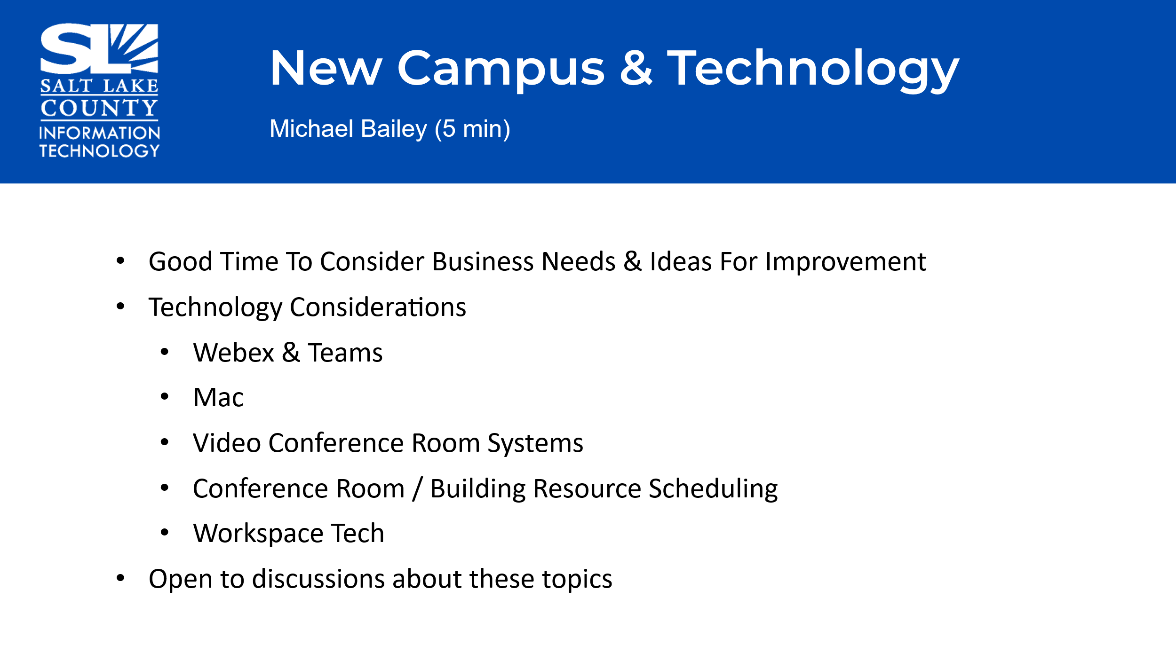
TAB Working Group Milestones  (Tony Jolley) | 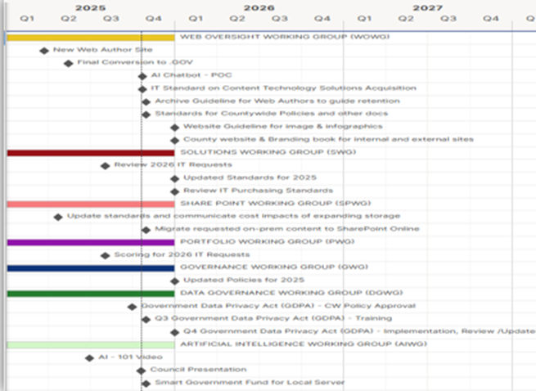
Web Oversight WG (Valina Eckley) | 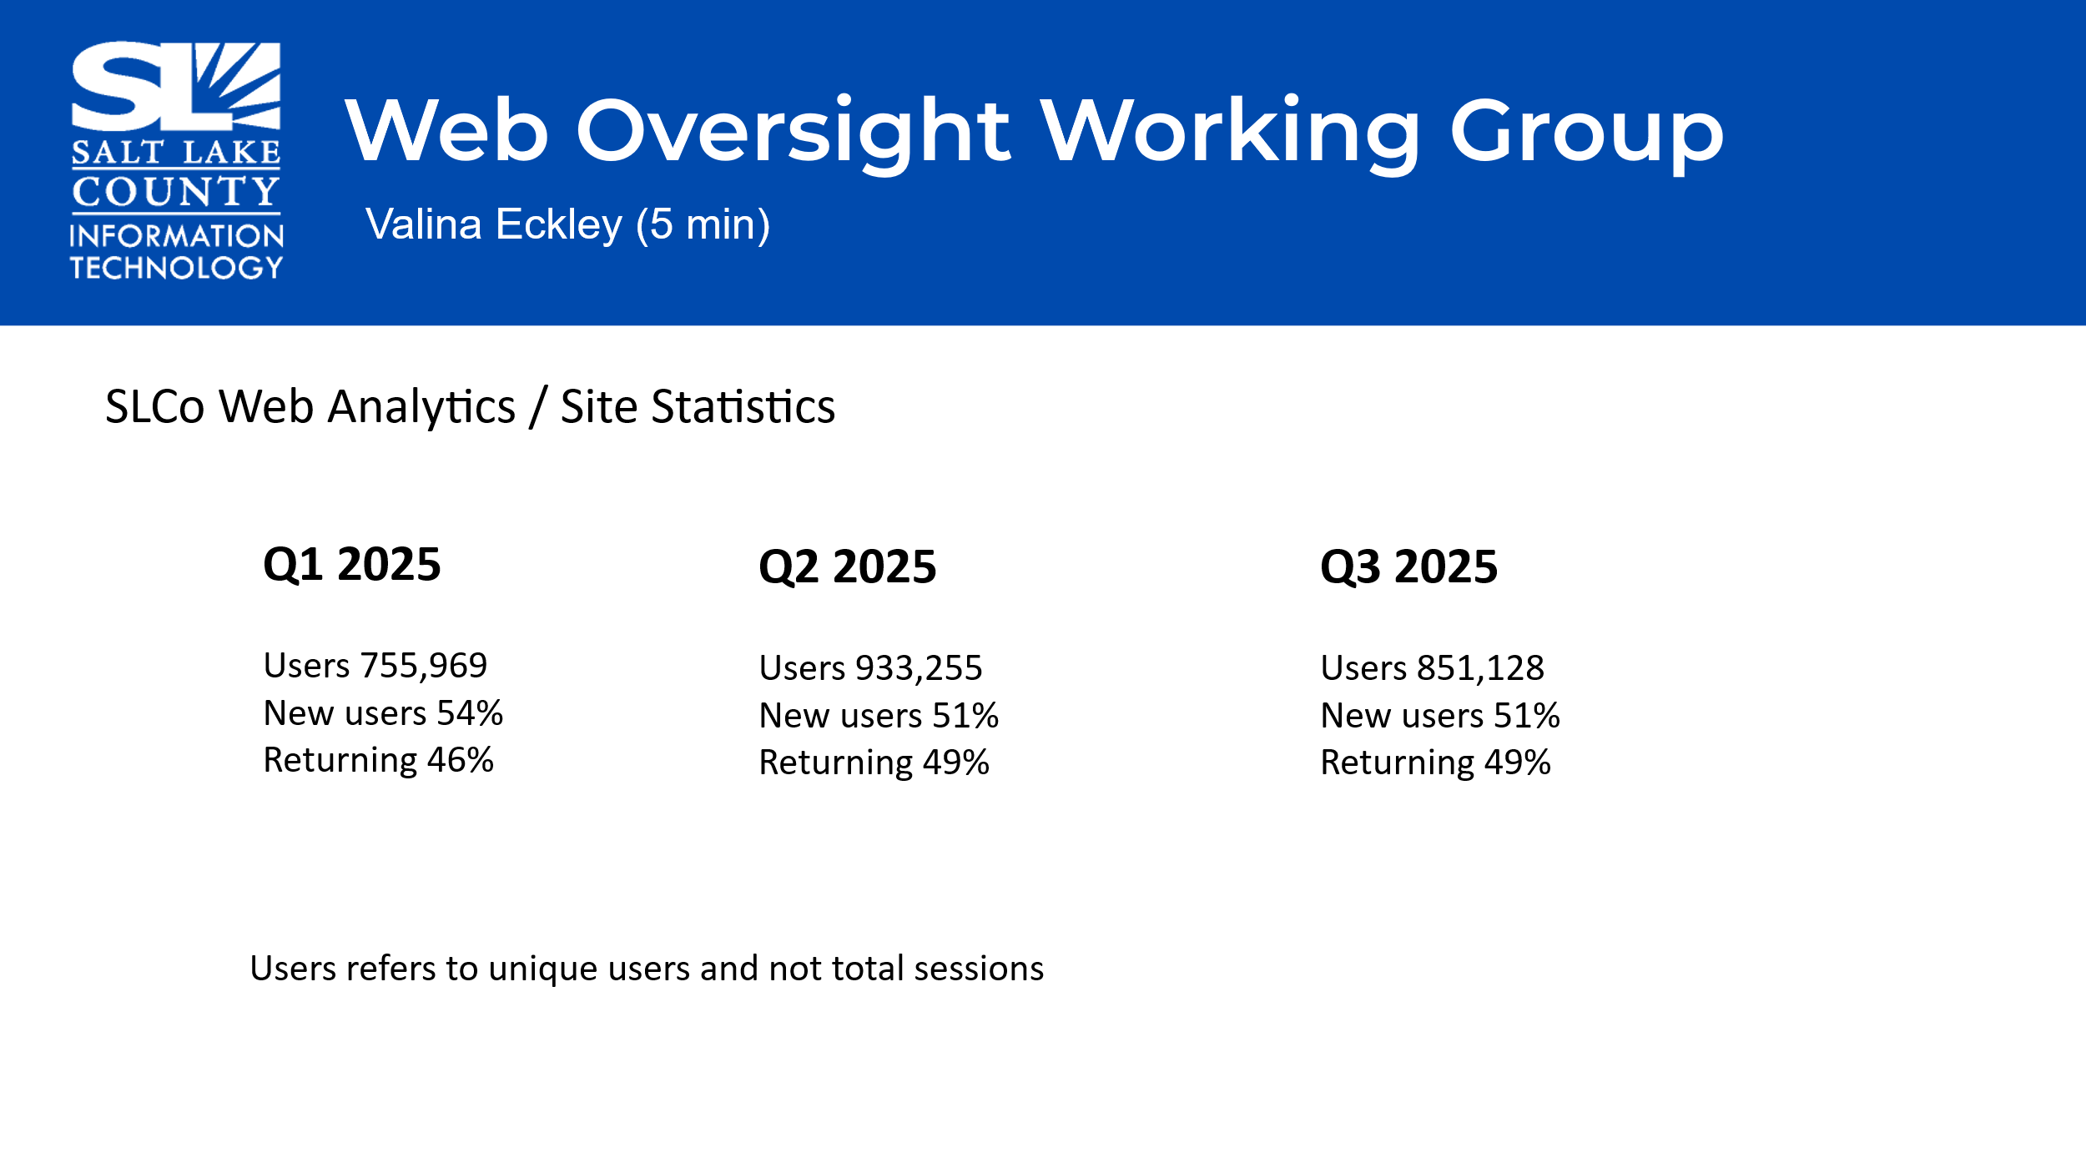  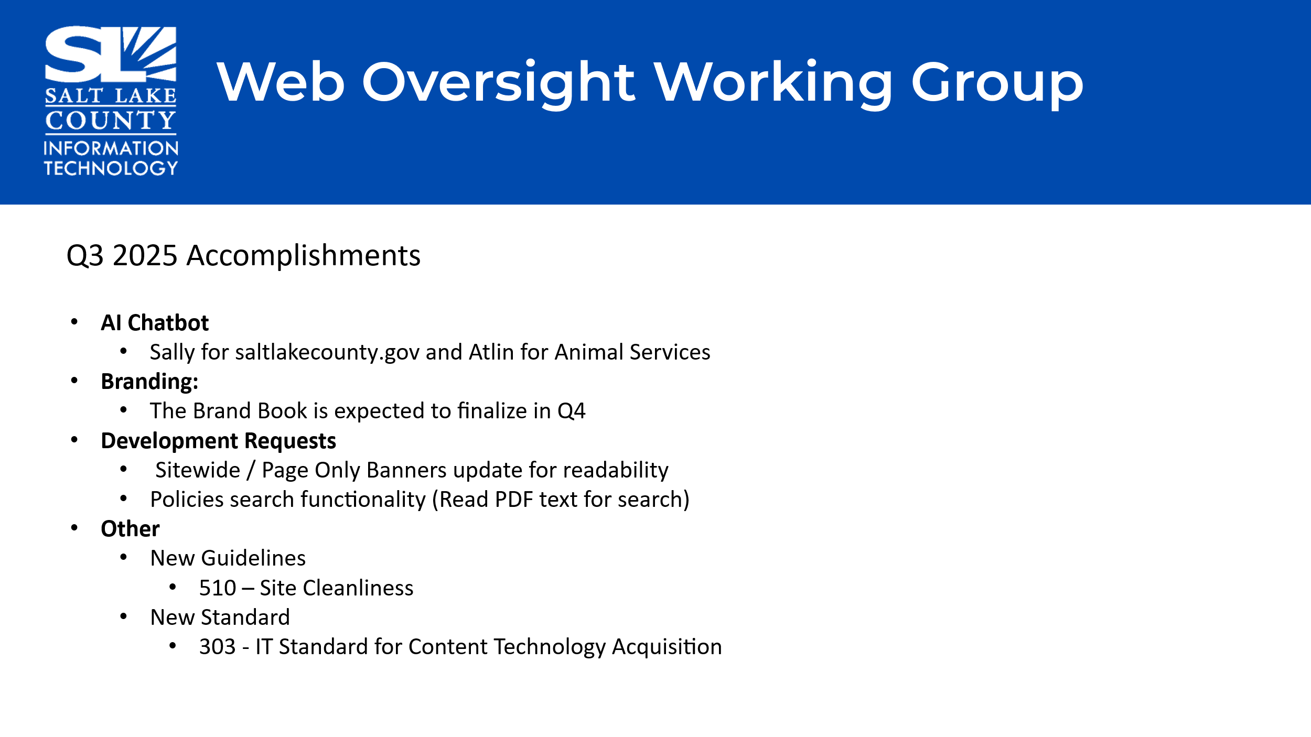    Motion to approve the Content Technology Solutions Acquisition Standard by Megan Hillyard, Chris Stavros seconds the motion. No further discussion.  Motion passed unanimously.
Solution Working Group  (Cherie Root)  Minor changes: explaining why virtual servers are preferred over physical servers. | 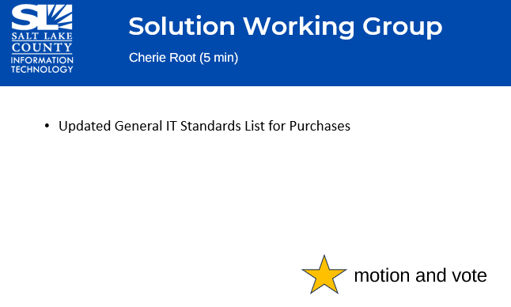  Motion to approve the Updated General IT Standards List for Purchases by Megan Hillyard, Chris Stavros seconds the motion. No further discussion.  Motion passed unanimously.
Portfolio Working Group  (Cherie Root &  Mark Miller)  The Mayor presented her budget this week to Council. Pleased to report, most TAB items were recommended. | 
AI Working Group  (Zach Posner)  When asked about using AI platforms, if there is no potential for the collection of private data or exposure of private data, then experiment, be cautious and have fun. Use of these tools helps learning and promotes efficiencies for the County. We have not approved a singular platform. We want to make sure there is a human in the loop, especially where elected officials are concerned. Machines shouldn’t make the final decisions, but AI can help inform more effective decision making. | 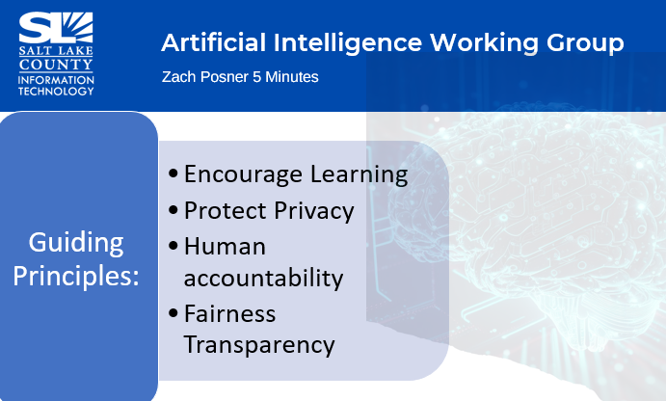  Enabling the use of AI  - Twelve AI platforms approved  - Tools generally approved in days  - No single enterprise platform  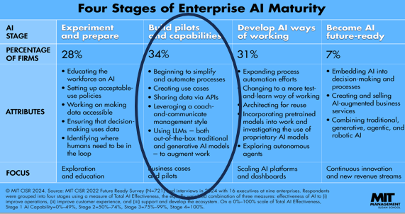
Data Governance Update  (Javaid Lal) |   Privacy Program Update  - 34 agencies have designated a Data Coordinator  - 40 attended the Introduction to Salt Lake County Privacy Program Training.  - Countywide Employee Privacy Training was launched on October 14, 2024.  - Next:  - Annual Privacy Report Survey  - Training / Workshops  - Survey launch October 31, 2025  - Due on December 05, 2025  We have officially launched our privacy program.  We’ve also launched our county wide privacy training program; it should be in your Saba profile. Required to be completed by year end.  Will be launching annual privacy policy survey on Oct 31 (due Dec 5). We are still testing and preparing 6 different training sessions for that survey completion. Once the survey is compiled, we are happy to share with TAB.  We’ve been working with Halo to create an internal chatbot to help those completing the survey.
Smart Government Fund Update  (Javaid Lal)  Highlights: No dumb ideas, we are looking for ways to innovate and better serve the people of SL County. | 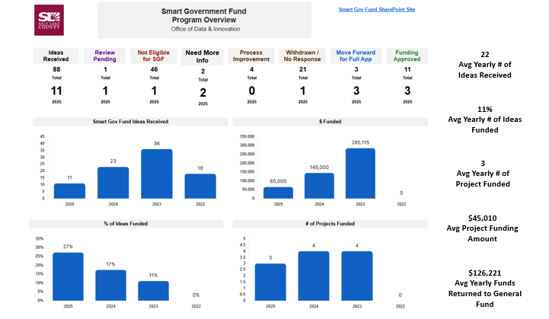  Ideas Advancing to Full Application:  - Invoice Data Extraction & Automation (IDEA) – Regional Development  - Unlocking the Past, Serving the Future: Historic Property Records Digitization,  Access, and Facility Consolidation Initiative – Recorder’s Office  - Solar-Powered Tree Care for Salt Lake County Parks – Parks & Recreation
Security Update  (Closed Session) | Motion to enter a closed session to discuss deployment of security personnel, devices, or systems by Chris Harding, Chris Stavros seconds the motion. No discussion.  Aye: Assessor, Auditor, Community Services, District Attorney, Human Services, Public Works, Recorder, Sheriff, Surveyor, Treasurer  Nay: None  Roll Call: (Absent: Clerk, Administrative Services, Mayor Administration)  Motion passed unanimously.  Motion to exit the closed session by Chris Harding and Chris Stavros, seconded.  Motion passed unanimously.
Upcoming Meeting Schedule for 2025  (Wendy Ormsby)  Webex Meeting Invites for TAB 2025 have been sent out. | 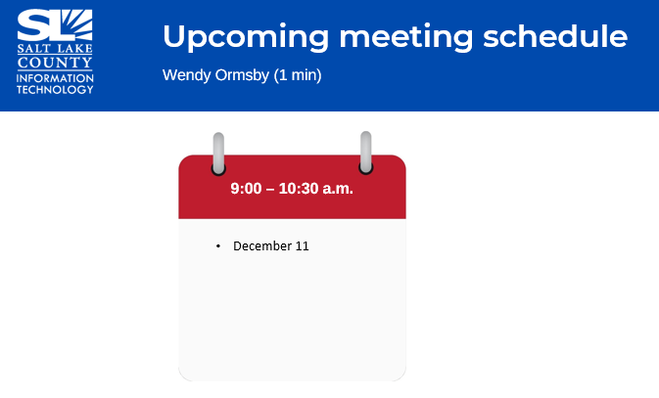
Review Action Items  (Wendy Ormsby)  There is one action item from this meeting  1) There will be a survey of Technology Options to be proposed at the next meeting. After that, the BRM’s will send it out. | 
Next TAB meeting:  December 11, 2025. | 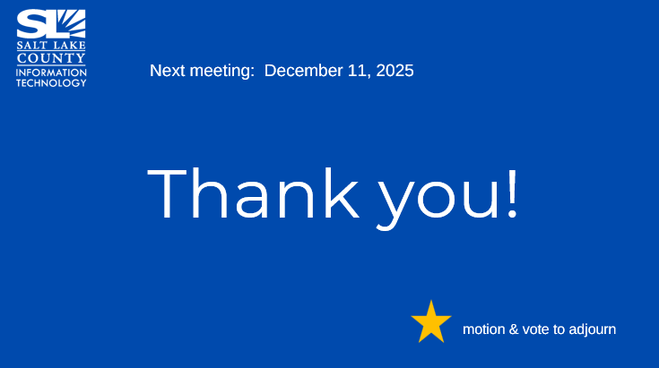
End of Session | Motion to adjourn the meeting by Brad Park. No objections. Meeting adjourned. So moved.
Submitted by Wendy Ormsby

