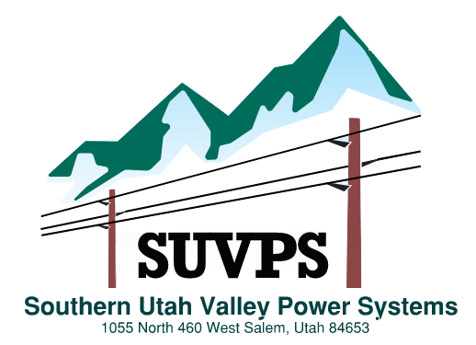
P.O. Box 11
Springville, Utah 84663
Kelly Peterson - Chairman Blake Anderson - Secretary

PUBLIC NOTICE
SOUTHERN UTAH VALLEY POWER SYSTEMS MEETINGS 2026
Southern Utah Valley Power Systems Board Meetings will be held on the last Thursday of each month. All Board Meetings will begin at 6:30 am. The public will be notified of any exceptions.

DATE__ ____ | LOCATION__________
January 29, 2026 | Salem City Power Building C
February 26, 2026 | Salem City Power Building C
March 26, 2026 | Salem City Power Building C
April 30, 2026 | Salem City Power Building C
May 28, 2026 | Salem City Power Building C
June 25, 2026 | Salem City Power Building C
July 30, 2026 | Salem City Power Building C
August 27, 2026 | Salem City Power Building C
September 24, 2026 | Salem City Power Building C
October 29, 2026 | Salem City Power Building C
November 19, 2026** | Salem City Power Building C
December 17, 2026** | Salem City Power Building C

Location: Salem City Power – Building C = located at 1055 N 460 W in Salem, Utah 84660

** Not the last Thursday

