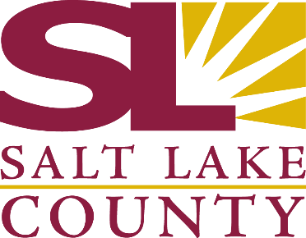
SALT LAKE COUNTY
2001 So. State Street
Salt Lake City, UT 84114
Meeting Minutes
Tuesday, November 18, 2025
10:00 AM
Council Chambers, Room N1-110
Board of Equalization

Board of Equalization
Meeting Minutes
November 18, 2025
1.
CALL TO ORDER
Present:
Chair Dea Theodore, Board Member Suzanne Harrison, Board Member Ross Romero, Board Member Natalie Pinkney, Board Member Aimee Winder Newton, Board Member Carlos Moreno, Board Member Jiro Johnson Vice Chair Laurie Stringham
Board Member Sheldon Stewart
Absent: Call In:
2.
PUBLIC COMMENT
There was no public comment.
3.
APPROVAL OF MINUTES
3.1 Acceptance of BoE minutes for November 4, 2025
Presenter: Chris Harding, Auditor Discussion - Vote Needed Attachments:
25-824
1.
110425 BoE Minutes
Board Member Moreno was absent for the vote.
A motion was made by Board Member Johnson, seconded by Board Member Harrison, that this agenda item be approved. The motion carried by a unanimous vote.
APPROVAL OF ASSESSOR AND HEARING OFFICER RECOMMENDATIONS
4.
4.1
Approval of Assessor and Hearing Officer Recommendations
Presenter: Brad Neff, Tax Administrator Discussion - Vote Needed
Attachments:
25-829
1.
2.
3.
4.
111825 Weekly Counts 111825 BoE Weekly Report
111825 BoE Value Adjustments
111825 Tax Relief Adjustments - Redacted
Board Member Moreno was absent for the vote.
Page 2 of 3

