Monthly Fire District Report EMS

Transports for the Year

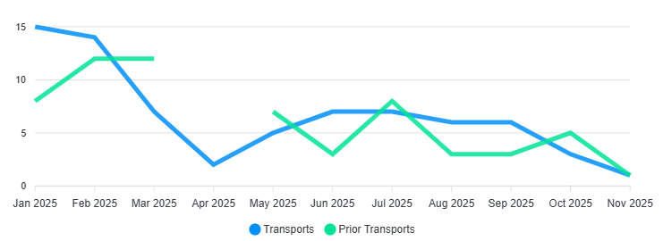

Billing

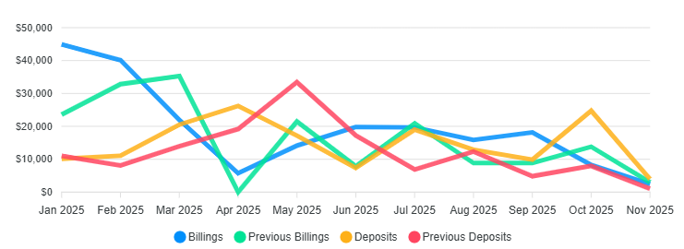

2025
Transports 74 / Billed $211,092.41 / Collected $162,835.96 / YTD

2024 Totals
Transports 74 / Billed $212,292.64 / Collected $150,340.23 /2024
Monthly Calls for Service
Red is a Monthly or Yearly Record
NFFD Trends

3 Year Monthly Call Average /13 21 Calls , Calls year to date 309

Notes of Interest

EMT Class January 2026
Hiring for the 2026 Fire Season has Started
Wildland Gross Revinue 1.68 Million
Utah House Bill-48
Sick Leave Totals and Accuals

