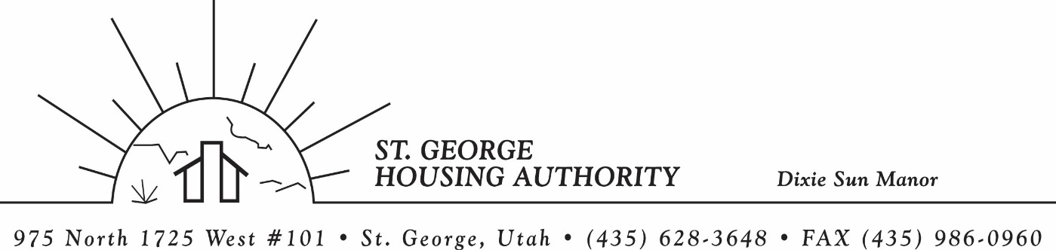
BOARD MEETING
DIXIE SUN MANOR 975 N. 1725 W. # 101
Wednesday November 12, 2025

PRESENT: Mike Barben, Kenny Miller, Jimmie Hughes, Jane Fehrenbacher, Tom Cover, Ryan Dooley, Daniel Baldwin

EXCUSED: Gloria Shakespeare, Greg Whitehead

MINUTES: Minutes of Board Meeting held October 14, 2025 were reviewed. Motion made by Tom Cover to approve minutes as reviewed, motion seconded by Kenny Miller. Motion carried.

Review Housing Assistance Report for November 2025: Mike Barben handed out the HAP reports for November 2025. Board members were able to see the money spent for the months on rental assistance, see the average unit cost, and verify the units leased for the month. The board was also able to ask questions and have a discussion about portability, C of C, VASH, EHV, & Mainstream Vouchers. Each board member present signed off on the HAP payments and month end totals.

Review current 2025-2026 budget: Mike Barben handed the board a copy of the fiscal year 2025-2026 SGHA budget. The board was able to see how the SGHA is doing in the current fiscal year budget. Mike reported that for the most part, SGHA was right on budget, and let the board ask questions on any of the items on the report. The board has asked Mike to provide and present the most recent budget accounts at each board meeting. By providing the current budget monthly, the board can see how the SGHA is keeping up with the current budget throughout the whole year. The board thought it would be great to ask questions and be on top of what the SGHA is doing financially. Greg Whitehead asked Mike if he could break the budget down into separate programs to verify which programs are doing well and which ones are needing help. Mike has now separated the budget into 3 programs so the board can better understand the flow of money in each program.

Update of admin updates from NanMcKay (Consulting Firm) for HOTMA & INSPIRE: Mike Barben reported that the admin update through Nan McKay was a success. Mike reported that he and his staff spent 6 days going through both the Section 8 Admin plan and also the Dixie Sun Manor Admin plan. Mike mentioned that the updates were very much needed and said that this update was really good for compliance. Mike said once the plan is finalized, he would give the board a copy of the plans for their review and approval. Mike said once the admin plan is approved by the board, then Mike would submit the plans to HUD for approval. The board seemed pleased with the report.

Update on training for SGHA staff and Board in Tennessee: Kenny Miller reported that the MRI Conference training on October 20-23 was a success. Kenny Miller and Gloria Shakespeare from the board attended the conference/training. Kenny mentioned that the conference was beneficial and recommended that board members go next year. Mike Barben reported that one item he would like to implement is opening the waiting list to on line applications for future waiting list openings.

Jane Fehrenbacker report on DSM: Jane reported that the community garden was thriving and doing well. Jane reported that 4 units have been filled. Jane reported that all DSM units have been re-piped and finished. Jane reported that DSM is a great place to live.

Report from Jimmie Hughes on City of St. George: Jimmie Hughes was voted in as Mayor of St. George. Jimmie reported that on January 5, 2025 he will be sworn in as Mayor once all the voting is counted and submitted. Jimmie also reported that on January 17, 2025 City Hall in St. George is opening to the public and all city employees will be moving that new building. Jimmie also reported of many new businesses and buildings being built in St. George. Also new addition to the St. George Airport. Good things happening in St. George Utah.

Ryan Dooley Training: Ryan Dooley (St. George City Attorney) was present at the board meeting along with Daniel Baldwin (Assistant city attorney) to do a training on the “Open and Public Meetings Act in Utah.” The training was very informational and each board member was certified of this training. Ryan said that this certification should be done annually for each board member. Ryan said you can also do the training on line. Each board member was given a power point of the presentation/training.

Reports from Board Member & Housing Director: None

Request of a closed meeting to discuss litigation, security, property acquisition or sale, or the character and professional competence or physical or mental health of an individual: None

Motion made by Tom Cover to close the meeting. Kenny Miller seconded the motion. Motion carried. Meeting adjourned at 9:30 a.m. Next board meeting will be Wednesday December 9, 2025 at 8:30 am.

