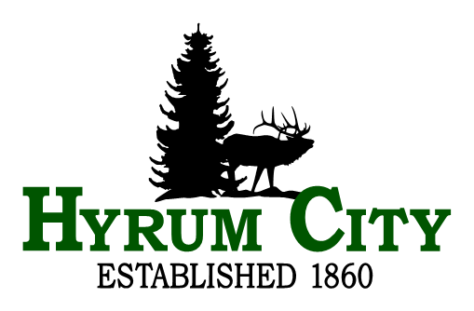
City Council Meeting
Thursday, December 18, 2025 at 6:30 PM
Public Notice of Meeting Cancellation
Agenda
NOTICE IS HEREBY GIVEN TO THE CITIZENS OF HYRUM CITY AND THE GOVERNING BODY THEREOF THAT THE HYRUM CITY COUNCIL MEETING SCHEDULED FOR THURSDAY, DECEMBER 18, 2025, HAS BEEN CANCELLED. THE NEXT REGULAR HYRUM CITY COUNCIL MEETING WILL BE HELD THURSDAY, JANUARY 15, 2026, AT 6:30 P.M. IN THE HYRUM CITY COUNCIL CHAMBERS 60 WEST MAIN, HYRUM, UTAH.

__________________________________
Stephanie Fricke
City Recorder

In compliance with the Americans with Disabilities Act, individuals needing special accommodations (including auxiliary communicative aids and services) during this meeting should notify Hyrum City at 435-245-6033 at least three working days before the meeting.

CERTIFICATE OF POSTING - The undersigned, duly appointed and acting City Recorder of Hyrum City, Utah, does hereby certify that a copy of the foregoing Notice was emailed to The Herald Journal, Logan, Utah, posted on the Utah Public Notice Website and Hyrum City’s Website, provided to each member of the governing body, and posted at the City Offices, 60 West Main, Hyrum, Utah, this 8th day of December, 2025. Stephanie Fricke, MMC, City Recorder.

