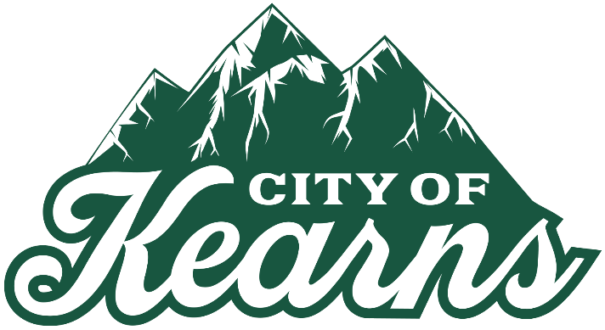
NOTICE OF MEETING CANCELLATION
The regularly scheduled Kearns Community Reinvestment Agency (CRA) meeting for December 8, 2025 has been canceled.

The next regularly scheduled CRA meeting will be
Monday, January 12, 2026.

A copy of this notice may be viewed or obtained from the following:
- Utah Public Notice Website: https://www.utah/gov/pmn
- Kearns City Website: https://www.kearns.utah.gov

