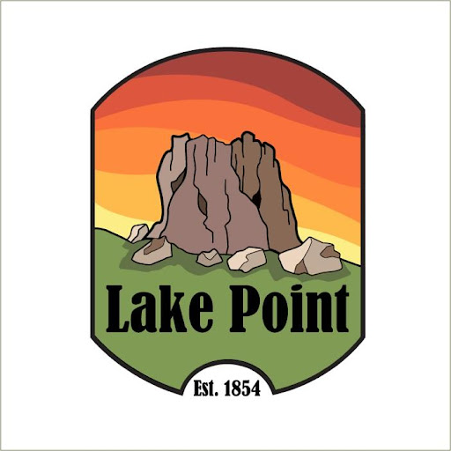

COMMUNITY DEVELOPMENT BLOCK GRANT (CDBG)
FIRST PUBLIC HEARING NOTICE

Notice is hereby given that Lake Point will hold a public hearing on December 10, 2025 at 1528 Sunset Road, Lake Point, Utah, 84074 at 6:00 pm. Lake Point is eligible to apply to the Utah Department of Workforce Services for funding under the Community Development Block Grant (CDBG) Small Cities Program, a federally funded program administered by the State of Utah, Housing and Community Development Division (HCD). Lake Point is eligible to apply for CDBG funding provided Lake Point meets the applicable program requirements.
The purpose of the public hearing is to provide citizens with pertinent information about the
Community Development Block Grant program and to allow for discussion of possible applications. This public hearing will cover eligible activities, program requirements, and expected funding allocations in the region. The CDBG Program can fund a broad range of activities, including, but not limited to: construction of public works and facilities, e.g., water and sewer lines, fire stations, acquisition of real property, and provision of public services such as food banks or homeless shelters. In the event that Lake Point chooses to apply for CDBG funding, a second public hearing will be held at a later time to discuss the project. Further information can be obtained by contacting City Council Member Kathleen VonHatten at 801-725-0590.

In compliance with the Americans with Disabilities Act, individuals needing special accommodations (including auxiliary communicative aids and services) during this hearing should notify Jamie Olson at 801-725-5095 1528 Sunset Road, Lake Point, Utah 84074 at least three days prior to the hearing. Individuals with speech and/or hearing impairments may call the Relay Utah by dialing 711. Spanish Relay Utah: 1.888.346.3162.

Published on State of Utah’s Public Meeting Notice Website – www.utah.gov/pmn on Nov. 11, 2025.

