



Site Plan Review
1605 Saddleback Blvd.

Meeting Date 2025 12.10 2025, 6:00 pm 1528 Sunset Road, Lake Point, UT 84074
Applicant Phil Johnson
Request Commercial Site Plan Review for a 4-stall Electric Vehicle Charging Station
Property Address 1605 Saddleback Blvd., Lake Point, Utah 84074
Parcel 13-032-0-0005
Acreage 13.21 Acres
Zone Commercial Highway
Prepared by Jamie Olson
Presented by Jamie Olson

Scope of Decision- This is a legislative matter to be decided by the land use authority, Lake Point City Council, upon receiving a recommendation from the Planning and Zoning Commission and a review from the DRT Committee.
Planning and Zoning recommended the approval of this Site Plan application on December 1, 2025.
Request Summary
- The applicant requests a Site Plan Review for a commercial build, adding a 4-stall Electric Vehicle Charging Station to the already existing parcel where Flying J is located.
- The Zoning is CH- Commercial Highway and is an allowed use under Chapter 13.5.2. through 13.5.3.
- Canopy Size is 56’ x 32’ covering the 4 charging station stalls
- Canopy Height is 19’

General Plan Considerations
After review, staff finds that this application does not conflict with the goals, policies, or land-use directives contained in the Lake Point General Plan adopted on April 10, 2024.

DRT Committee Review and Findings
- Building Official approved, and had no comments or corrections
- Engineering approved and had no corrections.
  - There were items waived as they were not applicable to the project. (See checklist for details)
- Fire Marshal approved and had no comments or corrections made
- Zoning Official approved and had comments or corrections
  - Mostly requesting missing application items and reviewing requested waivers and items waived. (See checklist for details)
- Any public feedback
  - No public feedback to report
- Complies with proposed use under current zoning -state ordinance and use

Development Review Team (DRT) Approvals

The following departments have reviewed the site plan application, which provides the subject for this staff report, and it has been found to be appropriate for review by the Lake Point City Planning Commission.

Fire Marshal (Buck Peck)
Recorder (Jamie Olson)
Engineering (Dan Fechner)
Building Official (Kelly Brown)
Rocky Mountain Power (Foster Greenwood)

Recommendation

In consideration of the findings and conclusions detailed in this report, staff recommends that the Council grant approval for the Site Plan Review Application submitted by Phil Johnson.

Supporting Document

Site Plan of Building
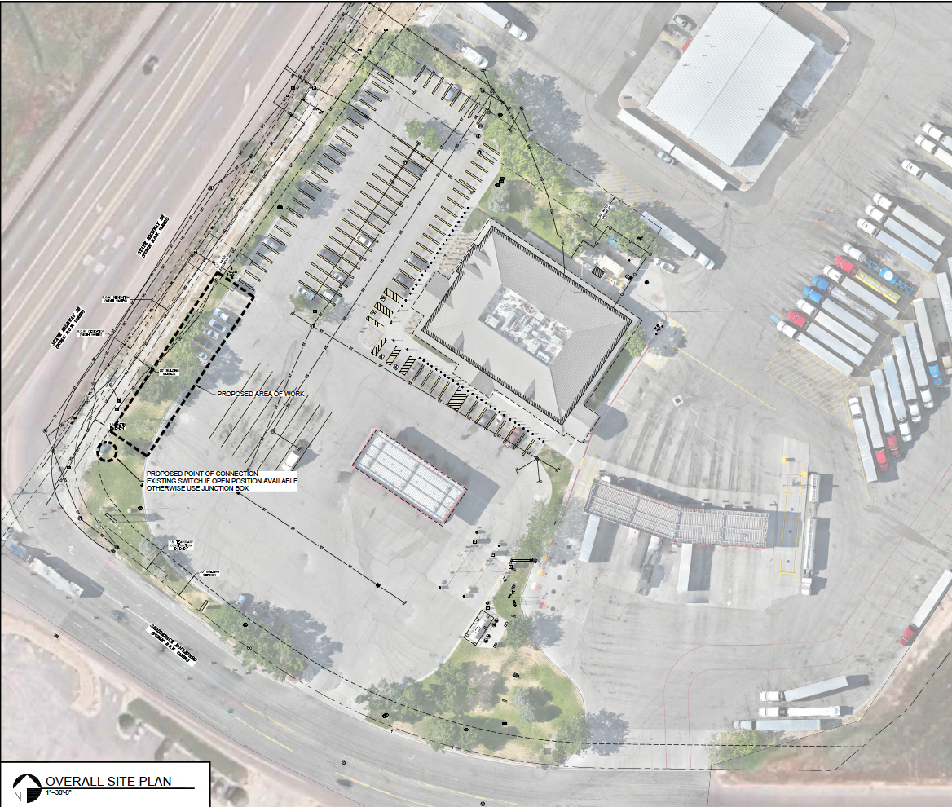

Utility Plan and Overview layout of the lot
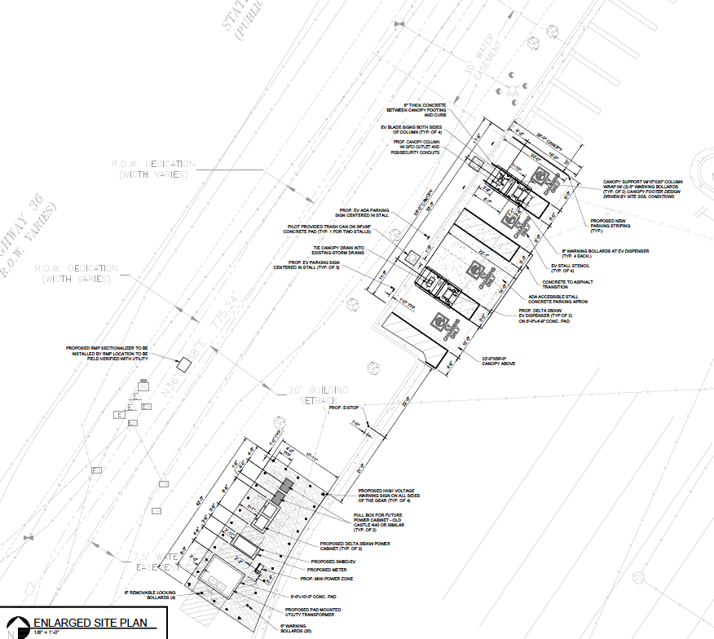

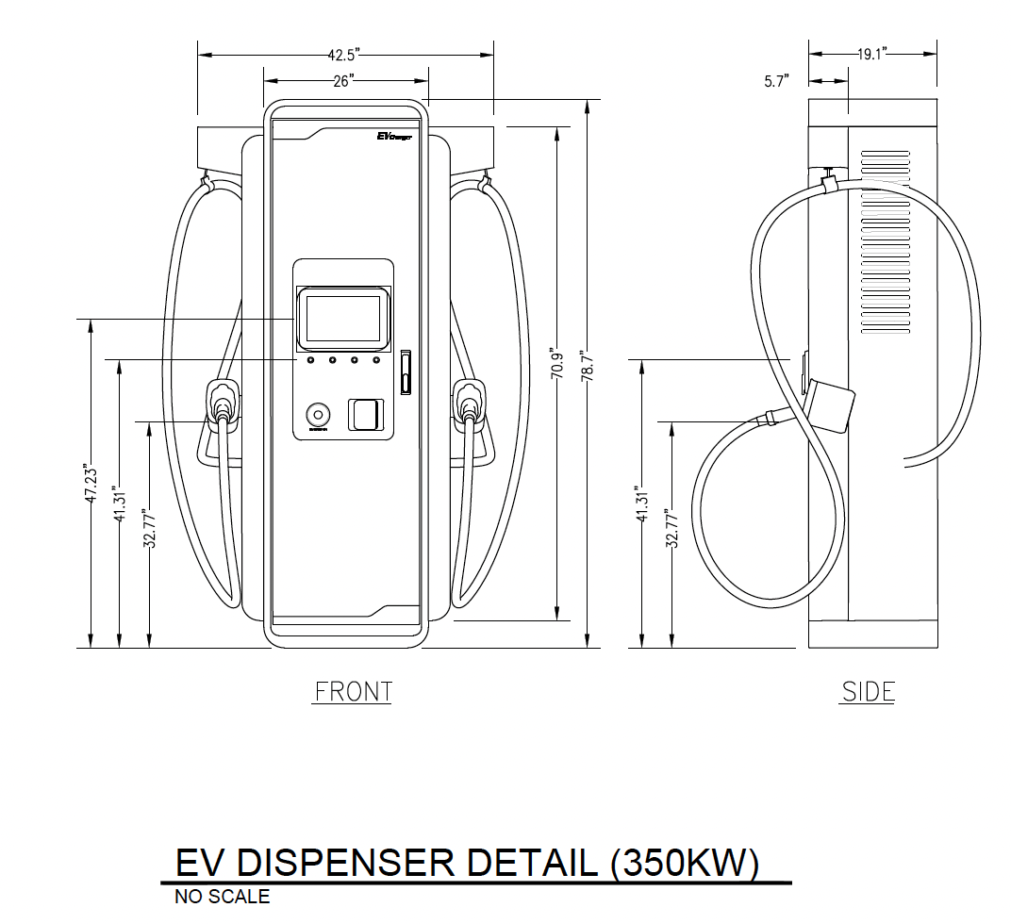

Canopy Overview
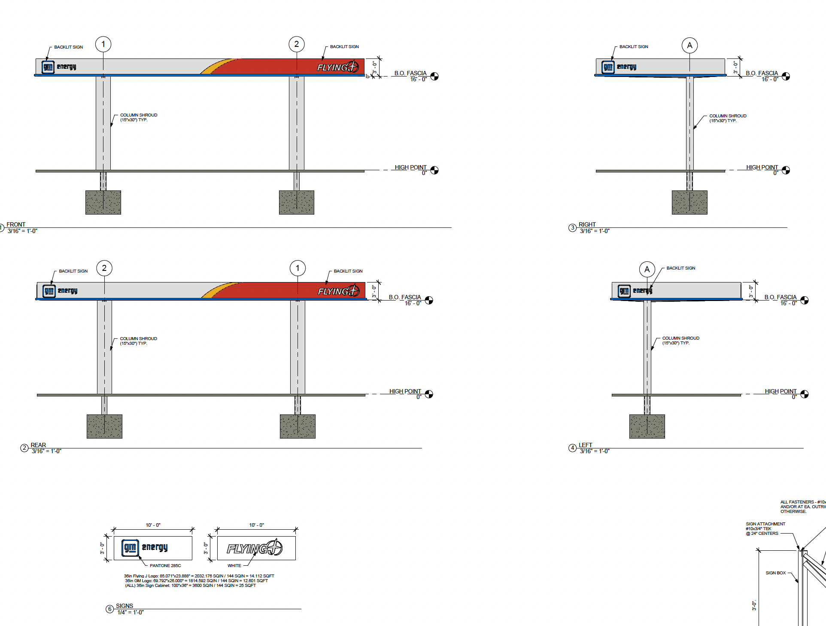

Lighting Information
