NOTICE OF PUBLIC HEARING
NORTH OGDEN CITY
Notice is hereby given that the North Ogden Planning Commission will hold a public hearing on Wednesday, December 17, 2025, at their regularly scheduled meeting beginning at 6:00 pm. The hearing will be held to receive comments on Zoning Map Amendment 2025-03 for the application to Rezone property located at approximately 600 E. 2100 N., parcel number 17-076-0047. The rezone request is to change the zoning from Rural Residential (RE-20) to a mix of zones including Small Lot Residential (R-1-5) and Multi-Family Residential (R-4).
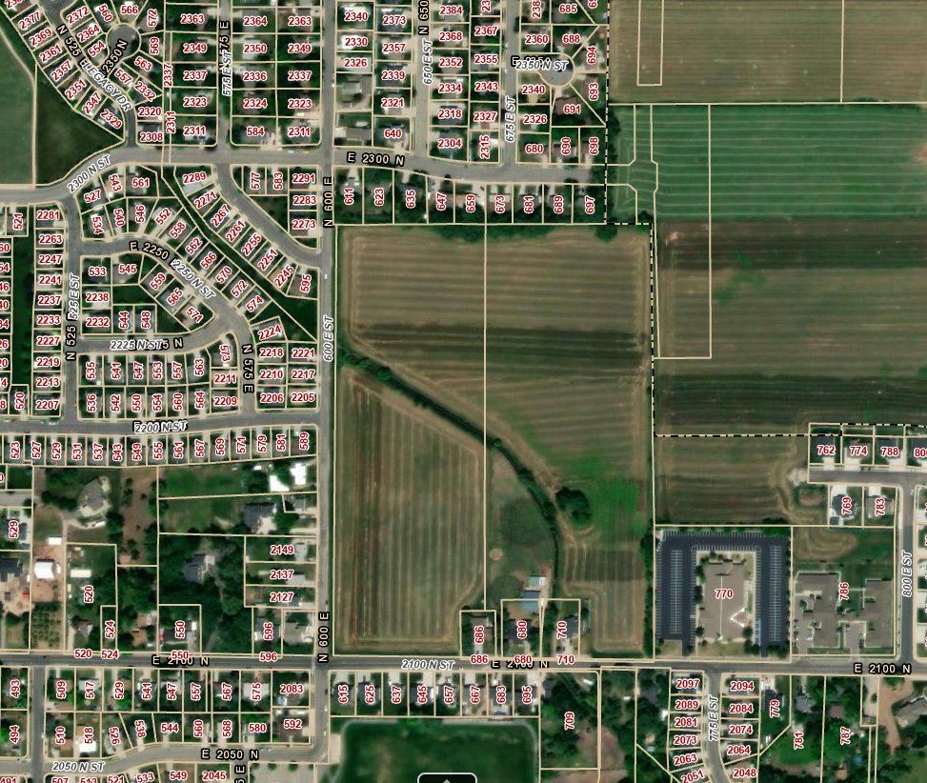
Copies of materials and staff reports are available for public inspection at www.northogdencity.gov or the North Ogden City Offices. This meeting will be held in the Council Chambers in the Public Safety Building at 515 East 2600 North, North Ogden, Utah.
All interested persons shall be given an opportunity to be heard. In compliance with the ADA, individuals needing special accommodation (including auxiliary communicative aids and services) during the meeting should notify the City Recorder at 801-737-9830 at least 48 hours prior to the meeting.
Rian Santoro
City Recorder

