Davis-Salt Lake Aerial Spray Authority
Budget Hearing Meeting
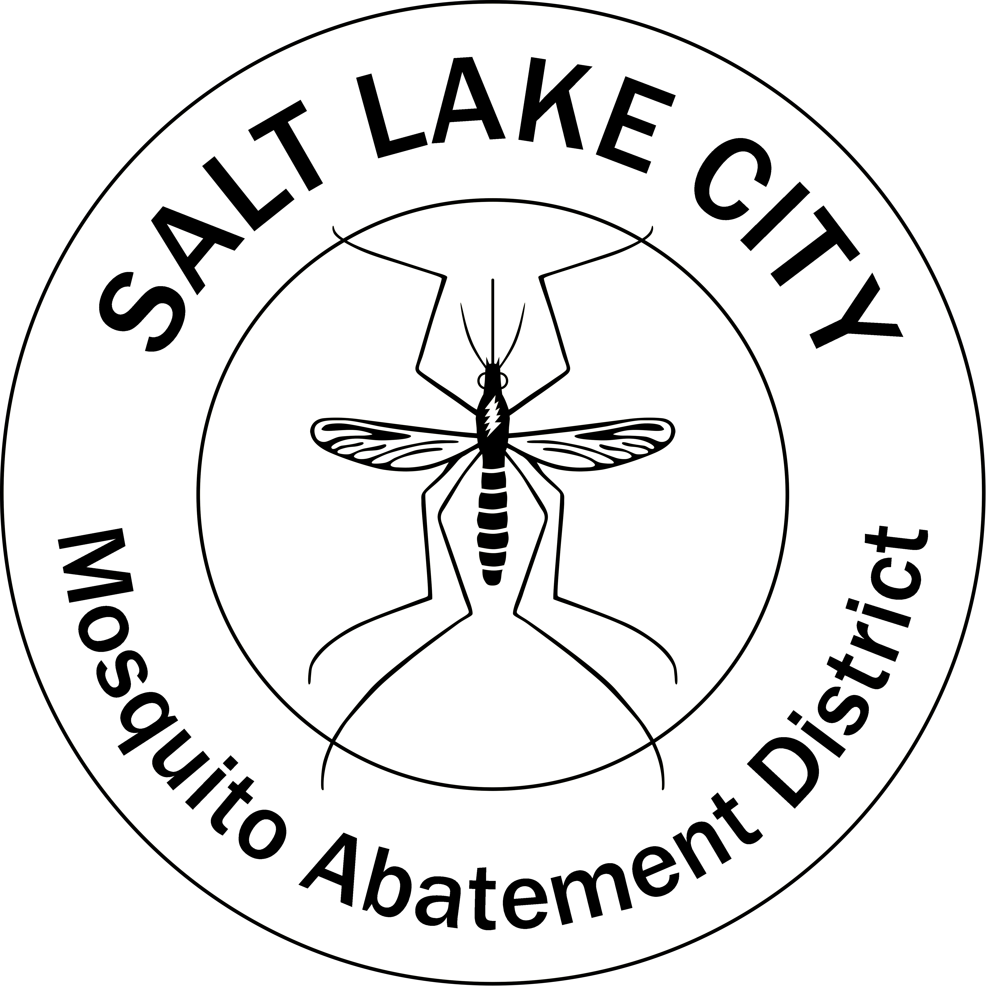
11 December 2025
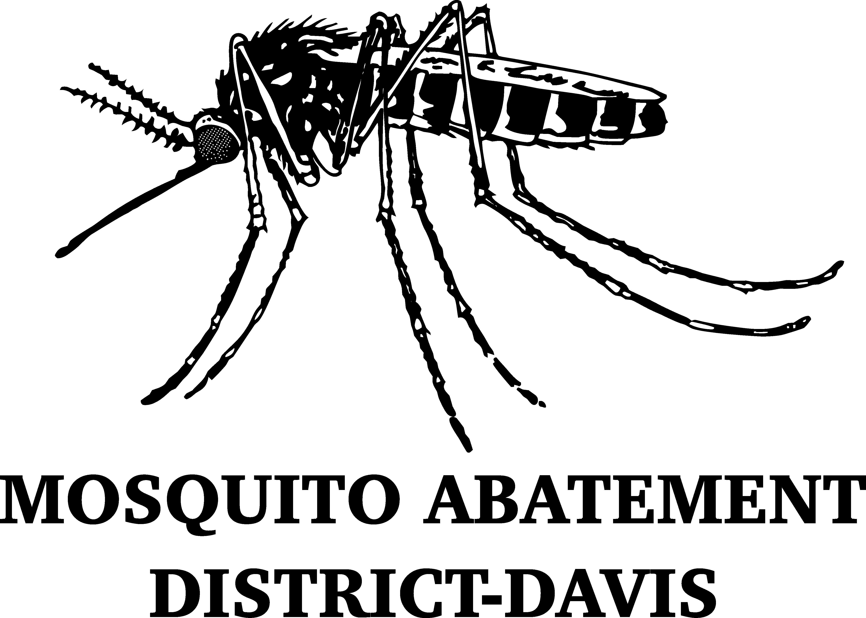
6:00 PM

MEETING TO BE HELD AT:

Mosquito Abatement District-Davis
85 N 600 W
Kaysville, UT 84307

Join Zoom Meeting
https://us06web.zoom.us/j/82510559282?pwd=9A60eOjbsUivephyrBXAUCXZTYdv4r.1

Presiding: Gary Hatch, Executive Director 2024-2025

Agenda:

- Confirmation That Recorder is on and Recording
- Presidents Greeting
- Roll Call
- Declaration of Potential Conflicts of Interest

- Consideration of the 2026 Tentative Budget for the Davis-Salt Lake Aerial Spray Authority
a) Public Budget Hearing (Public Comment Maximum 3 Minutes Each)
b) Action – Motion to Open Public Budget Hearing
c) Discussion of 2026 Tentative Budget
d) Public Comment Period
e) Action – Motion to Close Public Budget Hearing

- Consideration of Adoption of the 2026 Budget for the Davis-Salt lake Aerial Spray Authority

Action- Approval of 2026 Budget

- Adjourn

