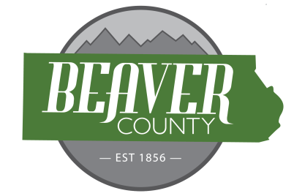
NOTICE AND AGENDA OF A PUBLIC MEETING
DECEMBER 2ND, 2025 PUBLIC MEETING OF THE
BOARD OF COUNTY COMMISSIONERS OF
BEAVER COUNTY, UTAH

PUBLIC NOTICE is hereby given that the Beaver County Commissioners of
Beaver County, Utah, will hold a regular Meeting on December 2nd, at the place
and time set forth below to consider the agenda item(s) hereinafter set forth.

MEETING PLACE: Beaver County Administration Building 105 East Center Street, Beaver, Utah.
MEETING TIME: 10:00 AM

10:00 AM
Open Meeting
Call to order
- Prayer offered by Wade Hollingshead
- Pledge of Allegiance led by Brandon Yardley
New Business
10:05: CDBG Public Hearing
10:10: Approve Bills
10:15: Approve September Minutes
10:25: Human Resource Topics
10:40: Budget Request Tourism
10:45: Budget Request Economic Development
10:55: Barking Dogs Ordinance
11:05: Ratify MOU for Utah and Nevada Counties
11:10: America’s 250 Discussion
11:25: Resolution 2025-15 Milford Hospital Board Approval
11:30: Resolution 2025-18 Economic Development Board Approval
11:35: Resolution 2025-16 EMSSD Board Approval
12:00: Adjourn Meeting

(To be discussed when/as time permits)

- Discussion Items
  - DNR Conservation Easement
  - 2026 LexisNexis Contract
  - Privacy Policy Resolution
  - Renewal of Facility Use Agreement
  - RMA Mel Clark
- Old Business
- Commission Updates

BEAVER COUNTY COMMISSION CHAIRMAN
Any other business properly brought before the Board.
Dated the 2nd day of December 2025

