
7505 S Holden Street Midvale, UT 84047
801-567-7200
Midvale.Utah.gov

REDEVELOPMENT AGENCY OF MIDVALE CITY MEETING AGENDA
December 2, 2025

Public Notice Is Hereby Given that the Redevelopment Agency of Midvale City will hold an electronic and in-person meeting on December 2, 2025 as follows:

Electronic & In-Person City Council Meeting This meeting will be held electronically and in-person. Public comments may be submitted electronically to the Board at Midvale.Utah.gov/PublicComment by 5:00 p.m. on December 1, 2025.

The meeting will be broadcast on You-Tube (Midvale.Utah.gov/YouTube) 7:00 p.m. or immediately following the City Council Meeting

GENERAL BUSINESS
  - Welcome and Roll Call

PUBLIC COMMENTS
Any person wishing to comment on any item not otherwise scheduled for public hearing on the agenda may address the Redevelopment Agency of Midvale City Board at this point by stepping to the microphone and giving their name for the record. Comments should be limited to not more than three (3) minutes unless additional time is authorized by the Redevelopment Agency of Midvale City Board. Resident groups will be asked to appoint a spokesperson. This is the time and place for any person who wishes to comment on issues not scheduled for public hearing. Items brought forward to the attention of the Redevelopment Agency of Midvale City will be turned over to staff to provide a response outside of the Redevelopment Agency meeting.

CONSENT AGENDA
  - Consider Minutes of November 18, 2025 — [Rori Andreason, H.R. Director/City Recorder]
  - Consider Resolution No. 2025-13RDA Establishing a Time and Place for Holding Midvale Redevelopment Agency Meetings for the 2026 Calendar Year. — [Rori Andreason, H.R. Director/City Recorder]

ACTION ITEM
  - Consider Resolution No. 2025-14RDA Approving the Term Sheet for a Business Loan Agreement between the Redevelopment Agency of Midvale City and Greek Streak Taverna, LLC — [Aubrey Ruiz, Redevelopment Agency Program Manager]

POSSIBLE CLOSED SESSION
The Board may, by motion, enter into a Closed Session for:
  - Discussion of the Character, Professional Competence or Physical or Mental Health of an Individual;
  - Strategy sessions to discuss pending or reasonably imminent litigation;
  - Strategy sessions to discuss the purchase, exchange, or lease of real property;

Redevelopment Agency Board Meeting December 2, 2025
  - Discussion regarding deployment of security personnel, devices, or systems; and
  - Investigative proceedings regarding allegations of criminal misconduct.

ADJOURN

In accordance with the Americans with Disabilities Act, Midvale City will make reasonable accommodations for participation in the meeting. Request assistance by contacting the City Recorder at 801-567-7207, providing at least three working days’ notice of the meeting. TTY 711
The agenda was posted at the following locations on the date and time as posted above: City Hall Lobby, on the City’s website at Midvale.Utah.gov and the State Public Notice Website at pmn.utah.gov. Board Members may participate in the meeting via electronic communications. Board Members’ participation via electronic communication will be broadcast and amplified so other Board Members and all other persons present in the Council Chambers will be able to hear or see the communication.

Date Posted: November 26, 2025 Rori L. Andreason, MMC
H.R. Director/City Recorder


REDEVELOPMENT AGENCY MEETING
Minutes
Tuesday November 18, 2025

Council Chambers 7505 S Holden Street Midvale, Utah 84047

CHAIR: Dustin Gettel
BOARD MEMBERS: Board Member Paul Glover
Board Member Bonnie Billings Board Member Denece Mikolash Board Member Bryant Brown Board Member Heidi Robinson
STAFF: Matt Dahl, City Manager; Nate Rockwood, Assistant City Manager; Rori Andreason, City Recorder; Garrett Wilcox, City Attorney; Adam Olsen, Community Development Director; Laura Magness, Communications Director; Jerimie Thorne, Deputy Public Works Director; Moira Gray; RDA Project Manager; Kate Andrus, Redevelopment Director; Aubrey Christensen, RDA Program Manager; Chief April Morse, UPD; and Juan Rosario, Systems Administrator.

Chair Gettel called the meeting to order at 10:05 p.m.

GENERAL BUSINESS
  - Welcome and Roll Call - Board Members, Bonnie Billings, Bryant Brown, and Heidi Robinson were present at roll call. Council Members Paul Glover and Denece Mikolash attended electronically.

PUBLIC COMMENTS
There was no one who desired to speak.

CONSENT AGENDA
  - Consider Minutes of October 7, 2025

MOTION: Board Member Bryant Brown MOVED to approve the consent agenda. The motion was SECONDED by Board Member Paul Glover. Chair Gettel called for discussion on the motion. There being none he called for a roll call vote. The voting was as follows:
Board Member Bryant Brown Aye Board Member Denece Mikolash Aye Board Member Paul Glover Aye Board Member Bonnie Billings Aye

Board Member Heidi Robinson Aye The motion passed unanimously.

ACTION ITEM
  - CONSIDER RESOLUTION NO. 2025-12RDA APPROVING AND AUTHORIZING THE MAYOR TO EXECUTE A CDBG SUBRECIPIENT PASS-THROUGH AGREEMENT FOR HRLP WITH MIDVALE CITY

Moira Gray said on June 26th, 2025, Midvale City was awarded $100,000 in Community Development Block Grant (CDBG) funding from Salt Lake County for the Redevelopment Agency’s Home Repair Loan Program (HRLP). Resolution No. 2025-12RDA approves the Pass-Through Agreement for the Redevelopment Agency to use the funds. These funds will be used to support the Home Repair Loan Program, which is administered by NeighborWorks Salt Lake. The program provides 5-year forgivable loans of up to $15,000 for low- to moderate-income homeowners in Midvale to be used for home repairs, such as accessibility modifications, health or safety repairs, and energy improvements.

FISCAL IMPACT:
Midvale City was awarded $100,000.00 in CDBG funds to support the Home Repair Loan Program for Program Year 25-26.

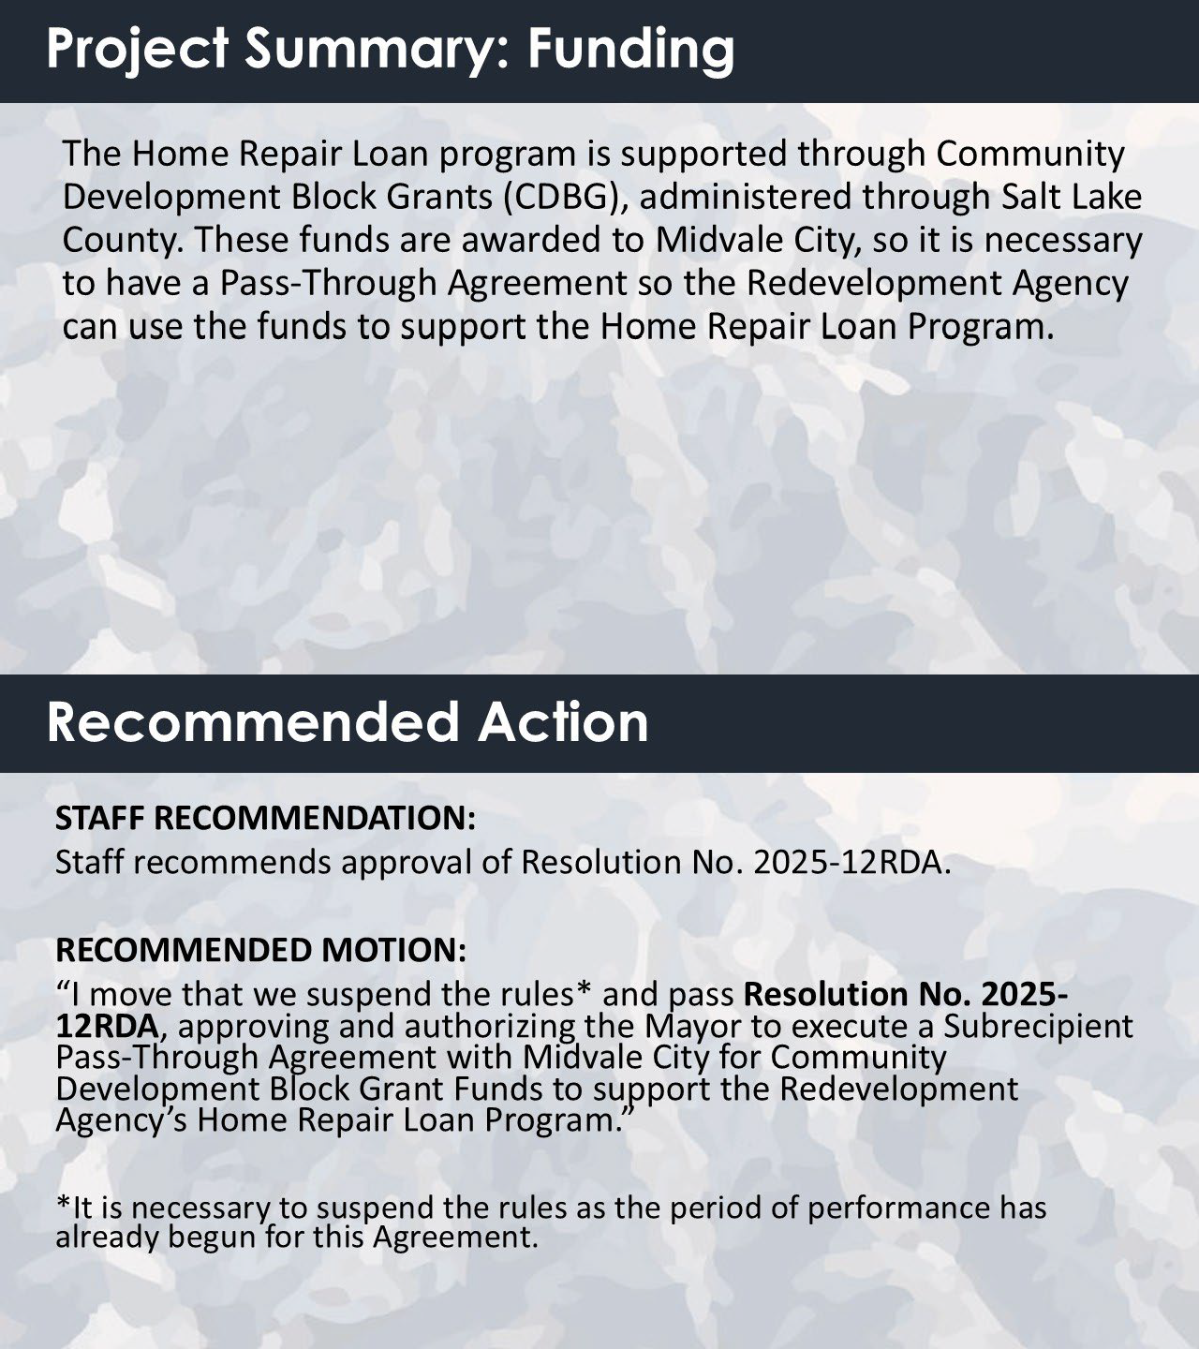
MOTION: Board Member Heidi Robinson MOVED to Suspend the Rules and Pass Resolution No. 2025-12RDA Approving and authorizing the Mayor to execute a Subrecipient Pass-Through Agreement with Midvale City for Community Development Block Grant Funds to support the Redevelopment Agency’s Home Repair Loan Program. The motion was SECONDED by

Board Member Bonnie Billings. Chair Gettel called for discussion on the motion. There being none he called for a roll call vote. The voting was as follows:
Board Member Bryant Brown Aye Board Member Denece Mikolash Aye Board Member Paul Glover Aye Board Member Bonnie Billings Aye Board Member Heidi Robinson Aye
The motion passed unanimously.

DISCUSSION ITEM
  - DISCUSSION REGARDING THE TERM SHEET FOR A BUSINESS LOAN AGREEMENT BETWEEN THE REDEVELOPMENT AGENCY OF MIDVALE CITY AND GREEK STREAK TAVERNA, LLC.
Aubrey Christensen said Agency staff received a loan request from Greek Streak Taverna, LLC, a local Greek restaurant, for $80,000. Staff has reviewed and evaluated the loan application based on program guidelines and criteria. It has been determined that the applicant has met the required threshold for consideration. As the loan request exceeds $25,000, the terms of the loan agreement are being presented to the RDA Board for discussion and eventual consideration for approval.

With most of the building restoration being handled by the property owner, Greek Streak Taverna requested funding to implement the additional tenant improvements crucial to creating a unique restaurant experience with both indoor and patio dining. Greek Streak Taverna has been a successful business operation in Utah for the last ten years, looking to expand.

As part of staff’s review, it was concluded that the application exceeded the minimum required threshold. This demonstration indicates that the funds provided will contribute to attracting and promoting the growth of businesses within the Main Street Area.
Furthermore, the loan proposal from Greek Streak Taverna received strong scores under the Public Benefit Criteria, attaining full points in the areas of 1) Economic Impact, 2) Historic Character, 3) Beautification, and 4) Street Activation, making it a qualified applicant for the 0% incentive.

Considering these findings, Agency staff recommends approving a loan of $80,000 to Greek Streak Taverna, LLC, with the terms outlined in the attached Term Sheet. This recommendation is based on a review of the applicant's proposal and supporting financial documents by Agency staff.

Fiscal Impact:
The current program budget is $750,000 to be utilized for individual loans. If approved, the RDA will provide a $80,000 loan to Greek Streak Taverna. This will bring the current

overall budget for the revolving loan programs to $670,000 to be loaned for additional projects.
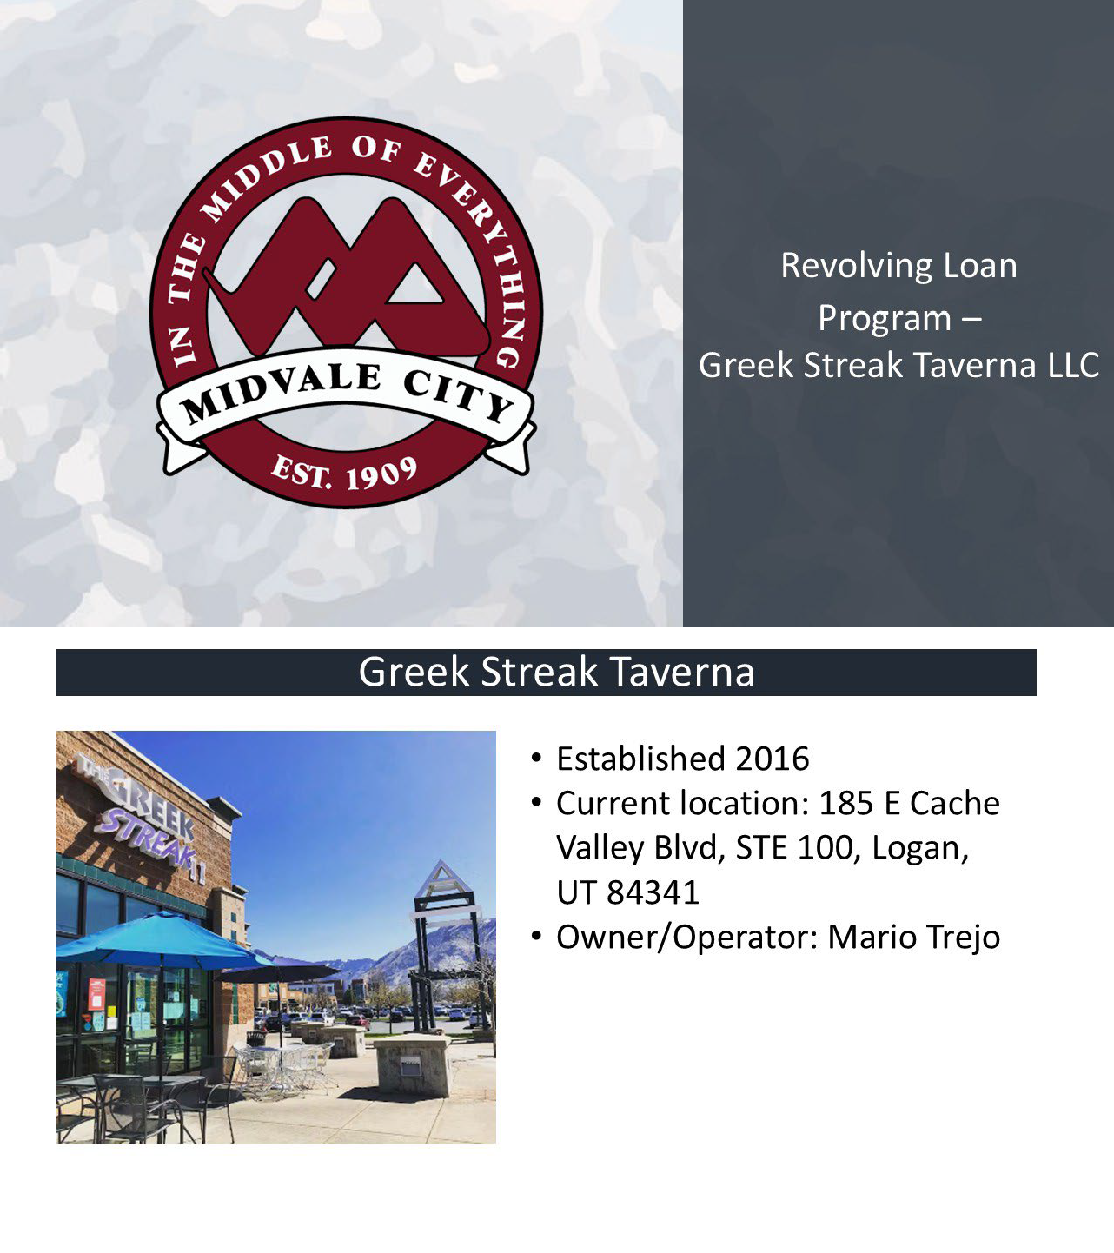

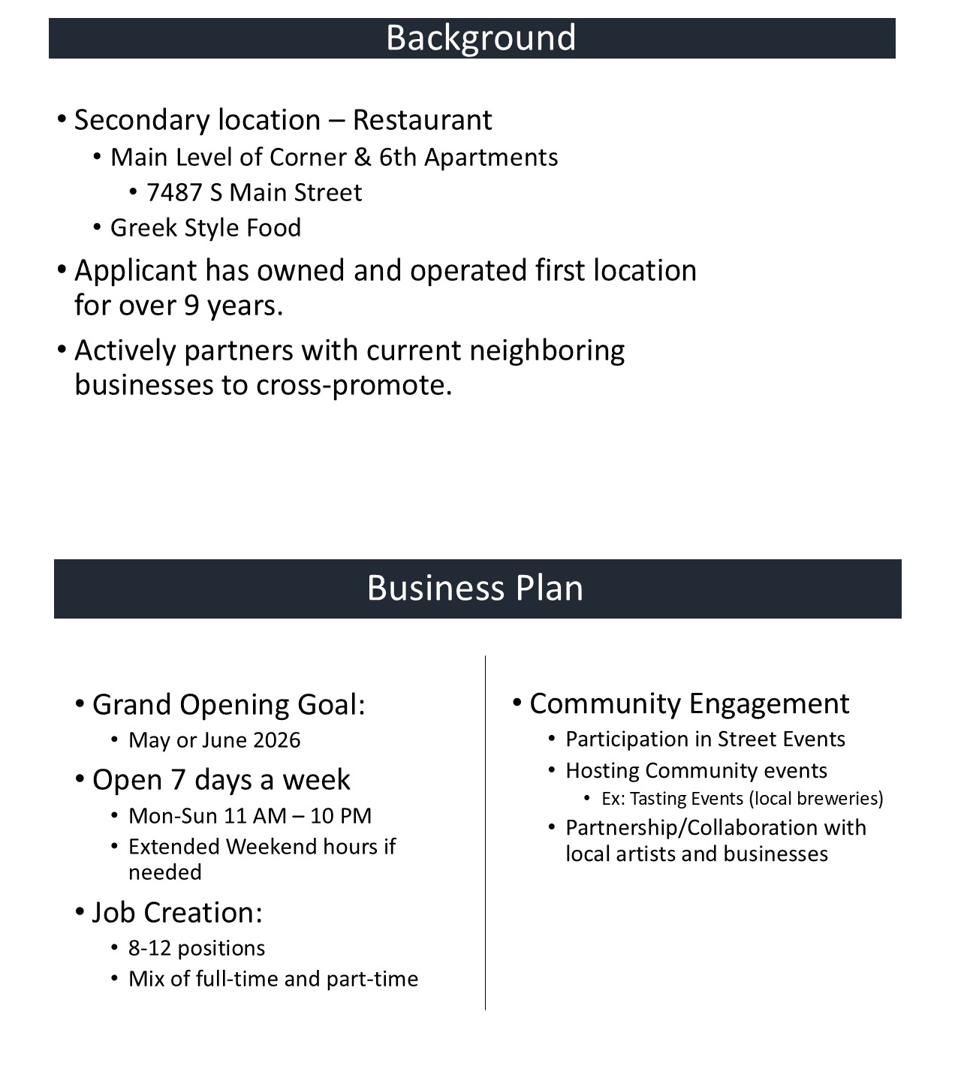

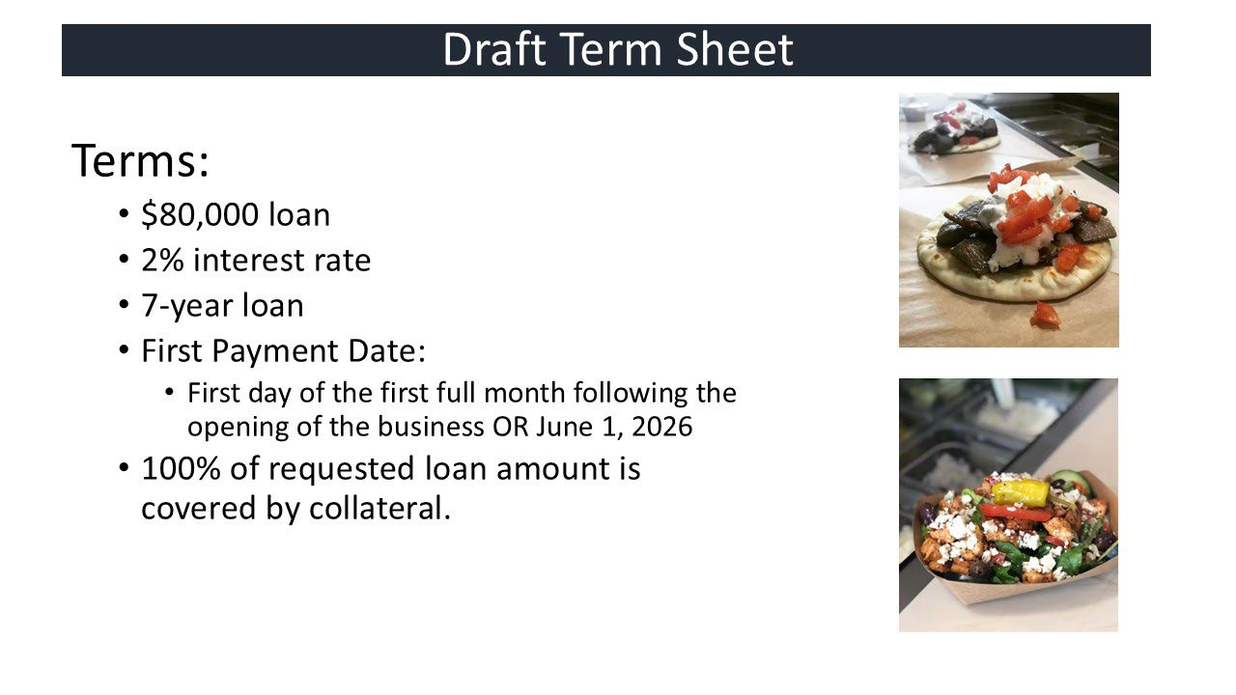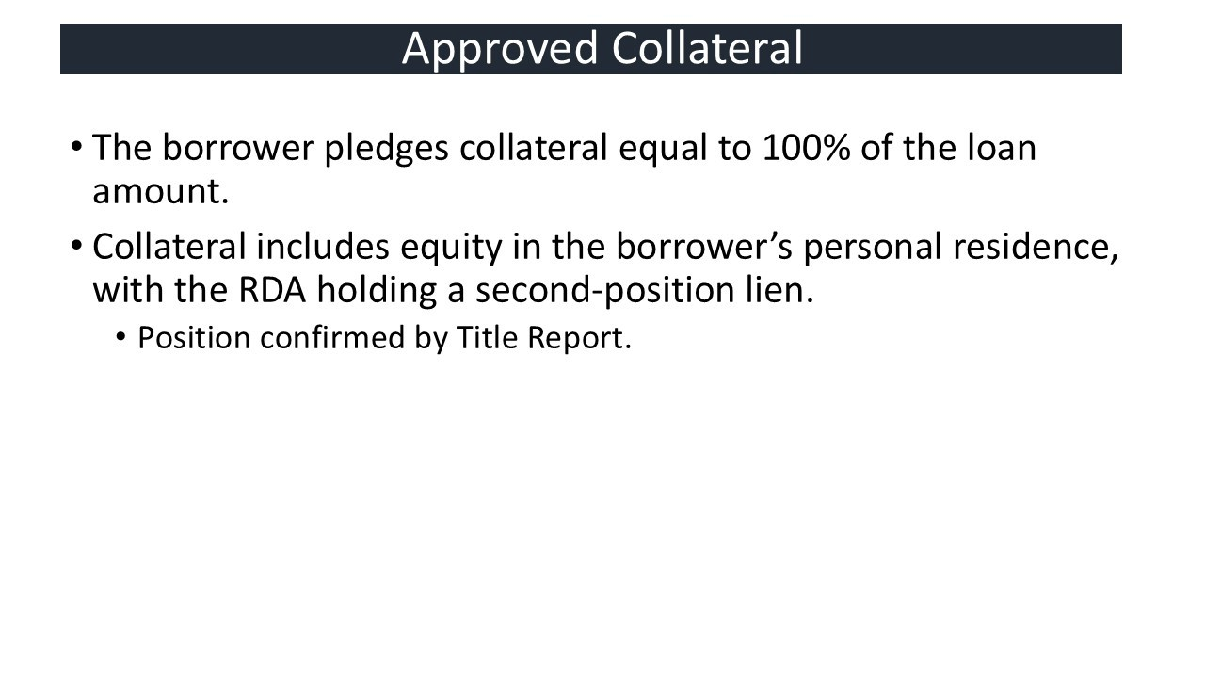

Mario Trejo, owner, said he is excited to move here and have this business opportunity. His Logan business caters to the lunch crowd, but he would like the Midvale location to cater to the evening crowd with groups of friends coming in for food and drinks later in the evening.

ADJOURN
MOTION: Board Member Bryant Brown MOVED to adjourn the meeting. The motion was SECONDED by Board Member Heidi Robinson. Chair Gettel called for discussion on the motion. There being none he called for a vote. The motion passed unanimously.

The meeting adjourned at 10:20 p.m.

Rori L. Andreason, MMC City Recorder
Approved this December 2, 2025.


MIDVALE RDA SUMMARY REPORT
Meeting Date: December 2, 2025

SUBJECT:

SUBMITTED BY: SUMMARY:
Consider Resolution No. 2025-13RDA Establishing a Time and Place to hold the Redevelopment Agency of Midvale City Meetings for the 2026 Calendar Year

Rori Andreason, Secretary

Section 2.12.060 of the Midvale Municipal Code designates the City Council to act as the Redevelopment Agency Board. The Redevelopment Agency meetings are scheduled on an as needed basis to be held in conjunction with regularly scheduled City Council meetings.

A Resolution has been prepared outlining the proposed Redevelopment Agency meeting schedule for the 2026 calendar year.

FISCAL IMPACT: N/A

RECOMMENDED MOTION:

I move that we adopt Resolution No. 2025-13RDA Establishing a Time and Place for Holding the Redevelopment Agency of Midvale City Meetings for the 2026 Calendar Year.

Attachment: Proposed Resolution

MIDVALE CITY, UTAH RESOLUTION NO. 2025-13RDA

A RESOLUTION ESTABLISHING A TIME AND PLACE
FOR HOLDING THE REDEVELOPMENT AGENCY OF MIDVALE CITY MEETINGS FOR THE 2026 CALENDAR YEAR
WHEREAS, pursuant to Section 52-4-202 of Utah Code Annotated and the Midvale Municipal Code, Section 2.12.080, the Board of Directors for the Redevelopment Agency of Midvale City hereby gives notice of their 2026 meeting schedule; and

WHEREAS, the Board desires to encourage residents of Midvale City to attend City meetings; and
NOW, THEREFORE, BE IT RESOLVED BY THE BOARD OF TRUSTEES OF THE REDEVELOPMENT AGENCY OF MIDVALE CITY, UTAH:

Section 1. The Board of Directors hereby gives notice of the time and place for holding Redevelopment Agency meetings for the 2026 Calendar Year as follows:
Redevelopment Agency: The City Council, acting in its capacity as the Board of Directors of the Midvale Redevelopment Agency will usually meet on Tuesdays, in conjunction with City Council meetings, as needed and for which public notice shall be given.
Location of Meetings: All meetings described above, except those meetings for which notice is given that the meeting will be held at a different location, will be held at City Hall, 7505 South Holden Street, Midvale, Utah.

Section 2. The Board directs the City Recorder to publish the 2026 City Council meeting schedule in accordance with Section 52-4-202 of the Utah State Code Annotated.
Section 3. This Resolution shall take effect immediately.

APPROVED AND ADOPTED this 2nd day of December 2025.

Dustin Gettel, Chief Administrative Officer
ATTEST:

Rori L. Andreason, MMC Secretary

Voting by the Board: | “Aye” | “Nay”
Bonnie Billings
Paul Glover
Heidi Robinson
Bryant Brown
Denece Mikolash



REDEVELOPMENT AGENCY OF MIDVALE CITY SUMMARY REPORT
December 2, 2025

SUBJECT: Consider Resolution No. 2025-14RDA approving the term sheet for a business loan agreement between the Redevelopment Agency of Midvale City and Greek Streak Taverna LLC.

ITEM TYPE: Action

SUBMITTED BY: Aubrey Christensen, RDA Program Manager

SUMMARY:
Agency staff received a $80,000 loan proposal from Greek Streak Taverna LLC. The application was reviewed and evaluated against the program’s guidelines and criteria, and staff confirmed that the applicant met and exceeded the minimum threshold required for consideration. The proposal demonstrates strong potential to support the attraction, growth, and enhancement of businesses within the Main Street Area. Based on this evaluation, agency staff determined that the proposal qualifies for the 2% interest loan incentive.

A term sheet outlining the proposed loan terms was presented to the Board for discussion on November 18, 2025. The finalized term sheet is now being presented to the Board for approval.

Fiscal Impact:

The current program budget is $750,000 to be utilized for individual loans. If approved, the RDA will provide a $80,000 loan to Greek Streak Taverna LLC. This will bring the current overall budget for the revolving loan program to $670,000 to be loaned to additional projects.

Recommended Motion
“I move that we pass Resolution No. 2025-14RDA approving the term sheet for a business loan agreement between the Redevelopment Agency of Midvale City and Greek Streak Taverna LLC.”

Attachments: Resolution 2025-14RDA Term Sheet Amortization Schedule Public Benefit Impact

THE REDEVELOPMENT AGENCY OF MIDVALE CITY RESOLUTION NO. 2025-14RDA

A RESOLUTION APPROVING THE TERM SHEET FOR A LOAN AGREEMENT BETWEEN REDEVELOPMENT AGENCY OF MIDVALE CITY AND GREEK STREAK TAVERNA LLC.

WHEREAS, the Redevelopment Agency of Midvale City (“Agency”) was created to transact the business and exercise the powers provided for in the Utah Redevelopment Agencies Act; and

WHEREAS, on November 17, 2015, the Agency adopted Resolution 2015-13RDA approving the CDA Project Area Plan for the Midvale Main Street CDA Project Area; and
WHEREAS, on October 6, 2020, the Agency adopted Resolution 2020-11RDA, adopting the Main Street Community Development Area Budget; and

WHEREAS, on September 7, 2021, the Agency adopted Resolution 2022-17RDA, approving the Midvale Main Business Loan Program (the “Program”); and

WHEREAS, on September 2, 2025, the Agency adopted Resolution 2025-07RDA, approving Amendments to the Midvale Main Business Loan Program; and
WHEREAS, the Program seeks to incentivize desired businesses and business improvements through low-interest loans to activate and revitalize Midvale’s Main Street area; and

WHEREAS, funds available in the amount of $2.25 million were loaned from the Bingham Junction Project Area to the Main Street Project Area to be utilized as loans for eligible businesses and upon completion of the program, will be repaid to the Bigham Junction Project Area; and

WHEREAS, Greek Streak Taverna LLC applied for a loan through the Program in the amount of $80,000 for tenant improvements to the dining and kitchen areas as well as needed equipment and fixtures; and

WHEREAS, the Agency reviewed the application and supporting documents submitted and believes that the funds loaned to Greek Streak Taverna LLC will contribute to the revitalization of the Midvale Main Street CDA Project Area.

NOW THEREFORE BE IT RESOLVED BY THE REDEVELOPMENT AGENCY OF
MIDVALE CITY, that the Board of Directors does hereby approve the Term Sheet for a Loan Agreement with Greak Streak Taverna LLC and authorizes the Chief Administrative Officer and Executive Director to execute loan agreement based on the Term Sheet, subject to such other terms and conditions as recommended by Agency’s legal counsel.

Passed and Adopted by the Board of Directors of the Redevelopment Agency of Midvale City, State of Utah, this 2nd day of December, 2025.

Dustin Gettel,
Chief Administrative Officer

Matt Dahl Executive Director

ATTEST:

Rori L. Andreason, MMC Secretary

Voting by the RDA Board: “Aye” “Nay” Paul Glover Heidi Robinson Bryant Brown Bonnie Billings Denece Mikolash

Midvale City Redevelopment Agency Term Sheet for Loan Agreement (Greek Streak Taverna, LLC)
Borrower: |  | Greek Streak Taverna LLC (Borrower)
Lender: |  | Redevelopment Agency of Midvale City (Lender)
Loan Amount: |  | $80,000.00
Interest Rate: |  | 2.00% Interest
Term: |  | 7 Years
Payments:  First Payment  Security:  Late Fee:  Prepayment:  Personal Guarantee Use of Proceeds |  | - Borrower shall pay to RDA equal monthly payments of principal and interest based on the outstanding Loan Amount.  - The first payment shall be the sooner of: a) The first day of the first full month following the opening of the business or b) June 1, 2026.  - Borrower pledges 100% equity from real estate property located at 690 W 500 N, Smithfield, UT 84335. A deed of trust will be recorded against the Real Property concurrent with the agreement. Borrower shall agree to subordinate all other liens and encumbrances other than the mortgage on the property. The Lender will be in second position.  - Borrower agrees to pay a late payment fee equal to five percent (5%) of the late amount, if payment is received after the 15th day of in which the payment is due. All sums in default will accrue interest at the rate of 18% per annum, compounded monthly, before and after judgment, until paid in full.  - Prepayment of the outstanding balance of the Loan, in whole or in part, may be made prior to the Maturity Date without a prepayment penalty.  - The loan must have a personal guarantee from all owners with over 20% equity in the property or project.  - Borrower shall use the proceeds of the Loan for the permitted uses which includes the tenant improvements, inventory, equipment, marketing and working capital. Improvements will include décor, kitchen sink areas, seating and tables, displays, lighting fixtures, counter construction, and unique plumbing and electrical needs. Inventory will include a point-of-sale system and computers, refrigeration, dish washer, freezer, flatware,

Default  Miscellaneous |  | shelving, knives, prep tables, outdoor patio furniture, etc.  - Borrower agrees to submit receipts, invoices, or other reasonable evidence as requested the RDA to verify that the Loan is being used for the permitted use.  - Defaulting on the loan will result in the loss of collateral.  - Borrower shall have executed and delivered to Lender the Loan Documents in a form satisfactory to Lender. Guarantor shall have executed and delivered to Lender the Guaranty in a form satisfactory to Lender.  - Personal guarantors are liable to pay back the outstanding balance of the loan after the liquidation of collateral to the RDA even if the business fails.  - Borrower shall comply with all other terms outlined in the Midvale Main Business Loan Program guidelines.

Proposal Letter/Public Beneﬁt Criteria
Greek Streak Taverna LLC
Mario Trejo Owner

Project: Midvale Main

Purpose of use:
Our restaurant seeks to oﬀer a contemporary, modern and a fun social gathering space. Along with our Greek dishes, we will oﬀer a variety of wine and beers on draft. We will collaborate with local breweries and continue the relationships established with them to frequently introduce a new selection of beers on a continuous basis and create a place where customers can relax, socialize and enjoy their time with us. Our objective is to continually keep things new and exciting, give customers our popular dishes and a new cuisine for the area. We want to add to and strengthen the culture between art and food in the Midvale downtown district. We will work closely with city oﬃcials and organizers to be included in the downtown events. We hope to become a local favorite in the community and the go-to Greek spot for many years to come.

Brief History:
The original Greek Streak in Price, Utah opened in 1986. My mother, Loretta Trejo, took over shortly after that, and has been operating since. The original Greek Streak still thrives today and is a local staple in the Carbon county community. After moving to Logan, Utah I felt that Cache Valley would be a great place to introduce those recipes and Greek dishes. After ﬁnding a good location we opened our doors in 2016 and have continually grown and have become a local favorite lunch and dinner spot.
https://etvnews.com/articles/local-news/the-greek-streak-celebrates-35-years-in-business/ The Greek Streak II: A family aﬀair | Allaccess | hjnews.com

Target renovation proposals to landlord for shell:
- HVAC for front of house and back of house to support max capacity persons
- Electrical ran throughout building in target locations
- ADA Unisex bathroom (sink, toilet, rails and plumbing)
- Doorway/framing moved a few feet to make room for the bathroom.
- Gas lines and 220v/240v stubbed under hood for quick connect connections
- Stone walls sealed, sealing sealed and the concrete polished ﬁnished in lobby
- FRP walls in proposed kitchen area with a wipeable ceiling per ﬁre code.
- Stainless wall under hood location
- LVT , Tile or any other approved kitchen ﬂooring for back kitchen
- Lighting in the back kitchen and basement.
- Insulation where needed
- Fire sprinklers/alarms or similar that is required by ﬁre marshall to pass inspection
- Mop sink and faucet

Tenant responsibilities beyond shell:
- Provide all kitchen equipment, sandwich station refrigeration, vertical refrigeration and freezer, prep tables, 3 compartment sink, vegetable sinks, dishwasher, broilers, griddle ect.
- Provide all booths, chairs, tables and seating
- Outdoor patio furniture
- Lighting ﬁxtures throughout lobby
- Decorative features and accents
- Kegerators (direct draft, bottom ﬁll, or remote)
- Wet bar, counters, sink and seating area
- Plumbing from all sinks to stubbed locations
- Additional electrical

- Walk in freezer and refrigerator (if enough room can be made)
- Installation of equipment and electrical to equipment
- Outdoor grease collection bins
- Outdoor lighting
- Signage (approved by landlord)
- 10 foot Hood and ventilation, exhaust, suppression.

Public beneﬁt Criteria
  - Economic Impact
    - Working alongside city oﬃcials and organizers of the downtown events, as well as organizing our own events with other local business
      - Music inside and outside of restaurant
      - Patio/sidewalk/street events and or collaborating on festivals/block parties
      - Local artists can use wall space for art
      - Discounts to staﬀ of surrounding business
    - Business, revenue and employee contributions to local economy
      - Business would work/purchase from local vendors, farms and local suppliers
      - Employees would contribute to local economy, funds circulating in the community supporting all the local small business
    - Tap takeovers and pop ups hosted by local organizers and breweries throughout the state
      - Create community events
      - Tasting events
      - Partnerships and collaborations with other business/artists
    - Only Greek restaurant in a 3-4 mile radius
      - Driving customers to the art district for another unique culinary option
    - Revitalization
      - We are excited and eager to be a part of the revitalization of the Midvale Main Arts & Culture District. We feel that our food and our customer base ﬁts well within the culture of that area. We would be a great addition to the downtown businesses.
      - Our Greek cuisine would complement and diversify the local food options. It not only would attract the locals but tourists as well.

  - Beautiﬁcation
    - The building of interest, is a new existing structure that has been built in an urban, modern, upscale building. The exterior is that of stone and black metal trim and apartments above.
    - Our restaurant would use that same urban modern look from the outside and tie that into the design inside. Although the restaurant is Greek. It would blend perfectly with the Greek Streak Taverna concept we aim to achieve
  - Sustainability
    - We would work closely with vendors and local farms that use sustainability practices. We would carry that into our restaurant by using energy eﬃcient equipment and practices that reduce waste.
  - Street activation
    - With a projected seating capacity of 70-80 persons and an average ticket time of 15 Minutes, we hope to utilize that time and space to cater to both quick lunch rushes and to patrons/groups who would like to stay for long periods of time.
    - With quick ticket times we are able to handle high loads of foot traﬃc
    - With the large booth seatings we encourage groups of friends and family to visit for longer periods of time. A place to conversate and enjoy themselves.
    - Bar area for those individuals who come alone or would like to watch sports/news
    - Patio seating for guests with pets/dogs and to be encouraged for the purpose
    - Hours of business 11am-10pm starting oﬀ. Weekends later.
    - Enhancing the local energy and culture
      - Employees from surrounding businesses visible on breaks, grabbing coﬀee, a drink or chatting outside adds to the district's welcoming presence and culture.
      - With the increased foot traﬃc, not only supports the restaurant but also neighboring galleries, boutiques, tattoo shops and other small businesses.
    - Greek expression
      - Cultural events, collaborations with the local Greek community, tastings and musical events with an emphasis of Greek culture

  - Permanent Job Creation and Retention
    - We currently have staﬀ in our Logan location that have been with us for up to 5 years. We have systems in place and competitive wages to keep staﬀ for a long period of time. Also have systems in place to hire and rehire for temporary positions and part time jobs. With both systems we can provide a stable employment impact on the community.
    - Projected staﬀ amount would be up to 8 no more than 12. A mix of part time and full time.
    - Oﬀer competitive wages
    - Employees will be positive representatives and ambassadors promoting the culture values and adding to the districts identity
    - Diversity and Inclusion
      - Hiring from diﬀerent backgrounds to all the locals near creates pride and adds to the positive culture in the midvale arts district.

  - Existing Business
    - We would be an addition to the existing apartment structure. Adding value to the residents and local business.
    - Easy access for those living near, above and around to get food, drinks and future employment.

Greek Streak Amortization Schedule

Debt Assumptions
Loan Amount | 80,000
Interest Rate | 2.00% | 0.17%

Proposed Loan | Amount | Interest | Project Proceeds | Date of First Payment
Loan #1 | $80,000 | $ 5,797 | $ (80,000) | 6/1/2026
Loan Amount Issued | $ 80,000
Costs of Issuance | $0
Total Amount | $ 80,000
Total | $ 80,000

Month | Payment Date | Beginning Balance | Payment | Principal | Interest Rate | Interest | Ending Balance
1 | 6/1/2026 | $80,000 | $1,021 | $888 | 0.17% | $133 | $79,112
2 | 7/1/2026 | $79,112 | $1,021 | $890 | 0.17% | $132 | $78,222
3 | 8/1/2026 | $78,222 | $1,021 | $891 | 0.17% | $130 | $77,331
4 | 9/1/2026 | $77,331 | $1,021 | $893 | 0.17% | $129 | $76,439
5 | 10/1/2026 | $76,439 | $1,021 | $894 | 0.17% | $127 | $75,545
6 | 11/1/2026 | $75,545 | $1,021 | $895 | 0.17% | $126 | $74,649
7 | 12/1/2026 | $74,649 | $1,021 | $897 | 0.17% | $124 | $73,752
8 | 1/1/2027 | $73,752 | $1,021 | $898 | 0.17% | $123 | $72,854
9 | 2/1/2027 | $72,854 | $1,021 | $900 | 0.17% | $121 | $71,954
10 | 3/1/2027 | $71,954 | $1,021 | $901 | 0.17% | $120 | $71,052
11 | 4/1/2027 | $71,052 | $1,021 | $903 | 0.17% | $118 | $70,150
12 | 5/1/2027 | $70,150 | $1,021 | $904 | 0.17% | $117 | $69,245
13 | 6/1/2027 | $69,245 | $1,021 | $906 | 0.17% | $115 | $68,339
14 | 7/1/2027 | $68,339 | $1,021 | $907 | 0.17% | $114 | $67,432
15 | 8/1/2027 | $67,432 | $1,021 | $909 | 0.17% | $112 | $66,523
16 | 9/1/2027 | $66,523 | $1,021 | $911 | 0.17% | $111 | $65,612
17 | 10/1/2027 | $65,612 | $1,021 | $912 | 0.17% | $109 | $64,700
18 | 11/1/2027 | $64,700 | $1,021 | $914 | 0.17% | $108 | $63,786
19 | 12/1/2027 | $63,786 | $1,021 | $915 | 0.17% | $106 | $62,871
20 | 1/1/2028 | $62,871 | $1,021 | $917 | 0.17% | $105 | $61,955
21 | 2/1/2028 | $61,955 | $1,021 | $918 | 0.17% | $103 | $61,037
22 | 3/1/2028 | $61,037 | $1,021 | $920 | 0.17% | $102 | $60,117
23 | 4/1/2028 | $60,117 | $1,021 | $921 | 0.17% | $100 | $59,196
24 | 5/1/2028 | $59,196 | $1,021 | $923 | 0.17% | $99 | $58,273
25 | 6/1/2028 | $58,273 | $1,021 | $924 | 0.17% | $97 | $57,349
26 | 7/1/2028 | $57,349 | $1,021 | $926 | 0.17% | $96 | $56,423
27 | 8/1/2028 | $56,423 | $1,021 | $927 | 0.17% | $94 | $55,496
28 | 9/1/2028 | $55,496 | $1,021 | $929 | 0.17% | $92 | $54,567
29 | 10/1/2028 | $54,567 | $1,021 | $930 | 0.17% | $91 | $53,636
30 | 11/1/2028 | $53,636 | $1,021 | $932 | 0.17% | $89 | $52,704
31 | 12/1/2028 | $52,704 | $1,021 | $934 | 0.17% | $88 | $51,771
32 | 1/1/2029 | $51,771 | $1,021 | $935 | 0.17% | $86 | $50,836
33 | 2/1/2029 | $50,836 | $1,021 | $937 | 0.17% | $85 | $49,899
34 | 3/1/2029 | $49,899 | $1,021 | $938 | 0.17% | $83 | $48,961
35 | 4/1/2029 | $48,961 | $1,021 | $940 | 0.17% | $82 | $48,021
36 | 5/1/2029 | $48,021 | $1,021 | $941 | 0.17% | $80 | $47,079
37 | 6/1/2029 | $47,079 | $1,021 | $943 | 0.17% | $78 | $46,137
38 | 7/1/2029 | $46,137 | $1,021 | $945 | 0.17% | $77 | $45,192
39 | 8/1/2029 | $45,192 | $1,021 | $946 | 0.17% | $75 | $44,246
40 | 9/1/2029 | $44,246 | $1,021 | $948 | 0.17% | $74 | $43,298
41 | 10/1/2029 | $43,298 | $1,021 | $949 | 0.17% | $72 | $42,349
42 | 11/1/2029 | $42,349 | $1,021 | $951 | 0.17% | $71 | $41,398
43 | 12/1/2029 | $41,398 | $1,021 | $952 | 0.17% | $69 | $40,446
44 | 1/1/2030 | $40,446 | $1,021 | $954 | 0.17% | $67 | $39,492
45 | 2/1/2030 | $39,492 | $1,021 | $956 | 0.17% | $66 | $38,536
46 | 3/1/2030 | $38,536 | $1,021 | $957 | 0.17% | $64 | $37,579
47 | 4/1/2030 | $37,579 | $1,021 | $959 | 0.17% | $63 | $36,620
48 | 5/1/2030 | $36,620 | $1,021 | $960 | 0.17% | $61 | $35,660
49 | 6/1/2030 | $35,660 | $1,021 | $962 | 0.17% | $59 | $34,698
50 | 7/1/2030 | $34,698 | $1,021 | $964 | 0.17% | $58 | $33,734
51 | 8/1/2030 | $33,734 | $1,021 | $965 | 0.17% | $56 | $32,769
52 | 9/1/2030 | $32,769 | $1,021 | $967 | 0.17% | $55 | $31,803
53 | 10/1/2030 | $31,803 | $1,021 | $968 | 0.17% | $53 | $30,834
54 | 11/1/2030 | $30,834 | $1,021 | $970 | 0.17% | $51 | $29,864
55 | 12/1/2030 | $29,864 | $1,021 | $972 | 0.17% | $50 | $28,893
56 | 1/1/2031 | $28,893 | $1,021 | $973 | 0.17% | $48 | $27,919
57 | 2/1/2031 | $27,919 | $1,021 | $975 | 0.17% | $47 | $26,944
58 | 3/1/2031 | $26,944 | $1,021 | $976 | 0.17% | $45 | $25,968
59 | 4/1/2031 | $25,968 | $1,021 | $978 | 0.17% | $43 | $24,990

60 | 5/1/2031 | $24,990 | $1,021 | $980 | 0.17% | $42 | $24,010
61 | 6/1/2031 | $24,010 | $1,021 | $981 | 0.17% | $40 | $23,029
62 | 7/1/2031 | $23,029 | $1,021 | $983 | 0.17% | $38 | $22,046
63 | 8/1/2031 | $22,046 | $1,021 | $985 | 0.17% | $37 | $21,061
64 | 9/1/2031 | $21,061 | $1,021 | $986 | 0.17% | $35 | $20,075
65 | 10/1/2031 | $20,075 | $1,021 | $988 | 0.17% | $33 | $19,087
66 | 11/1/2031 | $19,087 | $1,021 | $990 | 0.17% | $32 | $18,097
67 | 12/1/2031 | $18,097 | $1,021 | $991 | 0.17% | $30 | $17,106
68 | 1/1/2032 | $17,106 | $1,021 | $993 | 0.17% | $29 | $16,113
69 | 2/1/2032 | $16,113 | $1,021 | $995 | 0.17% | $27 | $15,119
70 | 3/1/2032 | $15,119 | $1,021 | $996 | 0.17% | $25 | $14,122
71 | 4/1/2032 | $14,122 | $1,021 | $998 | 0.17% | $24 | $13,125
72 | 5/1/2032 | $13,125 | $1,021 | $1,000 | 0.17% | $22 | $12,125
73 | 6/1/2032 | $12,125 | $1,021 | $1,001 | 0.17% | $20 | $11,124
74 | 7/1/2032 | $11,124 | $1,021 | $1,003 | 0.17% | $19 | $10,121
75 | 8/1/2032 | $10,121 | $1,021 | $1,005 | 0.17% | $17 | $9,116
76 | 9/1/2032 | $9,116 | $1,021 | $1,006 | 0.17% | $15 | $8,110
77 | 10/1/2032 | $8,110 | $1,021 | $1,008 | 0.17% | $14 | $7,102
78 | 11/1/2032 | $7,102 | $1,021 | $1,010 | 0.17% | $12 | $6,093
79 | 12/1/2032 | $6,093 | $1,021 | $1,011 | 0.17% | $10 | $5,082
80 | 1/1/2033 | $5,082 | $1,021 | $1,013 | 0.17% | $8 | $4,069
81 | 2/1/2033 | $4,069 | $1,021 | $1,015 | 0.17% | $7 | $3,054
82 | 3/1/2033 | $3,054 | $1,021 | $1,016 | 0.17% | $5 | $2,038
83 | 4/1/2033 | $2,038 | $1,021 | $1,018 | 0.17% | $3 | $1,020
84 | 5/1/2033 | $1,020 | $1,021 | $1,020 | 0.17% | $2 | $0
 |  |  |  | $ 80,000 |  | $ 5,797

