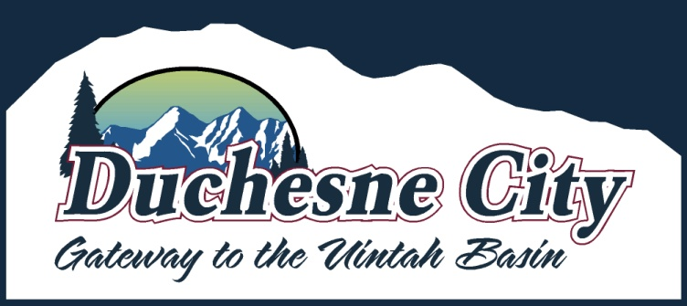

NOTICE OF PUBLIC HEARING

Notice is hereby given that the Duchesne City Council will hold a Public Hearing on Tuesday, December 9, 2025, at 6:00 pm. The hearing will be held at the Duchesne City Offices, 500 East Main Street, Duchesne, Utah.
The purpose of the hearing is to receive public comment regarding the proposed adoption of:
A RESOLUTION AUTHORIZING NOT MORE THAN $767,000 SEWER REVENUE BONDS, IN ONE OR MORE SERIES, FOR SEWER SYSTEM IMPROVEMENTS AND NOT MORE THAN $378,000 WATER REVENUE BONDS, IN ONE OR MORE SERIES, FOR WATER SYSTEM IMPROVEMENTS; FIXING THE MAXIMUM PRINCIPAL AMOUNTS, MATURITIES, INTEREST RATES, AND DISCOUNTS; PROVIDING FOR THE PUBLICATION OF A NOTICE OF PUBLIC HEARING AND BONDS TO BE ISSUED; PROVIDING FOR THE RUNNING OF A CONTEST PERIOD; AND RELATED MATTERS.
All interested persons are invited to attend and provide comment. Written comments will also be accepted prior to the hearing and may be submitted to the Duchesne City Offices.
Dated this 25th day of November 2025.
The complete public notice is posted on the following:
Utah Public Notice Website
Duchesne City Website
Duchesne City Office

