
City Council Work Session Meeting - CANCELLED
Tuesday, December 02, 2025, at 5:00 PM
PUBLIC NOTICE
THE CITY COUNCIL WORK SESSION MEETING SCHEDULED FOR DECEMBER 2ND AT 5:30 PM HAS BEEN CANCELLED.

CERTIFICATE OF MAILING/POSTING
The undersigned duly appointed City Recorder for the municipality of Santaquin City hereby certifies that a copy of the foregoing Notice and Agenda may be found at www.santaquin.gov, in three physical locations (Santaquin City Hall Building, Zions Bank, Santaquin Post Office), and on the State of Utah’s Public Notice Website, https://www.utah.gov/pmn/index.html. A copy of the notice may also be requested by calling (801)754-1904.
BY:
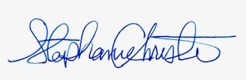
Stephanie Christensen, City Recorder

