MINUTES OF A SPECIAL CITY COUNCIL MEETING NOVEMBER 18, 2025, AT THE HYRUM CITY COUNCIL CHAMBERS OVERFLOW ROOM, 60 WEST MAIN, HYRUM, UTAH.

CONVENED: 4:00 P.M.

CONDUCTING: Mayor Stephanie Miller

ROLL CALL: Councilmembers Jared Clawson, Paul C. James, and Craig L. Rasmussen.

EXCUSED: Councilmembers Steve Adams and Michael Nelson.

CALL TO ORDER: There being three members present and three members representing a quorum, Mayor Miller called the meeting to order.

OTHERS PRESENT: Mayor Elect Steve Miller, Council Elect Rebecca Foulger, and Council Elect NaLyn Nelson. City Recorder Stephanie Fricke recorded the minutes.

WELCOME: Mayor Miller welcomed everyone in attendance and invited audience participation.

AGENDA ADOPTION: A copy of the notice and agenda for this meeting was emailed to The Herald Journal, posted on the Utah Public Notice Website and Hyrum City’s Website, provided to each member of the governing body, and posted at the City Offices more than forty-eight hours before meeting time.

ACTION Councilmember Clawson made a motion to approve the agenda for November 18, 2025 as written. Councilmember Rasmussen seconded the motion and Councilmembers Clawson, James, and Rasmussen voted aye. The motion passed.
4. BUSINESS:
A. Official Canvass of the 2025 Municipal General Election Results for Hyrum City.
5. ADJOURNMENT

Official Canvass of the 2025 Municipal General Election results FOR HYRUM CITY.

City Recorder Stephanie Fricke presented the 2025 Municipal General Election results and proceeded with the canvass process as outlined by state law. The Election was held on November 4, 2025, and conducted by mail through Cache County Clerk’s Office.
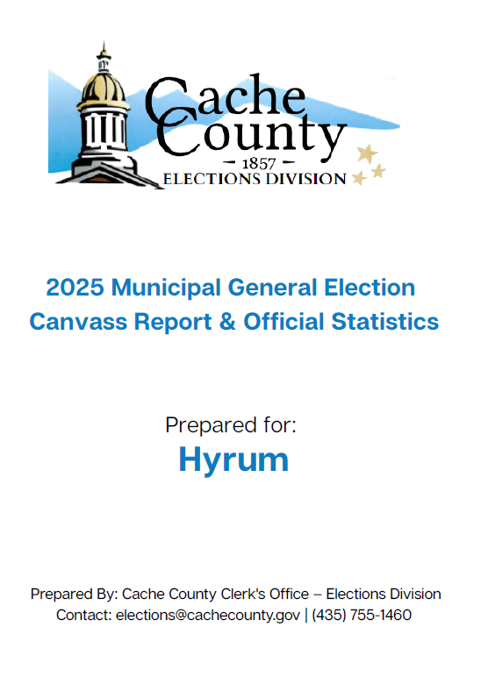
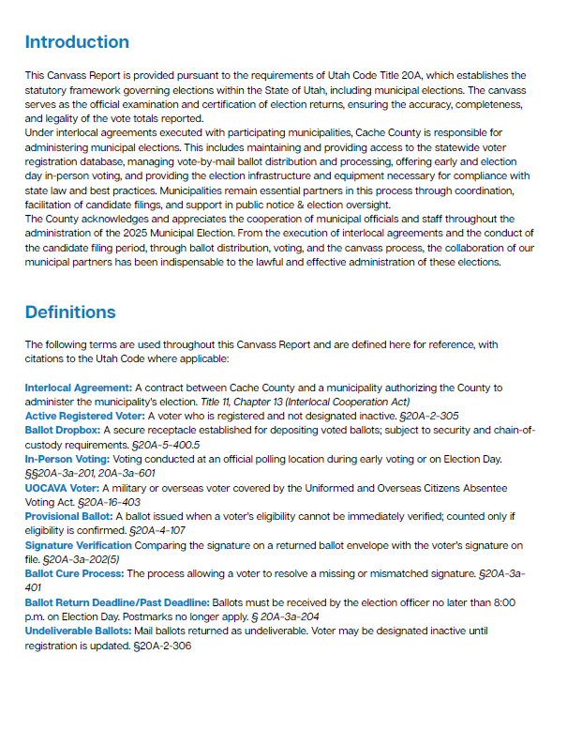
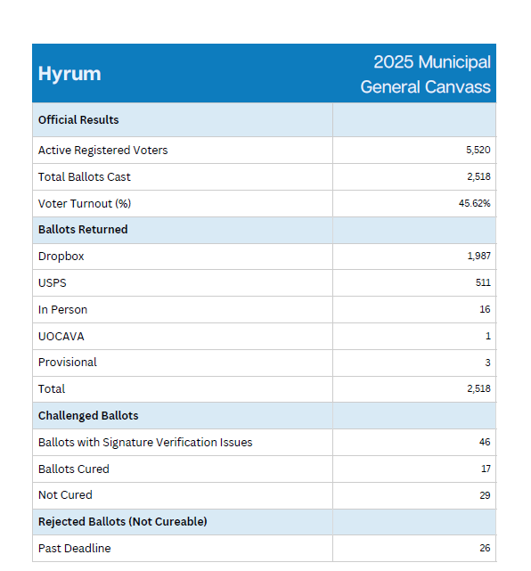

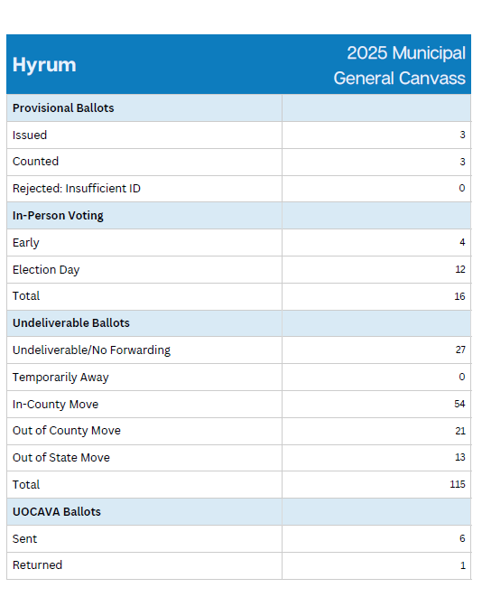

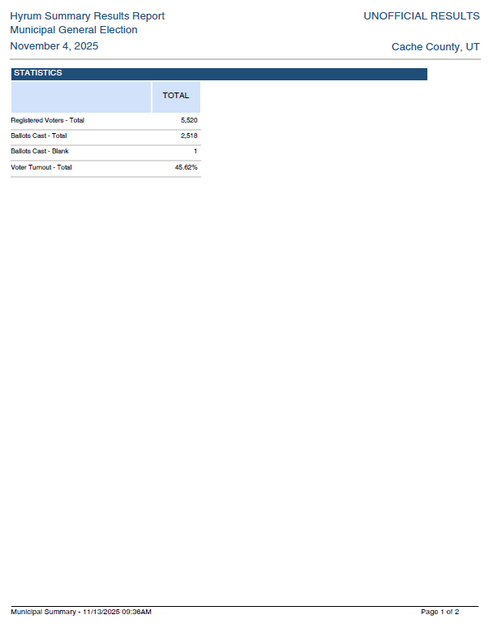
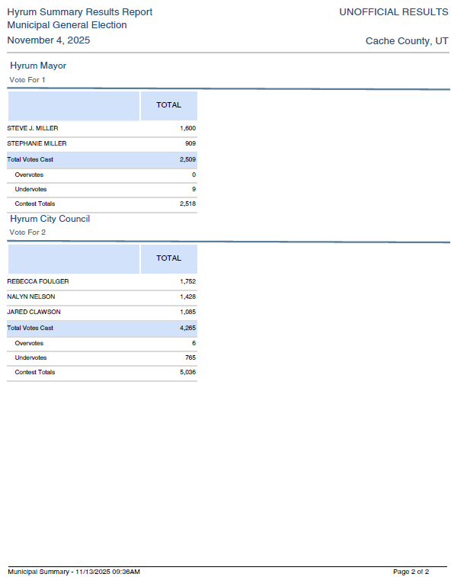

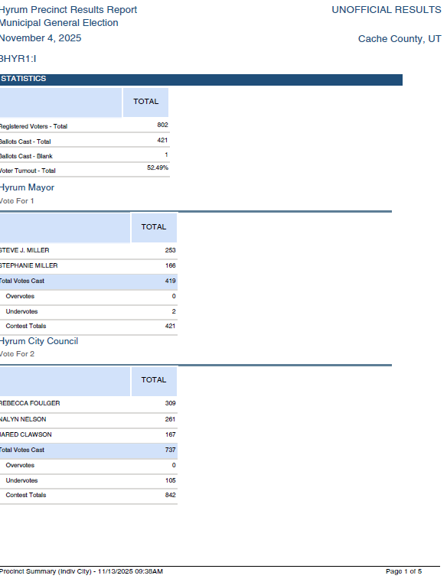
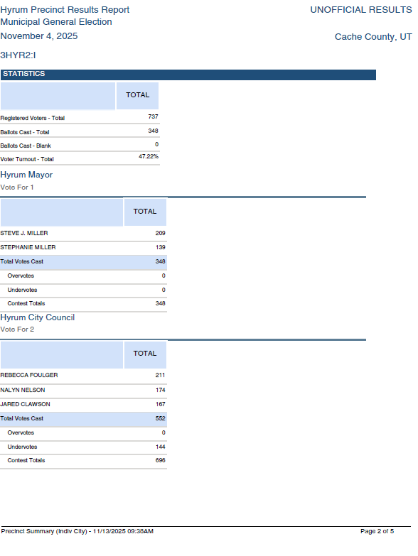
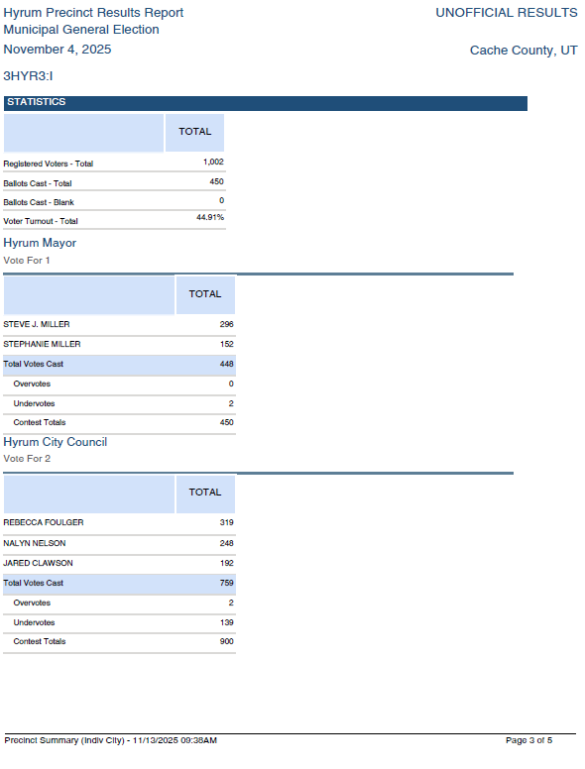
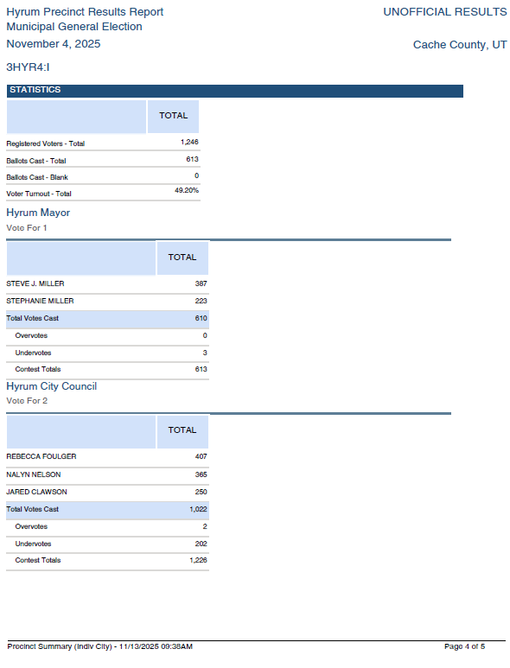
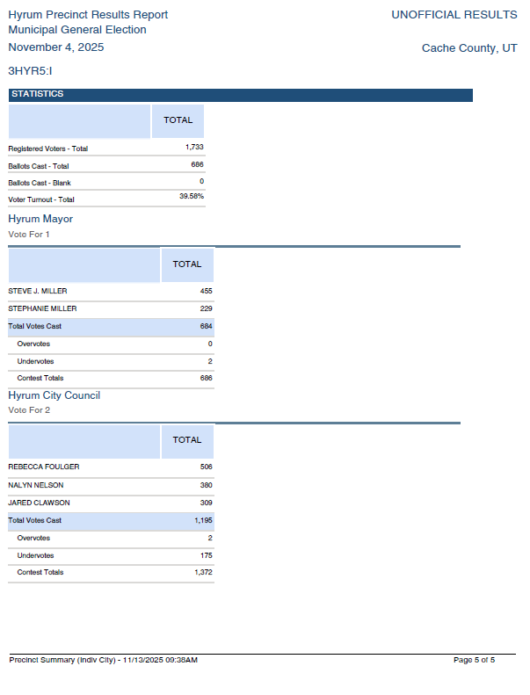
ACTION Councilmember Clawson made a motion to approve the 2025 Municipal General Election Canvass Report for Hyrum City. Councilmember James seconded the motion and Councilmembers Clawson, James, and Rasmussen voted aye. The motion passed.

ADJOURNMENT:
ACTION There being no further business before the City Council, the Council Meeting adjourned at 4:15 p.m.

_________________________________
Stephanie Miller
Mayor

ATTEST:

______________________________
Stephanie Fricke
City Recorder

Approved: November 20, 2025_
As Written

