Board Liaison
quest academy | 4862 W 4000 S, West Haven, UT 84401
Quest Academy Board Supporting Documents
November 2025


Quest Academy
Board Meeting Agenda
Date: November 20, 2025
Time: 6:00PM
Location: Electronic Teams Meeting
The mission of Quest Academy is to provide students a challenging, technology rich environment, enabling young citizens to become leaders prepared for the challenges of an evolving global community.

Agenda
Board Priorities
State Accountability
Fiscally Sound
Personalized Learning/Individualized Learning
Brand Awareness

CALL TO ORDER – Steve Reeve
PUBLIC COMMENT
CONSENT ITEMS
- October 21, 2025, Board Meeting Minutes

REPORTS
- Administration
  - State of the School
- Financial Report

VOTING & DISCUSSION ITEMS
- Policies Required for Review and Re-Approval:
  - Amended Purchasing and Disbursement Policy
- PTIF Account Access

CLOSED SESSION- to discuss the character, professional competence, or physical or mental health of an individual pursuant to Utah Code 52-4-205(I)(a).
CALENDARING
- Next Board Meeting December 9, 2025, at 6:00 PM via Teams.

ADJOURN
In compliance with the Americans with Disabilities Act, persons needing accommodations for this meeting should call 801-444-9378 to make appropriate arrangements. One or more board members may participate electronically or telephonically pursuant to UCA 52-4-207.
Page 1 of 1
QA Electronic Board Meeting Agenda 11-2-2025

Quest Academy Board Meeting Minutes
Date: October 21, 2025
Time: 6:00 PM

Location: Electronic Meeting via Zoom

Mission Statement
The mission of Quest Academy is to provide students a challenging, technology rich environment, enabling young citizens to become leaders prepared for the challenges of an evolving global community.

Board Priorities
- State Accountability
- Fiscally Sound
- Personalized / Individualized Learning
- Brand Awareness

CALL TO ORDER
The meeting was called to order at 6:00 PM by Steve Reeve.

Roll Call:
Present – Steve Reeve, Brittany Hale, Nicole Boucher, Stacee Phillips, Shawn Miehlke, Brett Greenwell, Dr. Dave, Angelee Spader, and Casey Arrington.
No members of the public were present for comment.

CONSENT ITEMS
Approval of the September 23, 2025, Electronic Board Meeting Minutes. Motion: Stacee Phillips
Second: Nicole Boucher & Brittany Hale Vote: Unanimous approval

REPORTS

Administration / State of the School – Dr. Dave
- Health Department Reporting: Required maturation and sex education assurances have been completed and submitted. The Required Health Department stats were emailed and reviewed by all Board members.
- Fundraiser: The cookie dough fundraiser raised $120,000, a new record. Approximately
$50,000 will go toward field trips and other activities.
- Accreditation: Quest Academy passed its mid-cycle accreditation review and retained

continued accredited status. The report confirmed progress toward goals set three years prior.
- Next Review: Full accreditation cycle occurs every six years; the next full review will be in three years.

VOTING & DISCUSSION ITEMS

RFP Submitted by Red Apple
Quest Academy issued an RFP for school services following the expiration of the previous contract. Only one proposal was received, from Red Apple Services. A scoring committee (Steve Reeve, Dr. Dave, and Brett Greenwell) reviewed the submission, evaluating scope, qualifications, references, compliance, and cost. The final score was 89/100, with strong performance in qualifications and references. Discussion noted the $15,000 one-time startup fee for the transition, justified by the extensive setup work required.

Motion to Award the RFP to Red Apple Services: Nicole Boucher Second: Brittany Hale
Vote: Aye – Steve Reeve, Brittany Hale, Nicole Boucher, Shawn Miehlke, Brett Greenwell. Abstain – Stacee Phillips
Motion passes.
- Approval of Curriculum and Materials (Curriculum Materials Review Committee) The board reviewed and approved the annual maturation and health curriculum recommended by the Curriculum Materials Review Committee. Curriculum includes:
  - Procter & Gamble: Always Changing and Growing Up program
  - Prentice Hall Health textbook
  - Supporting presentations on human reproduction and contraceptive education
  - Instruction facilitated by the school nurse from Weber School District Materials are consistent with those approved in previous years.

Motion: Stacee Phillips Second: Brittany Hale Vote: Unanimous approval

CALENDARING
  - Strategy Planning Session: Thursday, November 20, 2025, at 6:00 PM (in person).
  - Next Board Meeting: Tuesday, December 9, 2025, at 6:00 PM via Zoom (tentative; may be canceled if no urgent items).

ADJOURNMENT
Motion to Adjourn: Nicole Boucher Second: Brett Greenwell
Time: 6:25 PM

Vote: Unanimous approval Meeting adjourned.
In compliance with the Americans with Disabilities Act, persons needing accommodations for this meeting should call 801-731-9859 to make appropriate arrangements. One or more board members may participate electronically or telephonically pursuant to UCA 52-4-207.

Variance
Previous Yr's  Actuals | Current Yr's  Actuals | Approved  FY26 Budget

FY26 Forecast | % of  Forecast

Expenses
100 Salaries
121 Director & Principals | $ 432,502 | $ 97,100 | $ 505,000
131 K-5 Teachers | $ 4,025,217 | $ 562,974 | $ 4,290,300
131 6-9 Teachers | $ - | $ 502,576 | $ -
131 ESA HB215 | $ - | $ 95,700 | $ -
131 Special Education Teachers | $ - | $ 82,879 | $ 400,000
131 Stipends / Bonuses | $ - | $ 51,631 | $ -
132 Substitutes | $ 103,308 | $ 56,862 | $ 100,000
141 Title I/Curriculum, K5 Writing, Inst Coaches | $ - | $ 109,727 | $ -
144 Counselor | $ 49,423 | $ 14,100 | $ 55,000
145 Librarian | $ 44,121 | $ 14,180 | $ 50,000
152 Secretarial and Office | $ 135,411 | $ 49,989 | $ 190,000
161 Paraeducators | $ 1,419,685 | $ 426,721 | $ 685,000
161 SpEd Aides | $ - | $ - | $ 310,000
191 Food Service | $ 215,816 | $ 51,738 | $ 216,000
184 Admin Technology | $ 86,002 | $ 28,212 | $ 74,500
182 Custodial & Maintenance | $ 39,853 | $ 11,046 | $ 50,000
Total 100: | $ 6,551,338 | $ 2,155,435 | $ 6,925,800
200 Benefits
220 FICA (Social Security & Medicare) | $ 489,220 | $ 201,858 | $ 508,000
230 Retirement / Other Employee Benefits 290 | $ 371,771 | $ 369,413 | $ 395,000
241 Health / Life/ FSA | $ 223,478 | $ 44,776 | $ 165,000
270 Worker's Compensation Fund | $ 25,653 | $ 7,909 | $ 22,500
280 Unemployment Insurance | $ 102,285 | $ 24,758 | $ 84,500
Total 200: | $ 1,212,407 | $ 648,714 | $ 1,175,000

$ (112,573) $
$ (2,623,438) $
$ 1,522,959 $
$ 290,000 $
$ (44,460) $
$ 532,200 $
$ - $
$ 332,506 $
$ (18,877) $
$ (7,461) $
$ 15,954 $
$ 474,763 $
$ (310,000) $
$ 2,195 $
$ 13,191 $
$ 18,384 $
$ 85,343 $

$ 24,847 $
 |  |  | paid 8/25 last year?
$ - | $ 395,000 | 93.5%
$ - | $ 165,000 | 27.1%
$ - | $ 22,500 | 35.2% | 46k last yr GL  .013 to start
$ - | $ 84,500 | 29.3% | 46k last yr GL  .013 to start
$ 24,847 | $ 1,199,847 | 54.1%

392,427
1,666,862
1,522,959
290,000
355,540
532,200
100,000
332,506
36,123
42,539
205,954
1,159,763
- 218,195
87,691
68,384
7,011,143

532,847

24.7%
33.8%
33.0%
33.0% Holiday bonus/Year-En Church Stipend
23.3% Prep Period BuyOut
9.7% Purchasing Agent
56.9% Phone
Classified Bonus
33.0% Professional Time Stipe
39.0% PTO Cash Out
33.3%
24.3%
36.8% #DIV/0!
23.7%
32.2%
16.2%
30.7%

37.9%

300 Prof & Technical Services
320 Professional Educational Services | $ - | $ - | $ -
320 Special Education Services | $ 191,450 | $ 31,692 | $ 250,000
330 Employee Training | $ 39,957 | $ 43,669 | $ 25,000
340 Other Professional Services / Audit | $ 54,924 | $ 21,242 | $ 50,000
345 Business Services | $ 424,215 | $ 140,055 | $ 500,000
349 Legal Services | $ - | $ - | $ -
350 Technology Services | $ 110,883 | $ 30,871 | $ 145,000
Total 300: | $ 821,429 | $ 267,529 | $ 970,000
400 Purchased Property Services
411 Water / Sewage / Garbage | $ 32,669 | $ 11,802 | $ 50,000
430 Repairs & Maintenance | $ 83,645 | $ 31,718 | $ 65,000
434 Snow Removal & Lawn Care | $ 39,161 | $ 6,420 | $ 40,000
441 Rental of Land & Buildings (Portables) | $ 25,326 | $ 28,009 | $ 75,000
443 Lease of Copy Machines | $ 4,889 | $ 17,797 | $ 20,000
450 Construction Services | $ 162,498 | $ - | $ 100,000
490 Other Purchased Property Services | $ 10,432 | $ - | $ 30,000
Total 400: | $ 358,620 | $ 95,746 | $ 380,000

Audit $11.5 Payroll $8k

AW 140k - 180k
Red Apple 15k one time
9.8k monthly

Williams Scotsman
$ - | $ - | #DIV/0!
$ - | $ 250,000 | 12.7%
$ 25,000 | $ 50,000 | 87.3%
$ (20,000) | $ 30,000 | 70.8%
$ (226,600) | $ 273,400 | 51.2%
$ 20,000 | $ 20,000 | 0.0%
$ - | $ 145,000 | 21.3%
$ (201,600) | $ 768,400 | 34.8%

$ - | $ 50,000 | 23.6%
$ - | $ 65,000 | 48.8%
$ - | $ 40,000 | 16.1%
$ 3,000 | $ 78,000 | 35.9%
$ 28,000 | $ 48,000 | 37.1%
$ - | $ 100,000 | 0.0%
$ - | $ 30,000 | 0.0%
$ 31,000 | $ 411,000 | 23.3%

$25,609
Storage Star Hooper
$2,400 7/9
De Lage Landen $2304
First Citizens Bank $2,4

Peac Solutions $457

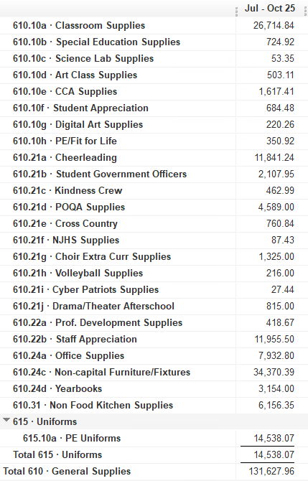
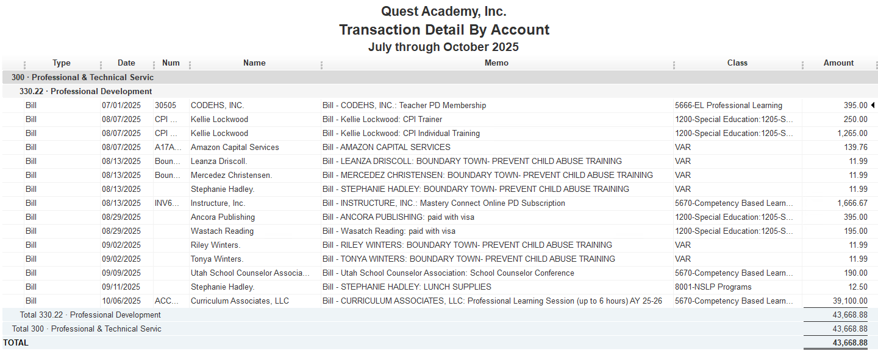

Amended Policy Summary Quest 11.20.2025

- Purchasing and Disbursement Policy: New Version (Revision D, Approved 11-20-25)
- Purchasing Authority: Updated thresholds to reflect current practices and minimize purchasing timetable.
- Clarified thresholds:
  - ≤ $5,000: Director approval
  - $5,001–$25,000: Director + Board President or Treasurer (replaced “and” with “or”)
  - ≥ $25,001: Majority Board vote
- Updated Approver of Small Purchases Title: from Principal to Director.

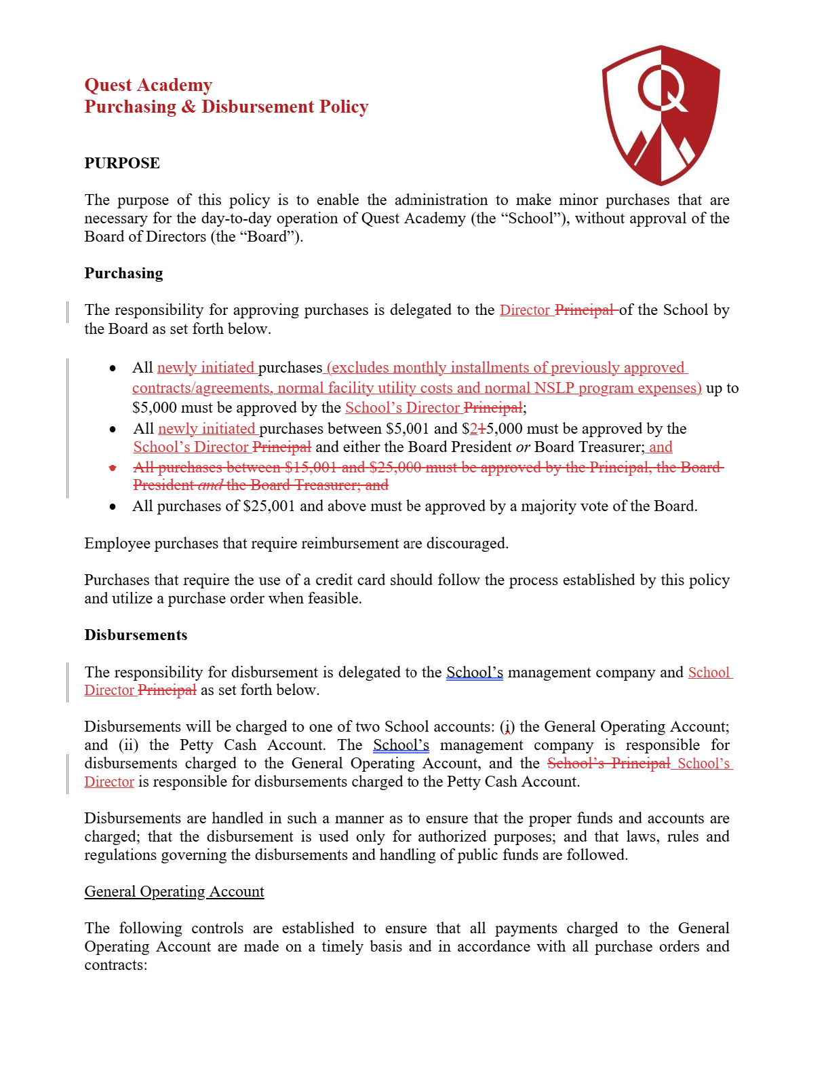
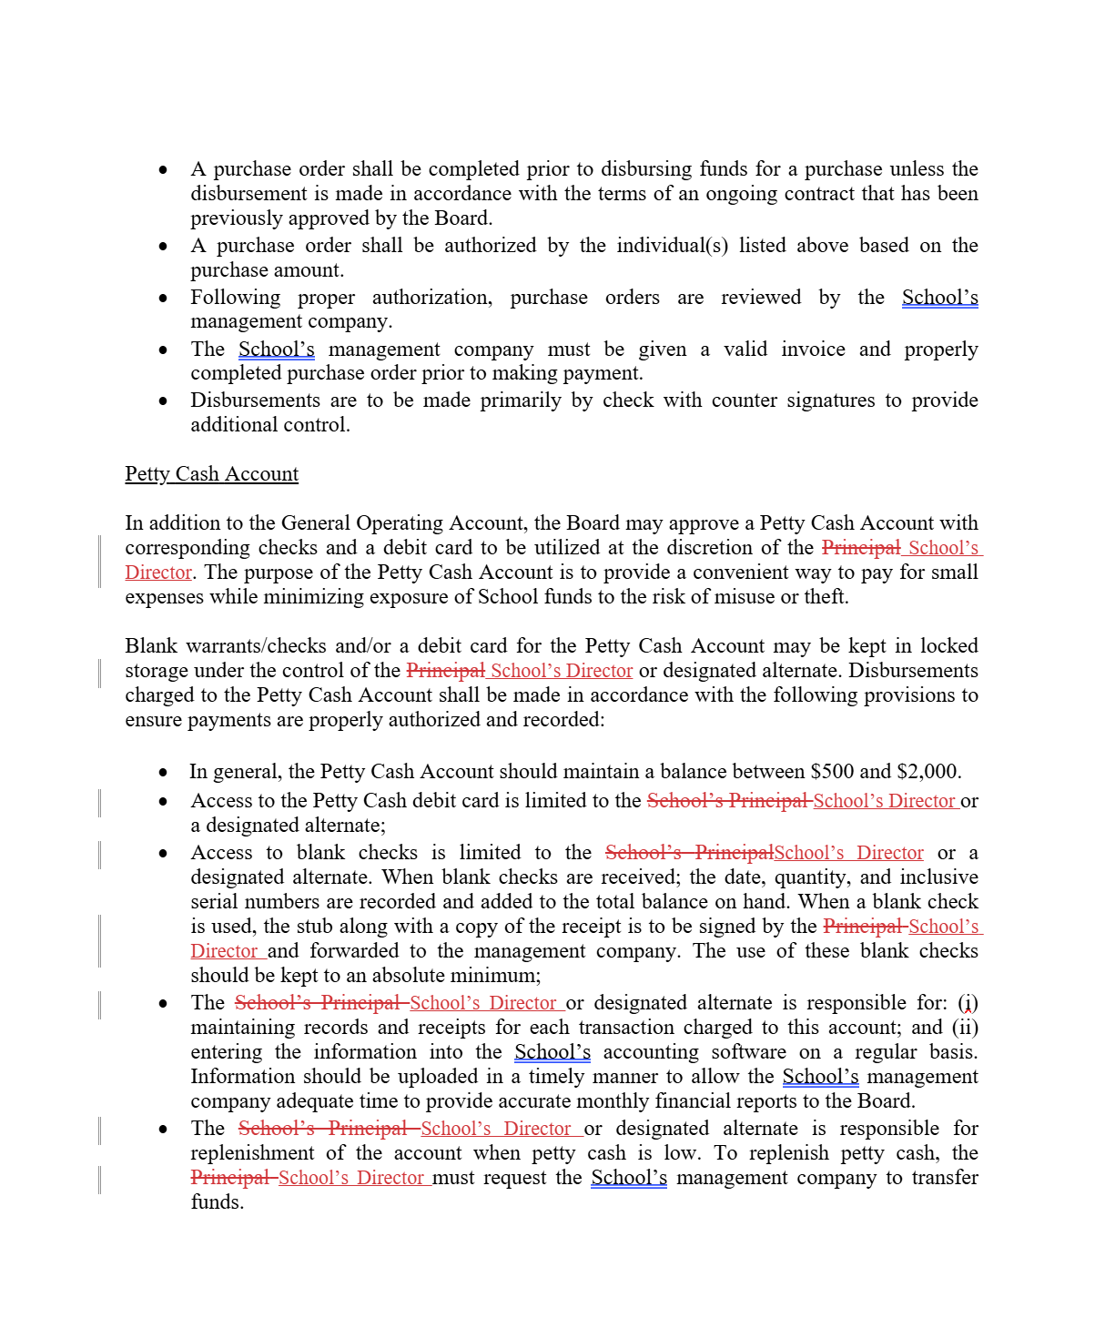

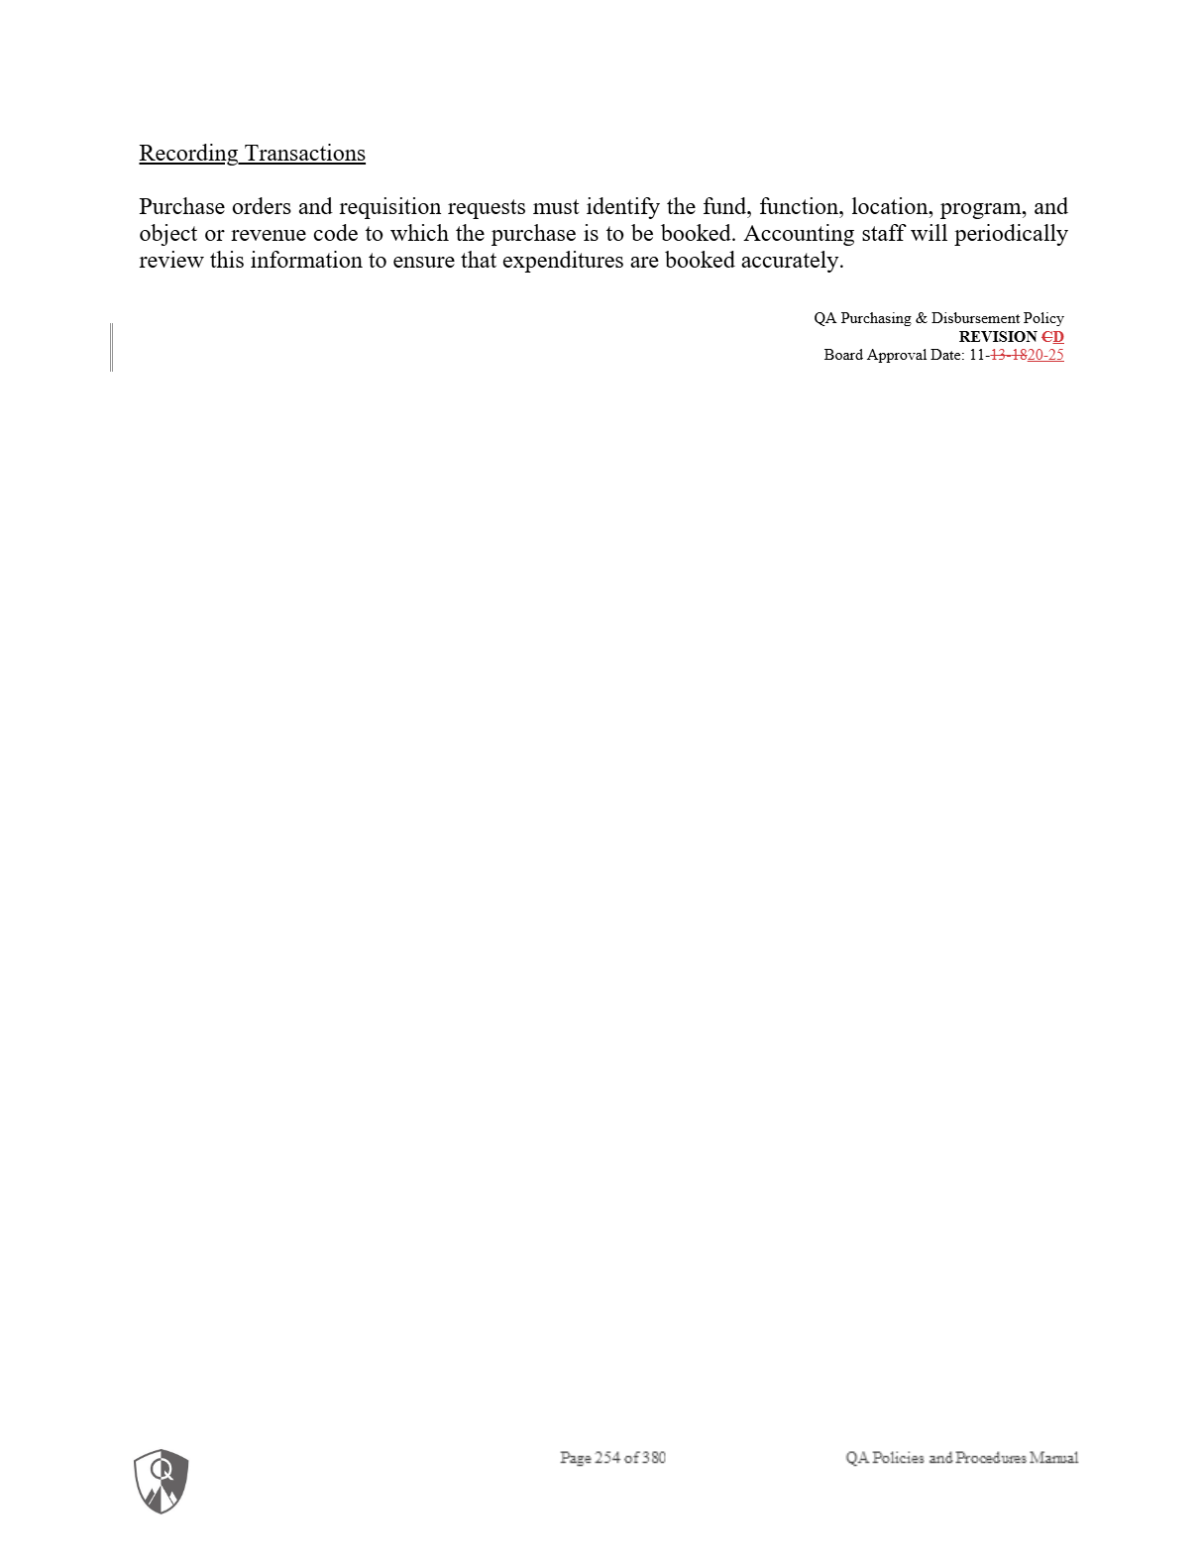


Quest Academy
Purchasing & Disbursement Policy

PURPOSE

The purpose of this policy is to enable the administration to make minor purchases that are necessary for the day-to-day operation of Quest Academy (the “School”), without approval of the Board of Directors (the “Board”).

Purchasing

The responsibility for approving purchases is delegated to the School's Director by the Board as set forth below.
- All newly initiated purchases (excludes monthly installments of previously approved contracts/agreements, normal facility utility costs and normal NSLP program expenses) must be approved by the School's Director;
- All newly initiated purchases between $5,001 and $25,000 must be approved by the
School's Director and either the Board President or Board Treasurer; and
- All purchases of $25,001 and above must be approved by a majority vote of the Board. Employee purchases that require reimbursement are discouraged.
Purchases that require the use of a credit card should follow the process established by this policy and utilize a purchase order when feasible.

Disbursements
The responsibility for disbursement is delegated to the School’s management company and School Director as set forth below.

Disbursements will be charged to one of two School accounts: (i) the General Operating Account; and (ii) the Petty Cash Account. The School’s management company is responsible for disbursements charged to the General Operating Account, and the School’s Director is responsible for disbursements charged to the Petty Cash Account.

Disbursements are handled in such a manner as to ensure that the proper funds and accounts are charged; that the disbursement is used only for authorized purposes; and that laws, rules and regulations governing the disbursements and handling of public funds are followed.

General Operating Account

The following controls are established to ensure that all payments charged to the General Operating Account are made on a timely basis and in accordance with all purchase orders and contracts:
- A purchase order shall be completed prior to disbursing funds for a purchase unless the disbursement is made in accordance with the terms of an ongoing contract that has been previously approved by the Board.
- A purchase order shall be authorized by the individual(s) listed above based on the purchase amount.
- Following proper authorization, purchase orders are reviewed by the School’s management company.
- The School’s management company must be given a valid invoice and properly completed purchase order prior to making payment.
- Disbursements are to be made primarily by check with counter signatures to provide additional control.
Petty Cash Account

In addition to the General Operating Account, the Board may approve a Petty Cash Account with corresponding checks and a debit card to be utilized at the discretion of the School's Director. The purpose of the Petty Cash Account is to provide a convenient way to pay for small expenses while minimizing exposure of School funds to the risk of misuse or theft.

Blank warrants/checks and/or a debit card for the Petty Cash Account may be kept in locked storage under the control of the School's Director or designated alternate. Disbursements charged to the Petty Cash Account shall be made in accordance with the following provisions to ensure payments are properly authorized and recorded:
- In general, the Petty Cash Account should maintain a balance between $500 and $2,000.
- Access to the Petty Cash debit card is limited to the School’s Director or a designated
alternate;
- Access to blank checks is limited to the School’s Director or a designated alternate. When blank checks are received; the date, quantity, and inclusive serial numbers are recorded and added to the total balance on hand. When a blank check is used, the stub along with a copy of the receipt is to be signed by the School's Director and forwarded to the management company. The use of these blank checks should be kept to an absolute minimum;
- The School’s Director or designated alternate is responsible for: (i) maintaining records and receipts for each transaction charged to this account; and (ii) entering the information into the School’s accounting software on a regular basis. Information should be uploaded in a timely manner to allow the School’s management company adequate time to provide accurate monthly financial reports to the Board.
- The School’s Director or designated alternate is responsible for replenishment of the account when petty cash is low. To replenish petty cash, the School's Director must request the School’s management company to transfer funds.

Recording Transactions

Purchase orders and requisition requests must identify the fund, function, location, program, and object or revenue code to which the purchase is to be booked. Accounting staff will periodically review this information to ensure that expenditures are booked accurately.

QA Purchasing & Disbursement Policy
REVISION D
Board Approval Date: 11-20-25

(seal)
