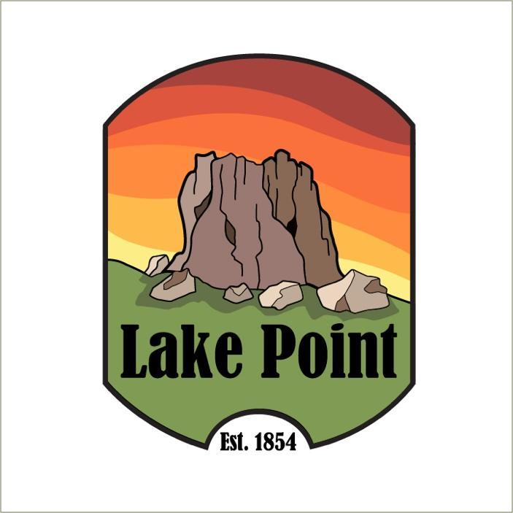

Notice of Public Hearing

The Planning and Zoning Commission proposed a Land Use Regulation to accept public comment on and consider a Wildland Urban Interface (WUI) code update and map

Being held in person
Dec. 1, 2025 at 7 pm
Lake Point Fire Station 1528 Sunset Rd. Lake Point Ut

WUI is a state fire code that the City is required to adopt, along with a map that shows where the WUI Fire Code would apply. The WUI code regulates certain building materials, construction requirements, building separation, and landscaping provisions to reduce the risk of fire.

If you have any questions, please email info@lakepoint.gov

