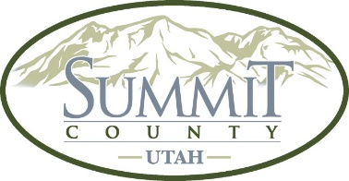

Draft MINUTES

Summit County Economic Development Advisory Board
Thursday, October 16, 2025
Meeting was conducted in Coalville at the Summit County Courthouse, 1rst floor, RM 1B, 60 N Main St, Coalville, UT 84017

PRESENT: In person: Jeffrey B. Jones, TJ Bates; Online: Pete Van Stee, Melissa Band, Jenny Diersen, Madlyn McDonough, Matt McCormick, Jessica Bateman

ABSENT: Dan McPhun, Marci Sargent

The Board was called to order at 12:00 Noon.

New Announcements:

None.

Old Business

None

Minutes

Jeff Jones moved to approve the minutes from September 18, 2025. The motion was seconded by Jenny Diersen.

Rural County Grant Compliance

Jeff Jones provided the Board with an update of the Rural County Grant Program. Jeff Jones said that County had received five applications (four (4) Small Business and one (1) Broadband application. These applications were currently under review.
Jeff Jones also recommended that for the 2025-2026 grant program that the Board target new start-ups (extended proprietors for funding).

Economic Indicators

Jeff Jones provided the Board with the unemployment rate for Summit County which was estimated at 2.8% for August of 2025. Jeff Jones also provided the Board with visitor statistics for Summit County and Park City.

Adjournment
The meeting was adjourned at 1:00 p.m.

