UTAH SCHOOLS FOR THE DEAF AND THE BLIND

Advisory Council Agenda November 20, 2025
Openshaw Education Center

GENERAL SESSION AGENDA

4:30 p.m.
- Welcome

4:30 – 4:45 p.m.
- Public Comments

ACTION ITEMS

4:45 – 4:50 p.m.
- CONSENT CALENDAR APPROVAL ACTION ON:

  - Advisory Council Summary 09.25.25.pdf contact Tamara Flint (801) 629-4712
or tamarf@usdb.org for more information.

  - Vacancy Report as of 11.12.25.pdf contact Melanie Butters (801)
629-4726 or melanieb@usdb.org for
more information.

  - Donated Funds Summary as of 10-31-25.pdf contact Deborah Jacobson (801)
538-7627deborah.jacobson@schools
.utah.gov for more information.

It is recommended that the Advisory Council review and approve the Advisory Council minutes of October 23, 2025, the Vacancy Report as of November 12, 2025 and the Donated Funds Summary as of October 31, 2025.

4:50 - 5:05 p.m.
- FY2026 Enrichment and Trust Lands Projects as of 11-11-25.pdf
FY26 USB Enrichment Position Information.pdf - Deborah Jacobson

5:05 - 5:15 p.m.
Family-Community Activity Enrichment Request.pdf
- - Susan Patten

5:15 - 5:35 p.m.
Utah State Board of Education Policy 4002.pdf
- - Darin Nielsen

INFORMATION ITEMS

5:35 - 5:50 p.m.
Space Camp Presentation.pptx
- - Kari Fredrickson - Melissa Chandler

5:50- 6:00 p.m.
- USDB Subcommittee Update - Member Wood

6:00 - 6:15 p.m.
- Superintendent Report

6:15 - 6:20 p.m.
- Future Agenda Items

6:20 - 6:25 p.m.
- Other
- There will not be a meeting in December. Happy Holidays and we will see everyone next year!

Public Comment
Individuals are welcome to address the Advisory Council. Please contact Tamara Flint (801) 629-4712 or tamaraf@usdb.org with 24 hours advance notice with your name and the group you represent and a link will be shared with you. Each person will be limited to three minutes. Total time allotted for public comments will be a total of 15-minutes. Anyone needing more time should make that request in writing and arrange to be on the agenda at the next meeting.

Notice of Procedure to Get on the USDB Advisory Council Agenda
Anyone interested in being on the agenda should contact Chairperson Ray Wright at (801) 560-9866 / metaltipman@gmail.com., Assistant Superintendent Darin Nielsen at (801) 629-4712 / darinn@usdb.org, or Tamara Flint at (801) 629-4712/ tamaraf@usdb.org. Please do so by the Friday of the week prior to the meeting.

Notice of Special Accommodation at Public Meetings
In compliance with the Americans with Disabilities Act, individuals needing special accommodations (including auxiliary communicative aids and services) during this meeting should notify Tamara Flint (801) 629-4712 or tamaraf@usdb.org at least three working days prior to the meeting.

UTAH SCHOOLS FOR THE DEAF AND THE BLIND
Advisory Council Meeting Summary October 23, 2025
Openshaw Education Center

4:30 p.m. - General Session

Attending: John Clements, Voting Member
Kiara Guymon, Voting Member, Zoom Aunilie Hathaway, Voting Member
Shari Solomon-Klebba, Non-Voting Member Katie Nelson, Voting Member
Amy Query, Voting Member
LeAnn Wood, Non-Voting Member, ZOom Ray Wright, Chair, Voting Member

Absent: Kari Harbath, Voting Member
Philippe Montalette, Vice-Chair, Voting Member Gretel Sampson, Non-Voting Member

Also Attending:

Tamara Flint, Executive Assistant
Deborah Jacobson, USBE Assistant Superintendent of Operations Darin Nielsen, USDB Assistant Superintendent
Susan Patten, USB Associate Superintendent, Zoom

Interpreters:

Cindy Andersen, Interpreter Alisa Ensign, Interpreter

Others:

Marla Palmer, Parent of a blind child
Jonathan Helgesen, USD Extracurricular Director Liz Mumford, Trust Advocacy Office
James Smith, KBS Director

- Welcome and Pledge of Allegiance

Chair Wright welcomed Council members in attendance to the October 23, 2025 Advisory Council meeting. Mr. Nielsen led the Council in the Pledge of Allegiance.

- Public Comments

James Smith - KBS Director - James is a parent of three deaf children and an active member of the deaf community. Add agenda items related to two things. USBE audit - Leah Voorhees outstanding questions. We must focus on language, not disability. That is a high impact. USDB has not had USBE involvement.

Jonathan Helgesen - USD Extracurricular Director. The deaf community is involved in this school and we value our deaf students and their successes. Don’t take their choices away. He is concerned about the cut in our Enrichment Funds. Our students' success depends on these funds. He is also concerned about the low wages of our ESA’s and that they do not receive benefits.

- Consent Calendar

Mr. Wright asked Council members if they had any questions or concerns regarding the October 23, 2025 consent calendar. There were no questions or concerns. Ms. Nelson made a motion to accept the Advisory Council minutes for September 25, 2025, the Vacancy Report as of October 15, 2025 and the Donated Accounts Summary as of October 20, 2025. Mr. Clements seconded the motion. Voting was unanimous. Motion carried.

Ms. Hathaway noticed that there are many vacant intervener positions. Ms. Patten noted that it is normal to have vacancies because we have such a high rate of turnovers in that position. We do our best to continually hire for this position, but it is an ongoing challenge.

- Review Updated FY2026 Enrichment Fund and Trust Lands Project List

The USDB Finance Director, Deborah Jacobson, presented an updated proposal for the use of FY26 enrichment funds. These funds are generated from permanent trust funds managed by the School and Institutional Trust Lands Administration and are distributed in two separate trusts: a trust for schools for the deaf and a trust for schools for the blind. The Advisory Council has responsibilities for receiving proposals and providing recommendations to the

Board. The Council reviewed recommended changes to the FY2026 USDB Enrichment and Trust Lands Projects.
There was a discussion about the eight positions including staff that provide 100% of their work to the expanded core curriculum and assistive technology. Following the discussion, Ms. Nelson made a motion to recommend these Enrichment Fund changes to the board for approval. Aunilie seconded the motion. Voting was unanimous. Motion carried.

- Enrichment Fund Requests

Ms. Patten reviewed an Enrichment Funds request from a parent for their child to attend the Performing Arts New York City tour January 29, 2026 - February 2, 2026. The tour includes performing at Carnegie Hall and attending a Broadway show and performance workshop. We will also be visiting the 911 Memorial, the Statue of Liberty, the Metropolitan Museum and SUMMIT One Vanderbilt Observation deck. Areas of the ECC include career education, independent living, orientation and mobility, recreation and leisure, self determination and social interaction skills. Costs for this trip include travel, hotel, meals, entrance fees, subway passes and tour hosts.

Following a discussion and addressing questions, Ms. Nelson made a motion to approve the Enrichment Fund request for $750. Mr. Clements seconded the motion. Voting was unanimous. Motion carried.

- Board Policy 4002 - USDB Community Council Discussion

The Council reviewed a recommendation from the Interim Assistant Superintendent Darin Nielsen proposing ways to increase parent participation on the Community Council stemming from an email from a parent of a blind student and the USDB Standing Committee request. Following a discussion, it was suggested forming a subcommittee to explore ways to increase parent representation. Katie Nelson, Kiara Guymon, Ray Wright, Alisa Ensign and Phillippe Montalette volunteered to serve on the subcommittee. Following the subcommittee meeting, the suggestions will be brought to the December USDB standing committee.

- 2024-25 Annual Report/Executive Summary

Dr. Tanner and Ms. Patten reviewed highlights from the 2024-25 Annual Report including student counts, campus educators, services provided, test scores and graduation rates. They encouraged Council members to review the annual report and are open to answering any questions they may have.
- USDB Subcommittee Update

Board Member Wood updated the Council on the activities for the USDB Standing Committee including updating policies. The subcommittee reported to PEA this month which will make recommendations to EAC for their November meeting. We continue to address data concerns to make sure that it is accurate. We will also continue to work on creating a mechanism for an automatic funding source for USDB. There is also a motion out of committee to request that the state superintendent rather than the board chooses the superintendent to be in better alignment with USDB being placed under USBE.

- Superintendent Report

Superintendent Nielsen will defer to Dr. Tanner and Ms. Patten for an update on USD and USB.

USD - Dr. Tanner

Science Teacher award - Shari Solomon-Klebba received the Outstanding Information Science Teacher from the Utah Science Teaching Association. If anyone knows her, she is so deserving of this award.

Deaf ed APPEL - This has been approved through the standing committee and will move to the board for final approval.

Deaf Town - We just wrapped up Deaf Town. It was a huge success. Thank you to the kitchen staff for their help to provide food and snacks to all the students who attended.

Basketball - We are excited for the upcoming basketball season. Craig Radford will be coaching this year.

Battle of books - This will be starting on November 3rd.

School Improvement Plan - We continue to work on this as it is constantly being reviewed and modified. We will bring this to Council when it is finalized.

Volleyball - Our volleyball team is at Idaho School for the Deaf and has won their

first three games.

USB - Ms. Patten
TVI Memo - This memo goes out monthly statewide to TVI’s to get the information out to parents via our TVI’s, board members and Advisory Council. We want to streamline this information so that it is reaching everyone and are open to any ideas on how to reach more parents. We encourage Advisory Council members to attend any of these activities. We are also trying to hit different regions of the state to meet the needs of students statewide.
- Future Agenda Items
Space Camp presentation - postponed until November 20, 2025 FY26 Enrichment Funds List
USDB Subcommittee report - Member Wood
13. Other
Mr. Wright thanked everyone for attending the October 23, 2025 Advisory Council meeting. Our next meeting will be November 20, 2025, which is the 3rd Thursday due to the Thanksgiving holiday.
Please email any future agenda items to Ray Wright or Tamara Flint.
The October 23, 2025 Advisory Council meeting was adjourned at 6:30 p.m.

USDB Vacancy Report as of November 12, 2025

State/ Enrichment

Org | Job Title | DPR | Schedule | Salary Range | F/P | Funds
5310 | Paraprofessional | 40050080 | AE | $9.10 - $18.00 | P | S
 | Educator for the Deaf/HH | 40050035 | AH | $7.25 - $99.99 | F | S
5320 | Job Coach | 40050009 | AE | $17.29 - $28.94 | F | S
5330 | Paraprofessional | 2 vacancies | AE | $9.10 - $18.00 | P | S
5340 | Paraprofessional | 3 vacancies | AE | $9.10 - $18.00 | P | S
5400 | Intervener | 8 vacancies | AE | $12.93 - $20.50 | P | S
5510 | Deaf Mentor | 2 vacancies | AE | $12.85 - $21.91 | F | S
6115 | Speech-Language Pathologist | 40050129 | AH | $7.25 - $99.99 | F | S
6220 | Student Life Technician | 10018169 | AE | $16.63 - $25.49 | F | S
6290 | Educational Interpreter | 4 vacancies | AH | $7.25 - $99.99 | F | S
6360 | Library Technician | 40050372 | AE | $16.83 - $28.16 | F | S
6730 | General Maintenance Worker | 40050759 | AE | $13.17 - $19.79 | F | S
6950 | Food Service Worker II | 40050365 | AE | $14.91 - $21.03 | F | S

USDB DONATED FUNDS OVERALL SUMMARY

October 31, 2025
5210 BLIND CAMPUS SERVICES KATE BORG/ROBBIN CLARK
DF12 BLIND CLASSROOMS $ 1,547.34
DF13 BLIND STEP PROGRAM $ -
DF17 MEMORY BOX $ -
5220 BLIND OUTREACH BRANDON WATTS
DF18 VISION CONSULTANTS $ -
5310 KBS MARTIN PRICE
DF30 KBS DISCRETIONARY $ 4,564.88
5320 ASL HILARY MOODY
DF43 DEAF CENTRAL DISCRETIONARY $ 206.45
5330 DEAF SOUTH TREVOR SCHRAMM
DF46 DEAF SOUTH DISCRETIONARY $ 1,080.56
DF47 DEAF SOUTH SAINT GEORGE $ 2,675.00
DF49 A. BREINHOLT DISCRETIONARY FUND $ 2,264.83
5340 JMS RACHEL BENEDICT
DF48 JMS DISCRETIONARY FUND $ 29,102.02
DF53 JMS STUDENT BODY GOVERNMENT $ 3,688.00
DF54 JMS GRANT SOCIAL SKILLS $ 196.30
5400 DUAL SENSORY ERIN FARRER
DF19 DEAF/BLIND DISCRETIONARY FUND $ 2,396.70
DF20 DEAFBLIND ACTIVITIES $ 678.60
5500 PIP-BLIND KAREN BORG
DF22 PIP BLIND FAMILY CAMP $ 10,561.97
5510 PIP-DEAF STEPHANIE MORGAN
DF56 PIP DEAF FAMILY CAMP $ 19,712.45
6220 DEAF RESEDENTIAL WADE HESTER
DF35 DEAF RESIDENTIAL ACTIVITIES $ 5,168.03
6400 USDB DONATED FUNDS DARIN NIELSON
DF01 USDB BLACK FOUNDATION $ 9,090.00
DF02 ADVISORY COUNCIL FUNDS $ 6,208.31
DF03 RURAL PROGRAMS $ 3,000.00
DF04 SUPERINTENDENT DISCRETIONARY FUND $ 77,740.75
6430 USD ADMINISTRATION MICHELLE TANNER
DF06 USD INTERPRETERS $ 4,954.69
DF21 USD ACTIVITIES DONATED ACCOUNT $ 29,032.59
DF23 USD DISCRETIONARY FUND $ 6,128.27
DF25 DEAF ATHLETICS $ -
DF29 DEAF SCIENCE $ 1,414.95
DF57 LOANER HEARING AID BANK $ 311.31
DF69 DEAF STUDY ABROAD $ 255.49
DF71 CONFERENCES $ 14,326.28

Page 1 of 2

USDB DONATED FUNDS OVERALL SUMMARY

October 31, 2025
6440 USB ADMINISTRATION SUSAN PATTEN
DF08 USB DISCRETIONARY FUND $ 9,401.84
DF09 BLIND OLYMPICS $ 8,421.83
DF10 PLAYGROUND EQUIPMENT FOR THE BLIND $ 1,800.51
DF11 SPACE CAMP FOR THE BLIND $ 7,916.80
DF58 PRESCRIPTION GLASSES/LOW VISION AIDS $ 6,091.39
DF61 STUDENT BRAILLE MATERIALS $ -
DF63 DEVICES FOR THE BLIND/SLC $ -
DF64 DEVICES FOR THE BLIND $ -
DF72 BLIND STUDY ABROAD $ 3,374.00
6135 PHYSICAL THERAPY CANDACE GEORGE
DF16 ORIENTATION & MOBILITY $ -
6115 SPEECH THERAPY CANDACE GEORGE
DF60 SPEECH/ LANGUAGE $ -
6630 COMMUNICATIONS SUSAN THOMAS
DF07 GENERAL MEMORIAL FUNDS $ 512.09
DF59 EMERGENCY KITS $ 47.68
6900 INFORMATION TECHNOLOGY JARED FELT
DF66 TECHNOLOGY LENDING $ -

Sum of Donated Funds | $ 273,871.91

AM31 10/31/2025 | $ 273,871.91
 | $ -

Page 2 of 2

FY2026 USDB Enrichment and Trust Lands Projects
November 11, 2025

Function Code | Deaf School Enrichment Fund Projects | Superintendent Recommendations | FYTD  Expenditures | Percentage Spent | Board Approval
 | FY2026 Available Funds | $ 200,981.54
 | Carryforward from FY2025 | $ -
EF2605 USD | Field Trip Transportation |  | $ -
EF2601 | Extra-Curricular Activities for the Deaf | $ 200,981.54 | $ 98,368.35 | 49% | 5/2/2025
EF2602 | Deaf Mentor Program | $ -
EF2601 | Extra-Curricular Activities for the Deaf | $ -
EF2607 | Study Abroad - France | $ -
EF2608 | USD Sailing Experience | $ -
 | Totals | $ - | $ 98,368.35

Function Code | Blind School Enrichment Fund Projects | Superintendent Recommendations | FYTD  Expenditures |  | Board Approval
 | FY2026 Available Funds | $ 1,208,573.47
 | Carryforward from FY2025 | $ 621,538.64
EF2605 USB | Field Trip Transportation | $ 20,000.00 |  |  | 05/02/25
EF2610 | Extra-Curricular Activities for the Blind | $ 155,000.00 | $ 70,159.45 | 45% | 05/02/25
EF2612 | Expanded Core for the Blind | $ 150,000.00 | $ 16,239.76 | 11% | 05/02/25
EF2605 | Genote | $ 50,000.00 |  |  | 05/02/25
EF2606 | Harmony Music | $ 30,000.00 | $ 3,680.00 | 12% | 05/02/25
EF2609 | LEA Activity Support | $ 25,000.00 |  |  | 11/07/25
EF2611 | Family Activity Support | $ 20,000.00 |  |  | 11/07/25
EF2603 | AT - ALMC | $0.00
EF2604 | AT - High Tech | $0.00
EF2613 | Salaries | $0.00
EF2614 | ERC USB Material refresh | $0.00
 | Totals | $ 1,380,112.11 | $ 90,079.21

Function Code | USDB Trust Lands Fund Projects | Superintendent Recommendations | FYTD  Expenditures |  | Board Approval
 | FY2026 Available Funds | $ 35,396.20
 | Carryforward from FY2025 | $ 33,480.46
EF2620 | School Community Land Grant | $ 35,396.20 |  |  | 05/02/25
 | Totals | $ 33,480.46 | $ -

Cell: A26 Note: ======
ID#AAABr7UObYw
Jacquelyn Phillips (2025-10-07 21:38:12) Proposed Function codes

Position Title | Primary Responsibilities
EXPANDED CORE CURRICULUM COORDINATOR | ECS TEAM MEMBER: Lead for the Expanded Core Services team, 2 personnel. Coordinates and oversees all Expanded Core events for families, activities and classes for students across the state ages birth - 22 years. 2025 includes 85 activities. Coordinates and oversees all ECS summer programs. 2025 will include 6 programs. Manages staffing organization for the activities and events. Attends events as staff.  Manages the purchasing and reconciliation of all activities, materials and supplies for the ECS programs.
ECC EDUCATOR | ECS TEAM MEMBER: Organizes, creates and collaborates with USB and district TVI’s on lesson plans for all ECS activities for students across the state for ages birth - 22 years. On site lead for all Expanded Core activities for students across the state ages birth - 22. TVI for all ECS classes for credit. 2025 includes 85 activities. Leads and creates lesson plans for all ECS summer programs. 2025 will include 5 programs.
STUDENT EDUCATIONAL SERVICES AIDE | ECS TEAM MEMBER: Manages materials organization of and is support staff for all Expanded Core Services activities for students across the state ages birth - 22 years. Staff for summer camps. Lead on ECS lesson bin project for campus elementary and preschool classes. Including organization, teacher connection, delivery and cleaning of all materials for all 3 campuses. Lead on social media and marketing projects for all ECS events and activities across the state ages birth - 22 years old. 2025 includes 85 activities and 6 summer programs.
Instructor | AT TEAM MEMBER: Serves in the ALMC as No/Low Tech Project manager. Direct support and consultation with educators and students. Provides Assistive technology devices for students to improve IEP goal outcomes. Serves students statewiude birth to 22. Certified TVI and ATP
Instructor | AT TEAM MEMBER: Provides direct service IEP minutes in Braille and braille technology. Serves on IEP teams at USDB. Provides consultation and professional development for TVIs statewide. Nationally certified educator, TVI
STUDENT EDUCATIONAL SERVICES AIDE | AT TEAM MEMBER: High tech device management, troubleshooting, consultation. Direct consultations with students and staff statewide. Device reccomendation. Statewide professional development.
STUDENT EDUCATIONAL SERVICES AIDE | AT TEAM MEMBER: Serves in the ALMC as an acrylic, laser cut, and graphic design specialist. Designing and producing products ordered by educators and stakeholders statewide for items with direct ties to IEP goals. Serves students birth-22 statewide. Maintains machinery and makes product purchase reccomendations.

STUDENT EDUCAITONAL SERVICES AIDE | AT TEAM MEMBER: Maintains AT team budget, completes purchases and reconciles purchase with budget utilizing state purchasing guidelines. Project flow software technician. Mangages all orders and automations for job flow and produtivity. General administrative support.
Educational Technology & E-Learning Specialist | AT TEAM MEMBER: Educational Technology & E-Learning specialist. Program license management for educational technology for USB. Device management and trouble shooting. Low vision device placement and follow up. E-learning management and platform creation. Accessibility liasion.
Low Vision Specialist | AT TEAM MEMBER: Provides Vision evaluations for children birth - 22 statewide. Worjs with TVIs for educational impact of vision. Manages low vision device interventions for students. Provides emergency replacements of eyewear as a stop gap/last resort. Provides proffessional developement for TVIs statewide. Direct serve approximately 300 students a year, all districts, not just USDB.

Family/Community Activity Support - Funds Request

The USDB Advisory Council has recently approved the allocation of Enrichment Funds for LEA use statewide. These funds will support blind and low vision students across the state to participate in various events with their sighted peers in their LEA, families, or communities.
These funds can be used for various purposes, such as extracurricular equipment, travel, special interests, and supporting competitions like the Braille Challenge National, etc.
Districts and families throughout Utah can access these funds by submitting an application to the USDB Advisory Council. The application and any other supporting documentation should be sent via email to Executive Assistant Tamara Flint at tamaraf@usdb.org.
Requestor Information:

Name:
Jen Crossley
Student Name:
Ezra Crossley

Phone:
801-722-5157
Email:
jen.c.phone@gmail.com
School District:
Alpine

School Name:
Riverview Elementary
Current Grade: 6

Event/Project Information:

Event/Project Name:
Accessible Computer Workstation
Dates:
Current

Event/Project Description:
This request is for an accessible home computer workstation for Ezra, who has low vision.
The enrichment funds would be used to purchase a Windows-based computer and two large-screen monitors that would enable Ezra to do school work independently, grow his assistive technology skills, access guitar music, and connect with friends. Please see the attached document for details.

Areas of the Expanded Core Curriculum (ECC) that will be Addressed:
Assistive Technology, Compensatory Access Skills, Independent Living Skills, Recreation and Leisure, and Self-Determination. Please see the attached document for details.

Amount Requested:
$1,440

Itemized list of what the funding will be used for:
Please see attached document.

Other funding sources?
We will personally provide funds for software, monitor stands, and desk.

Purpose of Request
This request is for an accessible home computer workstation for Ezra, who has low vision. The enrichment funds would be used to purchase a Windows-based computer tower and two
large-screen monitors. Ezra has acuity of 20/250-300, limited depth perception, and decreased visual fields. He is a dual media learner and uses various tools to access his school work, including braille, a school district-issued iPad and laptop, and a Jupiter magnifier. With these tools, there have been limitations that have been frustrating and have prevented Ezra from accessing his work at the same level as his peers.

Current Challenges
The district-issued devices have restrictions that make it difficult to install and use accessibility tools other than those approved by the district. This makes sense for a general ed student, but it is a roadblock for Ezra. We have discovered that the device-native accessibility tools are frequently insufficient for him to complete his work. To try new apps or programs, we have to go through a lengthy process to get them approved, or we wait and find out that they cannot approve them for Ezra’s device.

Another drawback for Ezra is the screen size of his devices. Ezra uses a high amount of magnification. While the devices he has been issued are larger than the typical student Chromebook, when he magnifies his laptop or iPad screen, the online programs he uses daily in the classroom often lose functionality. He spends a lot of time scrolling or moving his screen to see problems or diagrams, significantly increasing the time it takes to complete his work. He also uses these school-issued devices and programs at home to complete homework and unfinished schoolwork. Using these devices is not physically comfortable because he has to hunch over to get close enough to his screen. By the time he gets home, he is visually and physically fatigued.

Expanded Core Curriculum Objectives
We would like to create a workstation at home for Ezra that will eliminate the accessibility issues he faces at school. He is in sixth grade this year and has daily homework. As he enters junior high, the amount of studying he will complete at home will increase. With this accessible workstation, he will be able to work independently with programs like Google Suite, Canva, Kami, and iReady. He will also build his digital literacy skills in computer and web navigation, file management, writing, and editing using JAWS.

Aside from schoolwork, he will use the home computer to access enlarged guitar tablature. He plays the guitar and has learned to play by ear, but being able to use guitar tab will increase his music literacy. He would be able to learn new songs without relying solely on someone playing them for him first. He could follow along with peers or teachers who use written tab, and would develop transferable skills for other forms of music notation (such as chord charts or even braille music notation with a refreshable braille display). Another recreational purpose would be better access to an online game called Minecraft. He loves world-building within that game, and often plays online with another visually impaired friend who lives in another county.

This computer setup will directly support his independence in multiple areas of the Expanded Core Curriculum, specifically Assistive Technology, Compensatory Access Skills, Independent Living Skills, Recreation and Leisure, and Self-Determination.

Equipment and Cost
The computer will run Windows, JAWS, and magnification software, which we do not have at home, and will have dual monitors that can be used in either landscape or portrait mode. One of the monitors will be a touchscreen, providing flexibility in viewing and low-vision accessibility options.

Total Funds Request: $1,440

Itemized List of What the Funding Will Be Used For:

- Windows desktop computer – $700 (Similar to this Lenovo Tower)
- Touchscreen monitor – $540 (Similar to this 27” ViewSonic)
- Large monitor – $200 (Similar to this ASUS 31.5”)

UTAH STATE BOARD OF EDUCATION POLICY
Policy Number: 4002
Policy Name: Advisory Council for the Utah Schools for the Deaf and the Blind
Date Approved: May 4, 2023

The Utah State Board of Education (the Board) hereby establishes the Advisory Council for the Utah Schools for the Deaf and the Blind (the Advisory Council).
  - The purpose of the Advisory Council The purpose of the council is to:
    - discuss and make recommendations to the USDB Superintendency and the Board regarding the needs of deaf, blind, and deaf-blind students;
DRAFT
    - provide feedback to the Board from their areas of expertise; and
    - provide recommendations to the Board on use of enrichment funds and donated funds.
    - Serve as the School Community Council for the USDB

  - Meetings
    - The Advisory Council shall meet up to ten times per year at the call of the USDB Superintendent.
    - The Advisory Council may solicit public input, but is not subject to Title 52, Chapter 4, Open and Public Meetings Act.
    - The Advisory Council shall conduct committee business in accordance with bylaws adopted by the Board, which shall include:
      - nominating procedures for Advisory Council members;
      - dismissal procedures for Advisory Council members;
      - ethical standards; and procedures for operations.

  - Staff
The USDB Superintendency shall serve as staff to the Advisory Council and shall:

    - provide clerical support to facilitate meeting logistics, prepare meeting agendas and minutes, and assist with required written communication to the Board;
    - send a copy of each Advisory Council agenda to the Board at least three days before the Advisory Council meeting; and
    - prepare a one-two page summary of each Advisory Council meeting and send the summary with Advisory Council recommendations to the Board by e-mail.
  - Membership
    - The Advisory Council shall be comprised of the following members:
      - Up to 11 voting members, including at a minimum:
        - two members who are blind;
        - two members who are deaf;
        - two members who are deaf-blind or parents of a deaf-blind child;
DRAFT
        - Two members who have children receiving USDB outreach services;
        - one parent of a blind student; and
        - one parent of a deaf student;
      - 1 non-voting member from the Board, appointed by the Board chair.
    - The Board may appoint other members who have an interest in and knowledge of the needs and education of students who are deaf, blind, and deaf-blind.
    - The board may appoint members, representing each campus program, to serve as subcommittee members with a specific focus on developing the school land trust plan and supporting the Advisory Council in their capacity as the School Community Council for the USDB.
      - Up to 8 non-voting members, that have children enrolled in any of the USDB campus programs, including at a minimum:
- Two parents of blind children
- Two parents of deaf children

- Two parents of deaf-blind children

    - Members shall be appointed to serve two-year terms and may serve up to three terms.
    - Notwithstanding, Subsection (c), Advisory Council members serve at the pleasure of the Board.

  - Applicability of Board Policies
    - This policy is subject to Policy 1004 – Advisory Groups.
DRAFT

Space Camp
2025

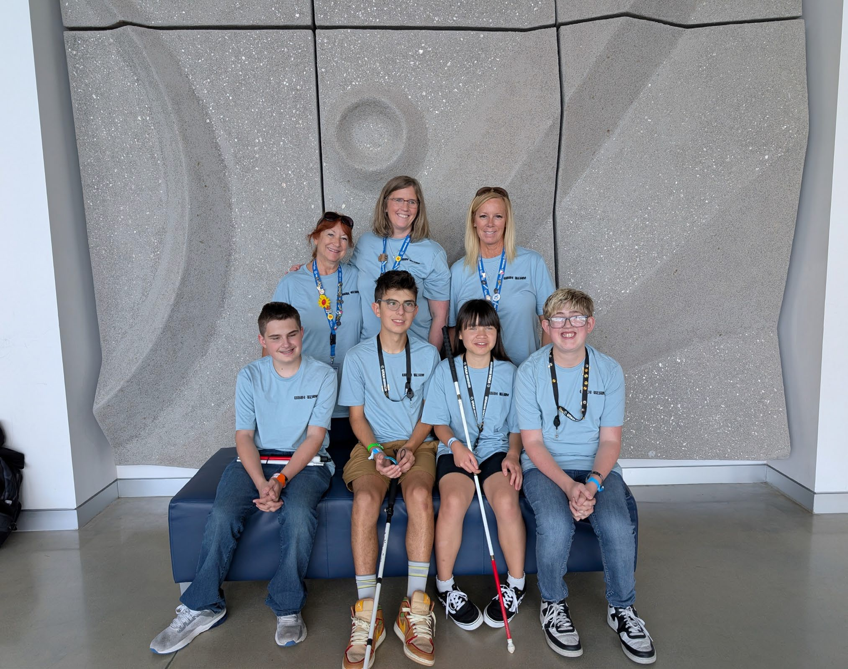
Utah Team
Jaxon Jensen
Snow Eklund Ashton Dunford JT Paxman
Kari Fredrickson Melissa Chandler Katee Westover

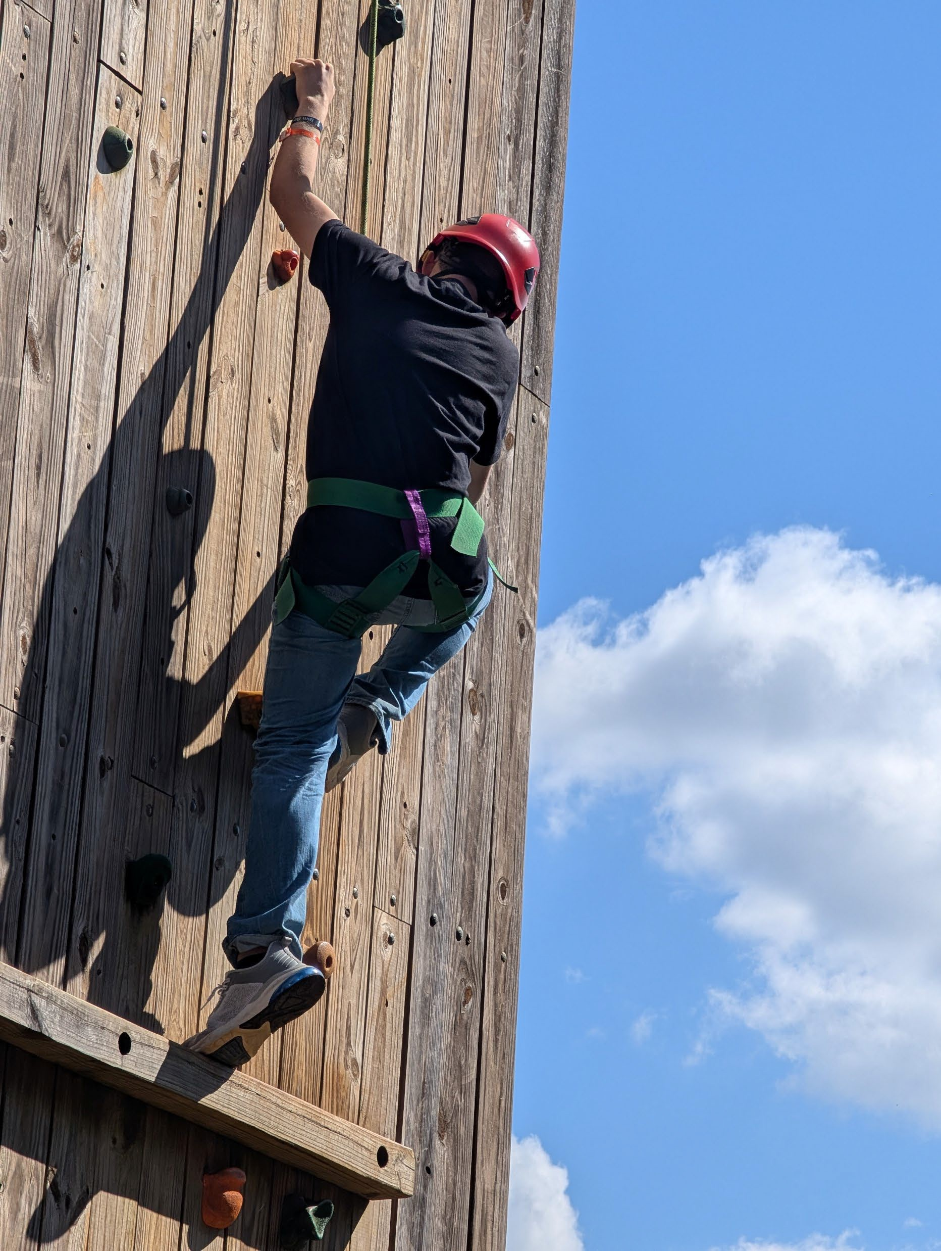
Climbing Wall

Area 51
- These are different Team Building Activities
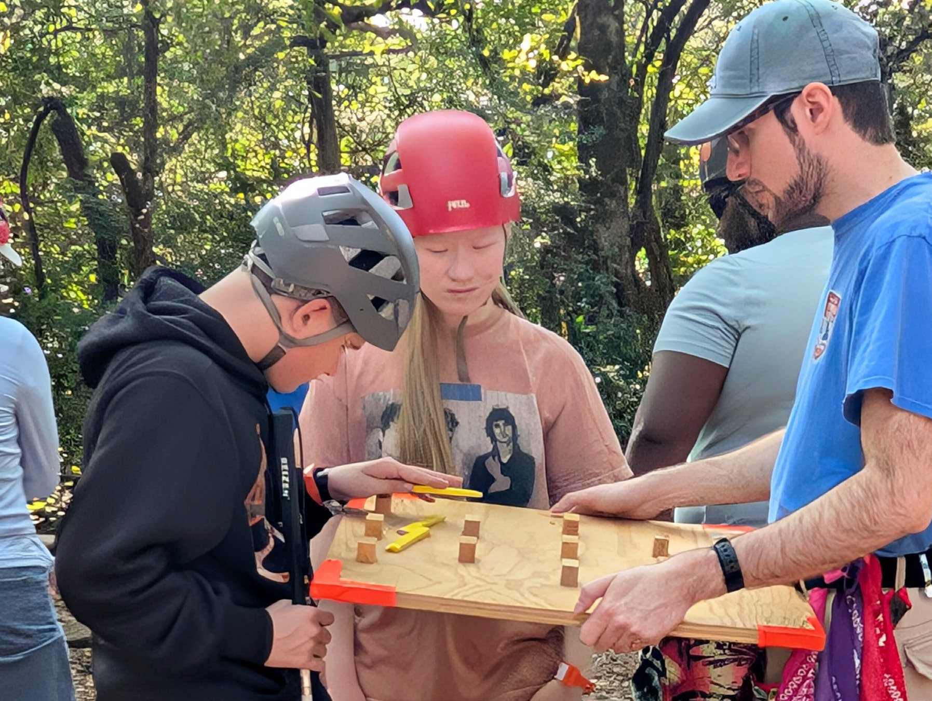

Rocket Launch

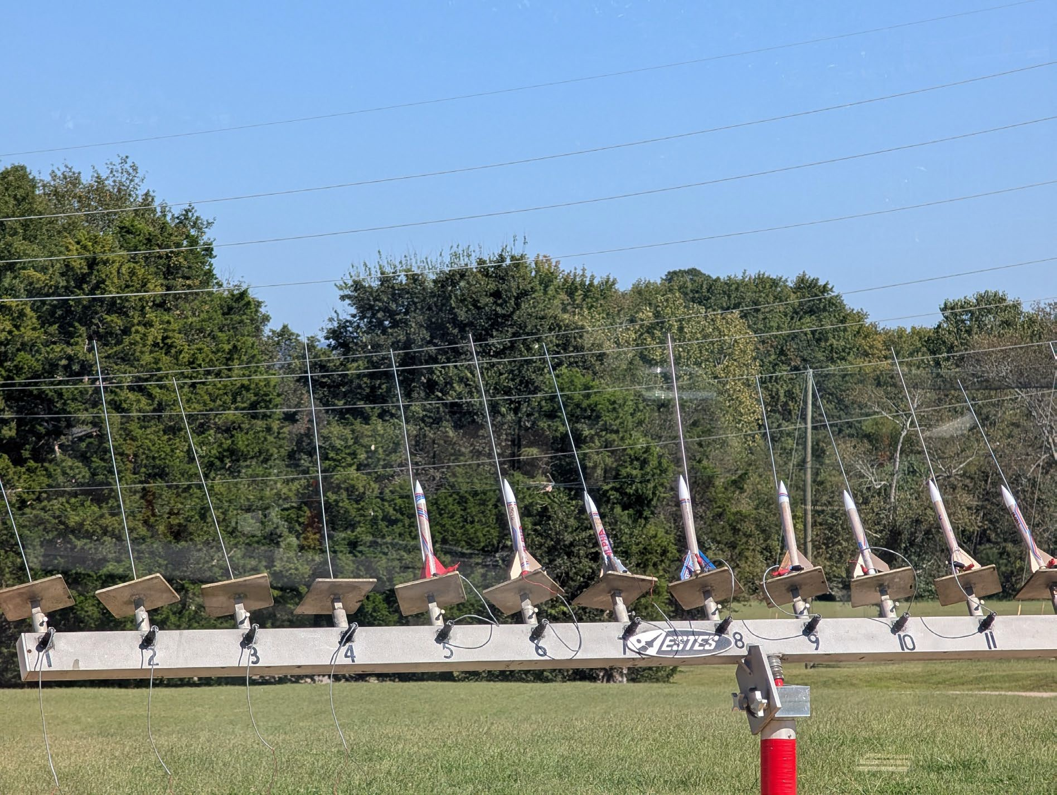

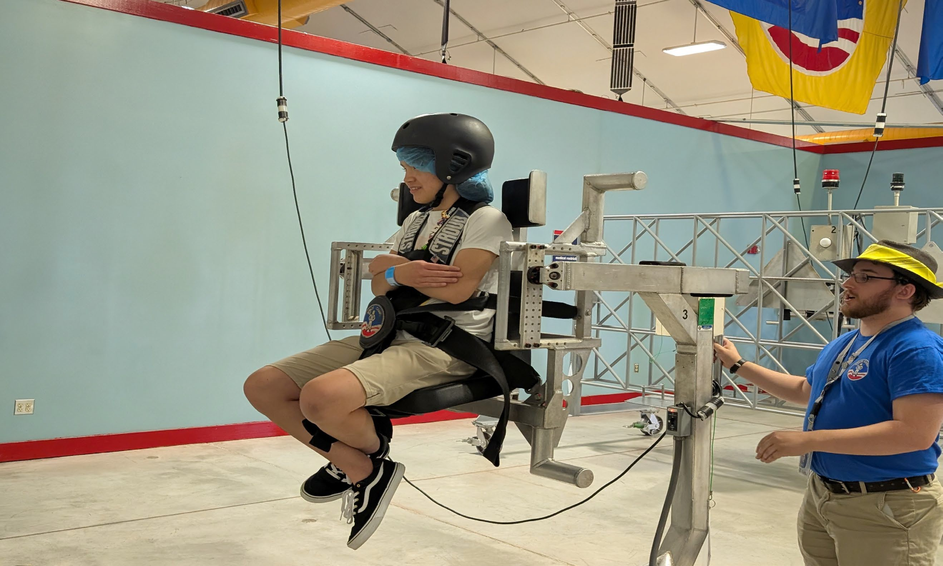
5- Degrees of Movement

Classroom Training

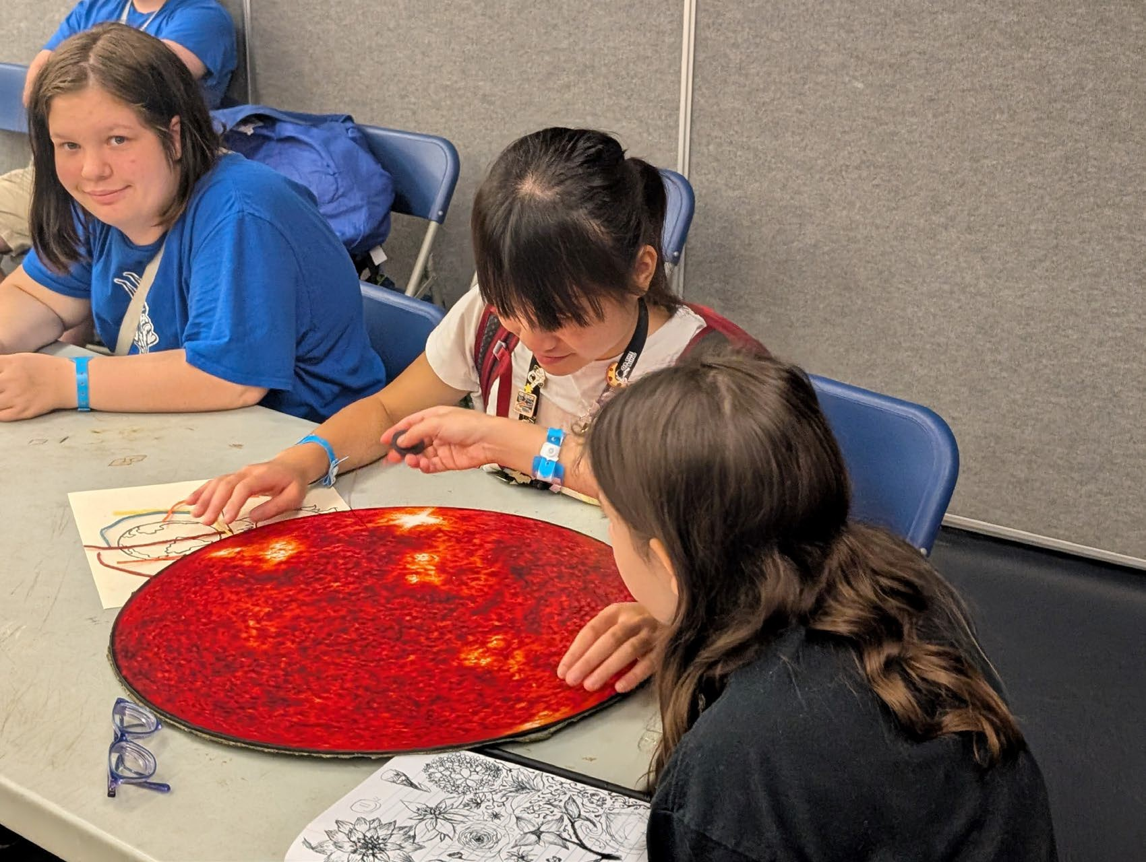
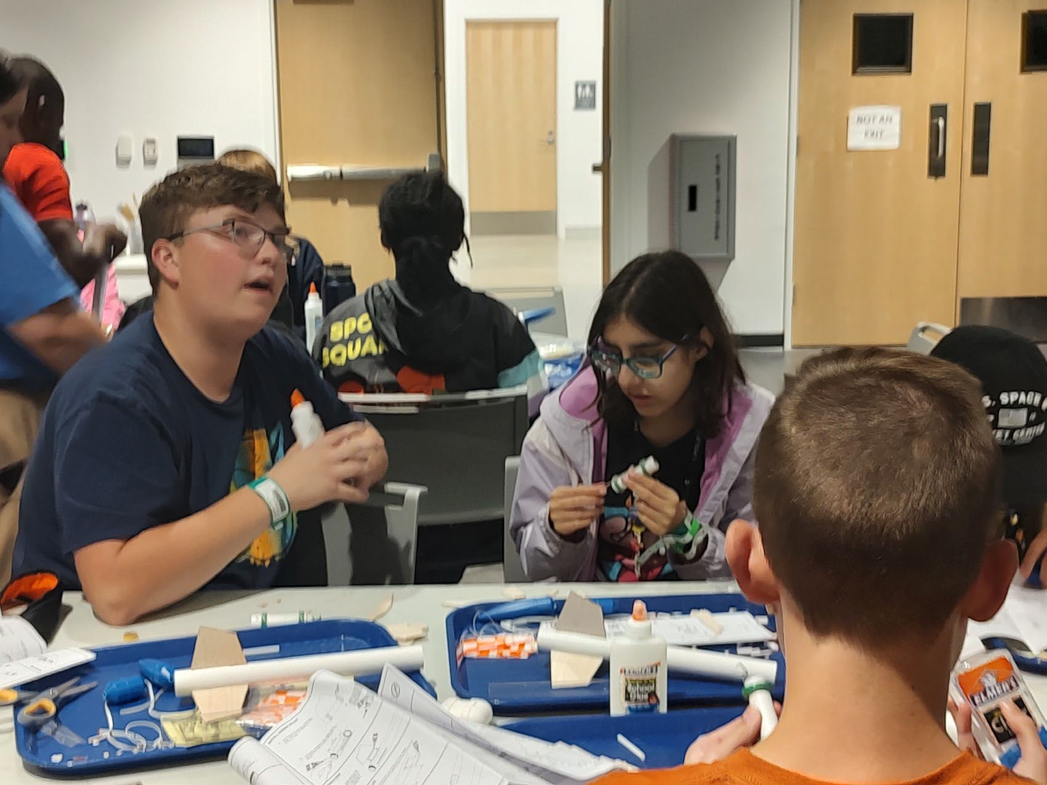

Missions

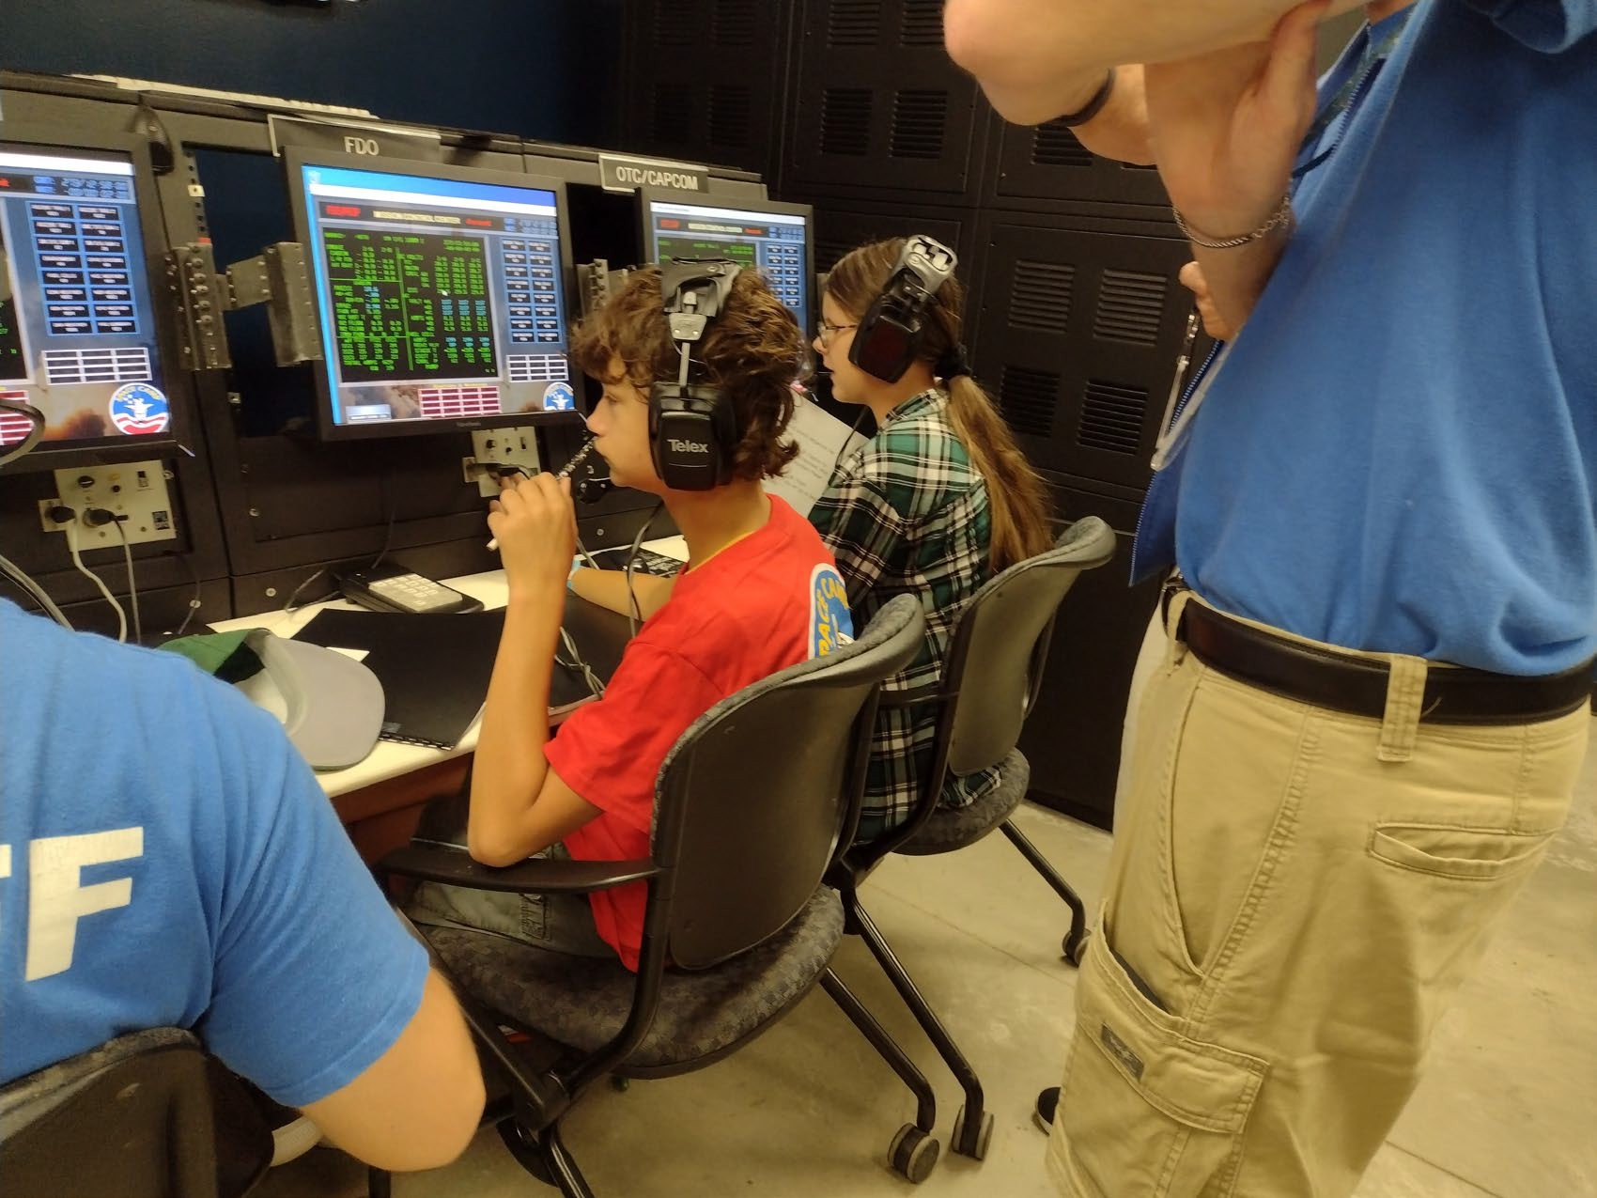
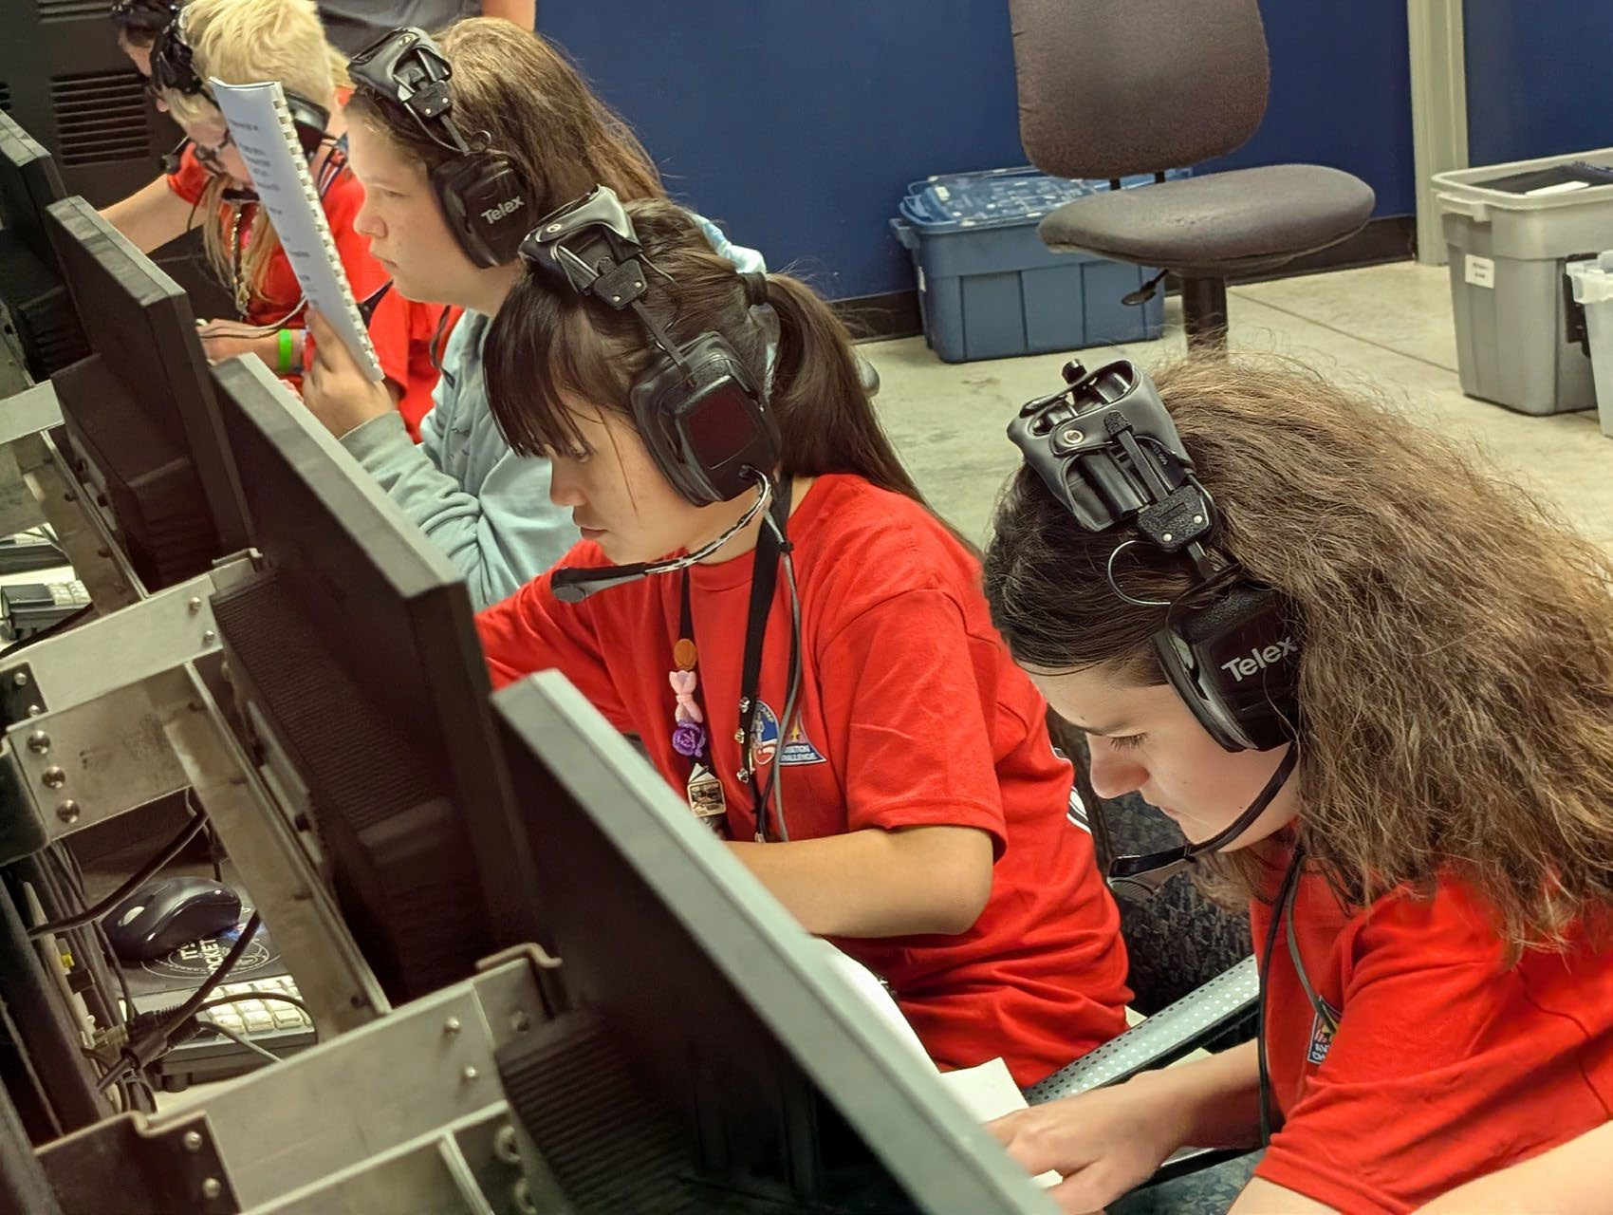

Scholarships
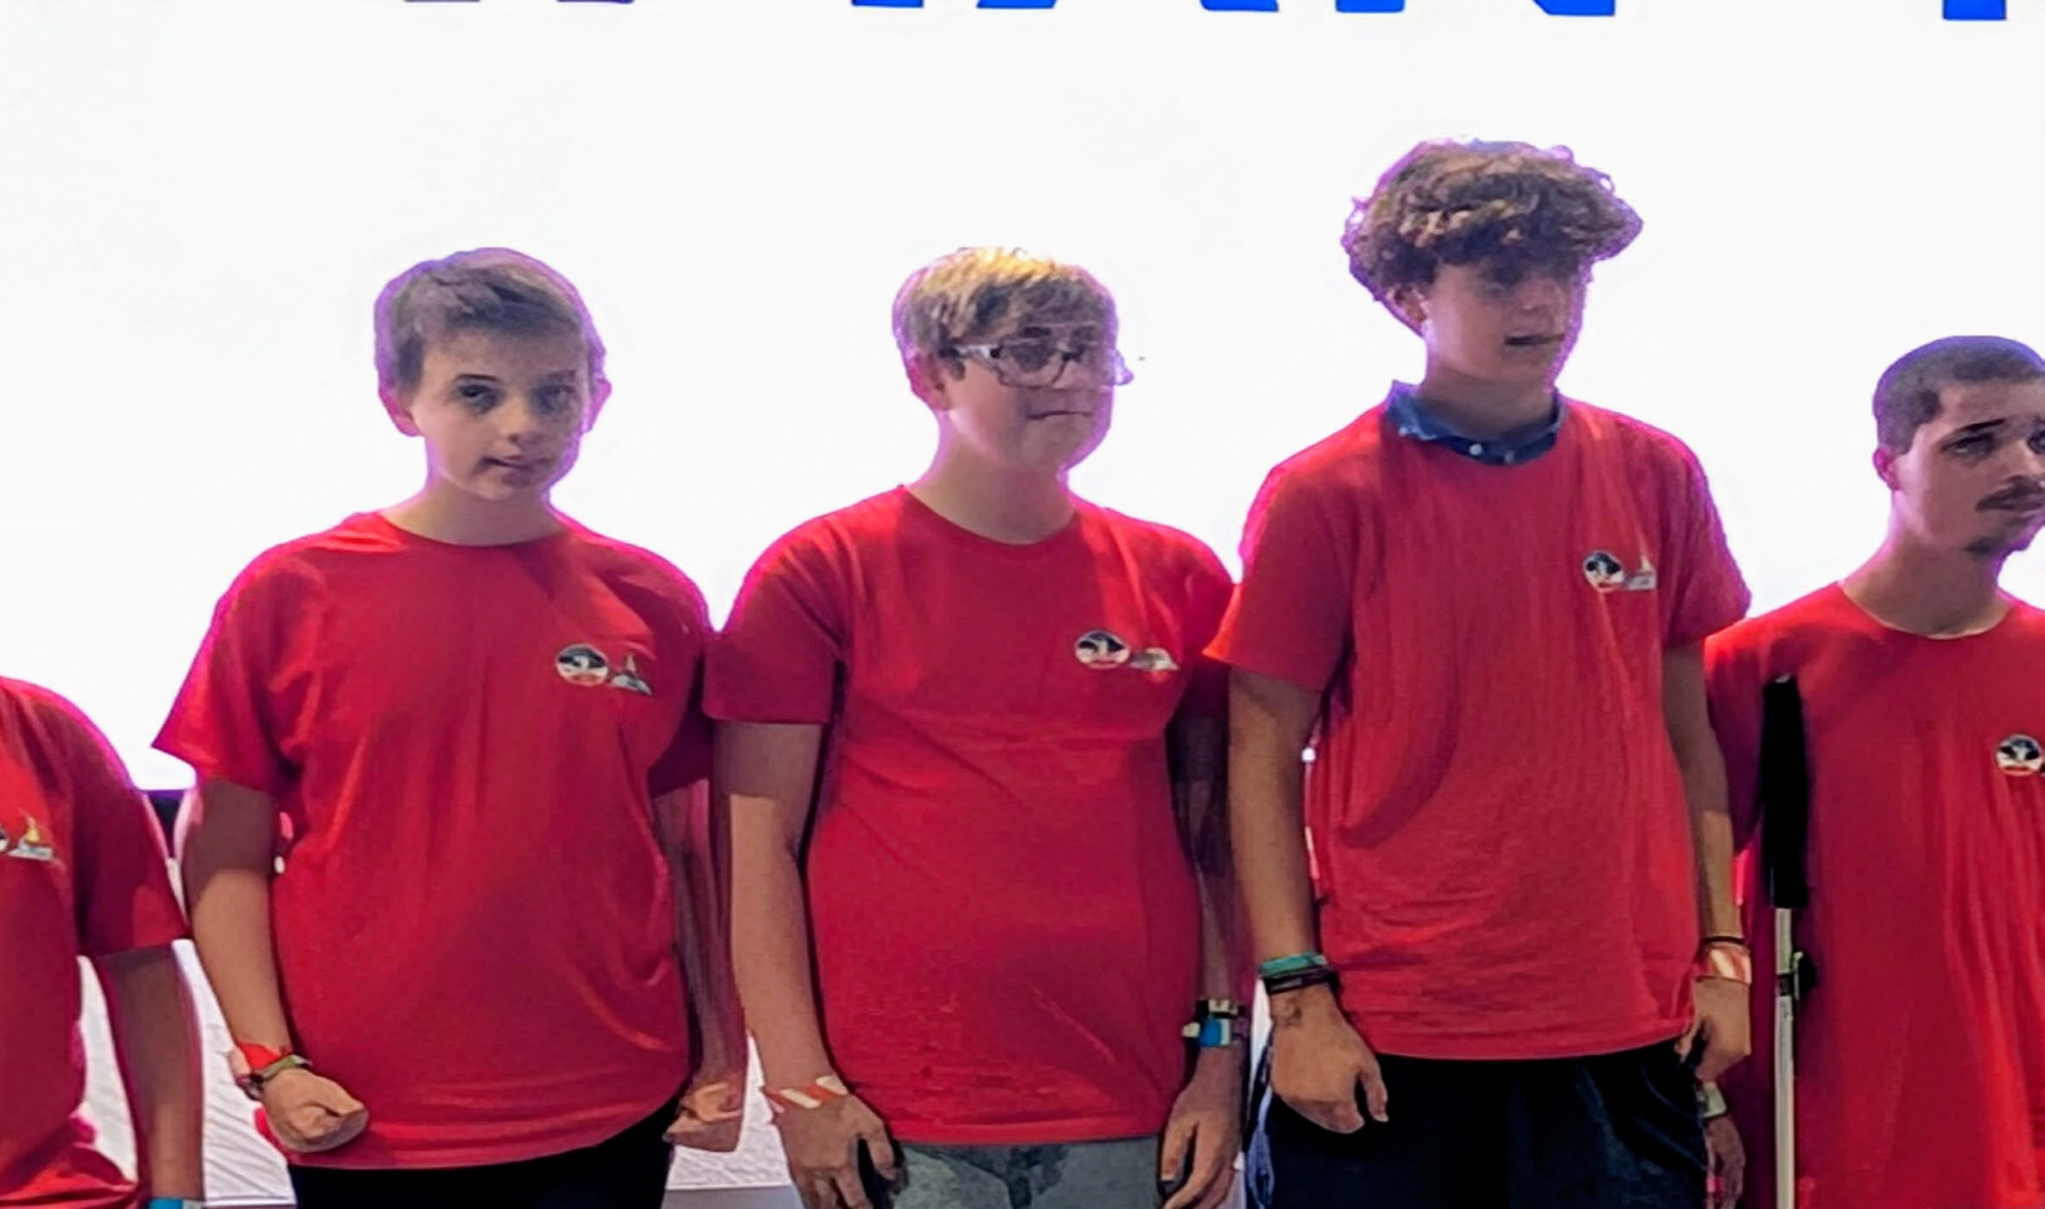

Thank you

- Thank you for giving us this experience. It was an amazing experience and we loved it.

