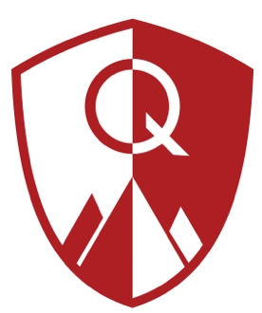
Quest Academy
Board Meeting Agenda
Date: November 20, 2025
Time: 6:00PM
Location: Electronic Teams Meeting
The mission of Quest Academy is to provide students a challenging, technology rich environment, enabling young citizens to become leaders prepared for the challenges of an evolving global community.

Agenda

Board Priorities
State Accountability
Fiscally Sound
Personalized Learning/Individualized Learning
Brand Awareness

CALL TO ORDER – Steve Reeve

PUBLIC COMMENT

CONSENT ITEMS
- October 21, 2025, Board Meeting Minutes

REPORTS
- Administration
  - State of the School
- Financial Report

VOTING & DISCUSSION ITEMS

- Policies Required for Review and Re-Approval:
  - Amended Purchasing and Disbursement Policy
- PTIF Account Access

CLOSED SESSION- to discuss the character, professional competence, or physical or mental health of an individual pursuant to Utah Code 52-4-205(I)(a).

CALENDARING
- Next Board Meeting December 9, 2025, at 6:00 PM via Teams.

ADJOURN

