CITY OF OREM
DEVELOPMENT REVIEW COMMITTEE MINUTES
November 10th, 2025

The following items are detailed in these minutes:
- Temporary Site Plan – Frederico Christmas Trees – Located generally at 25 West Center Street - Approved
- Administrative Site Plan – Tesla Superchargers – Located generally at 895 North 980 West - Approved
- Approve the Minutes from the November 10th, 2025 DRC Meeting - Approved

Place: Aspen Conference Room (Floor 2) – City Hall Building – 56 North State Street, Orem Utah, 84057

11:01 a.m. Jared Hall called the meeting to order.

Those Present: Jared Hall, Chris Clements, Taylor Taggart, Rick Sabey, Aaron McKnight, Taggart Bowen, Steve Norman, DRC Members; Rebecca Gourley, Associate Planner

Those Excused: Derek Spencer, Chelsea Lindsey, Darren Pead, Gary McGinn, DRC members; Grace Bjarnson, Associate Planner

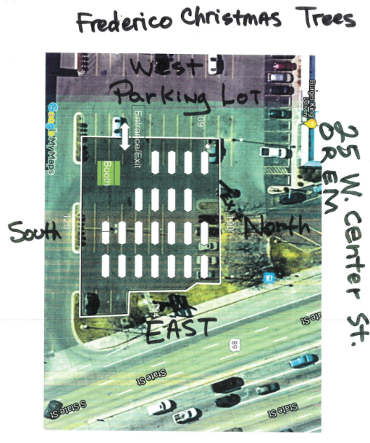
- Temporary Site Plan – Frederico Christmas Trees – Located generally at 25 West Center Street
Rebecca Gourley introduced the temporary site plan for Frederico Christmas Trees. The purpose of the plan is to create a temporary holiday sale location in the parking lot at 25 West Center Street. The Development Review Committee reviewed the plan and found it to be compliant with all codes. Mr. Hall asked for a motion.

DRC Action: Taylor Taggart motioned to approve the Frederico Christmas Trees temporary site plan. Steve Norman seconded the motion.
Yes: Jared Hall, Chris Clements, Taylor Taggart, Rick Sabey, Aaron McKnight, Taggart Bowen, Steve Norman
No: None

- Administrative Site Plan – Tesla Superchargers – Located generally at 895 North 980 West

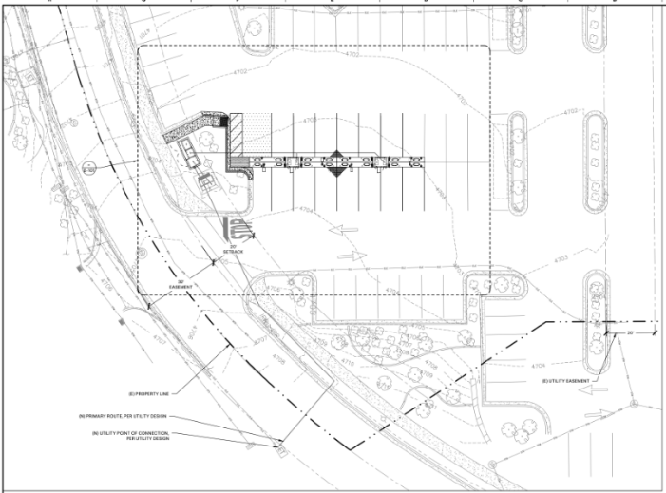
Rebecca Gourley introduced the Tesla Superchargers administrative site plan. The purpose of the project is to replace 17 existing standard stalls and replace them with 16 charging stalls at approximately 895 North 980 West in the PD22 zone. The Development Review Committee reviewed the project and found it to be compliant with all codes. Mr. Hall asked for a motion.

DRC Action: Steve Norman motioned to approve the Tesla Superchargers administrative site plan. Aaron McKnight seconded the motion.
Yes: Jared Hall, Chris Clements, Taylor Taggart, Rick Sabey, Aaron McKnight, Taggart Bowen, Steve Norman
No: None

- Approve the Minutes from the November 10th, 2025, Meeting
The minutes from the November 10th, 2025 meeting were previously sent out via email. No comments or questions regarding the minutes were presented.

DRC Action: Chris Clements motioned to approve the minutes. Taggart Bowner seconded the motion.
Yes: Jared Hall, Chris Clements, Taylor Taggart, Rick Sabey, Aaron McKnight, Taggart Bowen, Steve Norman
No: None

- Adjourn
DRC Action: Rick Sabey motioned to adjourn the meeting. Chris Clements seconded the motion.
Yes: Jared Hall, Chris Clements, Taylor Taggart, Rick Sabey, Aaron McKnight, Taggart Bowen, Steve Norman
No: None

Adjourn: 11:04 a.m.
Approved On: DRAFT

