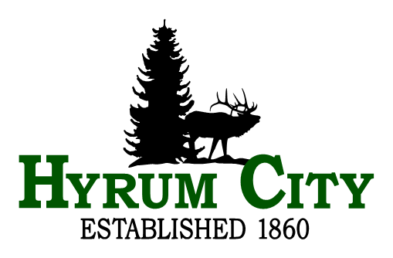
Library Board Meeting
Wednesday, November 12, 2025 at 6:00 PM
Library Board Room, 50 West Main, Hyrum, Utah
Agenda
Public notice is hereby given of a Hyrum Library Board Meeting to be held in the Library Board Room, 50 West Main, Hyrum, Utah at 6:00 PM, November 12, 2025. The proposed agenda is as follows:
1. ROLL CALL
2. CALL TO ORDER
3. WELCOME
4. REVIEW MINUTES
5. PUBLIC COMMENTS
6. BUSINESS
A. Directors Report - Emily Coltrin
B. City Council Report - Jared Clawson
C. Board Training - 10/23/2025
D. Cache Valley Library Association (CVLA)
E. Recertification standards - Information
F. Master Policy review
Section 4 - 6
7. ADJOURNMENT
__________________________________
Emily Coltrin
Library Director
In compliance with the Americans with Disabilities Act, individuals needing special accommodations (including auxiliary communicative aids and services) during this meeting should notify Hyrum City Library at 435-245-6411 at least three working days before the meeting.
CERTIFICATE OF POSTING - The undersigned, does hereby certify that a copy of the foregoing Notice posted on the Utah Public Notice Website and Hyrum City’s Website, provided to each member of the governing body, and posted at the Hyrum Library, 50 West Main, Hyrum, Utah, this 10th day of November, 2025. Emily Coltrin, Library Director.

