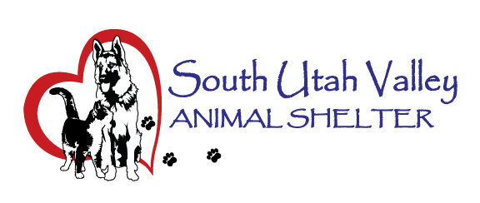
South Utah Valley Animal Special Service District
Board Meeting Minutes Tuesday September 16, 2025
South Utah Valley Animal Shelter Conference Room
582 W 3000 N Spanish Fork UT 84660
Board Member Attendance
Lt. Laursen Chief Rod Hurst @RandiLyn Warner*
Chief Lance Haight Chief John Jackson @Dr Bott
Chief James Chief Brad Bishop @Legal-not filled
Kari Malkovich Kevin Oyler Shawn Carter*
(*Absent / @ At large)
Executive Director: Kierstan Munford Minutes: Carrie Ward
Chairman Hurst called the meeting to order at 10:38 AM.
- Work Session: No items.
Public Hearing Items:
- No items.
General Meeting items:
- Public Comment. There was no public present.
- Approve Minutes of Board Meeting held on 7/15/2025. (This item was delayed until later in the meeting.) Motion to approve the minutes from the Board Meeting with the change to correct Kari Malkovich’s spelling. 1st Chief Bishop, 2nd Lt Laursen. Motion passed.
- Shelter Report by Kierstan Munford. The Shelter staff, volunteers and some animals were in the Spanish Fork parade and also Payson’s Onion Days parade. Kierstan felt it had a lot of positive feedback. The Springville Clinic was on August 9 and sold $1735 in licensing. The Payson Clinic was on September 6 and sold $795 in licensing. The Shelter will also be holding an Event on September 25 from 5-8 PM called Fall in Love. Flyers were shown and handed out to Board members. Our ASPCA Rescue Effect adoption events have resulted in 139 pets being adopted with three more adoption weeks planned by the end of October. The Shelter count was 71 dogs and 183 today. Carrie reported the August statistics to the Board. Kierstan shared an email from a rescue director asking if the cities could keep an ACO on call for the weekends? She has been receiving numerous calls from people who have found lost animals and can’t get someone to pick up the pet or meet them at the Shelter.
- Other business. No business.
- Set a date and time for the next meeting. The next Board Meeting will be on November 18 at 10:30 AM.
- Motion to adjourn. 1st Kevin Oyler, 2nd Chief James. Motion passed.
There was no closed-door session.

