GRAND COUNTY, UTAH ORDINANCE #______________

AN ORDINANCE AMENDING GRAND COUNTY ZONING MAP FROM LARGE LOT RESIDENTIAL, GENERAL BUSINESS, AND HIGHWAY COMMERCIAL TO HIGHWAY COMMERCIAL FOR FOOTHOLD INC., LOCATED AT APPROXIMATELY 1972 PLATEAU DRIVE, BEING THE ENTIRETY OF THE FINAL PLAT OF THE COMMUNITY AT VINA SUBDIVISION AND PARCEL 02-0017-0198 IN GRAND COUNTY, UTAH.
WHEREAS, Foothold Inc. owns an approximately 14.78-acre parcel of land incorporated into the Community at Vina Subdivision and Parcel 02-0017-0198, in the Highway Commercial, General Business, and Large Lot Residential Zones; and
WHEREAS, Foothold desires to change the zoning on the Community at Vina Subdivision to Highway Commercial; and
WHEREAS, the Grand County Commission unanimously passed an ordinance on December 17, 2024, Repealing and Replacing Section 6: Land Use of the 2030 General Plan, and the Future Land Use Map of Spanish Valley of the 2030 General Plan; and
WHEREAS, the General Plan Land Use Designation for the Community at Vina Subdivision is Mixed Use/Flex Commercial; and
WHEREAS, the Mixed Use/Flex Commercial General Plan designation is translated in the plan to the Highway Commercial zone; and
WHEREAS, the Foothold request complies with the officially adopted Future Land Use Plan for Spanish Valley; and
WHEREAS, the Planning Commission of Grand County held a duly advertised and noticed public hearing on November 24th, 2025, on the proposed change to the zoning map of Grand County, Utah, and carefully reviewed the proposed language, map and public input, and voted to forward the proposed ordinance to the Grand County Commission with a recommendation for [approval/denial]; and
WHEREAS, the Grand County Commission held a duly advertised and noticed public hearing on December 2nd, 2025, on the proposed zone change request and, after considering the public comments, the record, and the language of the Future land Use Plan, concludes that the amendment is consistent with the purposes and goals of the Grand County General Plan and the Grand County Land Use Code;

NOW THEREFORE, BE IT ORDAINED BY THE COUNTY LEGISLATIVE BODY OF GRAND COUNTY, UTAH, AS FOLLOWS:

SECTION 1: PLAIN ENGLISH SUMMARY OF THE ORDINANCE
This ordinance amends the Grand County Zoning Map for the Community at Vina Subdivision and Parcel 02-0017-0198, changing the zoning classification from Large Lot Residential, General Business, and Highway Commercial to just Highway Commercial.

SECTION 2: ZONE CHANGE
The Zoning Map of Grand County, Utah, shall be amended to change the zoning of the Community at Vina Subdivision and Parcel 02-0017-0198, from Large Lot Residential, General Business, and Highway Commercial to Highway Commercial, consistent with the Future Land Use Map of the Spanish Valley, in Grand County, Utah. See Exhibit A and B.

SECTION 3: SEVERABILITY
Should any portion of this ordinance be found for any reason to be unconstitutional, unlawful, or otherwise void or unenforceable, the remainder of the ordinance shall be severable therefrom and shall remain in full force and effect.

SECTION 4: EFFECTIVE DATE
This ordinance shall become effective fifteen (15) days after the required publication thereof, as provided by Utah Code §17-53-208.
APPROVED by the Grand County Commission in public meeting this 16th day of December 2025, by the following vote:
Those voting aye: ___________________________
Those voting nay: ___________________________
Absent: ___________________________
GRAND COUNTY COMMISSION
_________________________________________
Bill Winfield, Chair
ATTEST:
_________________________________________
Gabriel Woytek, Clerk/Auditor

Exhibit A Future Land Use Plan for Spanish Valley

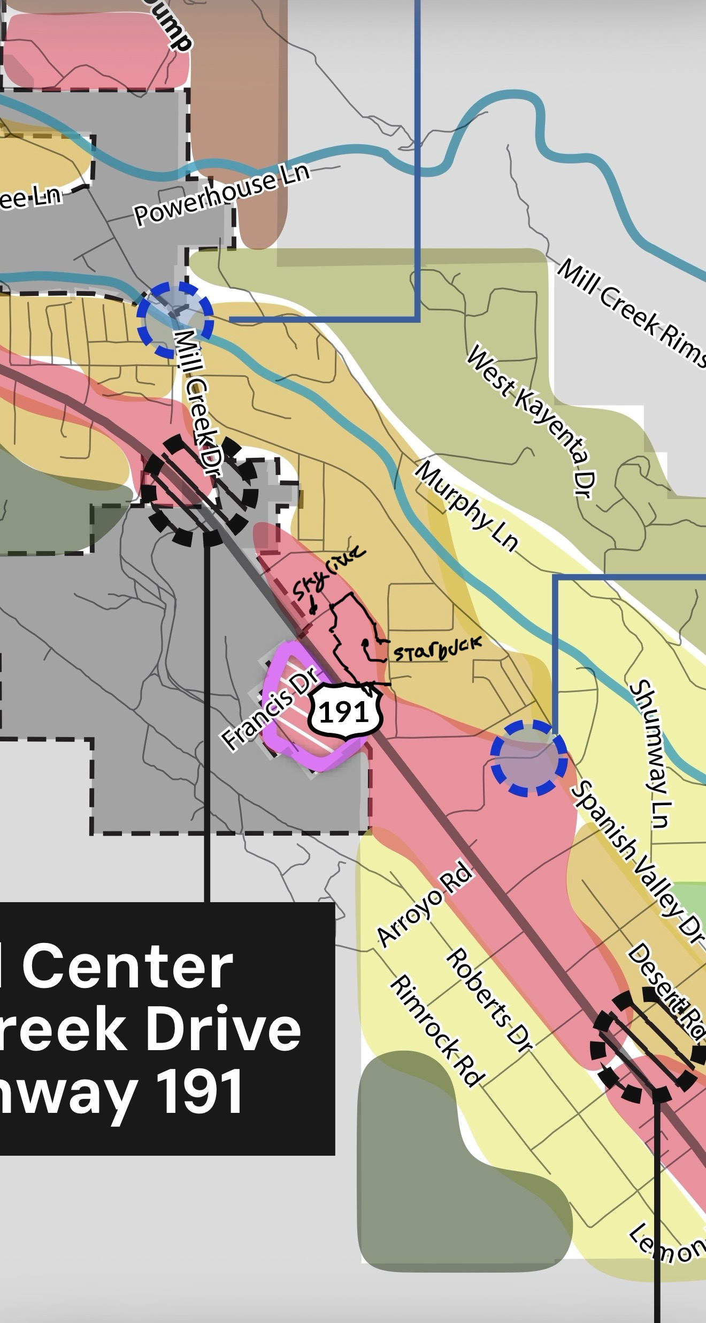
Exhibit B
Grand County Zoning Map

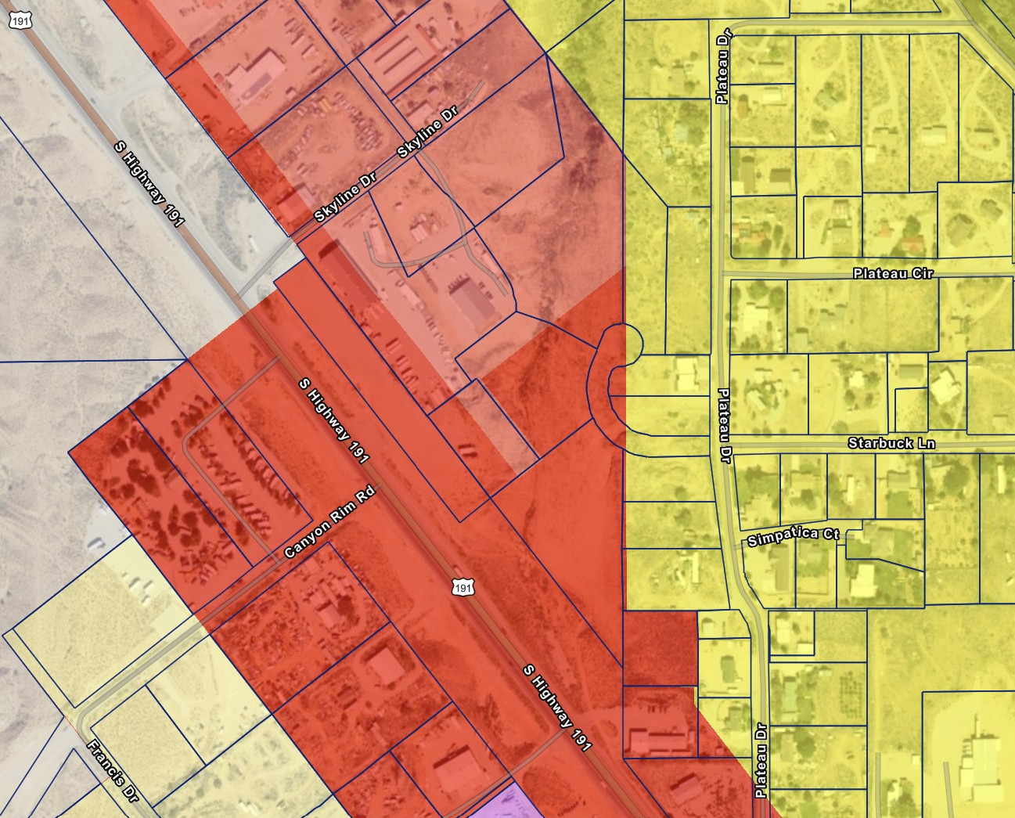
Legal Description:
Lots 1, 2, 3, 4, 5, 6, 7, and 8 of the Community at Vina Subdivision, and parcel 02-0017-0198.

